1997-98 BUDGET PAPER No. 3

Federal Financial
Relations
1997-98

Circulated by
The Honourable Peter Costello, M.P.,
Treasurer of the Commonwealth of Australia, and
the Honourable John Fahey, M.P.,
Minister for Finance
for the Information of Honourable Members
on the Occasion of the Budget 1997-98
13 May 1997

AUSTRALIAN GOVERNMENT PUBLISHING SERVICE
CANBERRA 1997
© Commonwealth of Australia 1997
ISBN 0 644 50221 5
This work is copyright. Apart from any use as permitted under the Copyright Act 1968, no part may be reproduced by any process without prior written permission from the Australian Government Publishing Service. Requests and inquiries concerning reproduction rights should be directed to the Manager, Commonwealth Information Services, Australian Government Publishing Service, GPO Box 84, Canberra ACT 2601.

Produced by the Australian Government Publishing Service
Contents
PREFACE 1
CHAPTER I: RECENT DEVELOPMENTS 4
1997 Premiers’ Conference 4
1997 Loan Council Meeting 7
National Fiscal Outlook 7
Budgetary and Financial Developments in the States 8
CHAPTER II: OVERVIEW OF FEDERAL FINANCIAL RELATIONS 13
Composition of Public Sector Revenue and Outlays 13
Composition of Commonwealth Payments to State/Local Sector 15
Horizontal Fiscal Equalisation 15
Effects of Horizontal Fiscal Equalisation 17
Fiscal Equalisation and Specific Purpose Payments 19
CHAPTER III: COMMONWEALTH PAYMENTS TO THE STATES
AND TERRITORIES 21
General Purpose Payments 23
Level of Financial Assistance Grants 24
Distribution of Financial Assistance Grants 26
National Competition Payments 29
Special Revenue Assistance 29
Funding Arrangements for the Australian Capital Territory 30
Medicare Guarantee Payments 30
Changes in the Distribution of General Revenue Assistance 31
Fiscal Contributions by the States 33
General Purpose Capital Assistance 34
General Purpose Assistance to Local Government 34
Nature and Derivation 34
Specific Purpose Payments 37
Nature and Purpose 37
Trends in Level and Composition of Specific Purpose Payments 38
CHAPTER IV: LOAN COUNCIL OVERSIGHT OF COMMONWEALTH
AND STATE BORROWINGS 41
Loan Council Allocations for 1997-98 41
Estimated Commonwealth LCA Outcome for 1996-97 43
Budget Time Commonwealth LCA for 1997-98 43
Other Loan Council Developments 43
Public Infrastructure Projects with Private Sector Involvement 43
Exemption of Telstra from Loan Council Coverage 44
Revised Uniform Presentation Framework for Government Financial
Information 45
APPENDIX 49
Estimated Specific Purpose Payments to the States, Repayments of Advances
and Interest Payments 1996-97 to 2000-01 49
Estimated Specific Purpose Payments to the States, Repayments of Advances
and Interest Payments 1997-98 80
Estimated Specific Purpose Payments Direct to Local Government Authorities 92
INDEX 96

PREFACE
This Budget Paper presents information on the Commonwealth Government’s financial relations with State, Territory and local governments.
Figures for 1996-97 and 1997-98 are estimates.

Relationship with Other Budget Papers and Terminology
In examining government finances, the most relevant aggregates for economic analysis are usually those relating to payments on a net basis — that is, after recoveries or repayments. In Budget Paper No. 1, this distinction is evident in the use of the term ‘payment’ as a gross measure and the term ‘outlay’ as a net measure, an approach that is also adopted in other budget papers and the national accounts. However, repayments lag the initial advances and, in many cases, are made in respect of programmes which have already terminated. Moreover, the direct relationship between payments and the programmes to which they nominally relate is not always clear. Largely for these reasons, this Paper presents information on payments on a gross basis, although some tables showing repayments are also included.
Consistent with the focus in Budget Paper No. 1 on the underlying rather than the headline budget balance, Chapter I of this Paper examines trends in the public sector underlying deficit of the States. The underlying deficit closely approximates the national accounts net lending measure and hence provides a good estimate of the savings-investment gap for the relevant sector. As explained in Statement 7 of Budget Paper No. 1, the definition of the underlying deficit differs from the Australian Bureau of Statistics’ (ABS) definition of the adjusted deficit in the treatment of provisions.
The Appendix to this Paper provides information on the level and interstate distribution of specific purpose payments, repayments, advances and interest. Information on the level and interstate distribution of Commonwealth payments to local government authorities is also included.

PARAMETER Estimates Used in this Paper
Table 1 sets out the population series and index factors used in this Budget Paper.
Table 1: Parameters
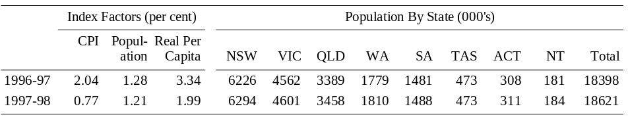
The population series which underlie per capita estimates in this Budget Paper for 1996-97 and 1997-98 are projections at 31 December 1996 and 31 December 1997 respectively. These projections were prepared by the ABS and are on the basis of assumptions agreed to by the Treasury. The index factors for population in 1996-97 and 1997-98 are based on the estimated annual growth in the Australian population to 31 December 1996 and 31 December 1997 respectively.
The index factors for prices in 1996-97 and 1997-98 are based on estimated year-average growth in the headline consumer price index (CPI) in the year to the March quarter 1997 and in the year to the March quarter 1998, respectively.

Further Information
A number of ABS publications also provide information that is relevant to analysing Commonwealth financial relations with other levels of Government, including:
- Government Financial Estimates, Australia (Cat. No. 5501.0);
- Government Finance Statistics, Australia (Cat. No. 5512.0);
- Taxation Revenue, Australia (Cat. No. 5506.0);
- Public Sector Financial Assets and Liabilities, Australia (Cat. No. 5513.0); and
- Government Finance Statistics — Concepts, Sources and Methods (Cat. No. 5514.0).
Some of the data presented in this Paper are drawn from ABS government finance statistics (preliminary) data and the Commonwealth Grants Commission Report on General Revenue Grant Relativities — Update 1997.

Style Conventions
The following style conventions are employed in this Paper:
- the Australian Capital Territory and the Northern Territory are referred to as ‘the Territories’. References to the ‘States’ or ‘each State’ include the Territories;
- the State and local government sector is denoted as the ‘State/local sector’. References to the ‘State/local sector’ include the Australian Capital Territory and the Northern Territory unless otherwise stated;
- figures in tables, and generally in the text, have been rounded. Discrepancies in tables between totals and sums of components reflect rounding. Percentage changes in all tables are based on the underlying unrounded amounts and not the rounded amounts;
- the following notations are used in the tables:
na not available
.. zero, or rounded to zero
- indicating negative amounts; and
- the following abbreviations are used for the names of the States, where appropriate, in tables:
NSW New South Wales
VIC Victoria
QLD Queensland
WA Western Australia
SA South Australia
TAS Tasmania
ACT Australian Capital Territory
NT Northern Territory
Budget Paper No. 3 is one of a series of Budget Papers, the purpose of which is to provide information supplementary to that in the Budget Speech. A full list of the series is printed on the inside cover of this paper.

Chapter I: Recent DevElopments
This chapter provides a summary of the decisions taken at the 1997 Premiers’ Conference and Loan Council Meeting on 21 March 1997. The chapter also summarises the National Fiscal Outlook and provides a brief discussion of fiscal developments in the States.

The 1997 Premiers’ Conference
At the 1997 Premiers’ Conference it was agreed that the level of financial assistance grants (FAGs) to the States will be maintained in real per capita terms in 1997-98. The Commonwealth also extended the real per capita guarantee for FAGs to 1999-2000, conditional on the States complying with their obligations under the Agreement to Implement the National Competition Policy and Related Reforms. On the basis of current estimates, Commonwealth general revenue assistance to the States is expected to be $16,829.9 million in 1997-98, an increase of $531.0 million or 3.3 per cent on the previous year, as shown in Table 2.
The States and Territories will make fiscal contribution payments of $627 million in 1997-98. These payments will be made in accordance with the schedule agreed at the 1996 Premiers’ Conference except for Tasmania and the Australian Capital Territory. In recognition of the difficult economic circumstances facing Tasmania and the Australian Capital Territory, it was agreed that they will defer the payment of half of their scheduled fiscal contributions of $16.3 million and $10.7 million, respectively, until 1998-99. The need for the revised fiscal contribution of $313 million in 1998-99 will be reviewed at the 1998 Premiers’ Conference in the light of developments in the Commonwealth’s fiscal position.
The Commonwealth reaffirmed its commitment to make National Competition Payments (NCPs) to the States as specified in the National Competition Policy Agreement. Competition Payments of up to $215.1 million will be made in 1997-98 and will be determined after the National Competition Council reports in June 1997. These payments, like the per capita component of the guarantee for FAGs, are conditional on the States achieving satisfactory progress in the implementation of National Competition Policy reforms.
The Commonwealth also indicated that the likely reduction in the aggregate level of specific purpose payments (SPPs) to the States, that was currently being contemplated as part of the budget process, would be a maximum of 1.3 per cent against the forward estimates in 1997-98. (The actual reduction will be around 0.5 per cent.)
Other key outcomes from the 1997 Premiers’ Conference were as follows:
- The per capita relativities recommended by the Commonwealth Grants Commission (CGC) in its Report on General Revenue Grant Relativities — Update 1997 (the 1997 Update report) were adopted to distribute the pool of FAGs and unquarantined hospital funding grants (HFGs).
- Medicare guarantee payments of $191.8 million and $244.4 million will be paid to New South Wales and Victoria, respectively, in 1997-98. In accordance with the arrangements established at the 1995 Premiers’ Conference, the Commonwealth will directly contribute $62.3 million to these guarantee payments with the remainder funded by the States from the FAGs pool.
- The Commonwealth will provide the Australian Capital Territory with special revenue assistance (SRA) of $20.7 million in the form of transitional allowances and $13.8 million as special fiscal needs, in 1997-98. These amounts are in accordance with the CGC’s recommendations and will be funded directly by the Commonwealth. Consistent with the CGC’s assessment, the recommended additional payments of transitional assistance for the health and education sectors of $10 million in 1997-98 and $5 million in 1998-99 will be the final payments to place the Australian Capital Territory on an equal footing with the States in all areas other than policing.
Details of these funding decisions and related issues considered at the 1997 Premiers’ Conference are contained in Chapter III.
Estimates of general revenue assistance to be provided to the States in 1996-97 and 1997-98 are shown in Table 2.

Loan Council
At its meeting on 21 March 1997, Loan Council endorsed the Loan Council Allocations (LCAs) nominated by the Commonwealth and each State and Territory for 1997-98.
In relation to public infrastructure projects with private sector involvement, Loan Council confirmed its in-principle decision last year that government contingent liabilities arising under such projects will in future be disclosed as a footnote to, rather than a component of, LCAs.
Loan Council also agreed to the Commonwealth’s proposal to exempt Telstra Corporation Ltd from its arrangements for monitoring and reporting borrowings on commerciality grounds.
In addition, Loan Council agreed to the implementation, from 1998-99, of a revised uniform presentation framework for government financial information. This framework has subsequently been published.
Loan Council issues — including the Commonwealth’s 1997-98 Budget time LCA and the estimated 1996-97 LCA outcome — are discussed further in Chapter IV.

National Fiscal Outlook
The fifth National Fiscal Outlook (NFO) report was prepared by a working party of Commonwealth and State Treasury officials as an input to the deliberations of the 1997 Premiers’ Conference.
The NFO presents medium-term projections of the finances of the Commonwealth and State general government sector (as defined by the ABS) on the basis of policy settings as at February 1997. The 1997 NFO provided updated estimates for 1996-97 and projections for the three years to 1999-2000.
The NFO projected a marked improvement in general government sector finances over the outlook period, with the total general government sector’s underlying deficit projected to decline from 1.7 per cent of gross domestic product (GDP) in 1996-97 to an underlying surplus of 0.8 per cent of GDP by 1999-2000. This primarily reflects an improvement in the position of the Commonwealth general government sector which is driven by fiscal consolidation measures and the impact on Commonwealth outlays and revenue of anticipated economic growth. Net debt for the combined sector was projected to decline over the outlook period, again mainly as a result of developments in the Commonwealth general government sector.
The forecast improvement in the underlying deficit for the combined Commonwealth and State general government sector will close the sector’s gap between saving and investment and hence eliminate its direct contribution to the current account deficit.
The measures announced in the 1997-98 Budget will further improve the fiscal position of the combined Commonwealth and State general government sector.
- The Commonwealth’s general government underlying balance is projected to move from a deficit of 1.4 per cent of GDP in 1996-97 to a surplus of 1.7 per cent in 2000-01. The aggregate State position is expected to remain in small surplus over the same period.
- The total general government sector underlying balance is now projected to move from a deficit of 1.0 per cent of GDP in 1996-97 to a surplus of 2.0 per cent of GDP in 2000-01.
The Commonwealth’s fiscal strategy is set out in Budget Paper No. 1.

Budgetary and Financial Developments in the States
The State public sector is expected to record an underlying surplus of around $2.2 billion, or 0.4 per cent of GDP in 1996-97. This follows the underlying surplus of $3.3 billion, or 0.7 per cent of GDP, achieved in 1995-96 and represents a break in the trend improvement in the fiscal position of the State public sector since its underlying deficit peaked at $3.9 billion, or 1.0 per cent of GDP, in 1991-92.
The State public sector surplus is expected to fall further in 1997-98 to around $0.1 billion. However, in subsequent years, some improvement is expected with recent State budget and NFO projections showing small but increasing underlying surpluses in the State general government sector.
Chart 1: State Public Sector Underlying Deficit
(per cent of GSP)(a)
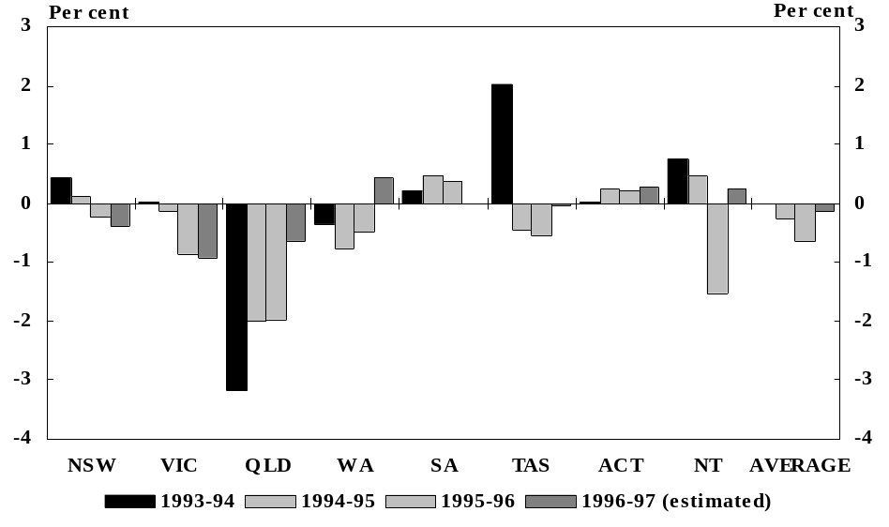
(a) The State public sector underlying deficit is the sum of the general government and public trading enterprise (PTE) underlying deficits. The general government sector underlying deficit is defined as outlays less revenue less net advances paid and the PTE sector underlying deficit is the ABS PTE underlying deficit measure. The average is the unweighted average.
Source: Based on 1996-97 Government Financial Estimates, Australia, ABS Catalogue No. 5501.0, 1997-98 State budgets where available, otherwise unpublished ABS data and 1997 NFO.
The decline in the State public sector’s underlying surplus in 1996-97 is attributable to growth in underlying outlays which more than offset the growth in revenue. Almost all of the change in 1996-97 reflects developments in Queensland and Western Australia. The expected fall in the underlying surplus in 1997-98 reflects New South Wales’ movement into underlying deficit and an expected fall in Victoria’s public sector underlying surplus.
Chart 2 shows the declining trend in the ratio of net debt to gross state product (GSP) since the early 1990s. This trend is expected to continue in 1997 due to the effect of economic growth and the continuation of headline surpluses in most States. These surpluses will result, in part, from asset sales.
In 1995-96, there were large asset sales including the sale of electricity assets in Victoria (worth around $10.7 billion), BankWest ($900 million) and BankSA ($730 million). There have been further asset sales in 1996-97, the largest being Victoria’s sale of the Loy Yang A ($4.9 billion) and Hazelwood ($2.4 billion) power stations.
Chart 2: State Public Sector Net Debt (per cent of GSP)
as at 30 June^{(a)}
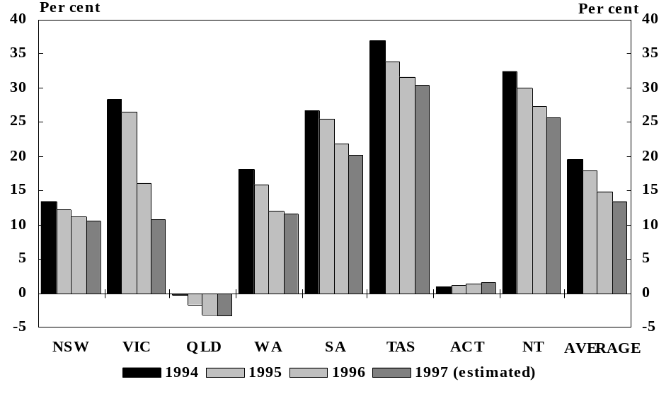
(a) Net debt is defined as gross debt less financial assets. For 1997, 1997-98 State budget estimates of net debt have been used where available. For other States, net debt is calculated by adding to the ABS net debt figure the sum of general government and PTE headline deficits (less net advances paid to PTEs). The average is the unweighted average.
Source: Unpublished ABS data, 1997-98 State budgets where available, otherwise Commonwealth Treasury estimates for 1997.
A number of States continue to carry relatively high public sector debt servicing burdens. These States will require further fiscal consolidation measures to reduce their debt to more sustainable levels.
Fiscal developments in individual jurisdictions are summarised below.
New South Wales is expected to record a significant deterioration in 1997-98 in the underlying position of its public sector which is projected to move into deficit. The growth in underlying outlays in 1997-98 is expected to be around twice that of revenue notwithstanding the introduction of new taxation measures.
Current outlays are expected to increase significantly in education and health in 1997-98 as they have in 1996-97. There will also be strong growth in underlying capital outlays in 1997-98 reflecting the capital projects associated with the 2000 Olympics and investment in transport infrastructure.
Substantial taxation measures were announced in the 1997-98 Budget. The major measures include an electricity distributors’ levy on businesses which have benefited from competition-induced price reductions, an increase in the rate of land tax and a change in the definition of the residential property exemption threshold. A 10 per cent duty is also to be introduced on the cost of accommodation in and around the Sydney central business district.
New South Wales has a short term fiscal target of achieving a sustainable surplus in the general government sector by 1998-99.
Victoria’s financial position has strengthened considerably in recent years. This has resulted from significant asset sales and public sector reforms, including expenditure restraint in service delivery, and increases in own-source revenue. The improvement in Victoria’s financial position has been reflected in a substantial reduction in the State’s net debt.
In underlying terms, the Victorian public sector is expected to record surpluses in 1996-97 and 1997-98. The reduction in the surplus in 1997-98 is expected to reflect strong growth in underlying capital outlays. The 1997-98 Budget announced reductions in a number of taxes, primarily payroll tax and petroleum franchise fees, to bring Victoria’s tax rates into closer alignment with the State average.
Victoria is committed to medium-term fiscal targets, which include the achievement of a sustainable current account surplus and further reductions in debt.
Queensland remains in the strongest financial position of all the States and is the only jurisdiction in a net asset position (that is, with financial assets exceeding financial liabilities). Queensland’s superior fiscal position reflects, in part, its policy of borrowing only for economic infrastructure which is able to service the debt, and funding social infrastructure from recurrent revenue.
However, a significantly lower public sector underlying surplus is expected in 1996-97 resulting from large increases in both current and capital outlays.
Western Australia remains in a relatively strong financial position as a consequence of strong economic growth flowing through to own-source revenue, and earlier public sector reforms.
Western Australia’s public sector is expected to record a decline in its underlying deficit in 1997-98 and to achieve moderate surpluses in the medium term as the historically high level of spending on capital works in the PTE sector is reduced.
Western Australia’s fiscal objectives include reducing public sector net debt as a share of GSP and reducing its interest burden. In its 1997-98 Budget, Western Australia announced its intention to implement fiscal responsibility legislation which will set out key fiscal principles, the process for setting and monitoring medium term fiscal targets, and financial reporting requirements.
South Australia has made steady progress in reducing its net debt to GSP ratio from the peak reached in 1991-92, although the ratio remains high in comparison to most other States. The high net debt ratio was associated with the need to provide financial assistance for its State Bank and State Government Insurance Commission in the early 1990s.
The public sector is expected to be broadly in balance in 1996–97. This improvement is due largely to an expected pick-up in revenue combined with relatively low growth in underlying outlays.
The South Australian Government’s fiscal objectives are to eliminate its underlying deficit in the non-commercial sector by 1997-98 and further reduce public sector net debt.
Tasmania’s net debt to GSP ratio remains the highest of any jurisdiction. Its large debt burden is attributable to its reliance on public sector borrowings through the 1980s, partly associated with investment in the State’s hydro-electric scheme. In recognition of the difficulties facing Tasmania as a result of a deterioration in its fiscal position, it was agreed at the 1997 Premiers’ Conference that Tasmania will defer half of its 1997-98 fiscal contribution to the Commonwealth until 1998-99.
The public sector is expected to be broadly in balance in 1996-97, following small surpluses in the previous two years. The deterioration is due to higher underlying outlays growth and lower revenue growth.
Tasmania’s medium-term fiscal strategy has focused on the continued reduction of net debt, debt servicing costs and State taxes, complemented by public sector reforms. However, significant budgetary pressures remain, including the ongoing expenditure requirements associated with an ageing population.
Although the Australian Capital Territory continues to have a relatively low level of net debt, its budgetary position is expected to deteriorate with the weakness evident in the Territory’s economy.
The Australian Capital Territory is expected to record a significant public sector underlying deficit in 1997-98 as a result of a decline in revenue to the general government sector and continued growth in outlays. In recognition of the difficulties facing the Territory, it was agreed at the 1997 Premiers’ Conference that it will defer half of its 1997-98 fiscal contribution to the Commonwealth until 1998-99.
The Northern Territory is expected to record a small public sector underlying deficit in 1996-97 following a surplus the previous year. The significant deterioration in the Northern Territory’s fiscal position is expected to result from strong growth in outlays. The public sector underlying deficit is expected to increase slightly in 1997-98. The ratio of public sector net debt to GSP is expected to decline slightly in 1997 but remain well above the State average.
The Northern Territory economy has grown faster than the average for all jurisdictions in recent years, with this growth reflected in own-source revenue. Moreover, under the horizontal fiscal equalisation principles, the Northern Territory continues to receive a relatively large share of the pool of Commonwealth general revenue assistance, reflecting the fiscal disabilities associated with its small and widely dispersed population.
The Northern Territory’s medium term fiscal strategy is to address its structural budget imbalance and its high level of public sector debt through the restraint of outlays growth and reduced reliance on borrowings. One of the Northern Territory’s fiscal objectives is to restrict any increase in gross debt to five per cent or less of total expenditures.

Chapter II: Overview of FEDERAL Financial Relations
This chapter begins by providing an overview of Commonwealth payments to the State/local general government sector. The second part of the chapter describes the process of horizontal fiscal equalisation which underlies the interstate distribution of the bulk of Commonwealth general revenue assistance.

Composition of Public Sector Revenue and Outlays
Federal fiscal arrangements in Australia are characterised by a significant difference between the relative revenue and expenditure responsibilities of the Commonwealth and the States, often referred to as vertical fiscal imbalance (VFI). The amount of own-source revenue raised by the Commonwealth is considerably larger than its own-purpose outlays. In contrast, the States’ own-purpose outlays outweigh the amount which they fund from their own-source revenue, with Commonwealth grants to the States forming a considerable part of State revenues. Chart 3 shows the estimated composition of general government own-source revenue and own-purpose outlays in Australia in 1996-97. Own-purpose outlays have been adjusted to include Commonwealth grants ‘through’ the States other than for local government purposes and to exclude net advances.
Chart 3: Composition of General Government Own-Source Revenue
and Adjusted Own-Purpose Outlays, 1996-97 (estimated)
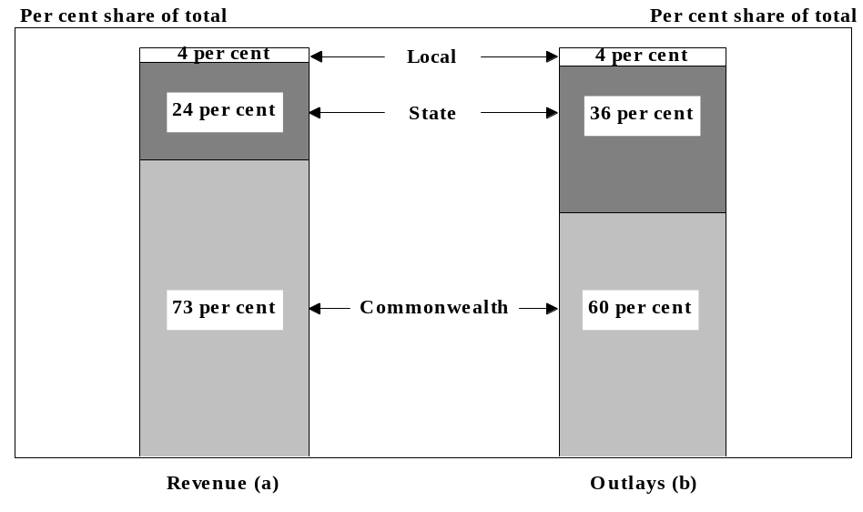
(a) Own-source revenue excludes the receipt of payments from other levels of government.
(b) The ABS measure of general government own-purpose outlays excludes payments to other levels of government and public trading enterprises (PTEs), such as general revenue assistance, SPPs and advances and subsidies, and interest payments on borrowings for other governments and PTEs. The adjusted measure adds back in to Commonwealth outlays SPPs ‘through’ the States (other than those for local government purposes). A corresponding adjustment is made to the State/local series. The adjusted measures for both Commonwealth and State levels of government abstract from all net advances, which is consistent with measures of the underlying deficit.
Source: ABS, Government Finance Statistics, unpublished data.

As noted above, there is a substantial flow of funds from the Commonwealth to supplement the own-source revenues of State/local government. The significance of this flow for Commonwealth general government outlays and State/local general government revenue is shown in Chart 4. Payments to other levels of government (excluding SPPs ‘through’ the States except for local government general purpose assistance grants) accounted for around 20 per cent of the total outlays of the Commonwealth general government sector in 1996-97. These payments also accounted for around 37 per cent of the total revenue of the State general government sector and for around 19 per cent of the total revenue of the local general government sector.
Chart 4: Impact of Commonwealth General Government Payments to Other Levels of Government, 1996-97 (estimated)(a)
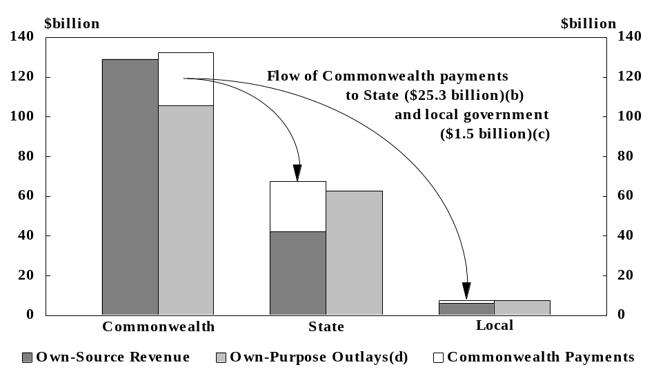
(a) Commonwealth payments comprise general purpose payments and SPPs.
(b) Excludes grants ‘through’ the States.
(c) Comprises grants made ‘through’ the States to local government and direct payments to local government.
(d) Commonwealth grants ‘through’ the States, except grants for local government purposes, have been treated as Commonwealth government own-purpose outlays.
Source: ABS, Government Finance Statistics, unpublished data.

The pattern of Commonwealth and State revenue raising and expenditure responsibilities is longstanding. The most significant difference is in relation to taxation and results primarily from the introduction of uniform Commonwealth income taxation in 1942 to maximise revenue to finance the war effort. Both the Commonwealth and the States have the legal capacity to levy taxes, the only exception being customs and excises which the Australian Constitution reserved for the Commonwealth. The States derive own-source revenue from a range of sources, the most important of which are payroll taxes and taxes on property, including stamp duty.
A degree of imbalance between the revenue raising and expenditure responsibilities of different tiers of government is characteristic of the fiscal arrangements of most federal systems of government. There are considerable advantages to Australia as a whole, from both an economic and an administrative perspective, from the maintenance of a national taxation system. In Australia, a certain level of VFI is also necessary if the Commonwealth is to distribute payments to the States in accordance with the principle of horizontal fiscal equalisation. The provision of grants to the States in the form of SPPs is a means for the Commonwealth to pursue its policy objectives in areas where the States are the primary service providers.
The extent of VFI has often been criticised on the grounds that it reduces government accountability and the amount and certainty of State revenue. Accountability is considered to be best served when the level of government responsible for expenditure is also responsible for funding that expenditure through taxes. In practice, however, State governments are accountable for their budgetary decisions at the margin. The States raise around 55 per cent of their total revenue, and increases in State expenditures have to be financed largely through increased State taxation. Financial market scrutiny also has a bearing on a government’s accountability for its spending decisions.

Composition of Commonwealth Payments to State/Local Sector
Chart 5 shows the composition of Commonwealth payments to the State/local sector in 1997-98. Chapter III discusses these payments in detail.
Chart 5: Payments to the State/Local Sector in 1997-98 (estimated)
Total Gross Payments $35.2 billion
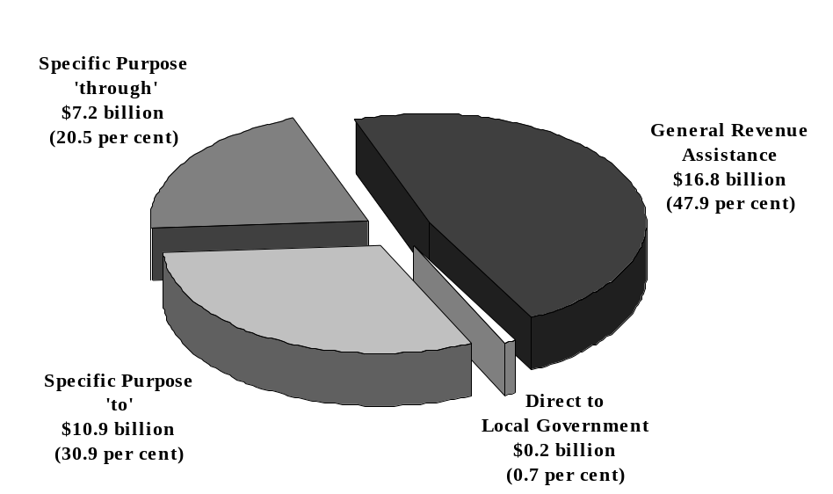

Horizontal Fiscal Equalisation
The general revenue assistance provided to the States by the Commonwealth is largely distributed on the basis of the horizontal fiscal equalisation (HFE) principles which are embodied in the per capita relativities recommended by the Commonwealth Grants Commission (CGC) — see Box 1. The objective of HFE is to improve equity for all Australian residents.
In its assessments, the CGC uses a complex methodology that takes account of differences in the per capita capacities of the States to raise revenues and differences in the per capita amounts required to be spent by the States in providing an average standard of government services. A State’s actual per capita expenditure or revenue generally differs from the average of all States for two reasons:
- influences that are beyond a State’s control (referred to as ‘disabilities’) affect the cost at which it can provide services and its capacity for raising revenue; and
- a State’s policies, practices and operating efficiency differ from those of other States.
HFE requires that only those factors beyond a State’s control be taken into account in determining a State’s relative needs and hence the distribution of Commonwealth general revenue grants. The CGC’s recommendations seek to ensure that each State has the capacity to provide the average standard of State-type public services if it makes the same effort to raise revenue as the States on average and operates at an average level of efficiency.
Since 1990-91, the CGC’s assessments have been based on data for the five financial years preceding the year in which the assessment is made. Accordingly, the review period for the per capita relativities to be applied in 1997-98 spans the years 1991-92 to 1995-96. The five year review period replaced a three year review period and aims to provide greater year-to-year stability in the distribution of FAGs among the States and hence provide a greater degree of certainty for the States in their forward planning. This was balanced against the greater contemporaneity of assessments with current circumstances that would be provided by a shorter review period.
By international standards, the extent of HFE in Australia is pronounced and the methodology is complex. The complexity of the CGC’s processes has arisen in response to the requirements of the States and the Commonwealth over time for a comprehensive and rigorous approach to HFE. For its part, the CGC has sought to maximise the transparency of its methodology and to provide the opportunity for input and comment by the States and the Commonwealth.
Further information on HFE is provided in the CGC’s 1997 Update report.
BOX 1: COMMONWEALTH GRANTS COMMISSION
• The Commonwealth Grants Commission (CGC) is an independent statutory authority established by the Commonwealth Grants Commission Act 1973.
• The CGC makes recommendations concerning the distribution of general revenue assistance to the States in response to terms of reference provided to it each year by the Commonwealth Government.
• The Commonwealth’s practice is to consult with the States concerning the CGC’s terms of reference with a view to reinforcing the Commission’s position as an independent arbiter in relation to horizontal fiscal equalisation.
• The terms of reference define the general approach to be followed by the CGC as well as any specific conditions or limitations on the extent to which fiscal equalisation is to apply.
• The CGC produces both annual updates and five-yearly reviews. Updates essentially revise the data upon which the CGC’s assessments are based. The longer term reviews encompass changes to the Commission’s methodology. The next review is scheduled for implementation in 1999.

Effects of Horizontal Fiscal Equalisation
The CGC first reported on relativities for the six States simultaneously in 1981. Prior to that time, the CGC’s major task was to assess applications by ‘claimant States’ for special financial assistance from the Commonwealth under section 96 of the Constitution. The reviews of relativities were widened to include the Northern Territory in 1985 and the Australian Capital Territory in 1993.
The distribution of the pool of FAGs and HFGs in accordance with the CGC’s per capita relativities means that New South Wales, Victoria, Western Australia and the Australian Capital Territory receive less than an equal per capita share, and the other States (particularly the Northern Territory and Tasmania) receive more. This reflects the CGC’s assessment that the ‘donor’ States have greater relative revenue capacities and/or less significant expenditure disabilities than the other States.
Table 3 shows the amount of FAGs and HFGs received by each State under HFE relative to the amount that they would receive on the basis of an equal per capita distribution or a distribution based on personal income tax collections. The table shows that, in 1997-98, around $1,500 million (or 7.4 per cent) of the FAGs/HFGs pool is to be redistributed among the States as a result of the application of the CGC’s relativities, compared with an equal per capita distribution.
Table 3: Impact of Horizontal Fiscal Equalisation on the Distribution of the Pool of Financial Assistance Grants and Hospital Funding Grants in 1997-98 ($million)(a)
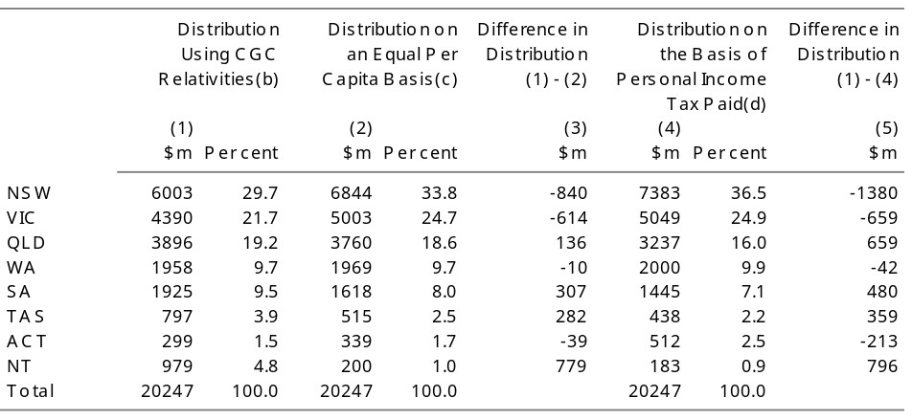
(a) The pool consists of $16144.0 million in FAGs and $4102.9 million in HFGs — see Table 11 in Chapter III.
(b) 1997 relativities as recommended by the CGC — see Table 4 below.
(c) Based on ABS population projections — see Table 1.
(d) Based on each State’s contribution to total net tax paid by individuals for 1994-95, as shown in Table P15 of Australian Taxation Office, Taxation Statistics 1994-95.

Table 4 shows the per capita relativities used to distribute the combined pool of FAGs and HFGs since 1993.
- Western Australia and Queensland have experienced the largest declines in per capita relativities, reflecting relatively strong economic growth in those States which has contributed to an increase in their assessed fiscal capacities.
- In its 1997 Update report, the CGC for the first time assessed Western Australia as having above average fiscal capacity, reflected in a per capita relativity of less than one.
- The per capita relativities of the remaining States (except for South Australia) have increased, particularly those of Victoria and Tasmania.
Table 4: Commonwealth Grants Commission Relativities, 1993 to 1997
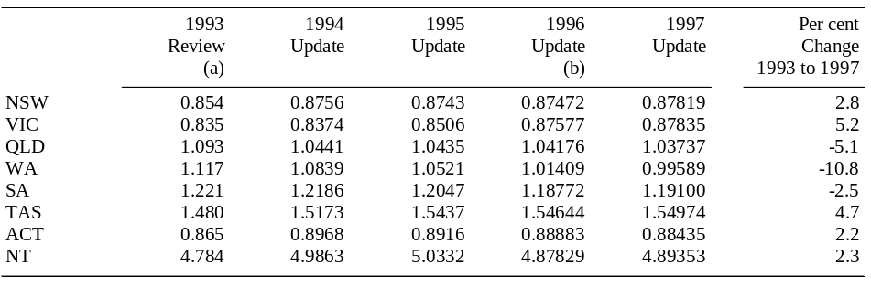
(a) Supplementary relativities calculated by the CGC to take into account the Medicare Agreements and Commonwealth policy in respect of State stamp duty exemptions for corporate reconstructions.
(b) The 1996 Update relativities as amended by the CGC’s subsequent alternative calculation of 29 May 1996 relating to the treatment of Section 130 payments to Western Australia by deduction.

The estimated State distribution of general revenue assistance on a per capita basis for 1997-98 is shown in Chart 6. It indicates that New South Wales, Victoria and Western Australia receive less than average per capita payments while the Northern Territory receives five times the national average and Tasmania and South Australia also benefit from above average per capita payments.

Chart 6: General Revenue Assistance, 1997-98
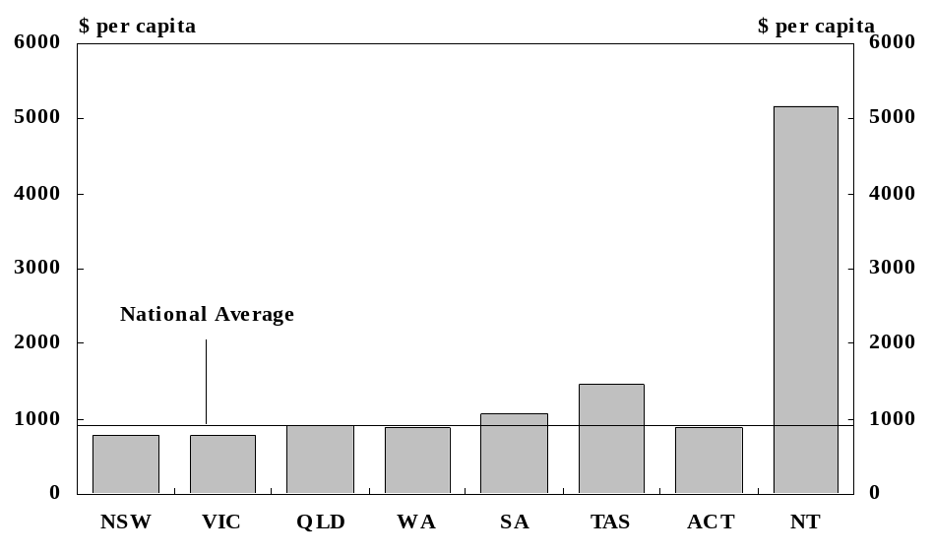
Source: Table 6 of this Budget Paper.

Fiscal Equalisation and Specific Purpose Payments
In determining per capita relativities for the distribution of general revenue assistance, the CGC takes account of the interstate distribution of most current SPPs. Within the CGC’s methodology there are four approaches to dealing with SPPs.
- Inclusion is used for SPPs which are considered to go towards meeting the CGC’s assessment of State expenditure needs (for example, SPPs for funding government schools). In essence, this assumes that the provision of funding through SPPs is no different in effect from the provision of general revenue assistance.
- Absorption is a variant of the inclusion approach with the main difference being that SPPs treated by this method are added to the pool of FAGs and the CGC’s recommended per capita relativities are determined with regard to the combined pool in that year. Unquarantined HFGs are treated in this manner.
- Deduction is used where an SPP is considered to finance expenditure in addition to that which the States would otherwise have undertaken or where an SPP is distributed in accordance with the CGC’s assessment of State needs. Under this approach, only the State-funded portion of expenditure is included in the CGC’s assessments. A number of health SPPs — including the incentives package and bonus pool payments in the Medicare Agreements — are treated by deduction. The deduction approach seeks to quarantine the distribution of FAGs from the interstate distribution of SPPs.
- Exclusion is used for SPPs which are directed to areas in which the Commonwealth has largely accepted financial responsibility (for example, most SPPs ‘through’ the States) or which are outside the scope of the CGC’s assessment. Under this method all expenditure in the particular area is excluded from the assessments.
The distribution of SPPs treated by inclusion or absorption (about three-quarters of current SPPs ‘to’ the States) affects the distribution of FAGs. In general, while the effect of the inclusion method on the overall distribution of funding depends on a number of factors, a State receiving a higher (lower) share of an ‘included’ SPP than the CGC considers appropriate to satisfy its relative ‘needs’ in the area will be assessed as requiring a commensurately lower (higher) share of the FAGs/HFGs pool. Concerns have been expressed that this may in some instances result in the Commonwealth’s policy objectives with respect to SPPs being overridden.
The Commonwealth attempts to balance the objectives of SPPs with the objectives of fiscal equalisation. Accordingly, the Commonwealth has sometimes instructed the CGC to treat certain SPPs in a different way from how the CGC may otherwise have treated them. For example, the financial assistance provided under the South Australian Assistance Package is excluded from the CGC’s assessments to ensure that the benefit of the assistance is not redistributed to the other States by a change in the distribution of FAGs.
In any event, it is not necessarily the case that the Commonwealth’s policy objectives will be forgone where an SPP’s distribution may be overridden over time in a financial sense. The objective of an SPP may be achieved by the fulfilment of the related conditions which the Commonwealth has agreed with the State receiving the payment.

Chapter III: Commonwealth Payments to the
States and Territories
This chapter discusses trends in Commonwealth payments to the States and outlines the arrangements for payments to the States and local government in 1996-97 and 1997-98.
Table 5 shows estimated Commonwealth total payments to the States through the forward estimates period after allowing for the fiscal contributions which the States have agreed to make to the Commonwealth and some large one-off payments in 1996-97 and 1997-98.
- Total payments to the States are estimated to be $34.1 billion in 1997-98. General purpose payments are expected to account for around 47 per cent of payments to the States and SPPs for around 53 per cent.
- Total payments are forecast to increase in both nominal and real terms by around 11 per cent and 2 per cent, respectively, over the forward estimates period to 2000-01.
Table 5: Commonwealth Payments to the States, 1996-97 to 2000-01 ($million, estimated)
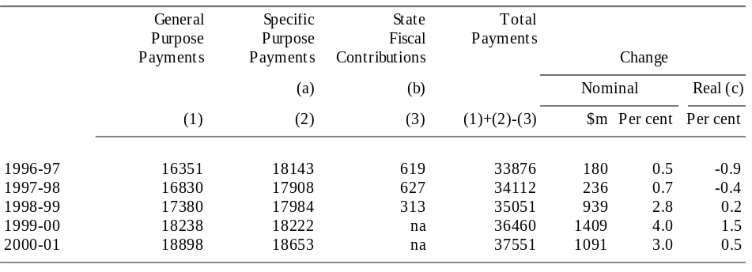
(a) Data exclude SPPs direct to local government authorities, deductions for State fiscal contributions ($142 million in 1996-97) and very large SPPs for the Guns Buyback Scheme ($329 million in 1996-97 and $167 million in 1997-98) and the Petroleum Resource Rent Tax agreement with Victoria ($556 million in 1996-97).
(b) States’ fiscal contributions agreed at the 1997 Premiers’ Conference.
(c) 1989-90 prices, based on forecast CPI growth.

Table 6 shows estimated total net Commonwealth payments to the States in 1997-98. The data are also shown for each State and in per capita terms and include SPPs made directly to local government authorities. After allowing for the States’ fiscal contributions, total net payments to the States and local government authorities are expected to be around $33.5 billion in 1997-98, an increase of $392 million or 1.2 per cent on 1996-97.
Repayments to the Commonwealth by the States will amount to around $887 million in 1997-98. Around 86 per cent of total repayments are expected to be accounted for by the States’ contributions to the Debt Retirement Reserve Trust Account to allow the redemption of amounts borrowed on their behalf by the Commonwealth in previous years. Other significant debt repayments in 1997-98 are related to the Commonwealth-State Housing Agreement.

General Purpose Payments
In 1997-98, general purpose payments to the States will comprise general revenue assistance in the form of FAGs, SRA and NCPs. In contrast to most SPPs, general revenue assistance is not required to be spent by the States in a specified area.
General revenue assistance is estimated to amount to $16,830 million in 1997-98, an increase of 3.3 per cent on the previous year. The estimates of general revenue assistance for 1997-98 have varied from those presented at the 1997 Premiers’ Conference in line with movements in the CPI.
- FAGs account for the bulk of general revenue assistance. The level of FAGs is indexed to movements in the CPI in the year to the March quarter and in accordance with projections of the population as at 31 December each year. The indexation of FAGs is guaranteed on a rolling three year basis subject to the States complying with obligations under the Agreement to Implement the National Competition Policy and Related Reforms.
- SRA can be funded from within the pool of FAGs or directly by the Commonwealth. Payments funded from within the pool reduce the level of FAGs by that amount and hence are effectively funded by the States in line with their weighted population shares. These payments are added back to the pool when determining the base level of FAGs for the next year (see Table 8).
- In 1997-98, SRA will comprise the Medicare guarantee payments to New South Wales and Victoria and payments to the Australian Capital Territory for transitional allowances and special fiscal needs.
- NCPs will commence in 1997-98 in accordance with the Agreement to Implement National Competition Policy and Related Reforms. A State’s receipt of NCPs is conditional on compliance with the obligations of the Agreement.
Table 7 sets out general revenue assistance by type of payment and State for the period 1993-94 to 1997-98.
Table 7: General Revenue Assistance to the States, 1993-94 to 1997-98 ($million)
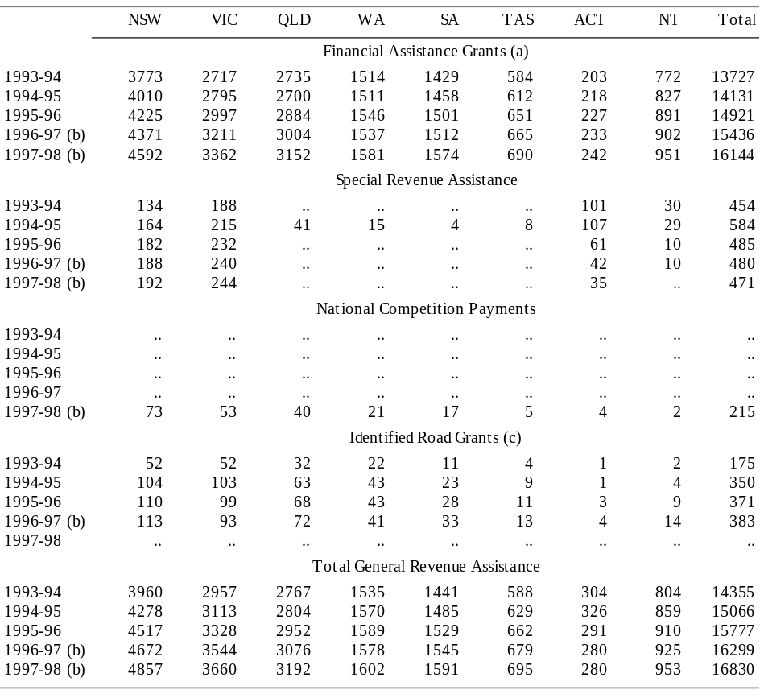
(a) The table shows the gross level of FAGs to the States. The actual payments made to some States in 1996-97 and 1997-98 will be reduced by all or part of their fiscal contributions to the Commonwealth.
(b) Estimates — final figures (except for transitional allowances and special fiscal needs for the ACT) will depend on the actual increase in the CPI for the four quarters to March 1997 and March 1998, and the determination of the Statistician as to the population at 31 December 1996 and 31 December 1997. Final figures for FAGs will also depend on final figures for HFGs.
(c) In 1993-94 and 1994-95, identified road grants were distributed on the basis of the average arterial road allocations for the three years to 1991-92. From 1995-96, the distribution of the grants was progressively moved to a distribution based on FAGs. In 1997-98, these payments will be absorbed into FAGs.

Level of Financial Assistance Grants
At the 1997 Premiers’ Conference, the Commonwealth agreed that the real per capita indexation arrangement of FAGs would be extended to 1999-2000. This continues the three year rolling guarantee of FAGs real per capita indexation which was introduced in April 1995 for the forthcoming financial year and following two years.
In 1997-98, FAGs to the States are expected to total $16,144.0 million, with the real terms adjustment and the per capita adjustment estimated to contribute $124.6 million and $197.8 million respectively. Final amounts will depend on the actual increase in the CPI for the four quarters to March 1998, the determination of the Statistician as to the population at 31 December 1996 and 31 December 1997 and final figures for HFGs.
Table 8: Level of Financial Assistance Grants (FAGs) 1997-98 ($million)(a)
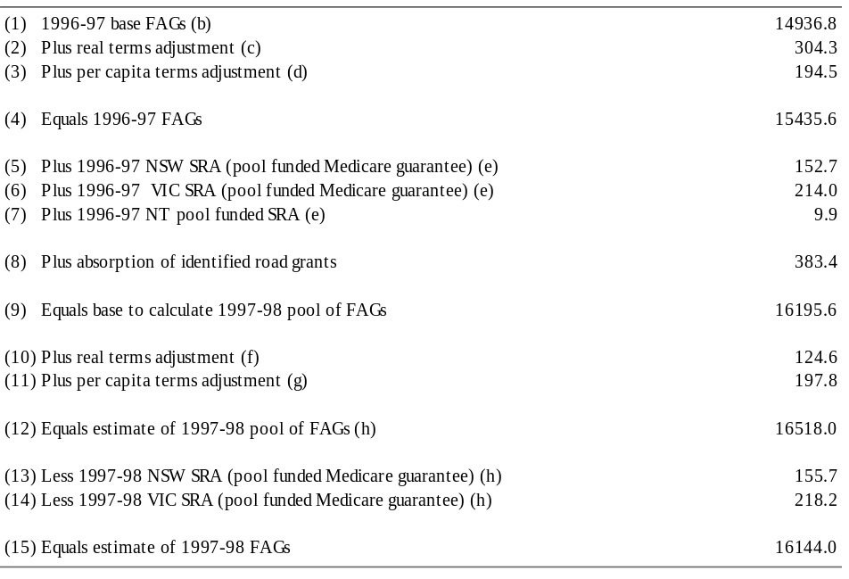
(a) The table shows the gross level of FAGs to the States. The actual payments made to some States in 1996-97 and 1997-98 will be reduced by the amount of their fiscal contributions to the Commonwealth.
(b) This is the amount set by the States Grants (General Purposes) Act 1994, as base assistance for 1996-97.
(c) This indexes the 1996-97 base FAGs for estimated year average CPI growth to the March quarter 1997 of 2.0 per cent.
(d) Based on a projection (prepared by the ABS on the basis of assumptions agreed to by Treasury) of an increase in the Australian population between 31 December 1995 and 31 December 1996 of 1.3 per cent. The final figure will depend on the determinations of the Statistician as to the population at those dates.
(e) Estimates — final figures will depend on the determination of the Statistician as to the population at 31 December 1995 and 31 December 1996.
(f) Assumes year average CPI growth of 0.8 per cent in the year to the March quarter 1998. Final figures will depend on the actual increase in the CPI.
(g) Based on a projection (prepared by the ABS for the Budget on the basis of assumptions agreed to by Treasury) of an increase in the Australian population between 31 December 1996 and 31 December 1997 of 1.2 per cent. The final figure will depend on the determinations of the Statistician as to the population at those dates.
(h) Estimates — final figures will depend on the actual increase in the CPI for the four quarters to March 1998 and the determination of the Statistician as to the population at 31 December 1996 and 31 December 1997.

The 1996 Premiers’ Conference agreed that the funds which were previously paid to the States as identified road grants (IRGs) will be absorbed into the FAGs pool from 1997-98. Table 9 shows the amount of each State’s FAGs which are notionally attributable to the IRGs which will be absorbed in 1997-98.
Table 9: Notional Identified Road Grants ($million, estimated)
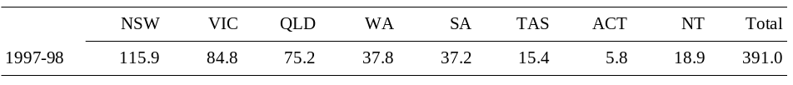

Distribution of Financial Assistance Grants
The distribution of FAGs among the States reflects the decision at the Premiers’ Conference that it should be based on the States’ populations as at 31 December of each year and per capita relativities assessed by the Commonwealth Grants Commission (CGC).
The per capita relativities are applied to the State populations in order to arrive at a weighted population share for each State. A State’s FAGs are equal to its weighted population share of the combined pool of FAGs and unquarantined HFGs, less the HFGs it receives. The distribution and level of HFGs among the States are determined by the Medicare Agreements between the Commonwealth and the States.
Tables 10 and 11 set out the estimated distribution of FAGs for 1996-97 and 1997-98, respectively.
The 1997 Premiers’ Conference adopted the per capita relativities recommended in the CGC’s 1997 Update report. The terms of reference for the 1997 Update report required the CGC to use the same methodology which it employed to calculate the relativities adopted at the 1996 Premiers’ Conference. (The role of the CGC is discussed in Chapter II.)
Table 12 shows that the total redistribution between the States implied by the 1997 Update report relativities is $49.3 million compared to the previous relativities. This is significantly smaller than the redistribution of $126.6 million implied by the amended 1996 Update report relativities, and entails a redistribution of grants away from Western Australia, Queensland and the Australian Capital Territory to the other States.

The main factor responsible for the redistribution is the substitution of 1995-96 for 1990-91 in the five-year review period of the CGC’s assessment. The primary impact on grant shares of updating the review period was through changes in the CGC’s assessment of disabilities which affect revenue raising capacities and expenditure requirements. More detail is provided below and in Table 12, with the emphasis on factors relevant to those States most affected by the 1997 Update report.
- The decline in Western Australia’s grant share was due almost entirely to the replacement of 1990-91 assessments with those for 1995-96. The assessment reflects a higher assessed revenue capacity and an increased share of the SPPs that are included in the CGC’s assessments. The latter included a three-fold increase in its Grant in Lieu of Royalties which are related to the North West Shelf project area.
- The decline in Queensland’s grant share was also largely attributable to the replacement of 1990-91 assessments with those for 1995-96. Its revenue raising capacity increased in areas such as payroll tax, land revenue and business franchise fees. Its relative costs of providing services fell in government education, agriculture and fisheries services, and housing.
- The main factor driving the small reduction in the Australian Capital Territory’s grant share was an increase in revenue raising capacity in areas such as payroll and gambling taxation. This was due to changes in assessment data within the 1996 review period rather than the advancement of the review period.
- New South Wales and Victoria gained the largest increases in grant shares, due mainly to their revenue raising capacities falling relative to those of Western Australia, Queensland and the Australian Capital Territory.
Table 12: Effects of Commonwealth Grants Commission’s Recommendations on the Distribution of FAGs ($million)(a)(b)
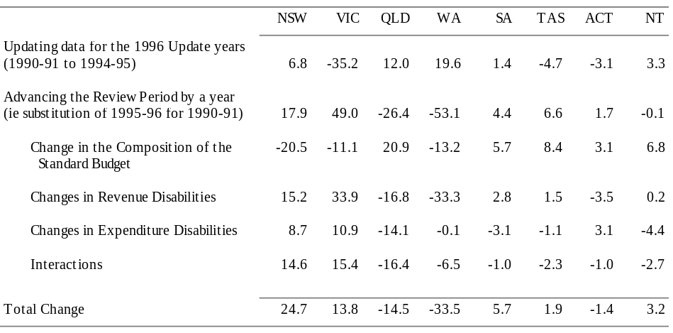
(a) Derived from Table 3-5 of the CGC’s Report on General Revenue Grant Relativities — Update 1997.
(b) Based on the estimate of the 1996-97 FAGs/HFGs pool given in Budget Paper No. 3 1996-97, as used by the CGC in its 1997 Update report.
Further information is provided in the CGC’s 1997 Update report.

National Competition Payments
At the April 1995 Council of Australian Governments (COAG) meeting, the Commonwealth and the States concluded the Agreement to Implement the National Competition Policy and Related Reforms. Under the Agreement the States are eligible for three tranches of ongoing NCPs. The NCPs will commence in July 1997 at a level of $200 million in 1994-95 prices and increase in July 1999 and July 2001, to $400 million and $600 million respectively, in 1994-95 prices.
Each State’s NCPs are subject to the State making satisfactory progress with the implementation of specified reform conditions in the Agreement. Prior to the scheduled commencement of NCPs in July 1997, the National Competition Council will assess whether each State has met these conditions and provide a final report for consideration by the Commonwealth. The NCC will conduct similar assessments before the commencement of each tranche of payments.
Subject to satisfactory progress, the Commonwealth will provide the States with NCPs estimated to total $215.1 million in 1997-98. The Agreement specifies that the NCPs will be paid on a quarterly basis and distributed between the States on an equal per capita basis. Table 13 shows the allocation of NCPs in 1997-98 if each State meets its obligations under the Agreements.
Table 13: National Competition Payments, 1997-98 ($million)(a)
(a) Estimates. Final figures will depend on the actual increase in the CPI and the Statistician’s determination of population as at 31 December 1997.

Special Revenue Assistance
The 1997 Premiers’ Conference agreed to maintain the existing arrangements for the funding of the major part of the Medicare guarantee payments to New South Wales and Victoria from the pool of FAGs and HFGs. Pool-funded SRA will not be provided for other purposes in 1997-98. The Commonwealth will directly fund SRA for the Australian Capital Territory’s transitional allowances and special fiscal needs and to meet an agreed component of the Medicare guarantee payments.
Table 14: Special Revenue Assistance, 1997-98 ($million)
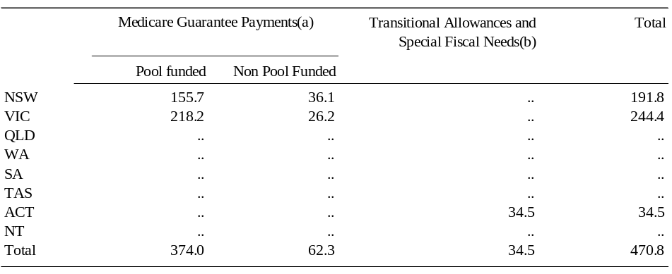
(a) Figures for the Medicare Guarantee Payments are estimates — final figures will depend on the actual increase in the CPI for the four quarters to March 1997 and March 1998 and the determination of the Statistician as to the population at 31 December 1996 and 31 December 1997.
(b) Transitional allowances and special fiscal needs are not adjusted for changes in the CPI or population.

Funding Arrangements for the Australian Capital Territory
The Australian Capital Territory receives funding not available to the other States in the form of transitional allowances and special fiscal needs. The level of payments in 1997-98 reflects the recommendation of the CGC in its 1997 Update report.
Transitional allowances are designed to assist with the Australian Capital Territory’s transition from the generous levels of Commonwealth funding which existed before self-government. In 1997-98, transitional allowances will amount to $20.7 million, a decrease of $7.9 million over 1996-97. This amount incorporates additional transitional allowances for education and hospital services of $10 million which the Commonwealth has agreed to provide to the Australian Capital Territory in accordance with the CGC’s recommendation. The Commonwealth will also provide an additional $5 million in 1998-99. The CGC’s assessment was that the Australian Capital Territory needed some additional time to implement changes to employment conditions to avoid the high costs it inherited from the Commonwealth. The CGC also indicated that, given the comprehensiveness of its review, these additional allowances should be treated as the final payments required to place the Australian Capital Territory on an equal footing with the States in all areas except policing.
Special fiscal needs are payments to the Australian Capital Territory in recognition that certain functions (for example, the Family Court) are not funded by the Commonwealth, whereas in other States funding arrangements exist between the Commonwealth and the State. In 1997-98, special fiscal needs will amount to $13.8 million, an increase of $0.2 million from 1996-97.

Medicare Guarantee Payments
It is estimated that in 1997-98 New South Wales will receive Medicare guarantee payments of $191.8 million, of which $155.7 million will be funded from the pool of FAGs, and that Victoria will receive $244.4 million, of which $218.2 million will be funded from the pool.
The funding of the five-year Medicare Agreements which commenced on 1 July 1993, and the Medicare guarantee payments, were explained in Budget Paper No. 3 1993-94.
At the 1993 Premiers’ Conference, the levels of the Medicare guarantee payments to New South Wales and Victoria were calculated by comparing the gain from distributing the pool of FAGs and HFGs using per capita relativities adjusted for the Medicare Agreements, against the amount the Commonwealth had guaranteed would be the benefit from using Medicare adjusted per capita relativities. Actual payments in 1993-94 and until the Agreement terminates in 1997-98 were to be set by adjusting the level of the guarantee payments agreed in the 1993 Premiers’ Conference in line with the growth in the pool of FAGs.
It was decided at the 1993 Premiers’ Conference that the Commonwealth would fund around half of the Medicare guarantees to New South Wales and Victoria ($107.7 million in 1993-94), but that this contribution would halve in 1994-95, with a concomitant increase in the payments funded from the pool. At the 1994 Premiers’ Conference, it was decided to defer this change in the funding arrangements to 1995-96, at a cost to the Commonwealth of $55.8 million. In accordance with that decision, at the 1995 Premiers’ Conference, the Commonwealth reduced its contribution to around one-quarter of the cost of the Medicare guarantees to New South Wales and Victoria.
Following this formula, it was decided at the 1997 Premiers’ Conference that the Commonwealth will contribute $62.3 million to funding the guarantees, with the balance to be met from the FAGs pool. The cost to the other States of funding the guarantee payments will be $182.0 million in 1997-98. The net benefits to New South Wales and Victoria of the guarantee payments will be $81.0 million and $163.4 million respectively. (The net benefits to New South Wales and Victoria are less than their guarantee payments because they contribute to the pool-funded component of the guarantees in line with their shares of the FAGs/HFGs pool.)

Changes in the Distribution of General Revenue Assistance
Table 15 sets out the impact on the distribution of general revenue assistance of revised population figures for 1997-98, the 1997 per capita relativities, changes in the distribution of HFGs, arrangements for Medicare guarantee payments and other special revenue assistance, and the introduction of NCPs.

Fiscal Contributions by the States
At the 1996 Premiers’ Conference, it was agreed that the States would make payments to the Commonwealth of $619 million in 1996-97, $640 million in 1997-98 and $300 million in 1998-99 as a contribution to the Commonwealth’s deficit reduction programme. The States decided that the payments would be shared among them on an equal per capita basis.
The need for the States to make these fiscal contributions was reviewed at the 1997 Premiers’ Conference. It was agreed to maintain the existing schedule of fiscal contribution payments other than for Tasmania and the Australian Capital Territory. In recognition of the difficult economic circumstances faced by these jurisdictions, it was agreed that they should defer half of their scheduled 1997-98 fiscal contributions, of $16.3 million and $10.7 million respectively, until 1998-99. This reduced the total fiscal contribution from the States in 1997-98 to $627 million. The need for the revised fiscal contribution of $313 million in 1998-99 will be reviewed at the 1998 Premiers’ Conference in the light of developments in the Commonwealth’s fiscal position.
Table 16 shows the estimated contributions of each State in the three years to 1998-99 on the basis agreed at the 1997 Premiers’ Conference and the method of payment by each State in 1996-97.
Table 16: Fiscal Contributions by the States
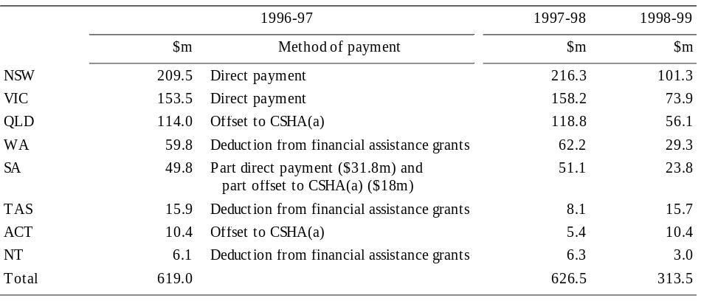
(a) Payments provided under the Commonwealth-State Housing Agreement.

The Commonwealth has provided the States with flexibility on the method of payment for fiscal contributions. This may take the form of direct weekly payments to the Commonwealth, weekly deductions from general revenue assistance or reductions in the Commonwealth’s payment of an SPP. The Commonwealth is prepared to accept payment by reductions in an SPP where this is consistent with its policy objectives and decisions underlying the payment and on the basis that any conditions attaching to the SPP, including the level of the State’s matching commitments prior to the reduction, will continue unchanged.

General purpose capital assistance
In 1996-97, general purpose capital payments to the States were confined to payments under the Better Cities Programmes, which accounted for only 0.3 per cent of total general purpose payments. With the completion of the Commonwealth’s contractual commitments under this programme no general purpose capital payments will be made in 1997-98.
The decline in the significance of general purpose capital assistance has mainly been a reflection of changes in Loan Council arrangements. Prior to 1987-88, capital payments to the States were made in the form of both loans and grants. After 1989-90, capital payments to the States were provided entirely by way of grants. At the 1994 Premiers’ Conference it was decided to abolish the Loan Council capital grants programme from 1 July 1994. Between 1994-95 and 1996-97, Commonwealth general purpose capital assistance consisted only of grants under the Better Cities Programmes.
Table 17 shows general purpose capital assistance since 1993-94. Chapter IV of Budget Paper No. 4 1991-92 provided details of earlier developments in general purpose capital assistance.
Table 17: General Purpose Capital Payments to the States ($million)
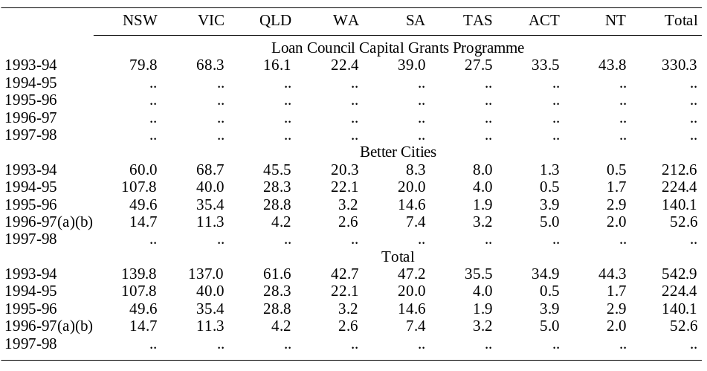
(a) Estimates.
(b) In 1996-97, $2.1 million of total Better Cities funding has not been allocated among the States but is being distributed on an alternative basis.

General Purpose Assistance to Local Government

Nature and Derivation
General purpose assistance to local government has been provided by the Commonwealth since 1974-75. Under current arrangements, the Commonwealth provides general purpose assistance to local government in the form of local government financial assistance grants and local government untied road funding. This assistance is paid to the States as an SPP on the condition that the funds are passed on to local government.
General purpose assistance is provided to local government authorities under the Local Government (Financial Assistance) Act 1995. The Act provides for local government FAGs and local government road funds to be increased each year in accordance with an escalation factor which is determined by the Treasurer in line with the underlying movement in general revenue assistance provided to the States. The escalation factor reflects the percentage increase in FAGs and pool funded special revenue assistance to be paid to the States in the current year compared to those paid to the States in the previous year.
In 1996-97, the Commonwealth will provide $1,216.4 million in local government general purpose assistance. Payments in 1996-97 have been based upon the estimated escalation factor of 4.0 per cent determined by the Treasurer in June 1996. The final entitlement for 1996-97 will be determined by the Treasurer in June 1997 on the basis of actual payments made to the States in 1996-97.
General purpose assistance to local government will be increased in line with the CPI in 1997-98. This level of funding will be more commensurate with trends in payments to the States, taking into account the fiscal contributions which the States are making to the Commonwealth. On this basis, the Treasurer has determined an estimated escalation factor of 0.77 per cent for 1997-98 which will result in the Commonwealth providing $1,205.2 million in local government general purpose assistance in 1997-98. The final entitlement will be dependent upon the Treasurer’s determination of the final escalation factor, which will be made in June 1998 on the basis of the actual payments made to the States in 1997-98.
Table 18 sets out the payments of general purpose assistance to local government in 1996-97 and 1997-98.
As in the past, the interstate distribution of local government FAGs for 1997-98 will be on an equal per capita basis, using the State populations at 31 December in the previous financial year. Untied local government road funding is to be distributed between the States on the basis of the criteria established under the Australian Land Transport Development Act 1988. In both cases, the intrastate distribution of these payments to local governments is determined by State Grants Commissions on the basis of fiscal equalisation.

Specific Purpose Payments

Nature and Purpose
SPPs are made under Section 96 of the Constitution, whereby the Parliament may grant financial assistance to any State on such terms and conditions as it sees fit. There are three types of SPPs:
- payments ‘to’ State governments — these are made direct to State governments for funding expenditures by the States;
- payments ‘through’ State governments — payments to State governments to be passed on to other bodies or individuals. The main payments in this category relate to higher education, non-government schools and local government general purpose assistance; and
- a small number of SPPs made direct to local government.
Most SPPs are paid to the States on the condition that policy objectives set by the Commonwealth, or national policy objectives agreed between the Commonwealth and the States, are met. It is because of the conditions attached to SPPs that they are sometimes called ‘tied grants’.
The conditions imposed on individual SPPs vary considerably in both degree and form. They may involve:
- a requirement that the payment be expended for a specified activity, with varying degrees of budgetary discretion available to the States according to conditions placed on payments; or
- general policy requirements on States (for example, that the States provide free public hospital treatment to Medicare patients as a condition of receiving hospital funding grants).
The Commonwealth can attach conditions to SPPs to reflect policy objectives in programme areas often including requirements for certain levels of spending by the States. The conditions attached to SPPs can thus limit the ability of State governments to set their own spending priorities.
The balance to be set between the Commonwealth’s policy objectives and the desirability of maximising the States’ flexibility on SPPs is not easily resolved and depends on the circumstances pertaining to particular areas of expenditure and policy. For example, the extent to which an SPP may restrict State budget flexibility depends on the degree to which States would have undertaken the expenditure concerned anyway, had they received the same level of funding through general purpose payments. For some large State expenditure items funded through SPPs, it could be expected that all of these funds would be directed to the same purpose regardless of the form of funding.
SPPs that are paid ‘through’ the States account for around 40 per cent of total SPPs. These SPPs have a minimal impact on State budgets as they are essentially Commonwealth own-purpose outlays, with the States acting as the Commonwealth’s agent.
Some SPPs include conditions which influence State own-purpose outlays through the use of ‘matching’ funding requirements. These conditions are commonly expressed in terms of inputs (that is expenditure levels) rather than outcomes. These arrangements have been questioned on the grounds that they may reduce the incentive for the States to pursue efficiency measures because a State cannot direct productivity gains to other expenditure priorities or use them to improve its fiscal position. Nevertheless, expenditure is often used as a proxy for a performance indicator because of the difficulty inherent in defining and agreeing an output or outcome indicator for a programme.

Trends in Level and Composition of Specific Purpose Payments
In 1997-98, SPPs are estimated to total around $18.1 billion, which represents a decrease of $809 million, or 4.3 per cent, on 1996-97. However, this fall is distorted by very large extraordinary SPPs associated with the Guns Buyback Scheme ($329 million in 1996-97 and $167 million in 1997-98), the Petroleum Resource Rent Tax settlement with Victoria ($556 million in 1996-97) and deductions from Commonwealth State Housing Agreement funding for State fiscal contributions ($142 million in 1996-97). After abstracting from these items, the decline in SPPs in 1997-98 is $235 million or 1.3 per cent and is mainly due to non-policy influences. For example, payments of debt redemption assistance are expected to fall by $158 million reflecting changes in the volume of debt maturing on behalf of the States and the inclusion in the 1996-97 payment of compensation relating to optional early debt repayments by some States. After allowing for the fall in debt redemption assistance, total SPPs are expected to decline by $77 million, or 0.4 per cent, in 1997-98.
Table 19 shows estimated SPPs for 1996-97 and 1997-98.
Table 19: SPPs ‘To’ and ‘Through’ the States and Territories, 1993-94 to 1997-98 ($million)
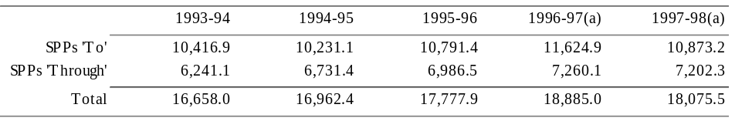
(a) Estimates.

At the 1996 Premiers’ Conference the Commonwealth advised the States that there would be a reduction in SPPs in 1996-97 of no more than 3 per cent against the forward estimates as a result of the budget processes in that year. In the event, the reduction in SPPs to the States was 2.5 per cent against the forward estimates. At the 1997 Premiers’ Conference the Commonwealth advised the States that the reduction in SPPs through the budget processes would be a maximum of 1.3 per cent against the forward estimates in 1997-98. The measures contained in the Budget resulted in a reduction in SPPs to the States of $49 million, or around 0.5 per cent, against the forward estimates in 1997-98.
SPPs are expected to account for around 52 per cent of total gross payments to the States in 1997-98. SPPs ‘to’ the States are expected to total $10.9 billion or 31 per cent of total gross payments, while SPPs ‘through’ the States are expected to be $7.2 billion or 21 per cent of the total. Chart 7 shows trends in SPPs as a proportion of total gross payments to the States since 1977-78, including trends in payments ‘to’ and ‘through’ the States. The chart contains adjustments for a number of classification changes and large one-off factors so as to allow comparisons on a consistent basis.
Chart 7: Specific Purpose Payments as a Percentage of Total Gross Payments
to the States, 1977-78 to 1997-98
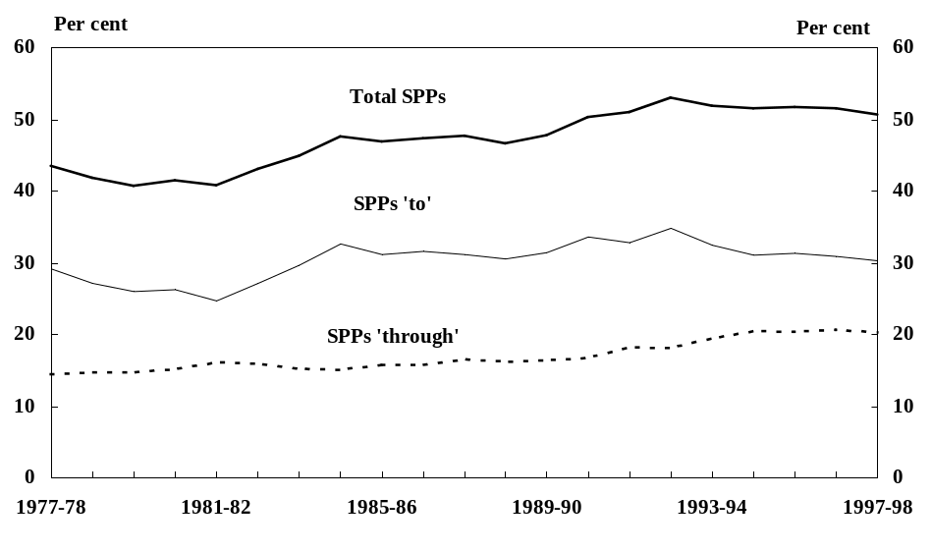
Chart 7 shows that SPPs have increased as a percentage of total Commonwealth payments to the States by around 7 percentage points over the last twenty years. This reflects, in part, the relatively generous escalation arrangements which have applied to SPPs compared to general purpose payments. Although the escalation arrangements for SPPs are diverse, a number have had agreed escalation formulae based, for example, on population growth and price movements.
Chart 8 illustrates the composition of major specific purpose programmes (‘to’ and ‘through’ the States) in 1997-98. Education and health account for the great bulk of payments.
Chart 8: Composition of Estimated Specific Purpose Payments ‘To’
and ‘Through’ the States, 1997-98
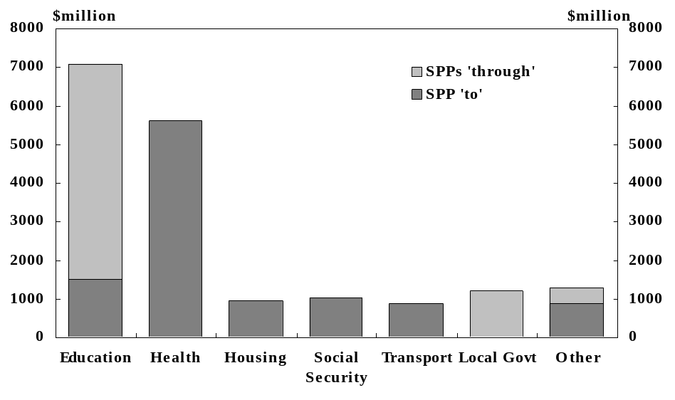
More detailed information on SPPs including State splits for 1997-98 and data on repayments, advances and interest is contained in the Appendix.

CHAPTER IV: LOAN COUNCIL OVERSIGHT OF COMMONWEALTH AND STATE BORROWINGS
This chapter sets out the Loan Council Allocations (LCAs) nominated by the Commonwealth and each State for 1997-98 and endorsed by Loan Council on 21 March 1997. It also reports the Commonwealth’s 1997-98 Budget time LCA and outlines Loan Council developments relating to public infrastructure projects with private sector involvement, reporting arrangements, and Telstra.

Loan Council Allocations for 1997-98
Under the current Loan Council arrangements, each jurisdiction nominates an LCA comprising:
- the estimated general government deficit/surplus (based on its NFO projections);
- its public trading enterprise (PTE) sector net financing requirement; and
- memorandum items (such as transactions that, while not formally borrowings, have many of the characteristics of borrowings).
These nominations are considered by Loan Council having regard to each jurisdiction’s fiscal position and reasonable infrastructure requirements, as well as to the macroeconomic implications of the aggregate figure. LCAs are on a headline rather than an underlying basis as they seek to measure a government’s call on financial markets.
The LCAs nominated for 1997-98 and agreed by Loan Council at its meeting on 21 March 1997 are set out in Table 20. In aggregate, they represent a surplus of $6.9 billion — a substantial improvement on the $3.3 billion deficit currently estimated for 1996-97. The turnaround largely reflects the expected improvement in the Commonwealth’s position.
Loan Council noted the Commonwealth’s announcement that it will continue to work towards the aim of balancing the budget over the term of the current Parliament and that this will require further fiscal tightening in the 1997-98 Budget. Against that background, Loan Council considered that the aggregate of LCA nominations is consistent with current macroeconomic policy objectives.
With the exception of New South Wales, LCA nominations were provided on a no policy change basis. They thus provide a well defined indication of the public sector’s likely call on financial markets. The actual call may vary from the nomination primarily because of changes in economic parameters and policy measures. Updated information will be provided to financial markets through publication by each jurisdiction of its budget time LCA and a mid-year update of its expected LCA outcome.
A tolerance limit of 2 per cent of total non-financial public sector revenue applies between the LCA approved by Loan Council and the budget time LCA, and again between the budget time LCA and the LCA outcome. Tolerance limits recognise that LCAs are nominated at an early stage of budget processes and that estimates are likely to change as a result of policy and parameter changes before and after budgets are brought down. If a jurisdiction expects to exceed the upper or lower bound of the tolerance limit around its LCA estimate, it is obliged to provide an explanation to Loan Council and to make this explanation public. While Loan Council would not be required formally to approve the change, it would have the opportunity to pursue with the particular jurisdiction any concerns raised by the new LCA estimate.
Box 2: loan council
The Australian Loan Council is a Commonwealth-State Ministerial Council which co-ordinates public sector borrowings under voluntarily agreed arrangements. It comprises the Commonwealth Treasurer as Chairman and his counterparts from the States and Territories, and usually meets in conjunction with the annual Premiers’ Conference. Loan Council was established in 1927 under the Financial Agreement between the Commonwealth and the States and was continued in existence under the Financial Agreement between the Commonwealth, States and Territories which became effective in 1995.
Commonwealth-State cooperation in this area derives from a common interest in ensuring that overall public sector borrowing in Australia is consistent with sound macroeconomic policy and that borrowings by each government are consistent with a sustainable fiscal strategy.
The Loan Council arrangements introduced from 1993-94 are designed to enhance the role of financial market scrutiny as a discipline on borrowings by the public sector. In doing so, they build on changes instituted in the late 1980s which gave the individual States responsibility for managing their own borrowings with the aim of making them more accountable to the markets for their actions. The arrangements therefore emphasise transparency of public sector finances rather than adherence to strict borrowing limits.
The Loan Council process is supported by uniform, comprehensive reporting of public sector finances to assist Parliaments, financial markets and the public to make their own judgements about each government’s financial performance. Loan Council recently agreed to changes to the Loan Council reporting arrangements as part of a revised uniform presentation framework for government financial information to apply from 1998-99. The revised uniform presentation framework is discussed briefly in this chapter and more fully in Statement 7 of Budget Paper No. 1.

Estimated Commonwealth LCA Outcome for 1996-97
The Commonwealth nominated an LCA for 1996-97 of $7.9 billion on a no policy change basis. This was endorsed by Loan Council at its meeting in June 1996. In considering the aggregate of nominated LCAs, Loan Council noted that the Commonwealth Government’s announced fiscal consolidation strategy would result in a significant reduction in the Commonwealth’s LCA from the nominated figure.
In August 1996, the Commonwealth provided (in Chapter V of Budget Paper No. 3 1996-97) a budget time LCA estimate of $3.5 billion, incorporating the then estimated headline budget surplus of $474 million. As reported at the time, the reduction from the nominated figure exceeded the lower bound of the tolerance limit of 2 per cent of public sector revenue.
A revised LCA estimate of $5.8 billion was provided in the Mid-Year Economic and Fiscal Outlook 1996-97 (MYEFO) (Table 28), incorporating an estimated headline budget deficit of $2.7 billion.
The current estimate of the Commonwealth’s 1996-97 LCA outcome is $5.0 billion. The deterioration from the budget time estimate of $3.5 billion reflects the increase in the underlying budget deficit noted in Statement 1 of Budget Paper No. 1, and slippage in the timing of some asset sales into 1997-98. The recapitalisation of Telstra affects the LCA components but not the total.
The changes through the course of the year in the Commonwealth’s 1996-97 LCA and its main components are shown in Table 21. The Commonwealth’s actual LCA outcome will be reported in the document, Final Budget Outcome 1996-97.

Budget Time Commonwealth LCA For 1997-98
In formulating its budget, each jurisdiction is required to take into account its Loan Council approved LCA and to report its budget time LCA in its budget papers.
The Commonwealth’s budget time LCA estimate is a $5.5 billion surplus. The improvement from the nominated $4.4 billion surplus approved by Loan Council reflects the increase in the estimated budget surplus from the no policy change figure of $4.6 billion included in the MYEFO to $6.4 billion as shown in Statement 1 of Budget Paper No. 1.

Other Loan Council Developments

Public Infrastructure Projects with Private Sector Involvement
As discussed in Chapter V of Budget Paper No. 3 1996-97, Loan Council agreed last year to change the basis on which jurisdictions report their exposure to public infrastructure projects with private sector involvement from the previous risk weighted estimate to the full contingent exposure as measured by the government’s termination liabilities. This change recognised that the risk weighting approach was producing lower than expected LCA impacts in some cases due to the routine valuation of assets at construction cost. It did not prove possible to find a satisfactory basis for the discounting of asset values to reflect the fact that certain projects would have a value in alternative use lower than their construction cost.
Loan Council also agreed in principle last year that termination liabilities would in future be disclosed as a footnote to, rather than a component of, LCAs. This reflected a concern that the inclusion of contingent exposures as part of the LCA was misleading as they would only be realised in the unlikely event of project failure and are thus materially different from actual borrowings undertaken to finance the public sector deficit.
Loan Council has now confirmed this in-principle decision. The inclusion of termination liabilities as footnotes to the LCA is consistent with disclosure and accountability objectives and will provide financial markets with sufficient information to assess the impact of projects on a jurisdiction’s financial position. Government outlays under these projects such as equity contributions and ongoing payments to the private sector will continue to be included in the annual ABS deficit/surplus and the LCA.

Exemption of Telstra from Loan Council Coverage
Loan Council also agreed to exempt Telstra Corporation Ltd from its monitoring and reporting arrangements under commerciality criteria agreed in 1991. The rationale behind the exemption criteria is that some PTEs operate within a sufficiently competitive environment that they respond to market signals — including changes in the general stance of macroeconomic policy — in much the same way as private sector entities so as to substantially reduce or eliminate the need for their borrowings to be included in government aggregates subject to Loan Council oversight.
The criteria provide for two main avenues of exemption:
- where a PTE does not have substantial private sector equity, it should be constituted to operate in a commercial manner and have a demonstrated track record of commercial performance; and
- where a PTE has substantial private sector equity (of the order of 40 per cent or more), it should be constituted to operate in a commercial manner and have at least a demonstrated commitment to fully meeting the commerciality criteria. The criteria stipulate that a level of private sector equity lower than 40 per cent may be appropriate depending on such factors as the method of sale (eg public float) or the nature of the private sector’s holding of equity.
Telstra’s commercial orientation will be further enhanced by the sale of one-third of its equity to the private sector and the introduction, from 1 July 1997, of open competition in the telecommunications market. It would then meet the private sector equity test and associated requirement to demonstrate a commitment to commercial performance. However, Loan Council agreed that Telstra currently satisfies the higher standard of a proven track record of commercial performance, demonstrated in a range of competitive and contestable markets. Telstra also complied with other aspects of the criteria such as an appropriate monitoring and accountability framework and the payment of government taxes.
Telstra will remain classified to the Commonwealth PTE sector (including after the one-third equity sale, reflecting continued majority Government ownership). Its net financing requirement will therefore continue to be included in ABS data for the PTE and total public sectors. However, future Commonwealth LCA figures will be adjusted to remove Telstra’s net financing requirement.

Revised Uniform Presentation Framework for Government Financial Information
Loan Council agreed to the implementation, from 1998-99, of a revised uniform presentation framework for government financial information. This updated the 1991 Premiers’ Conference Uniform Presentation Agreement which increased the uniformity of information published at budget time to assist soundly based fiscal comparisons between jurisdictions. The revised framework addresses the duplication and complexity of current reporting arrangements, particularly in relation to the presentation of uniform budget information and Loan Council reporting. It also introduces some valuable enhancements such as the presentation of general government forward estimates and the publication of a mid-year report by each jurisdiction.
Although the new framework will not be implemented until 1998-99, Loan Council has agreed that quarterly Loan Council reporting may be discontinued immediately on the basis that all jurisdictions publish a mid-year update of their LCA estimate. There will thus be three LCA estimates published each year — following Loan Council consideration of LCA nominations, at budget time, and in a mid-year report — in addition to the publication of actual outcomes. While the frequency of Loan Council reporting will be reduced, users will benefit from the more forward-looking focus and more integrated presentation of data compared to current Loan Council reports. Interpretation difficulties associated with quarterly reports (due to within year variability in the pattern of transactions) will also be avoided.
A paper setting out the new uniform presentation framework has been published and is available from the Commonwealth and State Treasuries. A fuller discussion of the revised framework is provided in Statement 7 of Budget Paper No. 1.

Table 21: Commonwealth’s Loan Council Allocation for 1996-97 ($million)
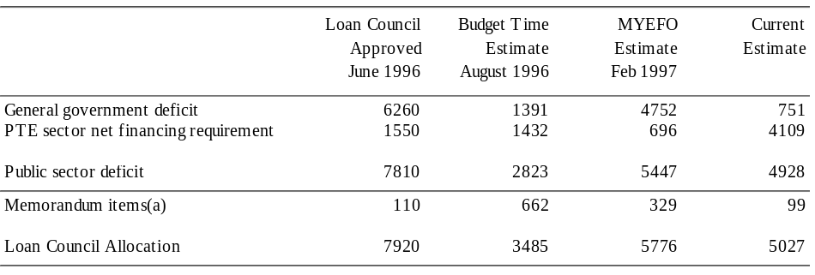
(a) For the Commonwealth, memorandum items comprise the change in the net present value of operating leases (with a net present value greater than $5 million) of departments and authorities and an adjustment to exclude the net financing requirement of statutory marketing authorities from the LCA.

Appendix

COMMONWEALTH SPECIFIC PURPOSE PAYMENTS TO OTHER LEVELS OF GOVERNMENT, REPAYMENTS OF ADVANCES AND INTEREST PAYMENTS
This Appendix provides details of Commonwealth specific purpose payments to the States and local government together with details of repayments and interest on advances (loans) to the States. The majority of these advances were funded from borrowings made on behalf of the States.

TABLE A1: ESTIMATED SPECIFIC PURPOSE PAYMENTS TO THE STATES, REPAYMENTS OF ADVANCES AND INTEREST REPAYMENTS 1996-97 TO 2000-01
This table provides details of Commonwealth specific purpose payments to the States, together with details of repayments and interest on advances. The majority of these advances were funded from borrowings made on behalf of the States under the State Governments’ Loan Council programme.
Details are classified as follows:
- specific purpose payments
- current;
- capital;
- repayments of advances (including repayments to the Debt Sinking Funds);
- details of new advances made; and
- interest on Commonwealth advances.
Specific purpose payments are classified on the functional basis used in Budget Paper No. 1, which aggregates outlays directed towards like objectives and purposes. Specific purpose payments are further divided into those paid ‘to’ the States (by far the larger group by number) and those judged to be paid ‘through’ the States to other groups. Programmes in the latter group are indicated within the table by (*) and separate totals for ‘to’ and ‘through’ are provided in the summary at the end of the table.
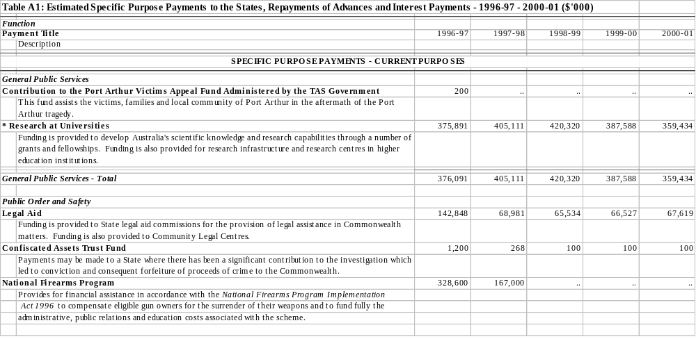
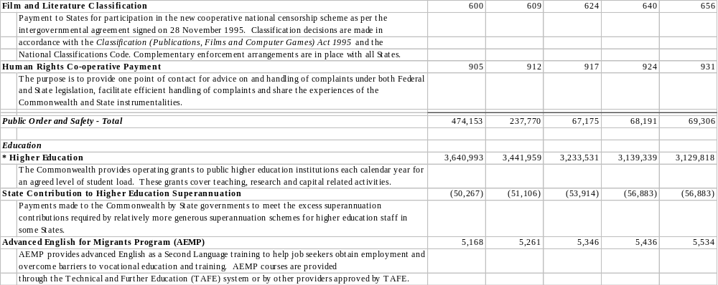
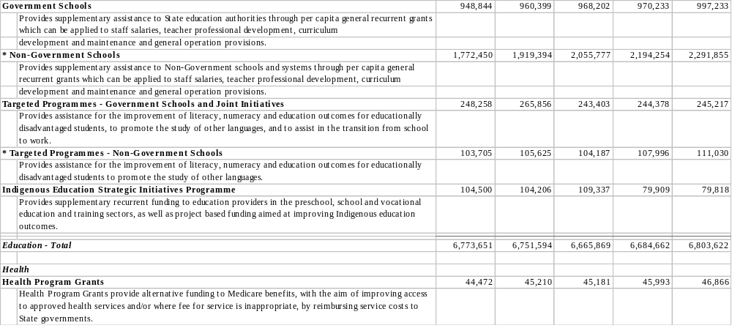
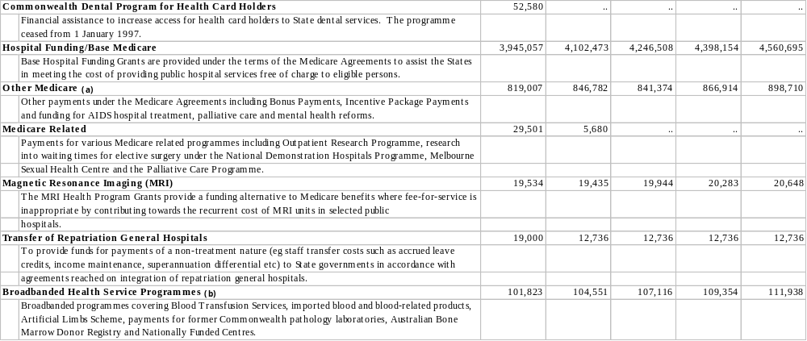
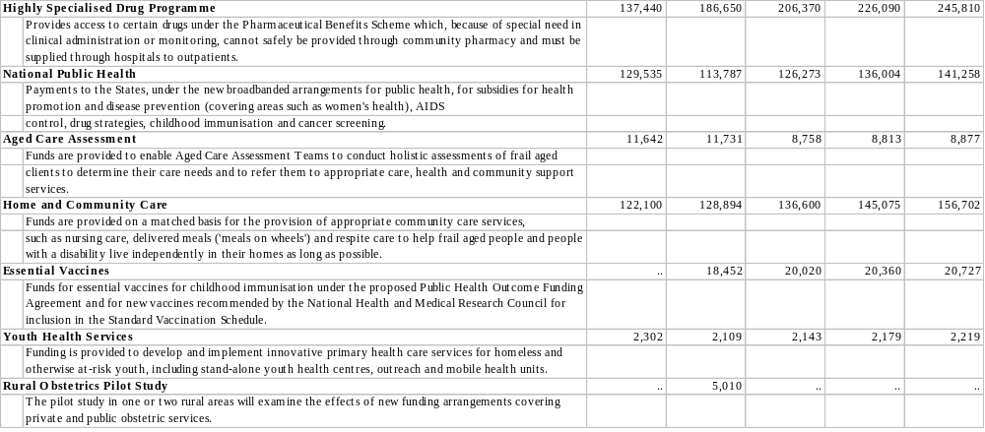
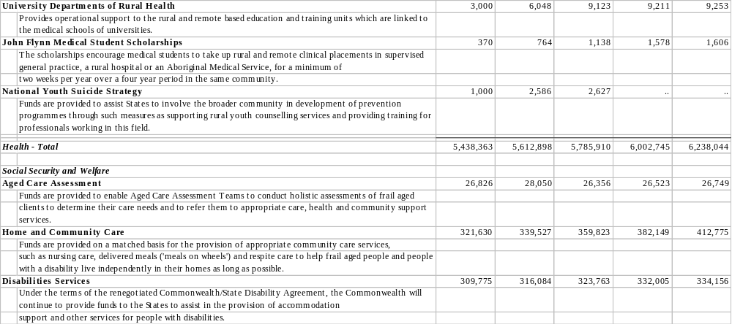
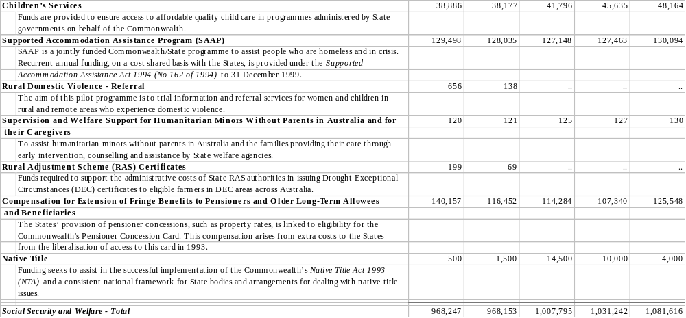
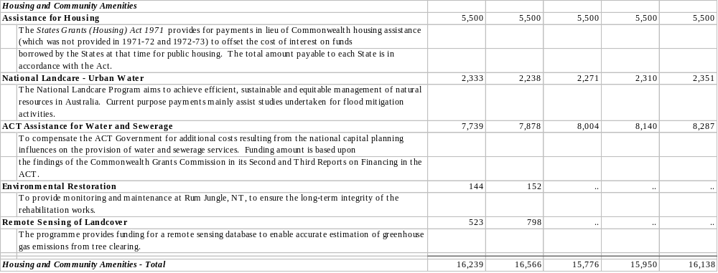
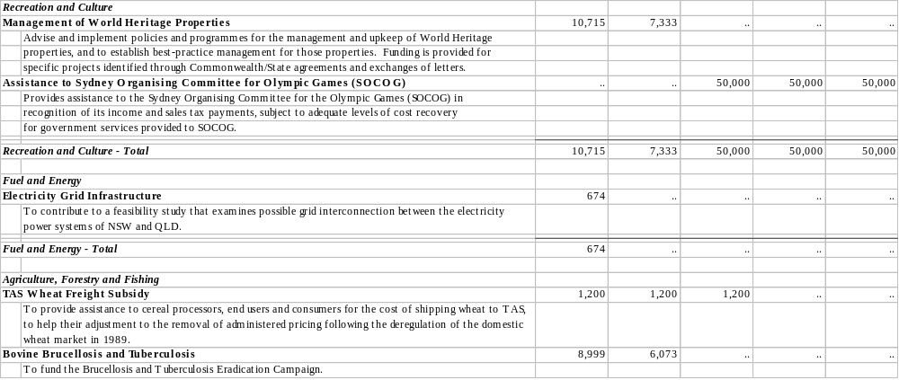
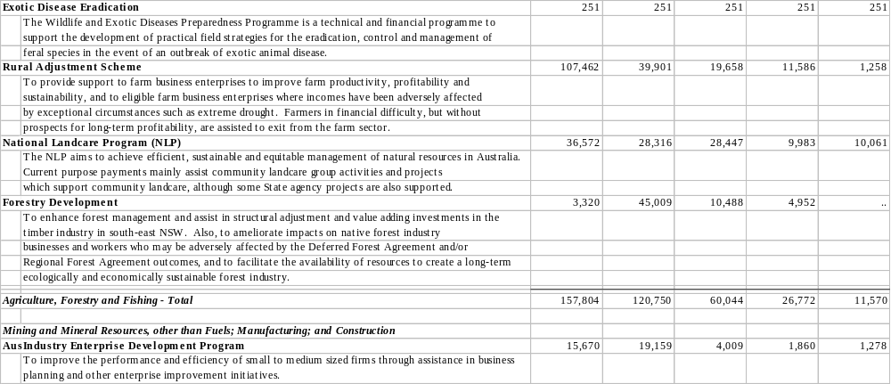
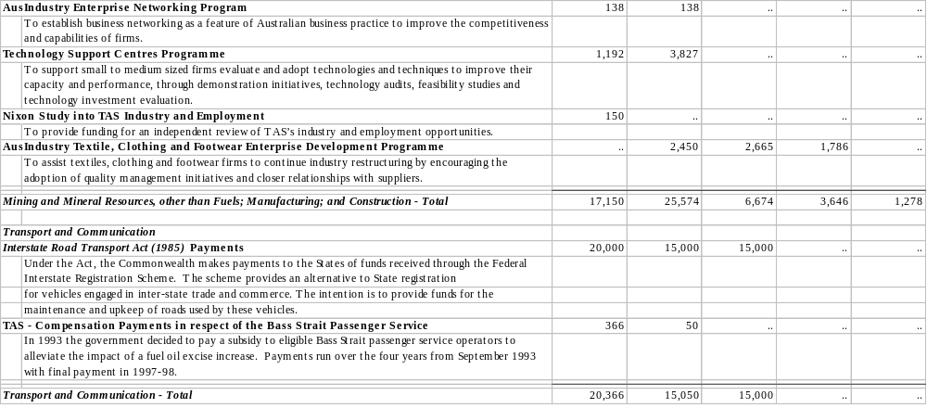
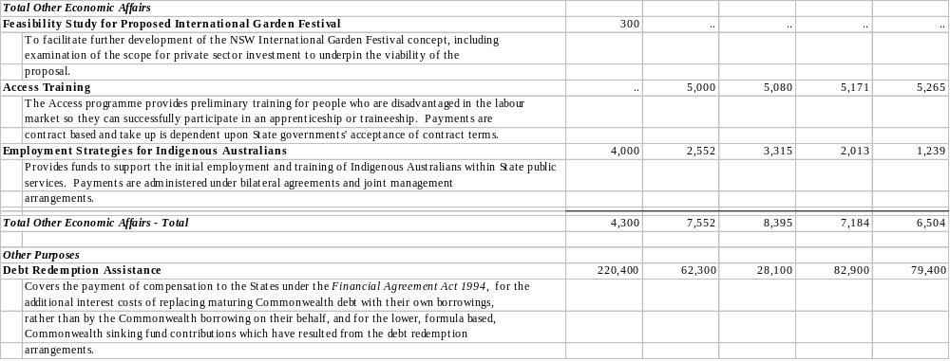
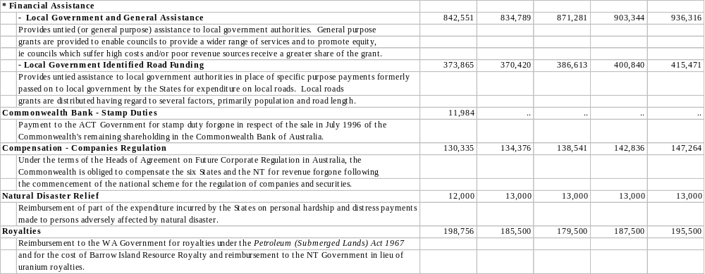
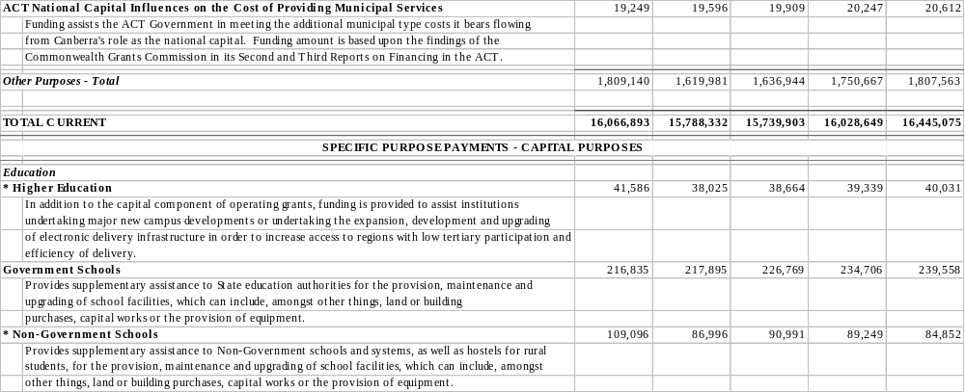
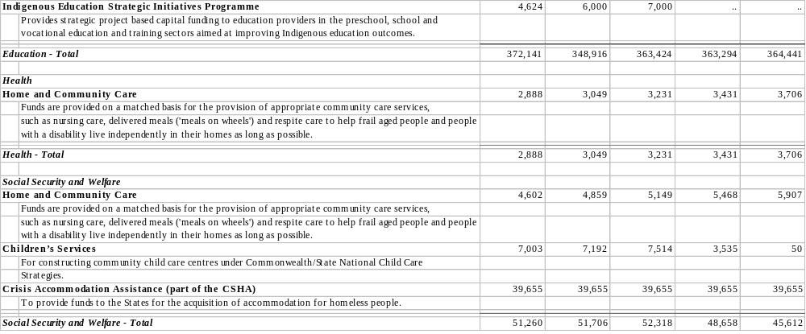
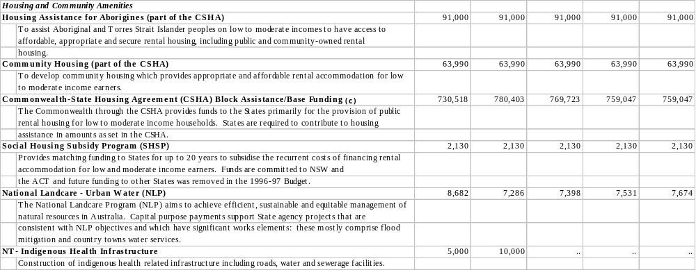
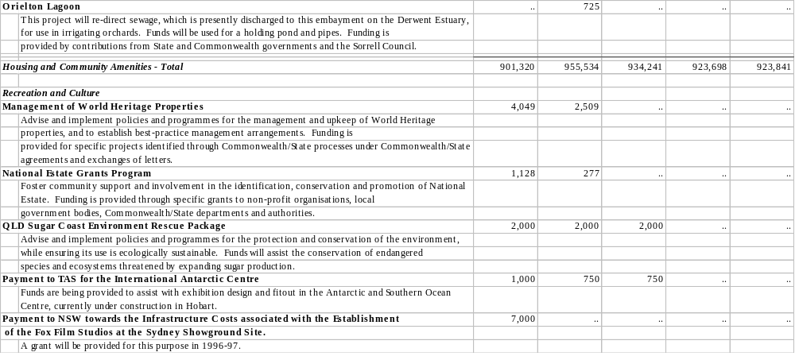
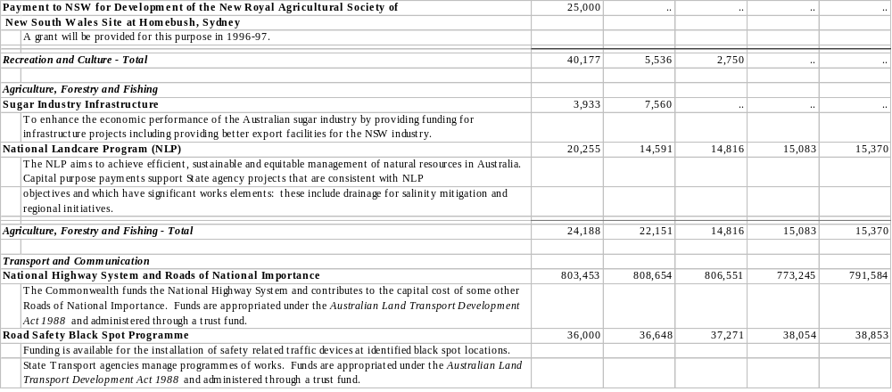
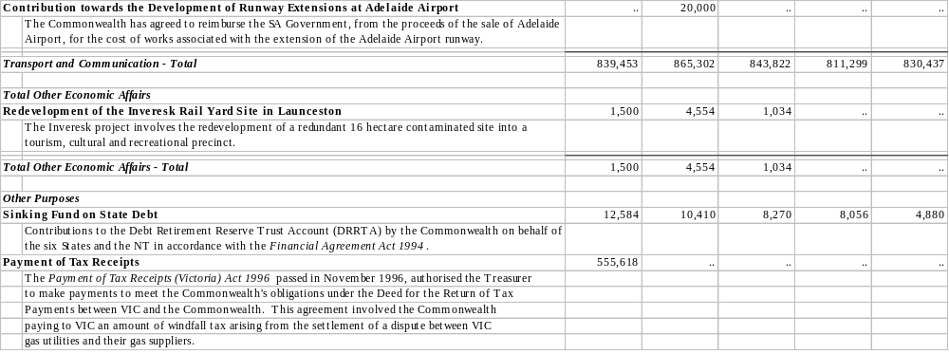
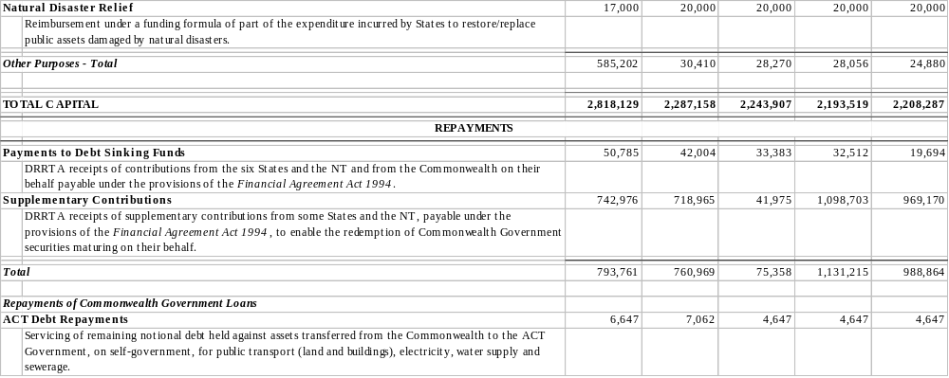
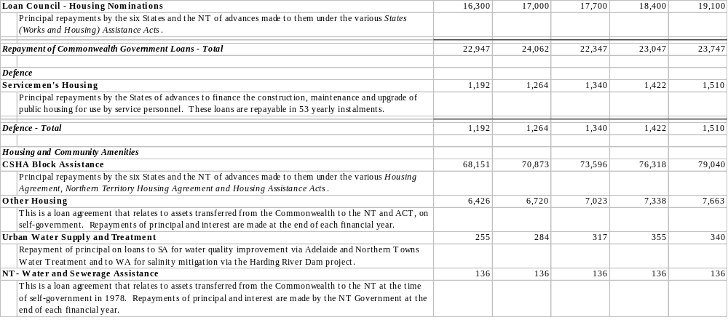
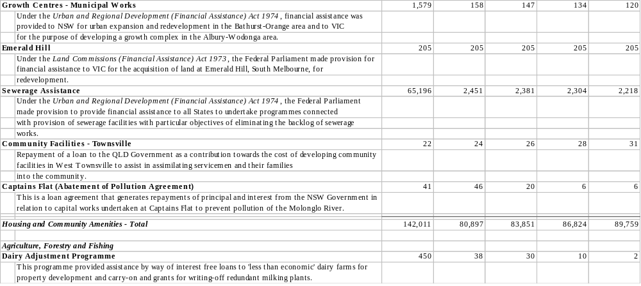
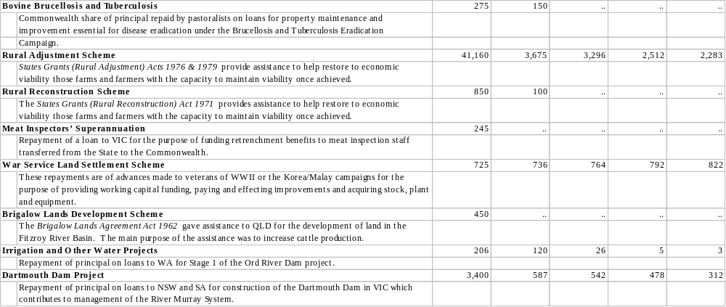
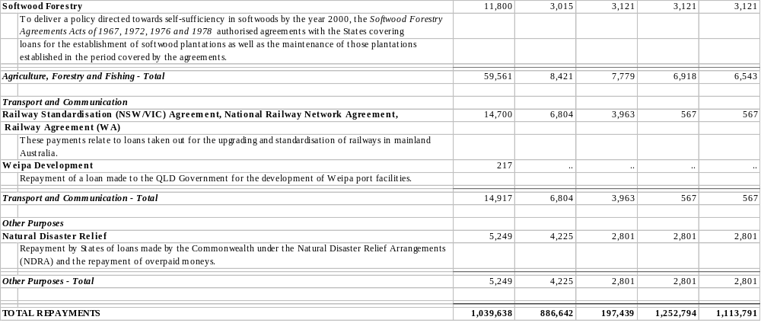
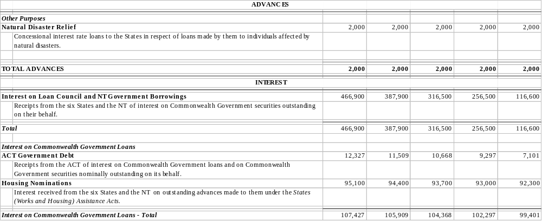
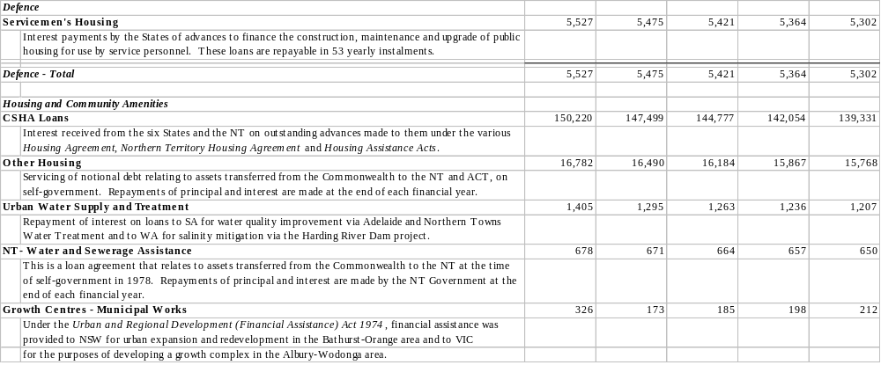
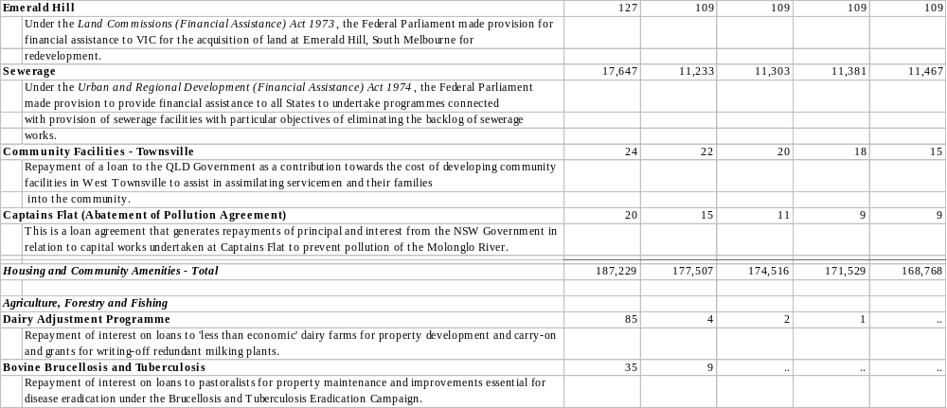
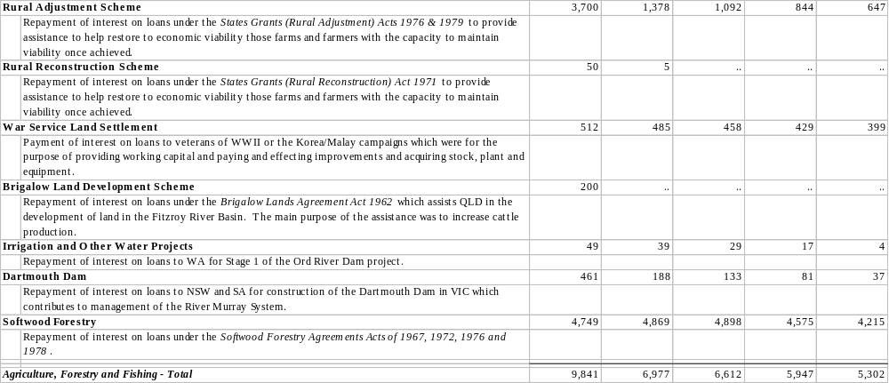
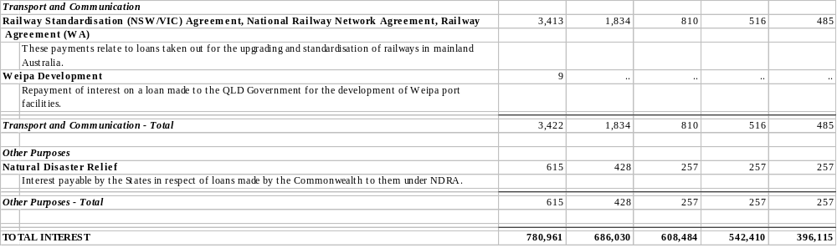
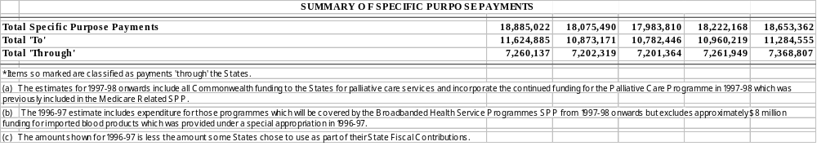

TABLE A2: ESTIMATED SPECIFIC PURPOSE PAYMENTS TO THE STATES, REPAYMENTS OF ADVANCES AND INTEREST PAYMENTS 1997-98
This table provides estimates of each State’s share of the items included in Table A1 as estimated for 1997-98.
As in other years, the distribution of assistance for 1997-98 under some programmes is dependent upon the recipient government undertaking to participate in programmes or approve particular projects. For a few programmes, final decisions on the distribution of payments among the States have still to be taken by the Commonwealth; for others, the final distribution for 1997-98 will not be settled until further data become available. In such cases, a provisional or notional estimate of the distribution is included. This does not commit the Commonwealth to a particular level of funding or indicate that a State has agreed to participate in the programme.
Specific purpose payments ‘through’ the States are indicated in the table by (*).
A summary of total payments ‘to’ and ‘through’ the States is provided at the end of the table.
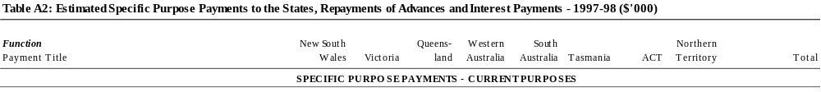
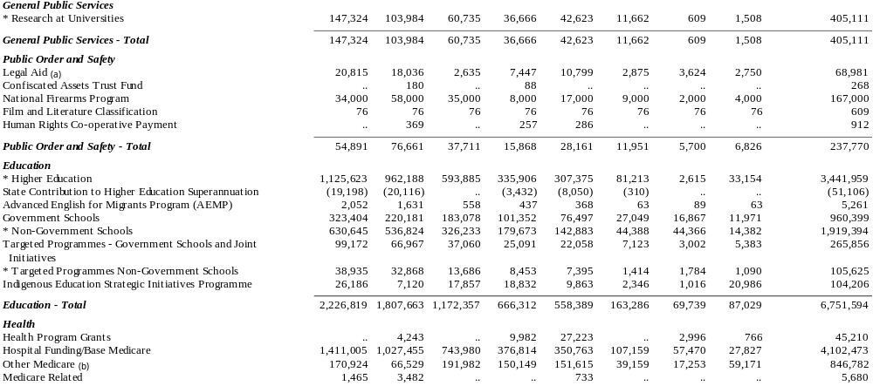
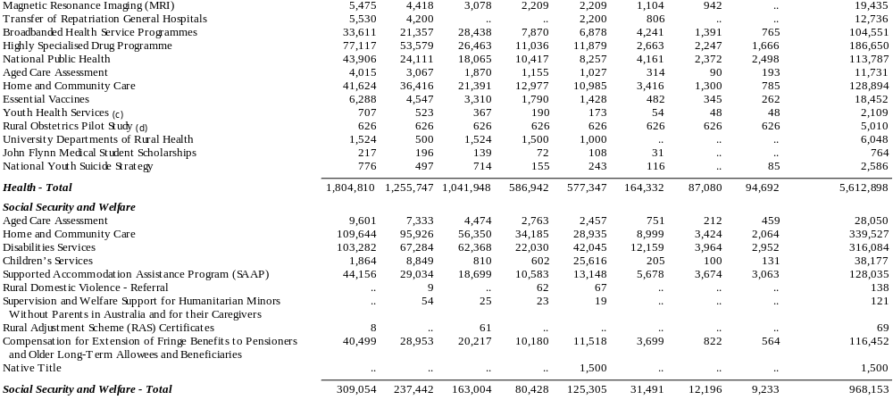
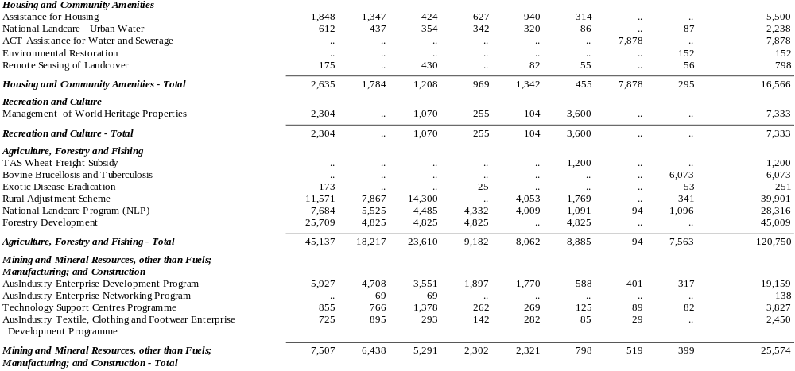

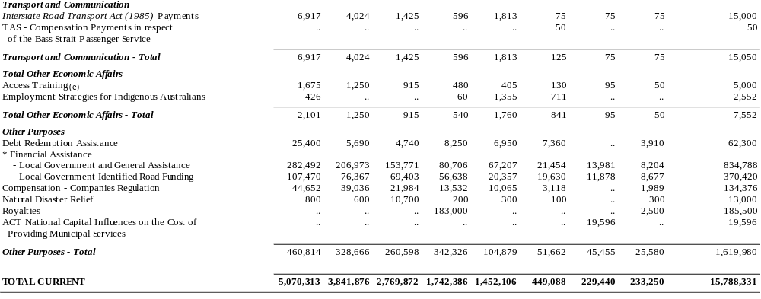
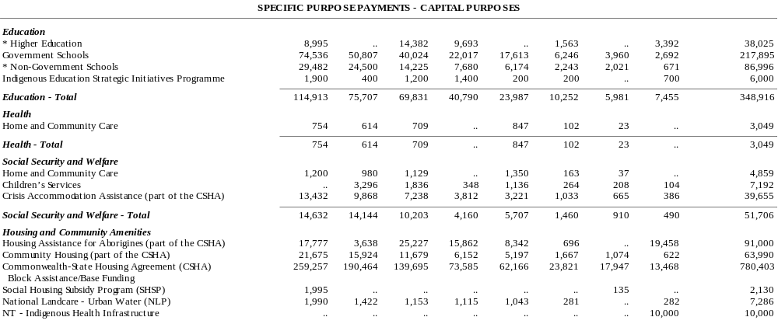
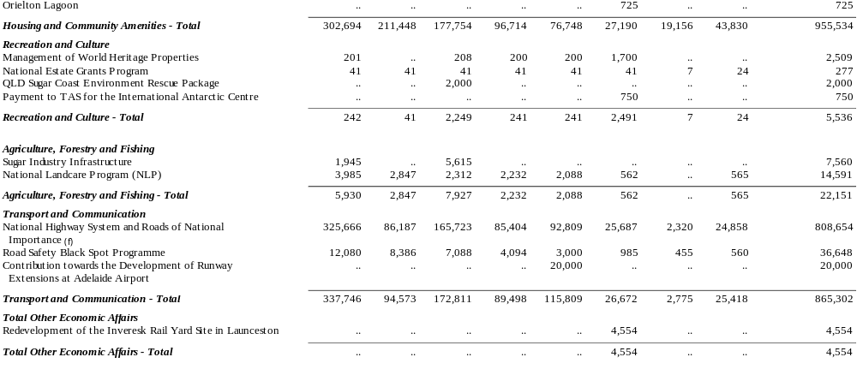
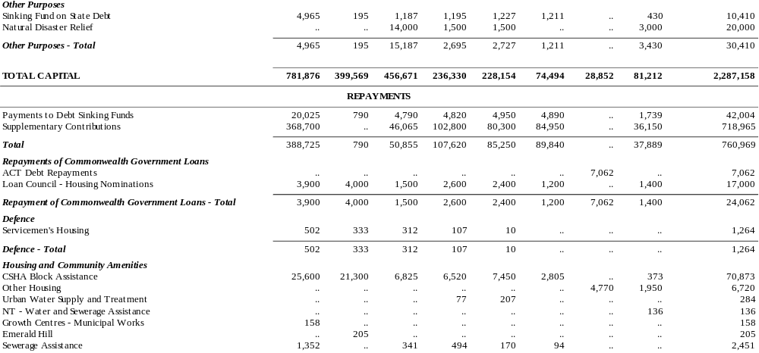
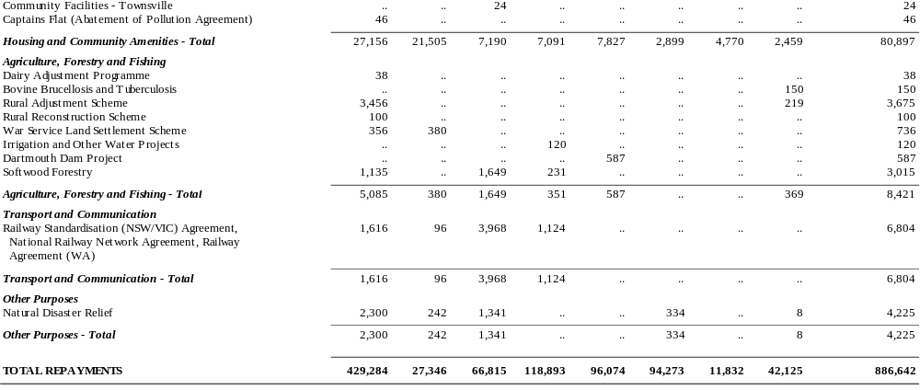
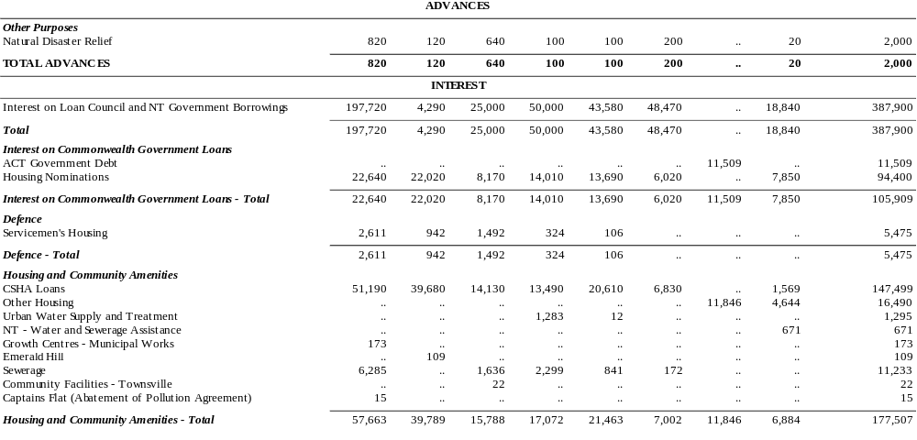
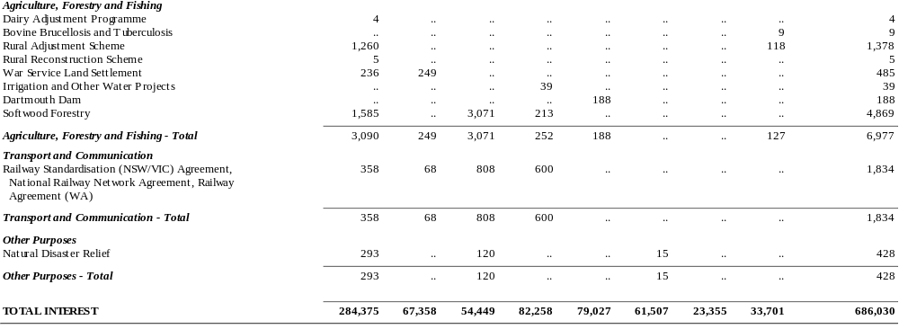
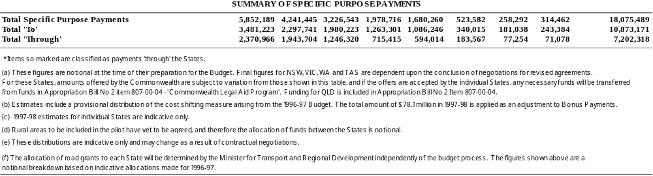

TABLES A3 AND A4: ESTIMATED SPECIFIC PURPOSE PAYMENTS DIRECT TO LOCAL GOVERNMENT AUTHORITIES
These tables provide details of Commonwealth specific purpose payments to local government authorities.
Table A3 provides details of estimated Commonwealth specific purpose payments to local government authorities for the years 1996-97 to 2000-01.
Table A4 provides an indicative distribution of the specific purpose payments direct to local government authorities among the States for 1997-98. The actual distribution of some payments may change in the light of factors such as revisions to estimates and national priorities.

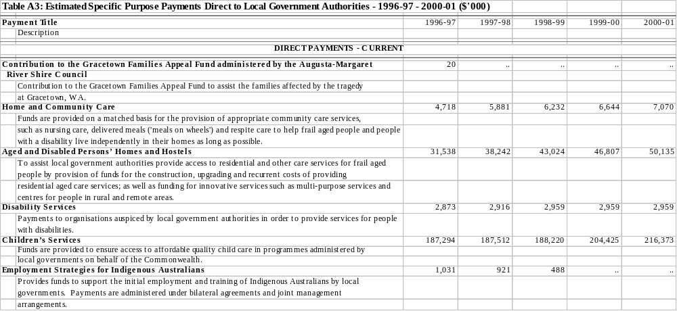
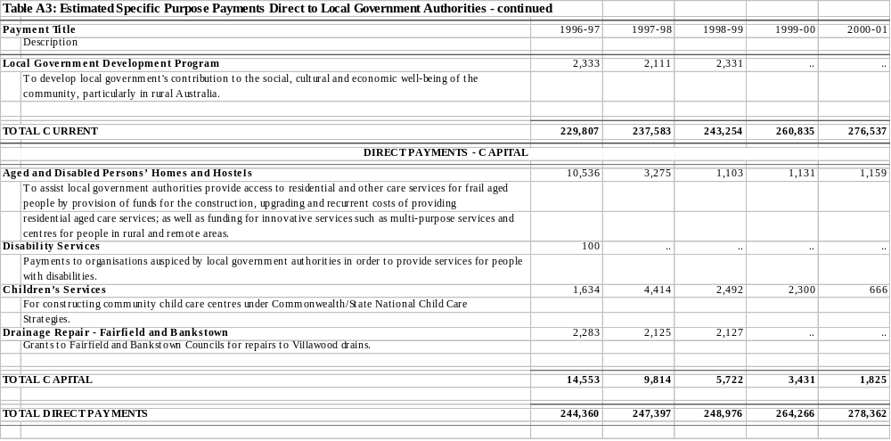
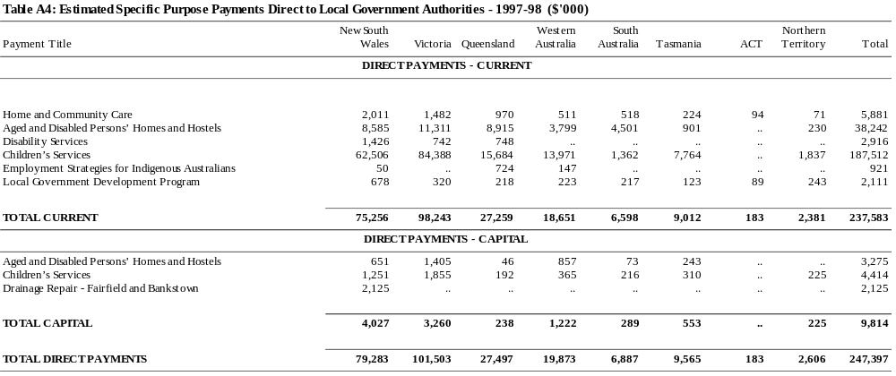

Index

A
Agreement to Implement the National Competition Policy and Related Reforms, 4, 29
Australian Capital Territory, 5, 17
Financial Position, 11
Movements in Grant Share, 28
Special Fiscal Needs, 5, 30
Special Revenue Assistance, 5, 30
State Fiscal Contributions, 4, 33
Transitional Allowances, 5, 30
Australian Land Transport Development Act 1988, 35
B
Better Cities Programmes, 34
Budgetary Developments in the
States, 8–12
C
Commonwealth Grants Commission, 4–5, 15–20, 28
1997 Update Report, 4, 26, 28, 30, 32
Impact of 1997 Update Report on the Distribution of State Grants, 28
Methodology, 15-17
Per Capita Relativities, 4, 15–19, 26
Commonwealth Loan Council Allocation
Budget Time Estimate for 1997-98, 43
Estimated Outcome for 1996-97, 43, 48
Commonwealth State Housing
Agreement, 21
Competition Payments, See National Competition Payments
Composition of Payments to the States, 15
Composition of Public Sector Revenue and Outlays, 13–15
Consumer Price Index, 1–2
D
Debt Retirement Reserve Trust Account, 21
F
FAGs, See Financial Assistance Grants
Financial Assistance Grants, 4, 17, 23–28
Derivation of Level in 1997-98, 25
Distribution in 1996-97 and 1997-98, 27
Distribution, 1993-94 to 1997-98, 24
Impact of Per Capita Relativities on Distribution, 17-18
Index Factors, 1–2
Level in 1997-98, 24
Local Government, 34–36
Local Government, Level and Distribution in 1996-97 and
1997-98, 36
Real Per Capita Guarantee, 4, 23–24
Financial Developments in the States, 8–12
Fiscal Contribution Payments, 4, 21, 33
G
General Government Sector
Impact of Commonwealth Payments to other Levels of Government, 14
Net Debt, 7
Own-Purpose Outlays, 13
Own-Source Revenue, 13
Underlying Deficit, 7
General Purpose Assistance
Local Government, 34–36
Local Government, Level and Distribution in 1996-97 and
1997-98, 36
General Purpose Capital Assistance, 34
General Purpose Payments, 23–32
Level, 1996-97 to 2000-01, 21
General Revenue Assistance, 4, 6, 23
1993-94 to 1997-98, 24
Factors Affecting the Distribution in 1997-98, 31–32
Level, Composition and Distribution in 1997-98, 22
Per Capita Distribution, 1997-98, 19, 22
H
HFGs, See Hospital Funding Grants
Horizontal Fiscal Equalisation, 15–20
Effects on the Distribution of State Grants, 17-18
Treatment of Specific Purpose
Payments, 19-20
Hospital Funding Grants, 4, 17, 27
I
Identified Road Funding (Local Government), 34–36
Level and Distribution in 1996-97 and 1997-98, 36
Identified Road Grants (States)
Distribution, 1993-94 to 1996-97, 24
Notional Amounts in 1997-98, 26
Index Factors, 1–2
Infrastructure Projects, Loan Council Treatment, 7, 43
L
LCAs, See Loan Council Allocations
Loan Council, 7, 41–48
Effect of Arrangements on General Purpose Capital Assistance, 34
Institutional Arrangements, 42
Public Infrastructure Projects with Private Sector Involvement, 7, 43
Telstra Exemption from Loan Council Coverage, 7, 44-45
Tolerance Limits, 41–42
Uniform Presentation Framework for Government Financial
Information, 7, 45
Loan Council Allocations
1997-98 Nominations, 7, 41, 46
Commonwealth Budget Time Estimate for 1997-98, 43
Estimated Outcome for Commonwealth, 1996-97, 43, 48
Local Government Funding, 34–36
Level and Distribution in 1996-97 and 1997-98, 36
Local Government (Financial Assistance) Act 1995, 35
M
Medicare Agreements, 26, 31
Medicare Guarantee Payments, 4, 30–31
N
National Competition Council, 4, 29
National Competition Payments, 4, 23, 29
Level in 1997-98, 29
National Competition Policy
Agreement to Implement, 4, 29
National Fiscal Outlook Report, 7
NCP, See National Competition Payments
New South Wales, 17
Financial Position, 9
Medicare Guarantee Payments, 30–31
Movements in Grant Share, 28
NFO, See National Fiscal Outlook Report
Northern Territory, 17
Financial Position, 11
Notional Identified Road Grants (States), 1997-98, 26
P
Parameters
Consumer Price Index, 1–2
Index Factors, 1–2
Population, 1–2
Per Capita Relativities, 4, 15–19, 26
1993 to 1997, 18
Population Parameters, 1–2
Premiers’ Conference
1995 Premiers’ Conference, 5
1996 Premiers’ Conference, 26, 33, 38
1997 Premiers’ Conference
Medicare Guarantee Payments, 31
Outcomes, 4
Specific Purpose Payments, 38
State Fiscal Contributions, 33
Public sector
Composition of Revenue and
Outlays, 13–15
Q
Queensland
Financial Position, 10
Movements in Grant Share, 28
Per Capita Relativities, 18
R
Real Per Capita Guarantee, 4, 23–24
Recent Developments in Federal Financial Relations, 4-7
Relativities, See Per Capita Relativities
Repayments, 21–22, 49, 80
S
SFCs, See State Fiscal Contributions
South Australia
Financial Position, 11
Per Capita Relativities, 18
Special Fiscal Needs
Australian Capital Territory, 5, 30
Special Revenue Assistance, 23, 29-30
Australian Capital Territory, 5, 30
Distribution, 1993-94 to 1997-98, 24
Medicare Guarantee Payments, 30–31
Transitional Allowances and Special Fiscal Needs for the Australian Capital Territory, 30
Specific Purpose Payments, 4, 37–40
’To’ and ’Through’ the States, 1993-94 to 1997-98, 38
By Programme, 1996-97 to 2000-01, 49
Composition, 40
Direct to Local Government, by Programme, 1996-97 to 2000-01, 92
Direct to Local Government, Distribution 1997-98, 22, 92
Distribution, 1997-98, 22, 80
Horizontal Fiscal Equalisation, 19-20
Level, 1996-97 to 2000-01, 21
Level, Composition and Distribution in 1997-98, 22
Nature and Purpose, 37
Per Capita Distribution, 1997-98, 22
Percentage of Total Gross Payments, 1977-78 to 1997-98, 39
State Fiscal Contributions, 4, 21, 33
States
Budgetary and Financial
Developments, 8–12
Level, Composition and Distribution of Commonwealth Payments in
1997-98, 22
Public Sector Net Debt, 9
By State, 1994 to 1997, 9
Public Sector Underlying Deficit, 8
By State, 1993-94 to 1996-97, 8
T
Tasmania, 17
Financial Position, 11
Per Capita Relativities, 18
State Fiscal Contributions, 4, 33
Telstra Corporation Ltd
Exemption from Loan Council
Coverage, 7, 44-45
Tolerance Limits
Loan Council, 41–42
Total Net Payments to the States
Level, Composition and Distribution in 1997-98, 22
Per Capita Distribution, 1997-98, 22
Total Payments to the States
Composition, 15
Level, 1996-97 to 2000-01, 21
Transitional Allowances
Australian Capital Territory, 5, 30
U
Uniform Presentation Framework for Government Financial Information, 7, 45
V
Vertical Fiscal Imbalance (VFI), 13–15
Victoria, 17
Financial Position, 10
Medicare Guarantee Payments, 30–31
Movements in Grant Share, 28
Per Capita Relativities, 18
W
Western Australia, 17
Financial Position, 10
Movements in Grant Share, 28
Per Capita Relativities, 18

Commonwealth Grants Commission Report on General Revenue Grant Relativities — Update 1997, February, 1997.
Chart 7 contains adjustments for the reclassification of existing programmes, such as the transfer in 1989-90 of nominated housing advances into Commonwealth-State Housing Agreement grants; and significant changes in the structure of Commonwealth hospital funding (such as the 1988 decision to combine States’ Medicare compensation grants (introduced in 1984) and identified health grants into a single new SPP — hospital funding grants). Chart 7 also contains adjustments for changes to the level of general purpose payments reflecting Commonwealth policy decisions, such as the transfer of some taxing powers to the States.

