Part 2: Economic outlook

Overview
The COVID-19 pandemic is causing the largest contraction in global economic activity since the Great Depression. Countries all around the world have closed their borders and put in place other containment measures to limit the spread of the virus and manage health systems to save lives.
The global economy is forecast to contract by 4¾ per cent in 2020, with falls widespread across countries. The falls in economic activity have already seen the loss of millions of jobs. According to the International Labour Organisation (ILO), the global decline in hours worked in the March quarter was equivalent to 185 million full-time jobs relative to the December quarter 2019, and a further fall equivalent to 480 million full-time jobs is expected to have occurred in the June quarter.
Significant monetary, fiscal, regulatory and financial stability measures have been put in place in all major advanced economies in order to dampen the economic downturn. The scale of the macroeconomic support measures is unprecedented and, in many economies, the measures far outweigh the size of the response to the Global Financial Crisis (GFC).
The global economy is forecast to expand by 5 per cent in 2021 due to the easing of containment measures and a gradual recovery in consumer and business confidence. However, high unemployment, continued physical distancing restrictions, business restructuring, high levels of sovereign debt and ongoing uncertainty will all weigh on the recovery. These factors are expected to leave most major economies below their pre-COVID-19 levels of activity until at least the end of 2021.
The Australian economy is expected to experience a significant contraction in 2020. However, Australia’s response to contain the spread of the virus has so far prevented the more severe health crises that have devastated many other countries. This has allowed an earlier easing of domestic restrictions than previously expected in many parts of the country.
Even with the current outbreak and reintroduction of more significant containment measures in Victoria, the Australian economy is expected to perform better than all major advanced economies in 2020.
The pandemic has pushed the Australian economy into recession, with real GDP expected to have fallen by 7 per cent in the June quarter, which would be the largest quarterly fall on record. This follows a fall of 0.3 per cent in the March quarter, which was affected by bushfires, international travel restrictions and the introduction of physical distancing restrictions late in the quarter. The June quarter decline reflects the scaling up of travel restrictions and containment measures alongside the impact of record falls in consumer and business confidence. Retail turnover in industries such as hospitality and apparel, which have been negatively impacted by COVID-19 restrictions, and housing turnover fell sharply during the quarter.
The most significant economic impact of the crisis has been on jobs, particularly for women, young people and low-skilled workers. The largest falls in employment have been in those industries most affected by the restrictions, such as accommodation and food services.
There are early indications that the easing of health restrictions in the latter part of the June quarter resulted in a noticeable recovery in economic activity. A range of high-frequency data suggest that household consumption has started to recover, with spending having regained some of the losses that occurred during the peak of the restrictions. Measures of employment have also risen from their troughs, while hours worked in June recovered around one-third of the hours lost between March and May. However, the recovery in consumption slowed in late June and July as economic and health concerns increased and health restrictions were reimposed in localised areas.
Real GDP is forecast to increase by 1½ per cent in the September quarter, reflecting an initial recovery in household consumption, partly offset by restrictions in Victoria, and continued declines in business investment, residential construction and export volumes related to the international border restrictions. Activity is expected to continue to recover over the forecast period, assuming uncertainty about the virus and the economic outlook reduces, restrictions ease and incomes recover. In year-average terms, real GDP is forecast to fall by 3¾ per cent in 2020 before rising by 2½ per cent in 2021 (Chart 2.1).
The jobs market will take time to recover. Following significant job losses, the unemployment rate is forecast to peak at around 9¼ per cent in the December quarter 2020 (Chart 2.2). The rise in the measured unemployment rate over 2020 reflects a forecast rise in labour force participation, as people who left the labour market are drawn back in as they look for work. The effective unemployment rate should continue to fall (Box 2.3) and employment is expected to pick up over the forecast period.
Chart 2.1: Real GDP | Chart 2.2: Unemployment rate
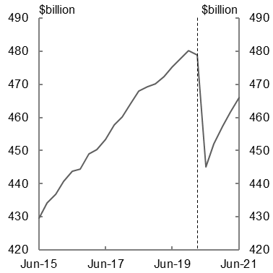 | 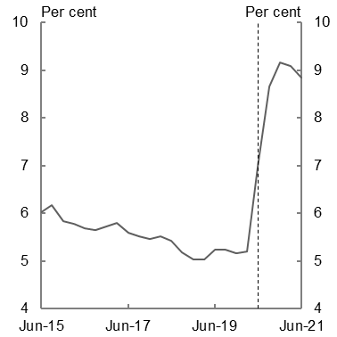
Source: ABS cat. no. 5206.0 and Treasury. | Source: ABS cat. no. 6202.0 and Treasury.

Without the significant and timely policy support announced by the Government, the Australian economy would have experienced a much more severe contraction and would face a more prolonged recovery. The Government’s overall economic support, totalling $289 billion, is supporting economic activity through a range of channels.
Measures such as cash payments to support household and business incomes directly support demand in the economy. Others, such as the JobKeeper Payment, support businesses and keep employers and employees connected, speeding up the pace of recovery. The introduction of fiscal measures also supported consumer and business confidence. These confidence effects are expected to have an ongoing beneficial impact on the economy over the forecast period.
Nevertheless, there remains significant uncertainty around the global and domestic recovery. Controlling the spread of the virus remains a significant challenge with COVID-19 infections continuing to rise globally and, even where infection rates appear to have been controlled, further outbreaks, such as those experienced in Victoria, could set back recovery at any time. There are also risks to the global economic and financial architecture, including from substantial increases in public and private debt that could lead to credit tightening and financial instability. Even with successful containment domestically, weaker-than-expected global demand may weigh on Australia’s recovery.
The extent of any longer-lasting effects from this crisis are also highly uncertain, particularly from the impact of persistently high unemployment or broader changes in the structure of the economy, such as a rise in online consumption and ongoing effects on global supply chains and trade flows. These uncertainties may affect investor confidence, especially if business solvency issues spread.
In light of the significant uncertainty, this update presents economic estimates for 2019-20 and 2020-21 only. The Government will present economic forecasts and projections over the forward estimates period in the 2020-21 Budget, to be delivered on 6 October 2020.

International economic outlook
The global COVID-19 pandemic is a once-in-a-century shock. It is placing immense pressure on health systems and economies all around the world.
The introduction of containment measures to limit the spread of the virus has helped slow the growth in infections in many economies, but has resulted in major economic contractions in the March and June quarters of 2020. The global economy is forecast to contract by 4¾ per cent in 2020, a much deeper and more widespread contraction than experienced during the GFC. A fall in global economic activity of this magnitude has not been seen since the Great Depression in the 1930s.
A recovery in activity is expected in 2021 as countries ease containment measures and the operation of businesses starts to normalise, with global growth forecast to be 5 per cent. However, the recovery is expected to be protracted. With the virus expected to continue to remain a threat for the foreseeable future, mobility and physical distancing restrictions are expected to remain in place and households and businesses are expected to remain cautious. This will flow through to slow labour market recoveries.
The size and duration of the economic effect of the shock will depend on the frequency of outbreaks, how widespread they are, and the extent of containment measures implemented to control them. Generally, countries that have had to put in place more stringent measures to contain COVID-19 have experienced sharper immediate declines in economic activity (Chart 2.3). Australia ranked middle-to-low on the stringency index and performed remarkably well economically in the March quarter, with only a slight fall in GDP.
With the exception of China, most major economies are forecast to contract sharply in the June quarter, consistent with the scaling up of containment measures. Countries with more success in controlling the spread of the virus are expected to achieve better economic outcomes over the forecast period, as they avoid the more severe economic impacts of longer-term job losses, business insolvencies and heightened economic uncertainty.
Chart 2.3: GDP growth and stringency of containment measures in the March quarter 2020
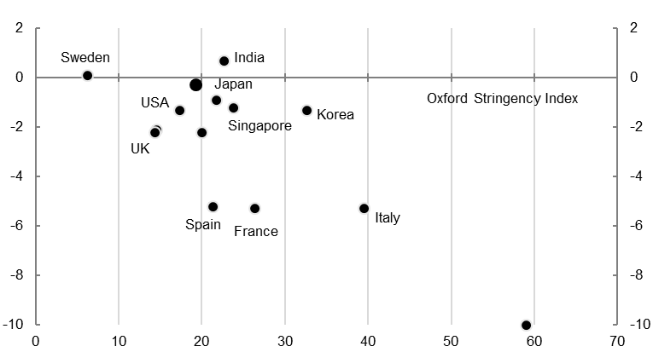
China
GDP growth, per cent
GDP growth, per cent
Canada
Germany
Australia
Note: Stringency is the average score on the Oxford Stringency Index recorded across the March quarter. The stringency index records the strictness of COVID-19 containment measures that restrict people’s behaviour.
Source: National statistical agencies, Refinitiv, Oxford COVID-19 Response Tracker, Blavatnik School of Government.

As health measures were being implemented across a number of economies, so too were measures to support economies. Wage subsidy schemes have been prominent in a number of countries, reflecting the effect this crisis has had on jobs. The aggregate size of these economic packages is unprecedented, with the IMF estimating that global economic support to date totals almost US$11 trillion. Around half of these measures are direct fiscal support, while the other half are balance sheet measures such as loans and guarantees. As a result, fiscal deficits are expected to widen significantly, averaging almost 14 per cent of global GDP in 2020. This is 10 percentage points higher than in 2019 with global public debt expected to surpass 100 per cent of global GDP.
Monetary policy is also providing support to the global economy. However, the extent of support through lowering interest rates has been more limited than during the GFC (Chart 2.4). At the height of the GFC, the US Federal Reserve reduced the federal funds rate target by over 500 basis points in around 18 months. In Australia, the Reserve Bank reduced the cash rate target by 425 basis points over an 8-month period. In contrast, following the COVID-19 pandemic the US federal funds rate target has been reduced by 150 basis points and the Reserve Bank has reduced the cash rate target by 50 basis points, with little room to reduce interest rates further.
Chart 2.4: Conventional monetary policy support, with GFC comparison
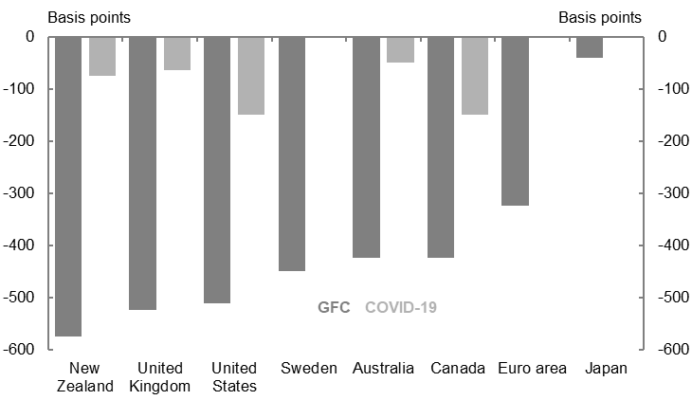
Note: The size of the change in policy rates for the GFC is the difference between the maximum and minimum policy rates at any point between August 2007 and January 2010. The size of the change in policy rates for COVID-19 is the difference between policy rates between January 2020 and May 2020.
Source: Bank for International Settlements.

Major central banks have needed to rely more heavily on a range of unconventional monetary policy measures to support the economy. This includes negative policy rates, asset purchases of both government and private sector securities and measures to mitigate disruption in financial markets and boost bank liquidity.
Financial markets remain volatile and, while conditions have improved since late March and early April when concerns about the spread of the virus peaked, there is a risk that global markets have not fully accounted for the economic consequences of the crisis, including from possible solvency issues arising from the ongoing fallout in corporate earnings.
In line with the significant contraction in economic activity, global labour markets have deteriorated sharply. Women, young people and low-skilled workers have been disproportionately impacted as they make up a greater share of employment in the sectors most heavily affected by containment measures.
In the United States, initial unemployment insurance claims totalled more than 51 million between the middle of March and the middle of July, equivalent to one-third of pre-crisis employment. Weekly new claims peaked in late March at 6.87 million. This compares with previous peaks of 695,000 in 1982 and 665,000 in 2009 during the GFC. In Europe, the ILO estimates that the decline in hours worked over the June quarter was equivalent to the loss of 44 million full-time jobs.
Employment conditions have also worsened across developing and emerging markets where the impact of the crisis on economic activity is magnified by weaker social safety nets.
There remain a number of uncertainties for the global economic outlook.
The outlook assumes that health restrictions are gradually lifted on average, albeit with minor periodic outbreaks. However, COVID-19 cases continue to rise despite improvements in controlling transmission in many countries and there is a risk that the pandemic may return in multiple waves over the coming period. Renewed outbreaks in countries where cases were previously falling give cause for concern, while some economies are still struggling to control infection rates, such as the United States, Brazil and Russia. As many countries move to ease containment measures, the global recovery depends on their ability to prevent further outbreaks and remain open. Severe health and economic outcomes in a range of countries could put pressure on the global economic and financial architecture, with implications for geopolitical stability more broadly.
The unprecedented policy support from governments, alongside automatic stabilisers, will see a significant rise in global debt over the forecast period. There are risks that the substantial increase in global debt may lead to credit tightening and financial instability, slowing the pace of recovery.
Uncertainty surrounding the COVID-19 pandemic and the global recession may dampen economic sentiment more than expected, leading to weaker-than-expected global economic activity. This will threaten recovery even in individual economies that do succeed in normalising domestic activity. These uncertainties may also play out in financial markets through investor confidence. The current financial market optimism around the evolution of the global economy presents some risk of another correction, should investor risk perceptions deteriorate.
The extent of any longer-lasting effects from the pandemic is also uncertain, including as a result of persistently high unemployment, business failures or broader changes in the structure of the economy both domestically and globally. This economic scarring may suppress the pace of recovery.

Chart 2.5: Real GDP growth
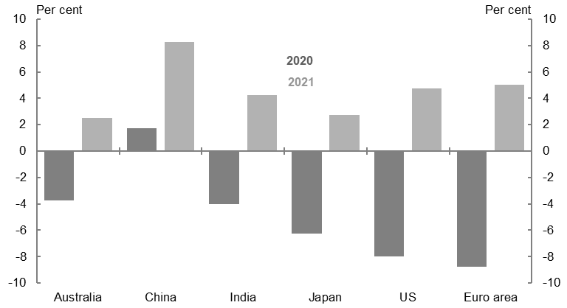
Source: National statistical agencies, Refinitv and Treasury.

All of Australia’s top ten trading partners, except for China, are expected to experience a contraction in GDP in 2020. Major trading partner (MTP) GDP is expected to fall by 3 per cent in 2020, before rebounding by 5½ per cent in 2021. Compared with global growth overall, China’s economic performance is more important for Australia’s MTP growth as it accounts for approximately one-third of Australia’s MTP basket. With Chinese GDP expected to grow this year, albeit modestly, Australia’s external outlook remains in a better position than many other economies (Chart 2.5).
Table 2.1: International economy forecasts^{(a)}
 | Outcomes | Forecasts
 | 2019 | 2020 | 2021
China | 6.1 | 1 3/4 | 8 1/4
India | 4.9 | -4 | 4 1/4
Japan | 0.7 | -6 1/4 | 2 3/4
United States | 2.3 | -8 | 4 3/4
Euro area | 1.2 | -8 3/4 | 5
Other East Asia^{(b)} | 3.6 | -3 1/4 | 3 1/2
Major trading partners | 3.6 | -3 | 5 1/2
World | 2.9 | -4 3/4 | 5
- World and Other East Asia growth rates are calculated using GDP weights based on purchasing power parity (PPP), while growth rates for major trading partners are calculated using goods and services export trade weights.
- Other East Asia comprises the Association of Southeast Asian Nations group of five (ASEAN-5), comprising Indonesia, Malaysia, the Philippines, Thailand and Singapore, along with Hong Kong, South Korea, Vietnam and Taiwan.
Source: National statistical agencies, Refinitiv and Treasury.

The Chinese economy is forecast to grow by 1¾ per cent in 2020 and 8¼ per cent in 2021. China’s success in largely containing the spread of the virus and the resumption of industrial production since March saw a significant rebound in activity in the June quarter. Economic activity is expected to continue to recover over the remainder of 2020 and into 2021 with the support of infrastructure investment and pent-up demand.
There have been devastating health and economic consequences from the COVID-19 pandemic in the United States, with the highest number of confirmed cases and fatalities in the world. This has led to a sharp increase in unemployment, as well as subdued demand and business activity. The economy is forecast to contract by 8 per cent in 2020, before growing by 4¾ per cent in 2021. While activity and employment partly recovered as containment measures were lifted, further outbreaks pose a significant downside risk to the recovery. Infection rates have remained high and several states have seen a further deterioration in health outcomes following an easing of containment measures. As a result, some states have postponed or partially reversed re-opening plans.
The euro area entered the health crisis in a weaker position than many other advanced economies and several European countries experienced an early surge in COVID-19 cases. While strict containment measures appear to have been effective at slowing infection rates, the economic impact has been severe particularly for those countries with high levels of cases and longer periods of lockdown. GDP in the euro area is forecast to fall by 8¾ per cent in 2020. Beyond the initial recovery, diverging national-level fiscal responses, sovereign debt overhangs and increases in long-term unemployment risk exacerbating existing imbalances. The risk remains that a no-deal Brexit at the end of the year could result in lower growth in the euro area, and even more so in the United Kingdom. GDP in the euro area is forecast to grow by 5 per cent in 2021.
Japan also entered the health crisis from a subdued economic position, having recorded a large fall in GDP in the December quarter 2019. There were signs of recovery over January and February, and the Japanese Government’s containment and support measures have been aimed at keeping businesses open, but the pandemic has taken its toll on both domestic consumption and exports. Japan’s economy is expected to contract by 6¼ per cent in 2020 before growing by 2¾ per cent in 2021.
GDP for Other East Asia is forecast to fall by 3¼ per cent in 2020. Countries in the region entered the crisis with different economic conditions and have had varying success in containing the virus. Economies like Korea, Taiwan and Vietnam appear to have limited transmission without substantially restricting production, and are consequently forecast to see smaller contractions in activity than most advanced economies. Others, like Indonesia and the Philippines, continue to face high infection rates and economic activity is expected to contract further. A rebound is expected for the region in 2021, fuelled by the expected recovery in China and a transition back towards pre-crisis growth trends. While relatively strong government balance sheets should support recovery, high reliance on trade and remittances leave the region vulnerable to the risk of sustained global weakness.
Indonesia has the highest number of COVID-19 cases in South East Asia, although it is yet to experience the peak of the virus impact. The Indonesian Government announced multiple rounds of fiscal stimulus, with the budget deficit to reach 6.3 per cent of GDP. Indonesia’s economy is forecast to contract by 3¼ per cent in 2020.
India has the third largest number of recorded COVID-19 cases in the world, and cases continue to rise. The Indian Government has announced a number of economic support measures to stimulate the economy. However, the pandemic is likely to exacerbate existing weakness, with fragile financial conditions and stress in India’s banking sector preventing the Government from increasing fiscal support in the face of further deteriorating health and economic conditions. The Indian economy is forecast to contract by 4 per cent in 2020 following a prolonged lockdown period.

Domestic economic outlook
The impact that the COVID-19 pandemic is having on the global economy and the measures implemented to slow the spread of the virus domestically are having profound impacts on the Australian economy. Despite this, Australia has outperformed most other countries in both health and economic outcomes to date, supported by the largest economic support package in our history.
In the June quarter, the economy is expected to have experienced its largest quarterly fall on record of 7 per cent. The fallout from containment measures has been evident across all parts of the economy since March, with record falls in a range of key economic indicators. Business conditions, confidence and activity indices all fell to record lows and there have been significant downgrades to firms’ capital expenditure plans. In the household sector, there have been record falls in consumer confidence, with consumption of services such as accommodation and food services and transport being particularly hard hit. Severe job losses have also occurred and the unemployment rate rose at its fastest pace on record in April, alongside a record fall in participation. Consistent with restrictions on international travel, overseas arrivals fell to record lows in May.
Economic activity is expected to pick up in the September quarter, by 1½ per cent. Activity in the quarter will be supported by the gradual easing of restrictions around most of the country that began in the latter part of the June quarter, which was accompanied by a partial recovery in consumer confidence, a rebound in business confidence and some improvement in the labour market. However, the recent increase in locally acquired COVID-19 cases in Victoria and the corresponding measures implemented to contain the outbreak will weigh on activity in that state. The increase in uncertainty about the spread of the virus is also expected to dampen the recovery in other parts of the country. Consumer confidence data for Australia showed falls from late June as COVID-19 case numbers in Australia rose.
Real GDP is forecast to fall by 3¾ per cent in calendar year 2020, the largest fall on official record, and fall by 2½ per cent in 2020-21. Activity is expected to gradually improve throughout 2021 as restrictions ease, uncertainty about the virus and the economic outlook reduces, the global economy improves and employment and incomes recover. Real GDP is forecast to grow by 2½ per cent in 2021.
Australia’s population growth is assumed to remain positive but lower over the forecast period. This is mainly due to lower net overseas migration. The fertility rate is also expected to fall due to the weaker economic conditions and outlook. As a result, annual population growth is assumed to slow to 1.2 per cent in 2019-20 and to 0.6 per cent in 2020-21 — the lowest annual rate of growth since 1916-17. Future migration levels remain highly uncertain, due to the path of the pandemic and the nature and duration of measures taken to contain its spread at home and abroad.
There are significant uncertainties surrounding the domestic outlook. The range of possible outcomes for GDP and unemployment is substantially wider than normal.
As is the case globally, the evolution of the virus is the greatest uncertainty for the domestic outlook (Box 2.1 contains key assumptions). Additional significant outbreaks in Australia, or a noticeable worsening of existing outbreaks, would lead to a further contraction in economic activity and employment, especially if accompanied by the reintroduction of containment measures (Box 2.2). Even if Australia is able to prevent a major regression in health outcomes as containment measures are relaxed, further outbreaks in our major trading partners also pose a risk to Australia’s recovery.
There is also significant uncertainty around the pace and shape of the recovery, given the unprecedented nature of this crisis. The economic recovery is forecast to be relatively fast by historical standards. The economy could recover more quickly than forecast if firms rapidly adjust to the new environment and household spending returns to usual levels. However, the recovery could be more protracted if confidence remains subdued or more people than expected lose their jobs, including from changes in the structure of the economy or a larger-than-expected wave of business closures. Structural change is a significant source of uncertainty; the health and economic shock has changed many aspects of the way people live, including the way people work, shop and socialise, and it is unclear how large and persistent some of these changes will be.

Box 2.1: Key assumptions
The evolution of the health crisis presents a significant risk to the outlook alongside uncertainty about the speed with which the Australian and global economies are able to resume activity following the lifting of restrictions.
The key assumptions that underpin the economic forecasts are set out below. Outcomes could be substantially different to the forecasts, depending upon the extent to which the following assumptions hold:
- Outside of Victoria, restrictions are assumed to be lifted in accordance with the 3-step process outlined by the Prime Minister on 8 May 2020.
  - Step 1 opening is assumed to have been in place from mid-May to mid-June. Maintain a 4 square metres per person and 10 person limit for indoor activities.
  - Step 2 opening is assumed to have been in place from mid-June to mid-July. Maintain a 4 square metres per person and 20 person limit for indoor activities.
  - Step 3 opening is assumed to be in place from mid-July to end of September, except in Victoria. Maintain a 4 square metres per person and 100 person limit for indoor activities.
  - The 4 square meters per person rule is assumed to remain in place from the end of September until the end of 2020.
- Localised outbreaks, such as those occurring in New South Wales, are assumed to be contained to the extent that, on average, they do not delay the lifting of restrictions set out above. Specific exceptions to this broad assumption are separately identified below.
- ‘Stay at home’ restrictions were reintroduced across metropolitan Melbourne and the Mitchell Shire from 9 July. These restrictions require people to ‘stay at home’ unless shopping for food, providing care and caregiving, exercise, or study and work, if it cannot be completed from home.
  - These restrictions are assumed to remain in place for six weeks, easing to step 1 opening of restrictions until mid-September before the gradual move to the final step by mid-December.
  - The Victorian border with New South Wales and South Australia is assumed to be closed until 19 August 2020, with freight allowed to pass between the states along with essential travel.
- International travel is assumed to remain at low levels until the end of the June quarter 2021.

Box 2.1: Key assumptions (continued)
- Net overseas migration is significantly affected by international travel restrictions and constraints on the ability of applicants to meet visa application requirements, and is assumed to fall from 232,000 in 2018-19 to be 154,000 in 2019-20 and 31,000 in 2020-21.
  - The Government implemented international travel bans in March 2020. This prevented all arrivals on visitor and temporary migration visas and prevented Australian citizens and permanent residents from departing Australia.
  - Between July and December 2020, only citizens, permanent residents, New Zealanders and a small number of international students are assumed to be able to travel to Australia, based on announced policy to date.
  - From 1 January to 30 June 2021, it is assumed that the travel ban is lifted, but that a two-week quarantine period is required of arrivals to Australia. This leads to the resumption of arrivals by temporary and permanent migrants, but at lower levels overall than normal.

Box 2.2: Second wave scenario
The recent outbreak of COVID-19 in Victoria and the subsequent reintroduction of restrictions in metropolitan Melbourne and the Mitchell Shire, including border closures, is a sobering reminder of the virulence of the virus and its potential to continue to disrupt the way we live. Though Australia is well prepared to manage the health crisis, the possibility of a major second wave of infections remains.
To some degree, such outcomes have already been observed in several countries that had initial success in suppressing transmission of the virus. In Singapore, a spike in new cases was observed in late April and new infections have been slow to decline. Similarly, after an initial peak was suppressed quickly, new cases in South Korea have slowly risen due to small but persistent groups of new infections.
How further outbreaks of the virus will play out and its effects on communities and the economy are highly uncertain. Higher rates of testing, contact tracing and increased health system capacity may enable persistent but small outbreaks to be managed without the reintroduction of large-scale restrictions. Widespread outbreaks and high rates of community transmission would likely necessitate the reintroduction of more severe health controls, of the kind we have seen in Victoria.

Box 2.2: Second wave scenario (continued)
Treasury estimates that, relative to a pre-pandemic economy, GDP was around $4 billion lower for every week the containment restrictions from late March to mid-May were in place. These containment restrictions included closures to high-risk activities including pubs, nightclubs and gyms, restricting cafes and restaurants to take-away only, the effects of school closures, stay at home restrictions and the physical distancing requirements limiting venues to one person per four square metres. Following the three steps of easing restrictions, Treasury estimates that economic activity could increase by around $2 billion per week within a few months, or around half of the original fall.
If similar large scale restrictions were reimposed across all of Australia, this would likely reduce economic activity to similar levels as observed across April and May, and therefore would likely cost the economy at least $2 billion per week compared to where we may have been without a second wave of infections.
Less severe or more geographically targeted restrictions would not have as large of an impact on economic activity. In this case, rather than experiencing another sharp downturn in economic growth, it would be more likely that the speed of economic recovery is slowed. This would be as a direct result of the restrictions themselves, but also from the spillovers continued community outbreaks may have on consumer and business confidence.
Initial estimates indicate that the reintroduction of restrictions in metropolitan Melbourne and the Mitchell Shire in response to the latest virus outbreak will reduce national real GDP growth by around ¾ of a percentage point in the September quarter 2020.
The impact on economic activity will moderate in the December quarter consistent with the current timetable for unwinding the new restrictions, assuming that the Victorian outbreak is contained and the reintroduced restrictions are not extended further. The estimate also assumes that the outbreak does not spread beyond the lockdown localities to other areas of Victoria or Australia, but does take into account the effect of the Victorian outbreak on consumer confidence and activity across the rest of Australia.

Table 2.2: Domestic economy forecasts^{(a)}
 | Outcomes^{(b)} | Forecasts
 | 2018-19 | 2019-20 | 2020-21
Real gross domestic product | 2.0 | - 1/4 | -2 1/2
Household consumption | 2.0 | -2 1/2 | -1 1/4
Dwelling investment | 0.0 | -10 | -16
Total business investment^{(c)} | -0.9 | -6 | -12 1/2
By industry
Mining investment | -9.4 | 4 | 9 1/2
Non-mining investment | 1.8 | -9 | -19 1/2
Private final demand^{(c)} | 1.0 | -3 1/2 | -4
Public final demand^{(c)} | 4.4 | 5 | 4 1/2
Change in inventories^{(d)} | -0.2 | 0 | 0
Gross national expenditure | 1.6 | -1 1/2 | -1 3/4
Exports of goods and services | 4.0 | -1 1/2 | -6 1/2
Imports of goods and services | 0.3 | -8 | -6
Net exports^{(d)} | 0.8 | 1 1/4 | - 1/4
Nominal gross domestic product | 5.3 | 2 | -4 3/4
Prices and wages
Consumer price index^{(e)} | 1.6 | - 1/4 | 1 1/4
Wage price index^{(f)} | 2.3 | 1 3/4 | 1 1/4
GDP deflator | 3.3 | 2 1/4 | -2 1/4
Labour market
Participation rate (per cent)^{(g)(h)} | 66.0 | 63.4 | 64 3/4
Employment^{(f)(h)} | 2.5 | -4.4 | 1
Unemployment rate (per cent)^{(g)(h)} | 5.2 | 7.0 | 8 3/4
Balance of payments
Terms of trade^{(i)} | 5.6 | 1 3/4 | -12 1/4
Current account balance (per cent of GDP) | -0.7 | 1 3/4 | -1 1/4
- Percentage change on preceding year unless otherwise indicated.
- Calculated using original data unless otherwise indicated.
- Excluding second-hand asset sales between the public and private sector.
- Percentage point contribution to growth in GDP.
- Through-the-year growth rate to the June quarter.
- Seasonally adjusted, through-the-year growth rate to the June quarter.
- Seasonally adjusted rate for the June quarter.
- 2019-20 is an outcome.
- The forecasts are underpinned by price assumptions for key commodities: iron ore spot price assumed to decline to US$55 per tonne free-on-board (FOB) by the end of the December quarter 2020; metallurgical coal spot price assumed to remain at US$110 per tonne FOB; and thermal coal spot price assumed to remain at US$54 per tonne FOB.
Note: The forecasts for the domestic economy are based on several technical assumptions. The exchange rate is assumed to remain around its recent average level — a trade-weighted index of around 60 and a $US exchange rate of around 69 US cents. Interest rates are assumed to move broadly in line with market expectations. World oil prices (Malaysian Tapis) are assumed to remain around US$34 per barrel.
Population growth is assumed to be 1.2 per cent in 2019-20 and 0.6 per cent in 2020-21.
Source: ABS cat. no. 5206.0, 5302.0, 6202.0, 6345.0, 6401.0, unpublished ABS data and Treasury.

Employment declined sharply in the June quarter, falling by 708,900 persons, to be 4.4 per cent lower through the year (Chart 2.6). Changes in employment have been largest in those industries directly affected by health restrictions, including service industries such as accommodation and food, arts and recreation, and transport. General physical distancing guidelines and guidance about essential-only travel has also had flow-on effects to employment in other industries, such as retail trade.
Alongside a recovery in activity, the easing of containment measures in the latter part of the June quarter has accompanied some improvement in the labour market. After falling significantly over April and May, total hours worked recovered around one-third of its fall, driven both by an increase in employment and an increase in average hours worked, including from those who were previously working zero hours. However, total hours worked in June remained almost 7 per cent lower than in March. Some leading indicators of labour market activity have also shown some positive signs, with measures of job advertisements picking up in June, albeit from very low levels. Employment outcomes are expected to recover over the forecast period, even accounting for the effect of the reintroduction of restrictions in parts of Victoria. The recovery in employment is expected to lag the recovery in total hours as employers prioritise increasing hours for existing staff, ahead of hiring new staff.
Chart 2.6: Employment growth
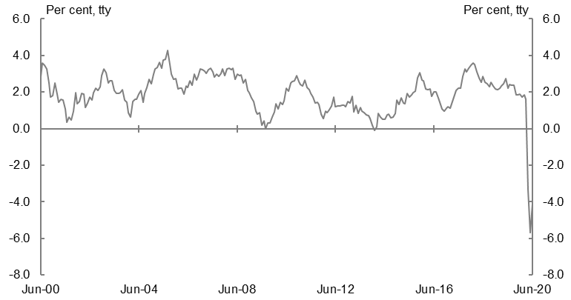
Source: ABS cat. no. 6202.0.

The unemployment rate is expected to increase over the remainder of 2020, peaking at around 9¼ per cent in the December quarter. Further increases in the unemployment rate are likely to be driven by rising labour force participation as those who dropped out of the labour market at the start of the crisis begin to look for work again as the economy opens up. The unemployment rate is expected to gradually decline from the start of 2021 to be around 8¾ per cent in the June quarter 2021. However, spare capacity in the labour market is expected to be more significant than suggested by the unemployment rate, particularly in the near term. The measured unemployment rate is a key uncertainty and will depend on the evolution of the participation rate and average hours worked (Box 2.3).
During this crisis, particular cohorts have experienced more adverse labour market impacts. Women and young people have been particularly affected, consistent with being over represented in industries hardest hit by the crisis, such as accommodation and food services, arts and recreation services and retail trade. Despite rising in June, employment amongst those aged 15-24 was significantly lower compared with March, accounting for around 35 per cent of the total fall in employment over this period. As a result, the youth unemployment rate rose to 15.5 per cent in the June quarter, its highest rate in over 20 years. The employment-to-population ratio and the participation rate declined more significantly for women than for men in the June quarter. The significant fall in female participation moderated the rise in the measured unemployment rate for women. Casual employees and those working part-time have also been disproportionately impacted.
Beyond 2020, labour market conditions will strengthen as demand picks up, but the unemployment rate will take some time to decline, as has been the case in previous recessions. In the recession of the early 1990s, it took around seven years for the unemployment rate to fall from its peak of 11.2 per cent in 1992 to below 7 per cent. In addition, there may be longer-term impacts on the labour market if some workers who have been dislocated, especially those in more vulnerable cohorts, lose skills or need to reskill to enter employment in a different occupation or industry.

Box 2.3: Assessing spare capacity in the labour market
The unemployment rate is the most commonly used indicator of spare capacity in the labour market. However, the unprecedented nature of the COVID-19 shock means that alternative labour market indicators — such as the underutilisation rate and measures that take into account those who have dropped out of the labour force altogether — are currently more useful indicators of spare capacity.
Many workers who have lost their jobs or have been stood down have not been counted in the unemployment rate. For some workers, this is because they have been unable to look for work, a fact recognised by the Government’s decision to temporarily waive requirements to look for work for people receiving unemployment benefits. Other workers were stood down working zero hours but remained (and were classified as) employed, in large part due to the operation of the JobKeeper Payment.
Chart 2.7: Underemployment rate | Chart 2.8: Average hours worked
Source: ABS cat. no. 6202.0. | Source: ABS cat. no. 6202.0.
In April, the number of unemployed increased by 126,000, but 482,000 people left the labour force. In addition, the number of people working zero hours for economic reasons increased by around 700,000. As a result, the ‘effective’ unemployment rate was close to 15 per cent in April. Total hours worked fell by 9.5 per cent in the month — much more than the fall in employment. Average weekly hours worked fell by 5.1 per cent, with the fall partly moderated by the fact that employment was hardest hit in industries where people typically work fewer hours on average.

Box 2.3: Assessing spare capacity in the labour market (continued)
Chart 2.9: The effective unemployment rate
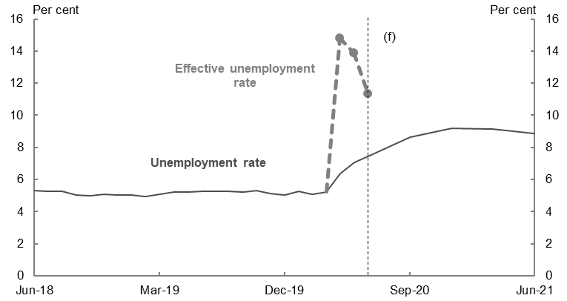
Source: ABS cat. no. 6202.0, ABS cat. no. 6291.0.55.001 and Treasury.

As the labour market recovers, people will return to work in a number of ways, which may not be reflected in the headline data on employment and unemployment but will reduce the ‘effective’ rate of unemployment. This is evident in the data already.
By June, the effective unemployment rate was close to 11 per cent, with employment higher than in May, fewer people working zero hours for economic reasons and more people counted as in the labour force. Average hours worked has also picked up from its trough in April as people started to return to more normal work patterns. However, measured unemployment continued to rise in June, as more people returned to the labour force than were able to find work. The measured unemployment rate is forecast to continue to rise as more people are drawn into the labour force.
The measured unemployment rate is a key uncertainty. It will depend on how employers allocate available hours amongst existing employees versus hiring new workers. If businesses choose to increase hours for existing staff by more than expected, rather than hiring new workers, the unemployment rate could be higher than expected. Similarly, the unemployment rate could be lower if businesses absorb a higher number of new workers at a lower level of average hours than expected. The degree to which the participation rate rises over the next several quarters is also a key sensitivity around the forecast unemployment rate.
Sensitivity analysis suggests that the measured unemployment rate could be between 7 per cent and 10¾ per cent by the December quarter, depending on how available hours are split between existing and new employees or the degree to which the participation rate recovers towards pre-crisis levels.

The sharp deterioration in labour market conditions and associated increase in spare capacity will put downward pressure on wage and price growth for some time. The Wage Price Index is forecast to increase by 1¼ per cent through the year to the June quarter 2021.
The sharp fall in petrol prices, following a fall in global oil prices, and the Government’s changes to make childcare free during the early stages of the COVID-19 pandemic will result in a significant fall in consumer price growth in the June quarter 2020. Consumer price inflation is forecast to increase to 1¼ per cent through the year to the June quarter 2021, with the re-establishment of the Child Care Subsidy arrangements. Inflation is expected to remain subdued across the forecast period, consistent with reduced pressures from wage growth and weaker inflation expectations.
Household consumption is forecast to fall by 1¼ per cent in 2020-21, reflecting the impacts of containment measures with significant declines in the income households receive from working, declines in wealth and consumer confidence, and fewer opportunities to spend as a result of the pandemic. Broad-based weakness is expected across most consumption categories, with a fall of 11½ per cent forecast in the June quarter. Consumption of services, which in recent years has driven growth in total household consumption, is expected to be particularly weak (Chart 2.10). This reflects the effect of restrictions on spending including on air transport, hotels, cafes and restaurants, as well as on healthcare due to the cancellation of elective surgeries and fewer visits to medical practitioners in the wake of the pandemic.
Consumption growth is expected to pick up strongly in the September quarter on the assumption that health restrictions broadly continue to ease in all states except Victoria, accompanied by an improvement in both labour demand and confidence. The recovery is expected to be broadly based across components, albeit with restrictions still affecting sectors such as arts, entertainment and recreation nationally, and additional sectors such as hospitality in regions with tighter restrictions. Spending on travel should also improve as interstate border restrictions are expected to be gradually relaxed, although international travel will remain subdued for some time. Potential shifts in consumer behaviour in the aftermath of the pandemic may see longer-term structural changes in household consumption.

Chart 2.10: Goods and services contributions to household consumption growth
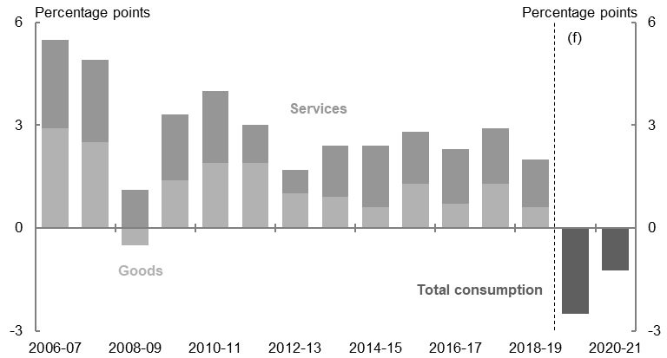
Source: ABS cat. no. 5206.0, unpublished ABS data and Treasury.

The COVID-19 pandemic is having a significant impact on household incomes and wealth. Significant job losses and reductions in hours have lowered income received by households from working. However, household incomes are being supported by significant Government support measures, including the JobKeeper Payment and Coronavirus Supplement (Box 2.4). While household income is expected to hold up in the near term, there have been significant falls in household wealth. Australia’s ASX200 has recovered some of its losses since the onset of the crisis, but it remains substantially below the highs reached in late February. The outlook for the established housing market remains uncertain with prices falling in June for a second consecutive month despite transaction activity starting to recover alongside the easing of restrictions.
The support to household incomes, combined with the weakness in consumption, is expected to result in a sharp increase in the household saving ratio in the June quarter 2020. The household saving ratio is expected to reach a near-record high in the June quarter to be around double that seen during the GFC, before moderating as labour market conditions improve.

Box 2.4: Fiscal response to the COVID-19 pandemic
The Government has responded to the pandemic with an historic amount of economic support, which has been effective and well targeted.
The Government’s economic support in response to the COVID-19 pandemic is estimated to be around $162 billion in 2019-20 and 2020-21, equivalent to 8.2 per cent of 2019-20 GDP. In addition, the Government’s balance sheet support totals $125 billion, equivalent to 6.3 per cent of 2019-20 GDP. Automatic stabilisers are also supporting the economy (for more detail see Box 3.1 of Part 3: Fiscal outlook).
A number of Government measures are supporting economic demand, such as cash payments to support household and business incomes and incentives to encourage investment. Some measures are also helping keep businesses in business and workers in jobs to speed up the pace of recovery, such as the JobKeeper Payment, loan guarantees and regulatory measures.
Fiscal support also has confidence effects, and can limit the effects on economic activity from heightened uncertainty and rising risk aversion. The Government’s economic measures were associated with an improvement in consumer and business confidence. The forecasts incorporate an ongoing beneficial impact of the Government support on household and business confidence (and, in turn, consumption and investment).
It is estimated that the fiscal support will have increased the level of real GDP by around ¾ per cent in 2019-20 and will increase it by around 4¼ per cent in 2020-21 relative to the case of no policy support. Fiscal measures are also estimated to have lowered the peak of the measured unemployment rate by around 5 percentage points, preventing the loss of around 700,000 jobs.
Chart 2.11: Real GDP | Chart 2.12: Unemployment rate
Source: ABS cat.no. 5206.0 and Treasury. | Source: ABS cat.no. 6202.0 and Treasury.

Box 2.4: Fiscal response to the COVID-19 pandemic (continued)
The economic impact of the Government’s direct fiscal policy measures has been estimated using Treasury’s macroeconomic model, drawing upon estimates of first-round fiscal multipliers of individual measures, analysis of the impact of the JobKeeper Payment on the labour market, and judgments about the impact of the economic support on business and household confidence.
The analysis is contingent on the forecasts of the evolution of the domestic and international economies and the assumptions that underpin the forecasts about the spread of the virus, industry containment measures and physical distancing.

Dwelling investment is forecast to fall by 16 per cent in 2020-21. The fall in the June quarter is forecast to be 7 per cent, given cancellations and delays in residential projects reflecting reduced demand, health restrictions on construction sites and some supply-chain disruptions. A further 11 per cent decline in dwelling investment is anticipated in the September quarter. The HomeBuilder program is expected to provide a significant boost to the future pipeline of work, and there are early indications that it has already improved confidence and incentivised some buyers to return to the market. The program is expected to contribute around $1.6 billion to activity in 2020-21, but total residential construction activity is expected to remain subdued for some time.
New business investment is forecast to fall by 12½ per cent in 2020-21, driven by a significant deterioration in the outlook for non-mining investment, which is forecast to fall by 25½ per cent in the June quarter. Containment measures alongside an environment of uncertainty are expected to drive a sharp decline in machinery and equipment investment, as businesses seek to preserve cash while operations are impacted by restrictions. Real-time data suggest that around three-quarters of firms have been operating under modified conditions as a result of the pandemic, including changed workplace practices, payment methods, operating hours and suppliers. Business solvency is also at risk with around two-thirds of all businesses reporting decreases in revenue and a number of firms deferring loan repayments and renegotiating lease agreements.
Non-mining business investment is forecast to decrease by a further 2½ per cent in the September quarter. Investment is expected to be supported over 2020-21 by Government policies such as accelerated depreciation deductions and the expansion to the instant asset write-off. However, elevated uncertainty, downgrades to investment intentions and lags between approvals and activity in the construction sector are expected to result in a more gradual recovery in business investment than in household consumption.
Mining investment is expected to grow for the first time in seven years by 4 per cent in 2019-20 and another 9½ per cent in 2020-21 (Chart 2.13). Industry consultation and recent capital expenditure data suggest that investment in large iron ore projects is expected to continue in order to sustain productive capacity and maintain large capital stocks accumulated over the investment boom. However, global uncertainty and lower commodity prices have led to delays in final investment decisions for new projects.
Chart 2.13: Business investment
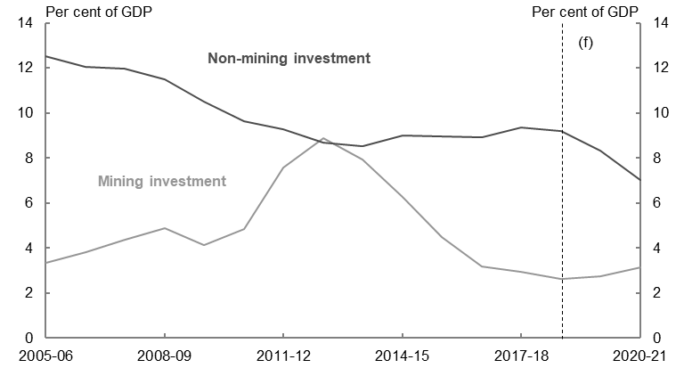
Source: ABS cat. no. 5206.0 and Treasury.

New public final demand is forecast to increase by 4½ per cent in 2020-21, with spending on the National Disability Insurance Scheme, transport infrastructure, healthcare and other essential services continuing to support the economy. While the Government has put in place significant economic support measures, most of these measures affect activity in household consumption and private investment rather than public final demand.
Net exports are forecast to modestly detract from GDP growth in 2020-21, following a 1¼ percentage point contribution to growth in 2019-20. These forecasts largely reflect bans on international travel and a recovery in goods import volumes over 2020-21. Exports are forecast to fall by 6½ per cent in 2020-21, largely driven by a 32½ per cent fall in services exports. Imports are forecast to fall by 6 per cent in 2020-21.
International travel restrictions have significantly affected tourism and education markets all over the world. In Australia, many international students did not make it into the country before the border was closed, and international tourism and education exports are expected to remain suppressed over the forecast period. Similarly, falls in imports are driven by dramatic falls in the number of Australians travelling overseas since the beginning of the year. It is likely that a share of the spending usually undertaken overseas will be redirected to consumption, including domestic travel.
Rural exports are forecast to fall by 2 per cent in 2020-21, following a 6½ per cent fall in 2019-20 as the drought continued to weigh on crop and livestock production. Although favourable seasonal conditions are expected to lead to an above-average winter crop in 2020-21, rural exports are forecast to decrease due to the gradual rebuilding of livestock herds and flocks, which are at historically low levels.
Mining exports are forecast to increase by 3 per cent in 2020-21, after a forecast increase of ½ per cent in 2019-20. Iron ore exports are expected to increase due to ongoing demand from China as project expansions support production volumes. However, lower global coal prices are likely to result in some reduced Australian coal production.
Metallurgical and thermal coal prices have fallen by around one-quarter since the beginning of the year due to lower global demand and the risk of Chinese coal import restrictions. Reflecting these recent falls, the metallurgical coal price assumption has been reduced to US$110 per tonne free-on-board (FOB), and the thermal coal price assumption has been reduced to US$54 per tonne FOB. The Tapis oil benchmark price is assumed to be US$34, around 45 per cent lower compared with the 2019-20 MYEFO. Oil prices have fallen dramatically as cuts in global production have not been enough to offset the large falls in demand. This will have a significant impact on the value of LNG exports, as the price of most of Australia’s LNG exports are directly linked to oil prices.
In contrast, iron ore prices have remained resilient to date as the impact of falling steel production outside China has been largely offset by strong demand from Chinese steel producers and supply disruptions in Brazil. However, there is uncertainty about the supply and demand outlook and the prudent assumption for the iron ore spot price has been retained. The iron ore price is assumed to decline to US$55 per tonne FOB by the end of the December quarter 2020. Commodity prices are volatile and the outlook remains a key uncertainty in the outlook for nominal GDP (Box 2.5).
Box 2.5: Sensitivity analysis of the iron ore spot price
Movements in commodity prices can have significant effects on nominal GDP and Commonwealth government tax revenue. The analysis below provides an indication of the direct impacts on nominal GDP and company tax receipts of altering the timing around the iron ore spot price assumption.
If the iron ore price was to fall immediately to US$55 per tonne FOB, rather than by the end of the December quarter 2020 as assumed, nominal GDP would be around $8.8 billion lower than forecast in 2020-21. This would result in a decrease in tax receipts of around $1.3 billion in 2020-21 and, due to the timing of company tax collections, a decrease in tax receipts of around $0.9 billion in 2021-22 (Table 2.3).
By contrast, if the iron ore price was to remain elevated until the end of the December quarter 2020, before falling immediately to US$55 per tonne FOB, nominal GDP could be around $9.0 billion higher than forecast in 2020-21. This would result in an increase in tax receipts of around $1.2 billion in 2020-21 and, due to the timing of company tax collections, an increase in tax receipts of around $1.0 billion in 2021-22.
Table 2.3: Sensitivity analysis of earlier and later fall in the iron ore spot price
 | Earlier fall to US$55/tonne FOB^{(a)} |  | Later fall to US$55/tonne FOB
 | 2020-21 | 2021-22 | 2020-21 | 2021-22
Nominal GDP ($billion) | -8.8 | - | 9.0 | -
Tax receipts ($billion) | -1.3 | -0.9 | 1.2 | 1.0
(a) FOB is the free-on-board price which excludes freight costs.
Source: Treasury.

