Part 3: Fiscal outlook

Overview
The Government has taken decisive action to support Australian households and businesses in dealing with the impacts of the COVID-19 pandemic. The Government is providing $289 billion in fiscal and balance sheet support, equivalent to around 14.6 per cent of 2019-20 GDP.
The Government’s economic response, together with large declines in taxation receipts and increases in unemployment benefit payments, will see the budget move sharply into deficit in 2019-20 and 2020-21, with government debt also increasing significantly.
The Government’s responsible fiscal management over the past six and a half years has provided the capacity to respond to the unprecedented economic challenges posed by the COVID-19 pandemic. Australia has low levels of debt-to-GDP compared to many other countries and in 2018-19 the Government returned the budget to balance for the first time in 11 years.
The COVID-19 pandemic is still evolving and the economic and fiscal outlook remains highly uncertain. In light of this uncertainty, this update presents fiscal estimates for 2019-20 and 2020-21 only. The Government will present fiscal estimates across the forward estimates and medium-term projections in the 2020-21 Budget, to be delivered on 6 October 2020.
The underlying cash deficit in 2019-20 is expected to be $85.8 billion (4.3 per cent of GDP), a $90.8 billion deterioration since the 2019-20 MYEFO. The estimate for 2020-21 has also been revised down significantly, with an expected deficit of $184.5 billion (9.7 per cent of GDP), a $190.6 billion deterioration since the 2019-20 MYEFO.
Gross debt was $684.3 billion (34.4 per cent of GDP) at 30 June 2020 and is expected to be $851.9 billion (45.0 per cent of GDP) at 30 June 2021. Net debt is expected to be $488.2 billion (24.6 per cent of GDP) at 30 June 2020 and increase to $677.1 billion (35.7 per cent of GDP) at 30 June 2021.
While debt levels have increased significantly as a result of the COVID-19 pandemic, Australia continues to have a low level of debt-to-GDP compared to other countries. Record low interest rates are also reducing the cost of servicing debt (Box 3.4). Once the economic recovery is established, stronger growth and an improvement in the fiscal position will help to stabilise government debt as a share of the economy.
Since the onset of the COVID-19 pandemic, each of the three major ratings agencies have affirmed Australia’s AAA credit rating, noting the underlying resilience of the Australian economy and the Government’s response to the pandemic.
The Government’s economic response is temporary and targeted with measures designed to support the economy without undermining the structural integrity of the budget. The unwinding of the Government’s economic response measures will ensure that the budget improves as the economy recovers. However, automatic stabilisers through the tax system and higher social security payments will continue to affect the budget bottom line for some time.
The Government’s economic recovery strategy is providing immediate support for business and consumer confidence, employment and growth. Over the medium term, the Government will strengthen the fiscal position to ensure Australia continues to be well-placed to respond to future shocks.

Budget aggregates
Table 3.1 provides the underlying cash balance, gross debt and net debt estimates over 2019-20 and 2020-21.
Table 3.1: Budget aggregates
 | Estimates
 | 2019-20 | 2020-21
 | $b | $b
Underlying cash balance(a) | -85.8 | -184.5
Per cent of GDP | -4.3 | -9.7
Gross debt(b) | 684.3 | 851.9
Per cent of GDP | 34.4 | 45.0
Net debt(c) | 488.2 | 677.1
Per cent of GDP | 24.6 | 35.7
- Excludes expected net Future Fund earnings before 2020-21.
- Gross debt measures the face value of Australian Government Securities (AGS) on issue. The 2019-20 number is the actual face value at 30 June 2020.
- Net debt equals the sum of interest bearing liabilities (which includes AGS on issue measured at market value) minus the sum of cash and deposits, advances paid and investments, loans and placements.

Table 3.2 provides key budget aggregates for the Australian Government general government sector over 2019-20 and 2020-21.
Table 3.2: Australian Government general government sector budget aggregates
 | Estimates
 | 2019-20 | 2020-21
 | $b | $b
Receipts | 469.5 | 455.5
Per cent of GDP | 23.6 | 24.0
Payments(a) | 550.0 | 640.0
Per cent of GDP | 27.7 | 33.8
Net Future Fund earnings(b) | 5.3 | na
Underlying cash balance(c) | -85.8 | -184.5
Per cent of GDP | -4.3 | -9.7
Memorandum:
Net Future Fund earnings(b) | 5.3 | 5.4
- Equivalent to cash payments for operating activities, purchases of non-financial assets and net cash flows from financing activities for leases.
- Under the Future Fund Act 2006, net Future Fund earnings will be available to meet the Australian Government’s superannuation liability in 2020-21. From this time, the underlying cash balance includes expected net Future Fund earnings.
- Excludes expected net Future Fund earnings before 2020-21.

Total receipts are expected to be $469.5 billion in 2019-20 (23.6 per cent of GDP), and $455.5 billion in 2020-21 (24.0 per cent of GDP), a deterioration of $94.1 billion over those two years compared with the 2019-20 MYEFO. This deterioration largely reflects lower forecasts across all major tax heads of revenue, consistent with falling average earnings, along with lower forecasts for employment and consumption in 2020-21.
At the same time, payments have increased by $187.5 billion over two years from the 2019-20 MYEFO estimates. They are expected to be $550.0 billion in 2019-20 (27.7 per cent of GDP), rising to $640.0 billion in 2020-21 (33.8 per cent of GDP). This increase is as a result of the Government’s targeted responses to the COVID-19 pandemic to support Australia’s economy, as well as the impact of automatic stabilisers including the payment of unemployment benefits.

Underlying cash balance estimates
Table 3.3 provides a reconciliation of the variations in the underlying cash balance estimates since the 2019-20 MYEFO.
Table 3.3: Reconciliation of underlying cash balance estimates
 | Estimates
 | 2019-20 | 2020-21
 | $m | $m
2019-20 MYEFO underlying cash balance(a) | 5,028 | 6,054
Per cent of GDP | 0.3 | 0.3
Changes from 2019-20 MYEFO to 2020 Economic and Fiscal Update
Effect of policy decisions(b)(c)
Receipts | -373 | -4,651
Payments | 58,026 | 113,726
Total policy decisions impact on underlying cash balance | -58,399 | -118,377
Effect of parameter and other variations(c)
Receipts | -32,602 | -56,435
Payments | -44 | 15,751
less Net Future Fund earnings(d) | -151 | na
Total parameter and other variations impact on
underlying cash balance | -32,406 | -72,186
2020 Economic and Fiscal Update underlying cash balance(a) | -85,778 | -184,509
Per cent of GDP | -4.3 | -9.7
Memorandum:
Net Future Fund earnings(d) | 5,317 | 5,410
- Excludes expected net Future Fund earnings before 2020-21.
- Excludes secondary impacts on public debt interest of policy decisions and offsets from the Contingency Reserve for decisions taken.
- A positive number for receipts improves the underlying cash balance, while a positive number for payments worsens the underlying cash balance.
- Under the Future Fund Act 2006, net Future Fund earnings will be available to meet the Australian Government’s superannuation liability in 2020-21. From this time, the underlying cash balance includes expected net Future Fund earnings.

Policy decisions taken since the 2019-20 MYEFO have reduced the underlying cash balance by $58.4 billion in 2019-20 and $118.4 billion in 2020-21. This largely reflects the Government’s response to the COVID-19 pandemic, with around $172 billion in spending over two years in this response. In addition, the Government committed $2 billion to establish the National Bushfire Recovery Fund in response to the bushfires of 2019-20.
Since the 2019-20 MYEFO, total parameter and other variations have reduced the underlying cash balance by $32.4 billion in 2019-20 and $72.2 billion in 2020-21. This primarily reflects the impact of the COVID-19 pandemic on the economic outlook and the effect of automatic stabilisers on both tax receipts and payments.
Box 3.1: The role of automatic stabilisers
Automatic stabilisers play an important role in reducing the impact of an economic shock, by buffering private sector incomes without direct intervention. This occurs through both decreased receipts (largely through lower taxation receipts) and increased payments (largely through an increase in unemployment benefit payments).
When an economic shock occurs, the tax and transfer system stabilises household and business income by apportioning some of the income loss to the government. For example, under a progressive personal income tax system, an individual’s after-tax income falls by less than their before-tax income.
Estimates variations reflect the automatic stabilisers, as well as other program specific variations such as demand driven programs. Since the 2019-20 MYEFO, total parameter and other variations have reduced the underlying cash balance by $32.4 billion in 2019-20 and $72.2 billion in 2020-21.
The Government’s policy response reflects the significance of the size of the economic shock from COVID-19. It has been designed to be temporary and targeted, but the experience from previous shocks suggests that the effect of automatic stabilisers on the budget, particularly a downturn in tax receipts (Box 3.2) and elevated payments of unemployment benefits, will continue for some time after the shock has passed.
Chart 3.1 shows the estimated effect of COVID-19 on payments and receipts. The sharp increase in the payments-to-GDP ratio reflects both the Government’s economic response and automatic stabilisers, and the impact of lower GDP.

Box 3.1: The role of automatic stabilisers (continued)
Chart 3.1: Payments and receipts as a share of GDP
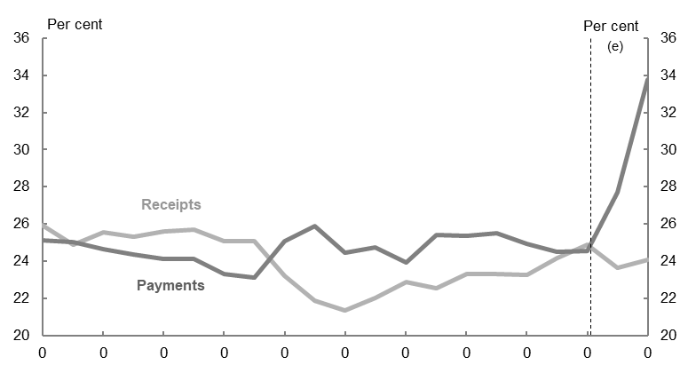
Source: Treasury estimates.

Chart 3.2: Effect of measures and estimates variations on the budget position
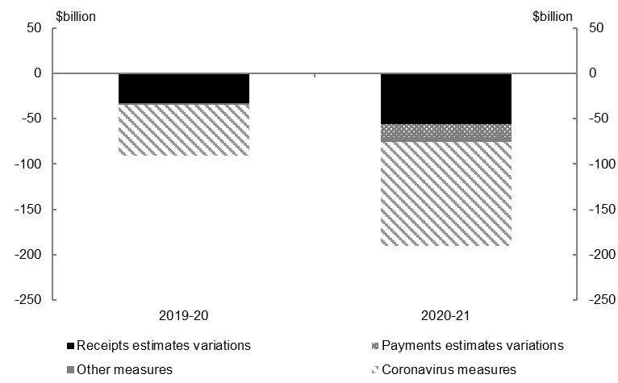
Source: Treasury estimates.

Box 3.1: The role of automatic stabilisers (continued)
The Government’s response to the COVID-19 pandemic accounts for the majority of the expected underlying cash balance deterioration over 2019-20 and 2020-21 (Chart 3.2). The support makes up $56.7 billion of the $90.8 billion deterioration of the underlying cash balance in 2019-20, and $115.0 billion of the $190.6 billion deterioration in 2020-21.
In addition, parameter and other variations have reduced tax receipts by $90.6 billion over 2019-20 and 2020-21 and increased social security payments, including Job Seeker Income Support by $11.8 billion over 2019-20 and 2020-21. These provide significant support to the economy.
While the budget position will be significantly affected in 2019-20 and 2020-21, the winding down of the temporary and targeted response will assist in improving the budget over time.

Receipts estimates
Table 3.4 provides a summary of receipts estimates for 2019-20 and 2020-21.
Table 3.4: Taxation receipts, non-taxation receipts and total receipts^{(a)}
 | Estimates
 | 2019-20 | 2020-21
 | $m | $m
Total individuals and other withholding tax | 221,656 | 213,600
Company tax | 85,002 | 81,600
Superannuation fund taxes | 6,270 | 6,460
Other income taxes(b) | 4,931 | 4,690
Income taxation receipts | 317,859 | 306,350
Goods and services tax | 60,401 | 60,064
Total excise and customs duty | 43,168 | 40,910
Other indirect taxes(c) | 10,618 | 8,606
Indirect taxation receipts | 114,187 | 109,579
Taxation receipts | 432,045 | 415,929
Non-taxation receipts | 37,452 | 39,582
Total receipts | 469,497 | 455,511

- 2019-20 figures are unrounded estimates, based on administrative data, which are subject to change prior to the release of the 2019-20 Final Budget Outcome.
- This item includes fringe benefits tax and resource rent taxes.
- This item includes wine equalisation tax, luxury car tax, major bank levy, agricultural levies and all other indirect taxes not listed above.

Total receipts (including Future Fund earnings) have decreased by $33.0 billion in 2019-20 and $61.1 billion in 2020-21 since the 2019-20 MYEFO.
Since the 2019-20 MYEFO, tax receipts have been revised down by $31.7 billion in 2019-20 and $63.9 billion in 2020-21. The downgrades in 2019-20 and 2020-21 are driven by significant reductions in all major heads of revenue, largely reflecting the impacts of the COVID-19 pandemic, related health restrictions and the Government’s policy response. Tax policy measures to support businesses such as increasing and extending access to the instant asset write-off, backing business investment, and tax instalment GDP adjustment factor are expected to reduce tax receipts in 2020-21.

Policy decisions
The net impact of policy decisions since the 2019-20 MYEFO has decreased total receipts by $0.4 billion in 2019-20 and $4.7 billion in 2020-21. Key measures include:
- backing business investment by temporarily allowing businesses with aggregated turnover of less than $500 million to deduct capital allowances for eligible depreciating assets at an accelerated rate, which is estimated to decrease receipts by $3.2 billion over the five years from 2019-20
- temporary early access to superannuation by allowing individuals affected by the financial impacts of the COVID-19 pandemic to access up to $10,000 of their superannuation in 2019-20 and a further $10,000 in 2020-21 to help support them during the COVID-19 pandemic. This measure is estimated to decrease receipts by $2.2 billion over the five years from 2019-20
- increasing and extending access to the instant asset write-off from 12 March 2020 until 31 December 2020 to give eligible businesses additional time to invest, which is estimated to decrease receipts by $1.0 billion over the five years from 2019-20.
Further details of Government policy decisions are provided at Appendix A.

Parameter and other variations
Parameter and other variations have decreased total receipts (including Future Fund earnings) since the 2019-20 MYEFO by $32.6 billion in 2019-20 and $56.4 billion in 2020-21.
Since the 2019-20 MYEFO, parameter and other variations have reduced tax receipts by $31.7 billion in 2019-20 and $58.9 billion in 2020-21. This significant reduction in tax receipts is largely driven by downward revisions to personal income tax, company tax and GST.
- Parameter and other variations have reduced personal income tax by $9.2 billion in 2019-20 and $26.9 billion in 2020-21. The downward revisions reflect lower forecasts for wages and employment, weaker-than-expected outcomes related to prior income years, and lower growth in unincorporated business income and dividend income.
- Parameter and other variations have reduced company tax by $13.2 billion in 2019-20 and $12.1 billion in 2020-21. The downward revisions reflect weaker-than-expected collections since the 2019-20 MYEFO. This is partly driven by the impact of lock-down restrictions, which have reduced taxable incomes, and by weaker-than-expected net on-assessment outcomes related to prior income years. The weakness in 2019-20 collections is expected to flow to lower company tax receipts in later years.
- Parameter and other variations have reduced GST by $5.2 billion in 2019-20 and $7.6 billion in 2020-21. The downward revisions reflect downgrades to the forecasts for household consumption and private dwelling investment. There has also been an increase in unpaid debt in 2019-20, in part due to payment deferrals offered to businesses experiencing financial hardship. Some of this debt is expected to be recovered in future years.
- Parameter and other variations have reduced excise and customs duties by $2.1 billion in 2019-20 and $3.1 billion in 2020-21. The downward revisions reflect lower fuel consumption due to reductions in travel, as well as weaker-than-expected tobacco excise collections in 2019-20.
- Falls in equity prices, in Australia and internationally, along with lower-than-anticipated house prices, are expected to weigh on capital gains tax, which is a component of income taxes on individuals, companies and superannuation funds.
Chart 3.3 shows the revisions to tax receipts since the 2019-20 MYEFO due to parameter and other variations.
Chart 3.3: Parameter and other variations to tax receipts since the 2019-20 MYEFO
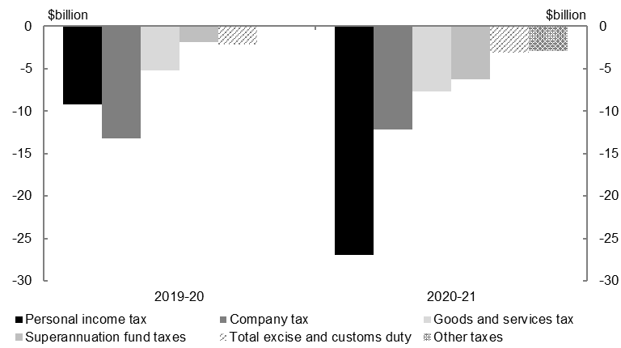
Source: Treasury estimates.
Box 3.2: The COVID-19 shock and the timing of tax receipts
There is significant uncertainty around the outlook for tax receipts. This is driven by the economic outlook and how it will impact taxpayer behaviour and the timing of when tax is collected. Cyclical and discretionary features of the tax system play an important role in cushioning the economy in a downturn (Box 3.1). As the economy starts to recover, structural features of the tax system mean that growth in tax receipts will tend to lag nominal GDP.
Personal income tax, and the income and capital gains tax bases for businesses are sensitive to cyclical changes in economic activity. When incomes, profits and asset prices fall so do the associated tax liabilities, helping to stabilise incomes across the economy. This effect is most contemporaneous in personal income tax collections withheld on salary and wages. Because of the progressive nature of personal income tax, average tax rates decrease alongside a fall in income, which means that recent and forecast falls in aggregate wages will disproportionately impact tax receipts.
Despite the timing between when businesses accrue profits and pay tax becoming more contemporaneous than it was in 1980s and 1990s, there are still significant lags in the tax system for companies, sole traders, partnerships and trusts. This is because while a business will pay instalments through the year, it generally will not finalise its tax liability until the following year. Businesses will also be able to offset losses accrued during the COVID-19 pandemic against tax payable on their profits in coming years (see Box 2, Budget Statement 5, Budget Paper No. 1 of the 2017-18 Budget for a discussion of losses and company tax timing). These features of the tax system create a lag between when the economic activity occurs and when tax is paid, meaning the effects of economic downturns are often seen in tax collections for several years after the initial shock.
Further, the treatment of capital gains can lead to lags in capital gains tax, which is a component of personal, company and superannuation fund taxes. Asset price falls generate capital losses which can be used to offset future capital gains and can significantly reduce tax collections. In the wake of the Global Financial Crisis, unapplied net capital losses for superannuation funds grew by over 800 per cent. It was not until 2016-17 that superannuation fund capital gains tax recovered to pre-crisis levels. The COVID-19 pandemic has already generated significant falls in asset prices. For example, at the end of June, the ASX 200 was over 15 per cent lower than it was at the beginning of the COVID-19 pandemic. The extent of these losses, and how taxpayers use them, will be a key source of uncertainty on the outlook for tax receipts.
At the same time, the ATO has administrative powers which can support businesses and individuals during a downturn. This can also impact the timing of tax receipts. Taxpayers have been using administrative support measures to either reduce the amount of tax they have to pay throughout the year to better reflect their income, or defer payment of their tax liabilities to a later date. It is estimated that around $5 billion in tax has been deferred from 2019-20 until 2020-21, largely relating to GST, company tax and individuals and other withholding tax.

Parameter and other variations have decreased non-taxation receipts, including Future Fund earnings, since the 2019-20 MYEFO by $0.9 billion in 2019-20 and increased receipts by $1.6 billion over the two years to 2020-21. This revision mainly reflects fewer than expected unclaimed superannuation fund balances transferring to the Australian Taxation Office in 2019-20, lower than expected investment returns across Australian Government Investment Funds, and a higher expected dividend from the Reserve Bank of Australia in 2020-21.

Payment estimates

Since the 2019-20 MYEFO, total payments have increased by $58.0 billion in 2019-20 and increased by $187.5 billion over the two years to 2020-21.

Policy decisions
The net impact of policy decisions since the 2019-20 MYEFO has increased payments by $58.0 billion in 2019-20 and $113.7 billion in 2020-21. Policy decisions largely reflect the Government’s response to COVID-19 and to the bushfires of 2019-20 and include:
- providing the JobKeeper Payment to help businesses and not-for-profits significantly impacted by COVID-19 cover the costs of their employees’ wages, so more Australians can retain their jobs and continue to earn an income ($85.7 billion over two years from 2019-20)
- providing temporary tax-free cash flow boosts of between $20,000 and $100,000 to eligible small and medium-sized businesses and not-for-profits ($31.9 billion over two years from 2019-20)
- providing a time limited Coronavirus Supplement to new and existing income support recipients and temporarily expanding eligibility to income support payments ($16.8 billion over five years from 2019-20)
- providing eligible pensioners, income support recipients, carers and student payment recipients two separate $750 economic support payments ($9.4 billion over four years from 2019-20)
- funding a package of measures to support hospitals to respond to COVID-19, including a commitment to pay for half of all additional costs incurred by states and territories in diagnosing and treating patients with COVID-19 and a viability guarantee for private hospitals, as a result of reduced elective surgery activity, and to provide surge capacity to assist public hospitals ($3.7 billion over two years from 2019-20)
- committing $2.0 billion to a National Bushfire Recovery Fund (NBRF) to assist communities and businesses to recover and rebuild following the 2019-20 bushfires ($2.0 billion over four years from 2019-20). The NBRF is in addition to funding provided through existing disaster recovery assistance arrangements.

Parameter and other variations
Parameter and other variations since the 2019-20 MYEFO have increased total payments by $15.7 billion over the two years to 2020-21. The increases in payments are primarily driven by the unprecedented economic impacts of the COVID-19 pandemic and include:
- payments relating to the Job Seeker Income Support program, which are expected to increase by $11.8 billion over the two years to 2020-21, largely reflecting an increase in the forecast recipient numbers as a result of the impact of the COVID-19 pandemic on employment levels
- payments relating to the National Disability Insurance Scheme, which are expected to increase by $2.3 billion over the two years to 2020-21, largely reflecting higher than expected average participant costs
- payments relating to Commonwealth Debt Management, which are expected to increase by $1.1 billion over the two years to 2020-21, largely reflecting the higher servicing costs from increased levels of Australian Government Securities on issue
- payments relating to the Family Tax Benefit program, which are expected to increase by $591 million over the two years to 2020-21, largely reflecting an increase to average payment rates and recipient numbers as a result of increased unemployment, reduction in hours worked and reduced workforce participation due to the impacts of the COVID-19 pandemic
- payments relating to the Disability and Carers program, which are expected to increase by $569 million over the two years to 2020-21, largely reflecting an increase in Disability Employment Services client numbers
- payments relating to the Income Support for People with Disability program, which are expected to increase by $527 million over the two years to 2020-21, largely reflecting a higher than projected number of recipients and average payment rates as a result of the impact of the COVID-19 pandemic on employment levels
- payments relating to Services Australia Departmental Funding, which are expected to increase by $512 million over the two years to 2020-21, largely reflecting a higher volume of claims to process as a result of the impact of the COVID-19 pandemic on employment levels
- payments relating to the Australian Government Disaster Financial Support Payments program, which are expected to increase by $452 million over the two years to 2020-21, largely reflecting the Government’s support for recovery in response to natural disaster events such as the Queensland monsoon event, Tropical Cyclone Blake and the bushfires of 2019-20.

Major decreases in payments as a result of parameter and other variations since the 2019-20 MYEFO include:
- payments relating to the provision of GST to the states and territories, which are expected to decrease by $12.7 billion over the two years to 2020-21, consistent with a reduction in GST receipts
- payments relating to the Families and Children program, which are expected to decrease by $610 million over the two years to 2020-21. This largely reflects a re-profiling of expenditure due to slower than expected uptake by survivors accessing redress under the National Redress Scheme. There has also been an associated downward re-profiling of the expected receipts received from the institutions liable for the payments. Payments are generally made around a week from survivors accepting an offer.
Box 3.3: Advance to the Finance Minister (AFM) in response to COVID-19
AFM provisions under the annual Appropriation Acts enable urgently required allocations to be issued to entities during the year. Allocations are made through a Determination by the Minister for Finance up to a statutory limit in the annual Appropriation Acts.
Given the unique and evolving nature of the COVID-19 pandemic and the associated uncertainty around the Government’s necessary response, Parliament supported extraordinary AFM provisions in 2019-20 and in the 2020-21 Supply Acts.
In 2019-20, $1,974 million was allocated from total AFM provisions of $42,975 million across Appropriation Acts 2019-20 (Nos. 1 to 6) and Appropriation (Coronavirus Economic Response Package) Acts 2019-20 (Nos. 1 and 2).
Table 3.5: AFMs issued in 2019-20
No. | Appropriation Source | Entity | Purpose | Amount($m) | Allocation Date
1 | Appropriation Act (No.2) 2019-2020 | Department of Health | Procurement of masks and other emergency medical or emergency health equipment for the National Medical Stockpile | 100 | 4/03/2020
2 | Appropriation Act (No.2) 2019-2020 | Department of Health | Procurement of masks and other emergency medical or emergency health equipment for the National Medical Stockpile | 200 | 9/03/2020
3 | Appropriation (Coronavirus Economic Response Package) Act (No.2) 2019-2020 | Department of Health | Procurement of masks and other emergency medical or emergency health equipment | 800 | 3/04/2020
4 | Appropriation (Coronavirus Economic Response Package) Act (No.2) 2019-2020 | Department of Health | Procurement of masks and other emergency medical or emergency health equipment | 400 | 9/04/2020
5 | Appropriation Act (No.2) 2019-2020 | Department of Health | Procurement of masks and other emergency medical or emergency health equipment | 380 | 9/04/2020
6 | Appropriation Act (No.1) 2019-2020 | Department of Industry, Science, Energy and Resources | Lease costs of storage in the United States Strategic Petroleum Reserve for purchases of oil stocks | 2.5 | 23/04/2020
7 | Appropriation Act (No.6) 2019-2020 | Department of Industry, Science, Energy and Resources | Purchase of oil stocks | 91.5 | 23/04/2020

Box 3.3: Advance to the Finance Minister (AFM) in response to COVID-19 (continued)
In 2020-21, AFM provisions of $40,000 million have been enacted across Supply Acts 2020-21 (Nos. 1 and 2) reduced by the value of AFMs issued under Appropriation Acts 2019-20 (Nos. 5 and 6) ($91.5 million). Accordingly, the balance available for allocation from Supply Acts 2020-21 (Nos. 1 and 2) is $39,908.5 million. As at 16 July 2020, $250 million has been allocated from 2020-21 AFM provisions.
Table 3.6: AFMs issued in 2020-21 to 16 July 2020
No. | Appropriation Source | Entity | Purpose | Amount ($m) | Allocation Date
1 | Supply Act (No.2) 2020-2021 | Department of Infrastructure, Transport, Regional Development and Communications | Provide funding to local governments for delivery of local roads and community infrastructure projects to boost economic activity following the initial impact of COVID-19 | 250.0 | 2/07/2020

Debt estimates
Gross debt, measured as the face value of Australian Government Securities (AGS) on issue, was $684.3 billion (34.4 per cent of GDP) at 30 June 2020 and is expected to be $851.9 billion (45.0 per cent of GDP) at 30 June 2021. The increase in gross debt since the 2019-20 MYEFO is primarily driven by increased borrowing for the Government’s response to the COVID-19 pandemic and the effect of automatic stabilisers.
Table 3.7 provides a summary of the estimated end-of-year AGS on issue measured at face value and market value.
Table 3.7: Estimates of AGS on issue subject to the Treasurer’s Direction^{(a)}
 | Estimates
 | 2019-20 | 2020-21
 | $b | $b
Face value — end of year(b) | 684.3 | 851.9
Per cent of GDP | 34.4 | 45.0
Market value — end of year(c) | 785.0 | 952.2
Per cent of GDP | 39.5 | 50.3
- The Treasurer’s Direction applies only to the face value of AGS on issue.
- The face value of AGS on issue is the amount that Government pays back to investors at maturity, independent of fluctuations in market prices. The 2019-20 value is the actual face value at 30 June 2020.
- The market value of AGS on issue is the measurement included in net debt and represents the value of securities as traded on the secondary market, which changes continuously with movements in market prices. The 2019-20 value is the actual market value at 30 June 2020.

The headline cash balance is a good indicator of the Government’s borrowing requirement. It consists of the underlying cash balance, net cash flows from investments in financial assets for policy purposes (for example, student loans and equity investment in NBN Co Limited) and net Future Fund earnings (included in the underlying cash balance from 2020-21).
Since the 2019-20 MYEFO, the headline cash deficit estimates have increased to $94.0 billion (4.7 per cent of GDP) in 2019-20 and $209.2 billion (11.0 per cent of GDP) in 2020-21. This deterioration is primarily driven by the underlying cash deficit for each year. Further detail on the headline cash balance estimates will be included in the 2020-21 Budget.
Net debt is expected to be $488.2 billion (24.6 per cent of GDP) at 30 June 2020 and increase to $677.1 billion (35.7 per cent of GDP) at 30 June 2021. The expected increase in net debt since the 2019-20 MYEFO primarily reflects the increased borrowing requirement.

Box 3.4: Government bond yields and debt servicing costs
Internationally, bond yields are at historical lows (Chart 3.4). Lower bond yields translate to a lower public debt interest (PDI) cost for governments on their borrowings.
While the unprecedented speed and scale of the Government’s economic response to the COVID-19 pandemic as well as the impact of automatic stabilisers have resulted in a rapid increase in borrowing, historically low interest rates mean that the cost of servicing this debt is relatively low. The assumed market yields in this update result in a weighted average yield for future issuance of Treasury Bonds of around 0.8 per cent, compared with around 1.1 per cent at the 2019-20 MYEFO. Low debt servicing costs will assist in reducing the stock of debt as a share of the economy over time.
Chart 3.4: International comparison of 10 year government bond yields
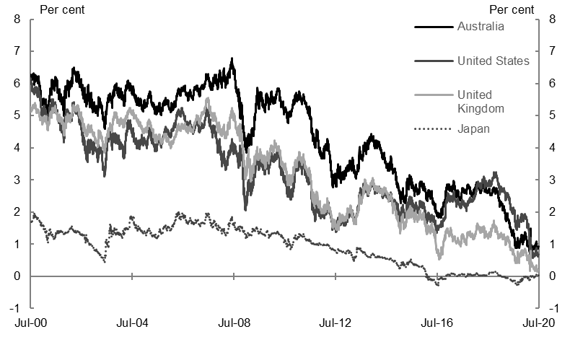
Source: Bloomberg.
Chart 3.5 presents the Government’s PDI costs and gross debt as a share of the economy. PDI costs as a share of the economy have historically trended in line with movements in gross debt, and were expected to fall over the forward estimates with the projected decline in debt-to-GDP in the 2019-20 MYEFO. While debt-to-GDP is now expected to increase in 2019-20 and 2020-21, PDI costs as a share of the economy are expected to be relatively flat due to yields falling to historical lows.

Box 3.4: Government bond yields and debt servicing costs (continued)
Chart 3.5: Gross debt and PDI
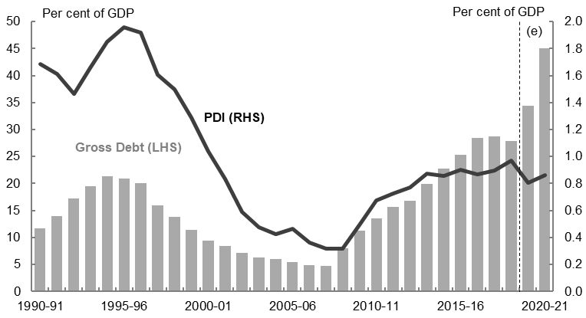
Source: Treasury estimates.

Risks to the fiscal outlook
The COVID-19 pandemic is still evolving and the outlook remains highly uncertain. The fiscal outlook is based on the outlook for the domestic and global economies. The range of possible outcomes for GDP and unemployment in particular is substantially wider than normal. This translates into a higher than usual degree of uncertainty for the forecasts for tax receipts and payments, and as a consequence for the fiscal estimates.
Generally, there is a strong correlation between revisions to nominal GDP and its components and revisions to the forecasts for tax receipts. Alongside uncertainty around the economic forecasts owing to the COVID-19 pandemic and associated restrictions, tax receipt forecasts are highly sensitive to the outlook for asset prices and capital gains. These have historically generated significant uncertainty around the revenue outlook. In addition, the take-up of administrative support measures, such as payment deferrals, is impacting tax collections. Further, the ability to utilise tax losses to offset future profits is expected to continue to pose a challenge when estimating the profile for tax receipts over the next few years.
The Government will present fiscal estimates across the forward estimates and medium-term projections in the 2020-21 Budget, to be delivered on 6 October 2020. These will reflect updated information about the economic recovery, including the evolution of the COVID-19 pandemic.

The 2019-20 estimates in this Economic and Fiscal Update reflect preliminary expected outcomes. There may be differences between this update and the 2019-20 Final Budget Outcome to be released in September 2020.

