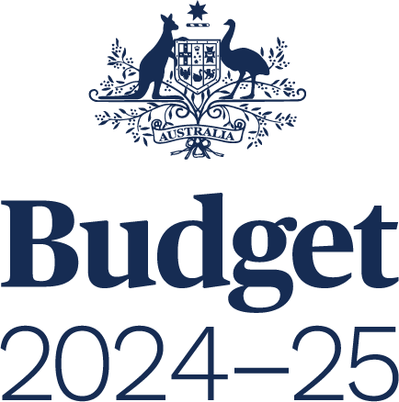

**BUDGET STRATEGY AND OUTLOOK**

BUDGET PAPER NO. 1

Circulated by

**The Honourable Jim Chalmers MP**

Treasurer of the Commonwealth of Australia

and

**Senator the Honourable Katy Gallagher**

Minister for Finance, Minister for Women,   
Minister for the Public Service of the Commonwealth of Australia

For the information of honourable members  
on the occasion of the Budget 2024–25

**14 May 2024**

© Commonwealth of Australia 2024

ISSN 0728 7194 (print); 1326 4133 (online)

This publication is available for your use under a [Creative Commons Attribution 4.0 International](http://creativecommons.org/licenses/by/4.0/) licence, with the exception of the Commonwealth Coat of Arms, third‑party content and where otherwise stated. The full licence terms are available from <http://creativecommons.org/licenses/by/4.0/legalcode>.



Use of Commonwealth of Australia material under [Creative Commons Attribution 4.0 International](http://creativecommons.org/licenses/by/4.0/) licence requires you to attribute the work (but not in any way that suggests that the Commonwealth of Australia endorses you or your use of the work).

**Commonwealth of Australia material used ‘as supplied’.**

Provided you have not modified or transformed Commonwealth of Australia material in any way including, for example, by changing the Commonwealth of Australia text; calculating percentage changes; graphing or charting data; or deriving new statistics from published statistics – then the Commonwealth of Australia prefers the following attribution:

Source: *The Commonwealth of Australia.*

**Derivative material**

If you have modified or transformed Commonwealth of Australia material, or derived new material from those of the Commonwealth of Australia in any way, then the Commonwealth of Australia prefers the following attribution:

*Based on Commonwealth of Australia data.*

**Use of the Coat of Arms**

The terms under which the Coat of Arms can be used are set out on   
the Department of the Prime Minister and Cabinet website (see [www.pmc.gov.au/  
honours-and-symbols/commonwealth-coat-arms](http://www.pmc.gov.au/honours-and-symbols/commonwealth-coat-arms)).

**Other uses**

Enquiries regarding this licence and any other use of this document are welcome at:

Manager  
Media Unit  
The Treasury  
Langton Crescent   
Parkes  ACT  2600  
Email: [media@treasury.gov.au](mailto:media@treasury.gov.au)

**Internet**

A copy of this document is available on the central Budget website at: [www.budget.gov.au](http://www.budget.gov.au).

Printed by CanPrint Communications Pty Ltd

Contents

Statement 1: Budget Overview 1

Economic and Fiscal Outlook 5

Budget priorities 8

Statement 2: Economic Outlook 39

Outlook for the international economy 43

Outlook for the domestic economy 50

Statement 3: Fiscal Strategy and Outlook 73

Economic and Fiscal Strategy 79

Fiscal outlook 84

The Government’s balance sheet 103

Fiscal impacts of the net zero transformation 107

Physical Impacts of Climate Change 107

Net zero spending 108

New net zero spending measures 113

Appendix A: Other fiscal aggregates 116

Statement 4: Meeting Australia’s Housing Challenge 121

Australia has underinvested in housing for too long 125

Affordability pressures are high 135

Barriers to the construction of new homes need to be addressed 140

The Government’s plan to meet Australia’s housing challenge 149

Australian Government housing measures since May 2022 156

Statement 5: Revenue 163

Overview 167

Variations in receipts estimates 172

Variations in revenue estimates 183

Appendix A: Tax Expenditures 186

Statement 6: Expenses and Net Capital Investment 189

Overview 193

Estimated expenses by function 196

General government sector expenses 200

General government net capital investment 227

Appendix A: Expense by function and sub‑function 231

Statement 7: Debt Statement 235

Australian Government Securities on issue 239

Green Treasury Bonds 244

Non‑resident holdings of AGS on issue 244

Net debt 245

Interest on AGS 247

Appendix A: AGS issuance 251

Statement 8: Forecasting Performance and Sensitivity Analysis 253

Assessing past forecasting performance 257

Assessing forecast uncertainty – confidence interval analysis 265

Assessing current forecasts through sensitivity analysis 271

Statement 9: Statement of Risks 275

Risks to the Budget – Overview 279

Agriculture, Fisheries and Forestry 288

Attorney‑General’s 290

Climate Change, Energy, the Environment and Water 292

Defence 296

Employment and Workplace Relations 299

Finance 301

Foreign Affairs and Trade 305

Health and Aged Care 307

Home Affairs 311

Industry, Science and Resources 314

Infrastructure, Transport, Regional Development, Communications and the Arts 317

Prime Minister and Cabinet 323

Social Services 324

Treasury 326

Veterans’ Affairs 333

Government loans 334

Statement 10: Australian Government Budget Financial Statements 349

Appendix A: Financial reporting standards and budget concepts 385

Appendix B: Assets and Liabilities 393

Statement 11 Historical Australian Government Data 407

Data sources 411

Comparability of data across years 411

Revisions to previously published data 413

Notes 435