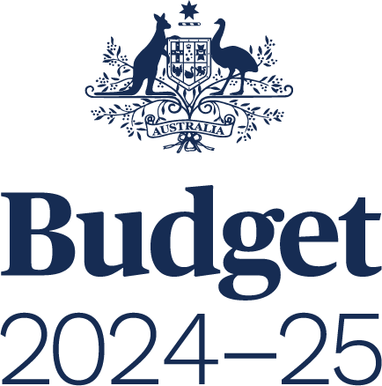

**FEDERAL FINANCIAL RELATIONS**

BUDGET PAPER NO. 3

Circulated by

**The Honourable Jim Chalmers MP**

Treasurer of the Commonwealth of Australia

and

**Senator the Honourable Katy Gallagher**

Minister for Finance, Minister for Women,   
Minister for the Public Service of the Commonwealth of Australia

For the information of honourable members  
on the occasion of the Budget 2024–25

**14 May 2024**

© Commonwealth of Australia 2024

ISSN 0728 7194 (print); 1326 4133 (online)

This publication is available for your use under [Creative Commons Attribution 4.0 International](https://creativecommons.org/licenses/by/4.0/) licence, with the exception of the Commonwealth Coat of Arms, third‑party content and where otherwise stated. The full licence terms are available from <http://creativecommons.org/licenses/by/4.0/legalcode>.



Use of Commonwealth of Australia material under a [Creative Commons Attribution 4.0 International](https://creativecommons.org/licenses/by/4.0/) licence requires you to attribute the work (but not in any way that suggests that the Commonwealth of Australia endorses you or your use of the work).

**Commonwealth of Australia material used ‘as supplied’.**

Provided you have not modified or transformed Commonwealth of Australia material in any way including, for example, by changing the Commonwealth of Australia text; calculating percentage changes; graphing or charting data; or deriving new statistics from published statistics – then the Commonwealth of Australia prefers the following attribution:

Source: The Commonwealth of Australia*.*

**Derivative material**

If you have modified or transformed Commonwealth of Australia material, or derived new material from those of the Commonwealth of Australia in any way, then the Commonwealth of Australia prefers the following attribution:

Based on Commonwealth of Australia data*.*

**Use of the Coat of Arms**

The terms under which the Coat of Arms can be used are set out on   
the Department of the Prime Minister and Cabinet website (see [www.pmc.gov.au/  
honours-and-symbols/commonwealth-coat-arms](http://www.pmc.gov.au/honours-and-symbols/commonwealth-coat-arms)).

**Other uses**

Enquiries regarding this licence and any other use of this document are welcome at:

Manager  
Media Unit  
The Treasury  
Langton Crescent   
Parkes  ACT  2600  
Email: [media@treasury.gov.au](mailto:media@treasury.gov.au)

**Internet**

A copy of this document is available on the central Budget website at: [www.budget.gov.au](http://www.budget.gov.au).

Printed by CanPrint Communications Pty Ltd.

# Foreword

This Budget Paper presents information on the Australian Government’s financial relations with state, territory and local governments.

Contents

Foreword iii

Part 1: Australia’s Federal Relations 1

Overview 1

Australian Government funding to the states 4

Measures affecting payments to the states 10

Part 2: Payments for specific purposes 15

Overview 15

Health 19

Education 45

Skills and workforce development 52

Community services 55

Affordable housing 62

Infrastructure 66

Environment, energy and water 83

Contingent payments 108

Other payments 110

Part 3: General revenue assistance 121

Overview 121

GST payments 122

Other general revenue assistance 126

Mirror tax arrangements 127

Appendix A: Parameters and further information 129

Population 129

Data sources 131

Further information 132

Notes 133

List of tables

Table 1.1: Australian Government payments to the states, 2023‍–‍24 to 2027‍–‍28 7

Table 1.2: Total Australian Government payments to the states as a proportion of GDP 8

Table 1.3: Australian Government’s contribution to state expenditure 9

Table 1.4: Measures affecting payments to the states 10

Table 2.1: Total payments for specific purposes by category, 2023–24 to 2027–28 16

Table 2.2: Payments for specific purposes by sector and category, 2023–24 to 2027–28 18

Table 2.3: Payments to support state health services 19

Table 2.3.1 Health services 22

Table 2.3.2 Health infrastructure 33

Table 2.3.3 First Nations health 37

Table 2.3.4 Other health National Partnership payments 40

Table 2.4: Payments to support state education services 45

Table 2.5: Payments to support state skills and workforce development services 52

Table 2.6: Payments to support state community services 55

Table 2.7: Payments to support state affordable housing services 62

Table 2.8: Payments to support state infrastructure services 66

Table 2.9: Payments to support state environment, energy and water services 83

Table 2.10: Contingent payments to the states 108

Table 2.11: Payments to support other state services 110

Table 3.1: General revenue assistance 121

Table 3.2: Reconciling GST revenue, GST entitlement and GST payments to the states 123

Table 3.3: Reconciliation of the GST entitlement estimates since the   
2023–24 MYEFO 123

Table 3.4: Policy decisions since the 2023–24 MYEFO that affect the GST entitlement 124

Table 3.5: Calculation of GST entitlements 125

Table 3.6: Reconciliation of the GST administration budget 126

Table 3.7: Other general revenue assistance 126

Table 3.8: Mirror taxes accrued on behalf of the states 127

Table A.1: Population by state, at 31 December 129

Table A.2: Population by state, at 30 June 129

Table A.3: Total fertility rate, for years ending 30 June 130

Table A.4: Projected life expectancy at birth, for years ending 30 June 130

Table A.5: Net overseas migration, for years ending 30 June 130

Table A.6: Net interstate migration by state, for years ending 30 June 131

Table A.7: Wage cost indices 131

List of charts

Chart 1.1: Net operating balance as a share of GDP 2

Chart 1.2: Payments for specific purposes 2024–25, by sector 5

Chart 1.3: Total Australian Government payments to the states, 2024‍–‍25 8