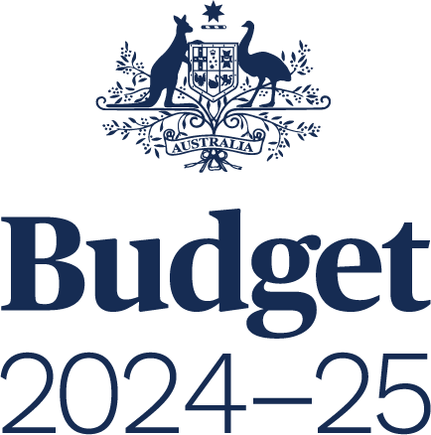

**AGENCY RESOURCING**

BUDGET PAPER NO. 4

Circulated by

**Senator the Honourable Katy Gallagher**

Minister for Finance, Minister for Women,   
Minister for the Public Service of the Commonwealth of Australia

For the information of honourable members  
on the occasion of the Budget 2024–25

**14 May 2024**

© Commonwealth of Australia 2024

ISSN 0728 7194 (print); 1326 4133 (online)

This publication is available for your use under a [Creative Commons Attribution 4.0 International](https://creativecommons.org/licenses/by/4.0/) licence, with the exception of the Commonwealth Coat of Arms, third‑party content and where otherwise stated. The full licence terms are available from <http://creativecommons.org/licenses/by/4.0/legalcode>



Use of Commonwealth of Australia material under a [Creative Commons Attribution 4.0 International](https://creativecommons.org/licenses/by/4.0/) licence requires you to attribute the work (but not in any way that suggests that the Commonwealth of Australia endorses you or your use of the work).

**Commonwealth of Australia material used ‘as supplied’.**

Provided you have not modified or transformed Commonwealth of Australia material in any way including, for example, by changing the Commonwealth of Australia text; calculating percentage changes; graphing or charting data; or deriving new statistics from published statistics – then the Commonwealth of Australia prefers the following attribution:

Source: *The Commonwealth of Australia.*

**Derivative material**

If you have modified or transformed Commonwealth of Australia material, or derived new material from those of the Commonwealth of Australia in any way, then the Commonwealth of Australia prefers the following attribution:

*Based on Commonwealth of Australia data.*

**Use of the Coat of Arms**

The terms under which the Coat of Arms can be used are set out on   
the Department of the Prime Minister and Cabinet website (see [www.pmc.gov.au/  
government/commonwealth-coat-arms](http://www.pmc.gov.au/government/commonwealth-coat-arms)).

**Other uses**

Enquiries regarding this licence and any other use of this document are welcome at:

Manager  
Media Unit  
The Treasury  
Langton Crescent   
Parkes  ACT  2600  
Email: [media@treasury.gov.au](mailto:media@treasury.gov.au)

**Internet**

A copy of this document is available on the central Budget website at: [www.budget.gov.au](http://www.budget.gov.au).

Printed by CanPrint Communications Pty Ltd.

Contents

Acronyms and notes iii

Preface 3

Introduction and Guide to Budget Paper No. 4 19

Part 1: Agency Financial Resourcing 27

Agency Resourcing Table 34

Special Appropriations Table 123

Special Accounts Table 137

Part 2: Staffing of Agencies 167

Part 3: Expenses and Net Capital Investment 183

Appendix A: Agency Outcome Statements 193

# Acronyms and notes

|  |  |
| --- | --- |
| AAO | Administrative Arrangements Order |
| AAS | Australian Accounting Standards |
| AASB | Australian Accounting Standards Board |
| ABS | Australian Bureau of Statistics |
| Agency/entity | Has the same meaning as *Commonwealth entity* within the *Public Governance, Performance and Accountability Act 2013* |
| APS | Australian Public Service |
| ASL | Average Staffing Level |
| CRF | Consolidated Revenue Fund |
| FBO | Final Budget Outcome |
| Finance Minister | Minister for Finance |
| GFS | Government Finance Statistics |
| GGS | General Government Sector |
| IMF | International Monetary Fund |
| MoG | machinery of government |
| PGPA Act | *Public Governance, Performance and Accountability Act 2013* |
| SPPs | Specific Purpose Payments |

The following notations are used in this Budget Paper:

|  |  |
| --- | --- |
| ‑ | nil estimates of expenditure |
| na | not applicable (unless otherwise specified) |
| $m | millions of dollars |
| $b | billions of dollars |