|  |
| --- |
| Purpose of Budget Paper No. 4  Budget Paper No. 4 presents information on the full allocation of resources across the General Government Sector. [1] In 2024–25, agencies will be responsible for administering approximately $734.5 billion to deliver services for individuals, families and businesses.  Budget Paper No. 4 sets out the departmental funding for agencies, administered funding managed by agencies, the nature of funding sources and the purposes of funding as defined by Outcome Statements for each agency.  Additionally, information is provided on the staffing resources allocated to agencies delivering services to the Australian community. |

# Preface

The Government has a strong record of delivering outcomes for all Australians. The public service is essential to delivering these outcomes, doing everything from processing Centrelink payments and Medicare rebates, to protecting Australia’s borders and economic interests, supporting job creation, responding to natural disasters, and helping to deliver the clean energy transition. The actions the Government is taking to rebuild the Australian Public Service (APS) and reduce its reliance on consultants and contractors recognises that delivering outcomes for Australians must be built on the foundations of a strong public service.

After almost a decade of outsourcing, reduced service outcomes and underinvestment by the previous Government, over the past two years the Government has invested in the public service to ensure it is best placed to do the job the Australian people expect. The public service needs people to deliver services across the country, support Australia’s economic growth and keep Australians safe.

The 2024–25 Budget builds on this investment, responding to the challenges of today and investing in a better future. The Budget helps ease cost‑of‑living pressures and supports building more homes for Australians. It lays the foundations of an ambitious strategy to build a future made in Australia, while investing in strengthening Medicare and building a strong, sustainable care economy. At the same time, the Budget delivers on the Government’s commitment to responsible economic management, broadening opportunity and improving equality.

The Government is delivering on its election commitment to reduce the public service’s reliance on consultants, contractors, and labour hire, which delivered a $3 billion saving in the 2022–23 October Budget. Demonstrating the Government’s commitment to responsible economic management, the 2024–25 Budget delivers an additional saving of $1 billion over four years from 2024-25 by reducing spending on external labour, bringing the total savings to $4 billion.

The Government will conduct a new Audit of Employment to measure and track how the public service is continuing to deliver on the Government’s commitment to reduce its reliance on external labour, coupled with targets established under the *APS Strategic Commissioning Framework*, to bring core public service work back into the public service.

The Government has an ambitious agenda for Australia and the effectiveness of the public service is central to successfully implementing the Government’s commitments to the Australian people.

## The impact of the previous Government’s Average Staffing Level cap

The 2023 Audit of Employment identified that the previous Government suppressed the true size of the public service, with an artificially low and misleading public service headcount augmented by a shadow workforce of tens of thousands of consultants and contractors. Abolishing the arbitrary Average Staffing Level (ASL) cap in 2022 was an important first step towards rebuilding the public service and ensuring that the jobs that need to be done are delivered more effectively and more cost‑efficiently by public servants.

The arbitrary restrictions on the size of the public service under the ASL cap had nothing to do with achieving efficiencies. The shadow workforce came at a costly premium for taxpayers without offering the value for money the Australian people expect. Under the previous Government, departmental spending in nominal terms rose 35 per cent between 2012–13 and 2021–22, whereas ASL numbers fell by four per cent over the same period.

|  |
| --- |
| Audit of Employment  The 2023 Audit of Employment provided an estimate of the use of external labour (contractors, consultants, outsourced service providers and labour hire) across the public service under the previous Government. The Audit brought together information on the use of external labour by 112 agencies across the public service that employ staff under the *Public Service Act 1999* and found that in 2021–22 these agencies employed an external labour workforce of 53,900 staff on a full‑time equivalent basis at a cost of $20.8 billion.  The Audit also found that around one in every four dollars spent by agencies for departmental purposes was on external labour. |

The impacts of the previous Government’s ASL cap policy were two‑fold. In the early years, departmental funding was reduced by around 10 per cent in real terms while the size of the public service was reduced by a similar amount. These reductions diminished the ability of the public service to provide high‑quality policy advice and deliver the services and programs that Australians expect of their government. From around 2015, funding to government agencies began to increase, but the ASL cap forced agencies to outsource core services using contracted labour or third‑party service providers rather than public service employees. By 2022, employment in the public service was around 14 per cent below the level it would have been had ASL growth kept up with the growth in departmental expenses in the absence of the ASL cap (Chart 1).

Chart 1 – Index of ASL and departmental expenses (real terms) (2007–08 to 2024–25)

Source: Department of Finance. Departmental expenses sourced from consolidated budget figures. Real values for Chart 1 have been calculated based on Wage Price Index as published by the Australian Bureau of Statistics. Estimated future Wage Price Index values are Department of the Treasury forecasts. ASL data sourced from historical and current Budget Paper No.4. Excludes Defence portfolio (except for the Australian War Memorial and Department of Veterans’ Affairs), the administered in nature National Disability Insurance Agency expenses, and Clean Energy Finance Corporation.

## Reducing the public service’s reliance on consultants and contractors

In October 2023, the Government released new instructions for the public service to limit the use of contractors and consultants. The *APS Strategic Commissioning Framework* requires core government work to be done by public service employees, such as policy formulation, drafting Cabinet submissions, developing legislation and regulations, and limits outsourcing of core work to defined circumstances.

All agencies that employ staff under the Public Service Act 1999 are now required to collect data on their use of the external workforce and how it is reducing over time. This will be reported in Annual Reports from 2024 onwards, for accountability and transparency purposes.

By rebalancing and rebuilding the public service, the Government has converted contractors into public service roles and achieved savings through reduced spending on consultants, contractors, and other external labour. Since the 2022–23 October Budget, 8,816 public service roles have been created to replace work previously undertaken by consultants and contractors. This includes:

* 5,816 roles that have been explicitly converted from contracted positions to public service positions. The 2024–25 Budget includes 2,502 additional conversions in addition to the 3,314 conversions reported in the 2023–24 Budget
* 3,000 roles in Services Australia that are now being performed by public servants instead of through outsourced arrangements. The Government is providing funding for public servants when extending terminating funding, instead of funding for outsourced arrangements, as was occurring because of the previous Government’s arbitrary ASL cap.

The use of the largest consulting firms has significantly reduced under the Government, dropping in value by $624 million year‑to‑date for 2023–24 compared to the same period in 2021–22. On average, use of the largest consulting firms was $84 million less each month for the first half of 2023–24 than for the same period in 2021–22.

To support the public service to do its core work in‑house, instead of outsourcing to more expensive private providers, the Government has established an in‑house consulting function, Australian Government Consulting. While still scaling up, Australian Government Consulting is undertaking management and strategy consulting work in partnership with public service agencies. It is also strengthening public service capability and supporting agencies to get better value when engaging external consultants.

Building on the work of Australian Government Consulting, the Department of Defence (Defence) will look to initiate a pilot program (Australian Defence Consulting) to provide internal consultancy support across Defence using public service and Australian Defence Force staff. This will further reduce Defence’s need for high‑cost external support and build the capability of its public sector workforce.

## Rebuilding an efficient public service that delivers for Australians

In rebuilding the public service over the past two years, the Government has worked to repair the damaging effects of the previous Government’s arbitrary ASL cap by appropriately funding and resourcing the public service to deliver on the Government’s priorities. In doing so, it has kept the relative size of the public service well below historical levels of public service resourcing, when measured as a proportion of the total Australian population and the labour force (Chart 2). At the same time, the public service is doing more as the roles and responsibilities of the Commonwealth have expanded in line with the needs and expectations of Australians.

Chart 2 – ASL as a percentage of population and Australian labour force since 2006–07

Source: Department of Finance, based on data from the Australian Bureau of Statistics, and ASL figures sourced from historical and current Budget Paper No.4.

In 2024–25, total ASL in the public service is expected to be around 209,000. This is about 17,000 below the level that would be consistent with the relative size of the public service in 2006–07 as a percentage of the labour force (which would be around 226,000 in 2024–25).

Over the past two decades, population growth, increasing economic complexity, engagement with new and emerging technologies and an increasingly challenging geo‑strategic environment have led to increased expectations on the Australian Government to expand services and enter new fields of responsibility. These include taking on new or expanded roles in:

* supporting aged care, health care and Australians with disabilities through significant reforms such as the National Disability Insurance Scheme (NDIS), robust aged care provision and regulation, and ongoing enhancements to our national health care system
* addressing security concerns and threats through transformational investments in our national capabilities in cyber security, law enforcement, intelligence and defence (including AUKUS)
* managing the economic transformation required to address climate change and deliver an effective energy transition, and deal with increasing digitisation.

Instead of paying a premium for outsourced capability, in many cases for work public servants are capable of doing, the Government is ensuring that the public service is equipped to deliver essential frontline services, protect Australians and secure our region. Additionally, the Government is tackling critical policy issues, including easing cost‑of‑living pressures, building a future made in Australia, promoting a strong care economy, driving the energy transition, and providing solutions that support people to meet their housing needs.

To respond to these pressing issues, the Government has invested in new agencies to ensure the public service is best placed to meet the needs of Australians. These include establishing the Domestic, Family and Sexual Violence Commission, the National Anti‑Corruption Commission, the Australian Submarine Agency, the Office of the Inspector‑General of Aged Care, and the Department of Climate Change, Energy, the Environment and Water. Legislation is also before Parliament to establish the Net Zero Economy Authority.

### Investing in the public service to improve services and support Australians

The Government has made significant investments in frontline service delivery agencies, such as Services Australia, the Department of Veterans’ Affairs, the National Disability Insurance Agency and the Australian Taxation Office. This makes sure there are more essential frontline staff to deliver improved services and support for Australians across the country. Further, investments in the Department of Health and Aged Care support the Government’s efforts to strengthen Medicare and increase bulk billing rates, and progress critical reforms in aged care to provide quality, safer and more accessible aged care for all Australians who need it.

Sixty‑two per cent of public servants are located outside of Canberra, across all states and territories, Australia’s external territories and overseas (Graph 1). The Government’s approach to rebuilding the public service to meet Australia’s diverse community needs is supporting employment opportunities and improving service delivery right around the country.

Graph 1 – Geographical spread of the APS workforce

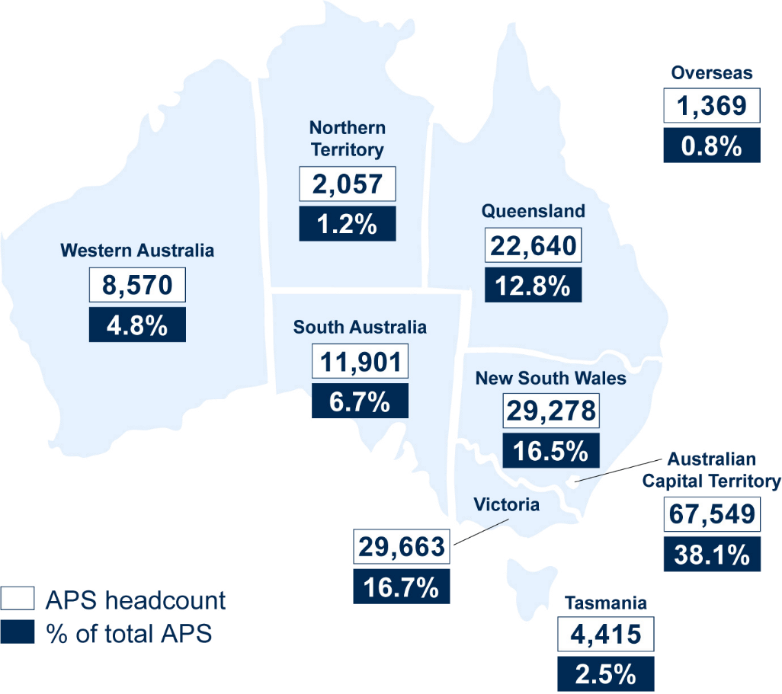

Source: Australian Public Service Commission, as at 31 December 2023 (headcount)

The Government’s investments in service delivery are essential to rebuild a fit‑for‑purpose public service that is resourced to deliver the services Australians expect. This has demonstrated clear benefits, including:

* clearing the 41,799 backlog of veteran’s compensation claims in the Department of Veterans’ Affairs, which are now all allocated for processing
* resolving 500,000 claims from Services Australia’s claims backlog in just ten weeks due to 3,000 additional staff funded in the 2023–24 Mid‑Year Economic and Fiscal Outlook (MYEFO)
* increasing compliance activity through more NDIS Quality and Safeguards Commission staff, resulting in additional banning orders being applied to disability support providers doing the wrong thing
* blocking more than 300,000 attempts by cyber criminals to use Australians’ stolen identity documents through investments in the Credential Protection Register.

|  |
| --- |
| Investing in the Department of Veterans’ Affairs  The Government’s investment in the public service is supporting veterans and their families. The *Royal Commission into* *Defence and Veteran Suicide* interim report found that the previous Government’s ASL cap led to more labour hire staff, higher staff turnover rates and, consequently lower proficiency among claims processing staff. Veterans were negatively affected by lower overall levels of staff proficiency through reduced corporate knowledge, greater chance of mistakes, and reduced efficiency; resulting in claims processing delays. Poor experiences of the claims processing systems were found to have had serious impacts on the mental health outcomes of veterans.  In responding to the interim report, the Government injected significant resourcing into the Department of Veterans’ Affairs—including 500 ongoing ASL in the 2022–23 October Budget and a further $82.7 million in the 2023–24 Budget to help clear the claims backlog and provide increased support to veterans during the claims process.  The support to veterans and their families continues in the 2024–25 Budget with a further investment of $186 million over four years from 2024–25, and $20.6 million ongoing from 2028–29 to reduce the time taken to process claims and to meet service delivery pressures now that the Department of Veterans’ Affairs has cleared the claims backlog.  Payments to veterans are expected to increase by $6.5 billion over five years from 2023–24 due to more claims being processed because of increased staffing levels that the Government has agreed in order to deliver on its commitment to clear the backlog. |

Alongside boosting frontline service delivery, the Government is also investing in the public service to enable delivery of new and improved digital solutions to improve essential services for Australians, aligned with the vision of simple, secure and connected public services set out in the Data and Digital Government Strategy.

These platforms, such as myGov with over 26 million active accounts and an average of 840,000 sign‑ins every day, provide Australians with a central place, and easy access to the government services they need with the confidence that their data is safe.

|  |
| --- |
| Investing in digital health solutions  The Government’s investments in the Australian Digital Health Agency are providing support to patients and health care providers, improving secure access to the clinical information they need in a broader range of settings and through new innovative products such as the My Health App and Provider Connect Australia, improving health outcomes for Australians.  The use of digital health infrastructure has seen the proportion of specialists registered to use the My Health Record more than double, increasing from 18 per cent to 48 per cent, between December 2021 and December 2023. Registrations for residential aged care providers has also grown significantly, from 13 per cent to 33 per cent for the same period.  Driven by the share‑by‑default agenda, announced as a part of the Strengthening Medicare Taskforce, significant growth in usage is also seen in pathology and diagnostic imaging. There was a 173 per cent growth in reports uploaded between December 2021 and December 2023, with a peak of over 3 million combined pathology and diagnostic imaging reports uploaded in a single week in March 2024. |

The Government is expanding the Digital ID System to provide a secure, convenient, voluntary and inclusive way for people to verify their identity online. Once a person has a Digital ID, they will no longer have to provide copies of their ID documents to businesses or government to verify who they are, and businesses will no longer have to store this information reducing the risks and impacts of data breaches and cyber‑attacks. More than 12 million Australians already have a myGovID.

The Government’s investment in the National Anti‑Scam Centre has helped reverse the long‑term trend of rising losses to scams, with Australians reporting 13.1 per cent, or $400 million, fewer losses in 2023 compared to 2022.

The Government has also invested in integrity measures across the public service to ensure a harmful failure like the Robodebt Scheme can never happen again. This includes establishing the National Anti‑Corruption Commission and investing in the new Administrative Review Tribunal (to replace the Administrative Appeals Tribunal). It also involves addressing the issues raised by the Royal Commission into the Robodebt Scheme, including enhancing the quality of legal advice to the Cabinet, re-establishing the Administrative Review Council and providing additional capacity for the Office of the Commonwealth Ombudsman to handle complaints and undertake investigations of systemic issues.

The 2024–25 Budget includes further investments in the public service to improve service delivery and support Australians, including investment in essential public service staff in:

* Services Australia to ensure Australians can access critical payments; enhance the ongoing safety and security arrangements for customers and staff; and put myGov on a more sustainable footing
* the Department of Veterans’ Affairs to increase claims processing capabilities to meet increased demand so veterans receive services faster and when they need it
* the Department of Health and Aged Care and the Aged Care Quality and Safety Commission to support implementing the New Aged Care Regulatory Framework and finalise the Commonwealth response to the Final Report of the *Capability Review of the Aged Care Quality and Safety Commission*
* the Department of Health and Aged Care to strengthen Medicare, facilitate a sustainable ongoing national response to COVID‑19, and secure primary health care services in rural and remote Australia
* the Department of Social Services to support the operation of the National Redress Scheme for survivors of institutional child sexual abuse
* the Department of Employment and Workplace Relations to progress critical employment services reform through strengthening integrity, establishing independent compliance mechanisms; and uplifting online capability to meet increased demand for Workforce Australia online services and telephone enquiries
* the National Indigenous Australians Agency to establish the Remote Jobs and Economic Development Program, which will create 3,000 jobs in remote Australia and assist income support recipients move into paid employment over five years
* the Australian Taxation Office to increase capability to bolster tax compliance and protect our taxation and superannuation systems against fraud
* the Department of Finance, Services Australia, the Australian Taxation Office, and supporting agencies including regulators to expand the Digital ID system to advance Australia’s digital economy
* the Australian Digital Health Agency to deliver new digital solutions to improve service delivery and increase growth of My Health Record.

|  |
| --- |
| Investing in Services Australia  An injection of over 4,000 permanent frontline staff into Services Australia is ensuring Australians can get the help they need, when and where they need it. Investment in these services has reduced wait times for Australians accessing important services and payments, including JobSeeker, Paid Parental Leave, and PBS Safety Net claims.  This has seen a backlog of 500,000 Centrelink and Medicare claims significantly reduced in just ten weeks, meaning more financial supports are getting to Australians dealing with cost‑of‑living pressures. These new recruits work in smart centres in capital cities and regional centres, including Port Macquarie and Coffs Harbour in New South Wales, Toowoomba and Maryborough in Queensland, and Ballarat and the LaTrobe Valley in Victoria.  With the support of additional funding, including $2.8 billion in the 2024–25 Budget, Services Australia is modernising its face‑to‑face services, improving service standards, extending its emergency response capability, enhancing safety and security for customers and staff and sustaining the myGov platform. |

### Investing in the public service to secure our region, build resilience and protect Australians

The public service provides essential support to Australians, both at home and internationally, in times of need and crisis. The Government remains committed to defence and national security and is responding to the most challenging strategic circumstances Australia has faced since the Second World War. Investments across the Defence, Home Affairs, Attorney‑General’s and Foreign Affairs portfolios have an important role to play in securing our region and protecting Australians.

|  |
| --- |
| Investing in the public service to deliver AUKUS  The public service has a vital role in delivering the 2024 National Defence Strategy and the Integrated Investment Plan*.* AUKUS Pillars I and II will require a highly skilled and specialised APS and industry workforce to deliver new and accelerated defence capability.  The recently established Australian Submarine Agency will create 900 new public service jobs by 2026–27 to support the delivery of a conventionally‑armed nuclear‑powered submarine capability for Australia, with significant flow on benefits for Australian jobs within defence industry.  As part of the investment in AUKUS Pillar II, Defence will establish the Advanced Strategic Capabilities Accelerator to rapidly translate innovative and advanced technologies into defence capabilities. Complementing this, public service staff are working with international counterparts and industry on delivering AUKUS Pillar II, accelerating the development and delivery of advanced military capabilities. |

|  |
| --- |
| Investing in cyber security  The Government has made significant investments in cyber security over the past two years, including as part of the Cyber Security Strategy in the 2023–24 MYEFO. Cyber security is an urgent national problem that touches the lives of every Australian, with one cybercrime reported every six minutes on average.  Investments in the Department of Home Affairs, including the establishment of the National Cyber Security Coordinator, means the public service is able to work across the economy to manage and recover from major cyber incidents. Work is also underway to strengthen Australia’s critical national infrastructure by working with industry, including telecommunication providers, hospitals and banks, to better protect infrastructure from attacks and make it more resilient.  Additional investments in the Counter Foreign Interference Taskforce are supporting work to counter foreign interference in Australia, helping to disrupt foreign interference and espionage threats to Australians at home. |

Investments in the public service have also supported the Government to better protect our environment, build disaster resilience and preparedness, and back our farmers.

The 2024–25 Budget includes further investments in the public service to secure the region, build resilience and protect Australians, including investment in essential public service staff in the:

* Australian Federal Police, for capabilities such as training, cyber investigations and protective security services, including federal policing at Western Sydney International Airport
* National Emergency Management Agency to ensure the Agency can continue to deliver on the Government’s crisis management activities, including disaster resilience, preparedness and responding to communities in need
* Department of Agriculture, Fisheries and Forestry to support effective delivery of drought and climate resilience outcomes through the Future Drought Fund
* Department of Climate Change, Energy, the Environment and Water to sustain water policy functions and to expand the oversight and independence functions of the Inspector‑General of Water Compliance.

### Investing in the public service to manage the economic transformation

The future made in Australia agenda lays the foundations of an ambitious strategy to secure the nation’s future prosperity and resilience as we confront the challenges of the clean energy transition and emerging technologies.

After a decade of delay and inaction on the clean energy transition, the Government has had to rebuild the public service’s capability to manage the economic transformation required to effectively address climate change and deliver the required energy transition.

|  |
| --- |
| Rebuilding capability in the public service to effectively address climate change and support the energy transition  After the 2022 election, the Government established the Department of Climate Change, Energy, the Environment and Water—a department of state that was abolished by the previous Government. The Government has resourced the Department to play an important role in powering Australia with cheaper, cleaner and more reliable energy; with the public service playing a critical role in supporting the net zero industry and job creation. This includes introducing legislation to establish the Net Zero Economy Authority to help guide the net zero transformation. The Department has delivered significant policies and programs to drive Australian climate action, to transform our energy system to deliver cheaper, more reliable power, and to conserve, protect and sustainably manage our environment and water resources.  Over successive Budgets, investments in the Department of Climate Change, Energy, the Environment and Water has enabled the Department to reduce its reliance on contractors from 22.5 per cent of the total workforce in September 2022 to 10.6 per cent currently. Reliance on external consultancies by the Department has fallen by over 40 per cent in the first half of 2023–24 compared to the same period in 2022–23. |

|  |
| --- |
| Delivering the Nature Positive Plan  The Government’s investments in the Department of Climate Change, Energy, the Environment and Water have sped up environmental approval decisions under the *Environmental Protection and Biodiversity Conservation Act 1999*, with 84 per cent of approvals considered within the statutory timeframe, up from 46 per cent on average under the previous Government. Rebuilding the capacity of the public service will also facilitate renewable and clean energy projects.  These investments are part of the Government’s Nature Positive Plan, which also includes establishing an independent Environment Protection Australia to improve confidence in decision‑making, and Environment Information Australia, to ensure high quality environmental data is available to facilitate timely and transparent decision‑making. |

The 2024–25 Budget makes further investments in Australia’s economic future, including investment in essential public service staff in:

* the Department of Industry, Science and Resources and the Department of Climate Change, Energy, the Environment and Water to advance Australia’s plans to become a renewable energy superpower, including expanding the Hydrogen Headstart program, delivering the 2024 National Hydrogen Strategy and foundational and policy initiatives to expedite the development of Australia’s green metals and critical minerals industries
* the Department of Climate Change, Energy, the Environment and Water to implement priority reforms to improve social licence for the energy transition and remove regulatory impediments for renewable energy projects
* Geoscience Australia to provide specialised capabilities in pre-competitive geoscience data collection and analysis of ground water systems and resources to support increases in industry investment
* the Department of Foreign Affairs and Trade and the Department of Finance to support the establishment of a Domestic National Interest Account, to support, as required, investments consistent with the future made in Australia agenda
* the Department of the Treasury to coordinate the development of the future made in Australia legislation and associated policy frameworks, including a new National Interest Framework and Community Benefit Principles. A Treasury taskforce will also lead consultation on a new ‘front door’ for major projects, which will streamline how investors and business interact with the Government, helping them navigate approvals processes and fast‑track major projects where possible.

### Working for Australia

The Government recognises that you cannot deliver outcomes for Australians without the foundations of a strong public service. After almost a decade of outsourcing, reduced service outcomes and underinvestment, the Government has invested in the public service to ensure it is best placed to do the job the Australian people expect.

The 2024–25 Budget delivers cost‑of‑living help and builds a future made in Australia. The Budget helps ease the pressures people are under today and invests in a stronger and more resilient economy. The Government remains committed to delivering quality services, securing our region, and building a stronger economy for all Australians.

An appropriately‑resourced public service is critical to delivering on the investments made in the 2024–25 Budget to grow Australia’s future prosperity.

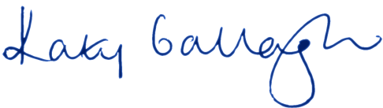

Senator the Hon Katy Gallagher

Minister for Finance

Minister for Women

Minister for the Public Service

1. The General Government Sector provides public services that are mainly non‑market in nature and for the collective consumption of the community or involve the transfer or distribution of income. These services are largely financed through taxes and other compulsory levies, user charging and external funding (Budget 2024–25, Budget Paper No. 1, *Statement 10, Appendix A*).