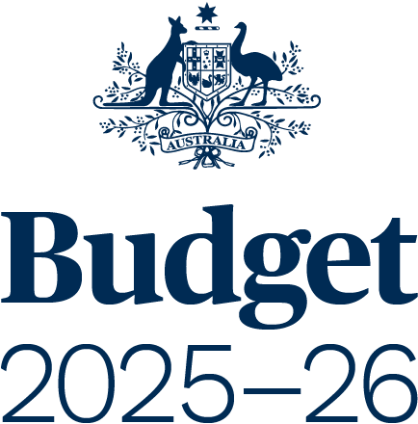

BUDGET STRATEGY AND OUTLOOK
BUDGET PAPER NO. 1

Circulated by
The Honourable Jim Chalmers MP
Treasurer of the Commonwealth of Australia
and
Senator the Honourable Katy Gallagher
Minister for Finance, Minister for Women, Minister for the Public Service,
Minister for Government Services of the Commonwealth of Australia

For the information of honourable members
on the occasion of the Budget 2025–26
25 March 2025

© Commonwealth of Australia 2025
ISSN 0728 7194 (print); 1326 4133 (online)
This publication is available for your use under a Creative Commons Attribution 4.0 International licence, with the exception of the Commonwealth Coat of Arms, third-party content and where otherwise stated. The full licence terms are available from http://creativecommons.org/licenses/by/4.0/legalcode.

Use of Commonwealth of Australia material under Creative Commons Attribution 4.0 International licence requires you to attribute the work (but not in any way that suggests that the Commonwealth of Australia endorses you or your use of the work).
Commonwealth of Australia material used ‘as supplied’.
Provided you have not modified or transformed Commonwealth of Australia material in any way including, for example, by changing the Commonwealth of Australia text; calculating percentage changes; graphing or charting data; or deriving new statistics from published statistics – then the Commonwealth of Australia prefers the following attribution:
Source: The Commonwealth of Australia.
Derivative material
If you have modified or transformed Commonwealth of Australia material, or derived new material from those of the Commonwealth of Australia in any way, then the Commonwealth of Australia prefers the following attribution:
Based on Commonwealth of Australia data.
Use of the Coat of Arms
The terms under which the Coat of Arms can be used are set out on
the Department of the Prime Minister and Cabinet website
(see www.pmc.gov.au/honours-and-symbols/commonwealth-coat-arms).
Other uses
Enquiries regarding this licence and any other use of this document are welcome at:
Manager
Media Unit
The Treasury
Langton Crescent
Parkes ACT 2600
Email: media@treasury.gov.au
Internet
A copy of this document is available on the central Budget website at: www.budget.gov.au.
Printed by CanPrint Communications Pty Ltd.
Contents
Statement 1: Budget Overview 1
Economic and Fiscal Outlook 5
Budget Priorities 11
Statement 2: Economic Outlook 33
Outlook for the international economy 37
Outlook for the domestic economy 42
Statement 3: Fiscal Strategy and Outlook 53
Economic and Fiscal Strategy 58
Fiscal outlook 62
The Government’s balance sheet 76
Fiscal impacts of the net zero transformation 80
Appendix A: Other fiscal aggregates 85
Statement 4: Revenue 89
Overview 93
Variations in receipts estimates 95
Variations in revenue estimates 104
Appendix A: Tax Expenditures 107
Statement 5: Expenses and Net Capital Investment 111
Overview 115
Estimated expenses by function 117
General government sector expenses 121
Appendix A: Expense by function and sub-function 150
Statement 6: Debt Statement 153
Australian Government Securities issuance 157
Estimates of AGS on issue 157
Changes in AGS on issue since the 2024–25 MYEFO 159
Breakdown of AGS currently on issue 159
Non-resident holdings of AGS on issue 162
Net debt 162
Interest on AGS 164
Statement 7: Forecasting Performance and Sensitivity Analysis 167
Assessing past forecasting performance 171
Assessing forecast uncertainty – confidence interval analysis 178
Assessing current forecasts through sensitivity analysis 184
Statement 8: Statement of Risks 189
Overview 193
Agriculture, Fisheries and Forestry 202
Attorney-General’s 203
Climate Change, Energy, the Environment and Water 205
Defence 209
Employment and Workplace Relations 212
Finance 215
Foreign Affairs and Trade 220
Health and Aged Care 222
Home Affairs 226
Industry, Science and Resources 230
Infrastructure, Transport, Regional Development, Communications and the Arts 234
Prime Minister and Cabinet 240
Social Services 241
Treasury 243
Veterans’ Affairs 250
Government loans 251
Statement 9: Australian Government Budget Financial Statements 267
Notes to the general government sector financial statements 286
Appendix A: Financial reporting standards and budget concepts 302
Appendix B: Assets and Liabilities 310
Statement 10: Historical Australian Government Data 327
Data sources 331
Comparability of data across years 331
Revisions to previously published data 333
Notes 355

