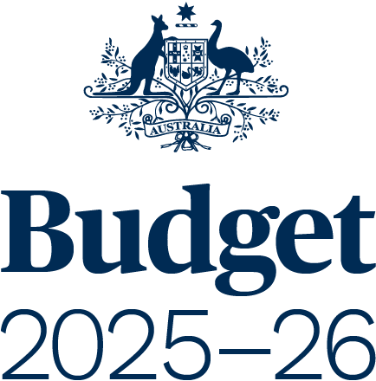

AGENCY RESOURCING
BUDGET PAPER NO. 4

Circulated by
Senator the Honourable Katy Gallagher
Minister for Finance, Minister for Women, Minister for the Public Service,
Minister for Government Services of the Commonwealth of Australia

For the information of honourable members
on the occasion of the Budget 2025–26
25 March 2025

© Commonwealth of Australia 2025
ISSN 0728 7194 (print); 1326 4133 (online)
This publication is available for your use under a Creative Commons Attribution 4.0 International licence, with the exception of the Commonwealth Coat of Arms, third-party content and where otherwise stated. The full licence terms are available from http://creativecommons.org/licenses/by/4.0/legalcode

Use of Commonwealth of Australia material under a Creative Commons Attribution 4.0 International licence requires you to attribute the work (but not in any way that suggests that the Commonwealth of Australia endorses you or your use of the work).
Commonwealth of Australia material used ‘as supplied’.
Provided you have not modified or transformed Commonwealth of Australia material in any way including, for example, by changing the Commonwealth of Australia text; calculating percentage changes; graphing or charting data; or deriving new statistics from published statistics – then the Commonwealth of Australia prefers the following attribution:
Source: The Commonwealth of Australia.
Derivative material
If you have modified or transformed Commonwealth of Australia material, or derived new material from those of the Commonwealth of Australia in any way, then the Commonwealth of Australia prefers the following attribution:
Based on Commonwealth of Australia data.
Use of the Coat of Arms
The terms under which the Coat of Arms can be used are set out on
the Department of the Prime Minister and Cabinet website (see www.pmc.gov.au/government/commonwealth-coat-arms).
Other uses
Enquiries regarding this licence and any other use of this document are welcome at:
Manager
Media Unit
The Treasury
Langton Crescent
Parkes ACT 2600
Email: media@treasury.gov.au
Internet
A copy of this document is available on the central Budget website at: www.budget.gov.au.
Printed by CanPrint Communications Pty Ltd.

Contents
Acronyms and notes v
Preface 3
Introduction and guide to Budget Paper No. 4 15
Part 1: Agency Financial Resourcing 23
Agency Resourcing Table 28
Special Appropriations Table 110
Special Accounts Table 124
Part 2: Staffing of Agencies 151
Part 3: Expenses and Net Capital Investment 167
Appendix A: Agency Outcome Statements 177

Acronyms and notes
AAO | Administrative Arrangements Order
AAS | Australian Accounting Standards
AASB | Australian Accounting Standards Board
ABS | Australian Bureau of Statistics
Agency/entity | Has the same meaning as Commonwealth entity within the Public Governance, Performance and Accountability Act 2013
APS | Australian Public Service
ASL | Average Staffing Level
CRF | Consolidated Revenue Fund
FBO | Final Budget Outcome
Finance Minister | Minister for Finance
GFS | Government Finance Statistics
GGS | General Government Sector
IMF | International Monetary Fund
MoG | machinery of government
PGPA Act | Public Governance, Performance and Accountability Act 2013
SPPs | Specific Purpose Payments
The following notations are used in this Budget Paper:
- | nil estimates of expenditure
na | not applicable (unless otherwise specified)
$m | millions of dollars
$b | billions of dollars

