Part 2: Economic Outlook

Overview
The Australian economy is gathering momentum against the backdrop of heightened global uncertainty. Growth and the private sector recovery are strengthening, unemployment is low, participation is near record highs, employment continues to grow, business investment and real household incomes are growing again. While the Australian economy has not been immune to global economic challenges, it is one of the best placed economies to manage them.
The global economic outlook is complex and uncertain and risks are tilted to the downside. Global trade disruptions, conflict and geopolitical tensions remain major headwinds. Several major advanced economies face the potential of persistently higher inflation and there are concerns about fiscal sustainability for some advanced economies.
The effective tariff rate on imports into the United States (US) increased sharply in 2025. This has precipitated some shifts in global trade patterns, while the longer-term effects of structurally higher tariffs are yet to be fully realised. The tariff rate on imports of Australian goods into the US remains low compared to the rates facing many other advanced economies, with most goods subject to a baseline tariff of 10 per cent.
Despite these global challenges, the Australian economy is strengthening and the private sector recovery is now broader and stronger. Growth in real GDP, which was 1.4 per cent in 2024–25, is forecast to increase to 2¼ per cent in 2025–26 and in 2026–27.
Private demand has resumed as the primary driver of economic growth and this is expected to continue over the forecast period. Household consumption is forecast to strengthen over the next two years, underpinned by ongoing growth in real household disposable income. Business investment picked up sharply in the September quarter 2025 and is forecast to grow by 3 per cent in 2025–26 and 1½ per cent in 2026–27. Non-mining business investment is forecast to grow strongly and reach its highest level on record by the end of the forecast period. Businesses are continuing to invest in digitising their operations and expanding their productive capacity. Investment in wind, solar and battery projects is growing in support of the renewable energy transition. Dwelling investment is forecast to grow by a strong 5½ per cent in 2025–26, supported by lower borrowing costs and robust housing demand.
Growth in public demand is expected to ease over the coming years, with public demand expected to grow at a lower rate than private demand. Growth in public final demand is forecast to moderate from 4.4 per cent in 2024–25 to 2¾ per cent in 2025–26 and 2¼ per cent in 2026–27. This reflects the phasing in of structural reforms to some demand-driven Commonwealth programs and lower expected growth in consumption and investment by state and territory governments.
Headline and underlying inflation are substantially below their peaks. While inflation has recently increased to be above the Reserve Bank of Australia’s (RBA) target band, this can be partly attributed to temporary factors, such as the cessation of state electricity rebate schemes, large increases in council property rates, and increases in the prices of volatile items such as fuel and travel. However, increases in services inflation and the prices of newly constructed dwellings are expected to be more persistent and are in line with the sustained recovery in demand. The recent increase in inflation is similar to the experiences of many advanced economies.
Excluding the effect of rebates and fuel, inflation is expected to return sustainably to the target band by the end of 2026. The moderation in inflation has been achieved while preserving post-pandemic gains in employment and labour force participation. This differs from previous inflationary episodes in Australia in the 1980s and 1990s and recent experience in some advanced economies, such as Canada and New Zealand, where efforts to curb inflation have coincided with larger rises in the unemployment rate.
Conditions in the labour market are expected to remain solid. The unemployment rate has increased gradually, but is forecast to remain low by historic standards, at around 4½ per cent in 2025–26 and 2026–27. Employment is expected to grow by 1¼ per cent in 2025–26 and 1½ per cent in 2026–27. The labour force participation rate is forecast to remain at around 67 per cent, which is close to its recent record highs.
Wages growth is forecast to remain above pre-pandemic averages. The Wage Price Index is forecast to grow by 3¼ per cent in 2025–26 and 2026–27. Annual real wages have grown for eight consecutive quarters, the longest consecutive run of annual real wages growth in almost a decade. While the recent increase in inflation is likely to result in a slight decline in real wages in 2025–26, real wages are expected to grow again in 2026–27.
There are a range of risks to the outlook for the Australian economy, many of which are related to potential global developments. Trade tensions could increase further, fragmenting supply chains, increasing input and end-user costs, and weighing on global growth. The risk of persistent inflation in advanced economies could lead to monetary policy having to remain tighter, which would also constrain growth.
More stable trade settings would create more confidence around supply chains, which would help support higher investment, particularly in Southeast Asia. Greater use of and improvements in artificial intelligence technology could also provide a boost to global productivity and growth.
There are also domestic sources of risk. If households’ real incomes grow at a slower pace, the pick-up in consumption and private final demand could be slower. Conversely, if the recent pick-up in business investment is sustained, it could boost the productive capacity of the economy. There is also potential for higher mining investment as firms look to capitalise on recent increases in gold prices by expanding operations or opening new mines.

International economic outlook
Since early 2025, the global economic outlook has become increasingly complex and uncertain. Global trade settings have changed significantly. Although the full effects of evolving trade policy settings – both by the US and other economies – are yet to be felt, trade flows have been affected. A shift towards a less efficient global trading system can be expected to create headwinds for the global economy. Reflecting this, global growth is forecast to remain low by historical standards at 3 per cent in 2025 and is then expected to recover slightly to 3¼ per cent in 2026 and 2027 (Table 2.1).
Table 2.1: International GDP growth forecasts^{(a)}
 | Outcomes | Forecasts (Calendar Years)
 | 2024 | 2025 | 2026 | 2027
Australia | 1.1 | 2 | 2 1/2 | 2 1/4
China | 5.0 | 5 | 4 3/4 | 4 1/2
India | 6.7 | 6 1/2 | 6 1/2 | 6 1/2
Japan | 0.1 | 1 | 3/4 | 3/4
United States | 2.8 | 1 3/4 | 1 3/4 | 2
Euro area | 0.9 | 1 | 1 | 1 1/2
United Kingdom | 1.1 | 1 | 1 | 1 1/4
Other East Asia^{(b)(c)} | 4.4 | 3 3/4 | 3 3/4 | 4
Major trading partners^{(b)} | 3.4 | 3 1/2 | 3 1/4 | 3 1/2
World^{(b)} | 3.3 | 3 | 3 1/4 | 3 1/4
- Percentage change on previous year.
- World and Other East Asia growth rates are calculated using GDP weights based on purchasing power parity (PPP). Growth rates for major trading partners are calculated using Australian goods and services export trade weights.
- Other East Asia comprises Indonesia, Malaysia, the Philippines, Thailand, Vietnam and Singapore, along with Hong Kong, South Korea and Taiwan.
Source: National statistical agencies, IMF, Refinitiv and Treasury.

Countries face headline tariff rates of at least 10 per cent on nearly all exports to the US (Table 2.2). Tariffs are likely to weigh more heavily on growth in economies that are more export-oriented, such as Japan, the Republic of Korea (South Korea) and Germany. Economies in Southeast Asia that are deeply integrated into global manufacturing production chains, such as Vietnam, may also experience weaker growth. However, this could be partially offset by firms seeking to relocate production in response to recent changes to trade policy settings.
Inflation remains above central bank targets in many advanced economies, including the US, the United Kingdom (UK), and Japan. Inflation has also recently increased to the top of the Reserve Bank of New Zealand’s target band (Charts 2.1 and 2.2). Persistently elevated inflation is creating more difficult trade-offs for monetary policy, particularly as a number of advanced economies are now also slowing and experiencing an easing in labour market conditions.
In the US and the UK, services inflation remains sticky, which is limiting central bank efforts to lower headline inflation rates towards their targets. Following a period of post-pandemic goods price deflation, goods prices in both economies have recently begun to increase again, contributing to higher headline inflation. In the US, tariffs have contributed to goods price inflation, which has increased from around zero in May 2025 to around 2 per cent in September 2025. In the UK, goods inflation largely reflects higher food and energy prices, while elevated wages growth is contributing to more persistent services inflation.
In Canada, the impact of policy measures, like the removal of the consumer carbon tax, has pushed inflation close to the middle of the Bank of Canada’s target band. However, core measures of inflation have remained around the top of their target band for much of 2025.
Table 2.2: Selected headline tariff rates applied by the United States
Economy | Headline tariff rate (per cent)
Australia | 10
United Kingdom | 10
European Union | 15
Republic of Korea (South Korea) | 15
Japan | 15
China | 20
Vietnam | 20
Taiwan | 20
Mexico | 25
Canada | 35
India | 50
Source: Treasury
Note: The above figures are not effective tariff rates, as they exclude sector-specific measures imposed by the US. For instance, steel and aluminium are subject to additional tariffs, whereas many agricultural products are not subject to duties under the new US tariff framework.

Chart 2.1: Headline inflation in economies with 2 per cent targets | Chart 2.2: Inflation in economies with 1 to 3 per cent target bands
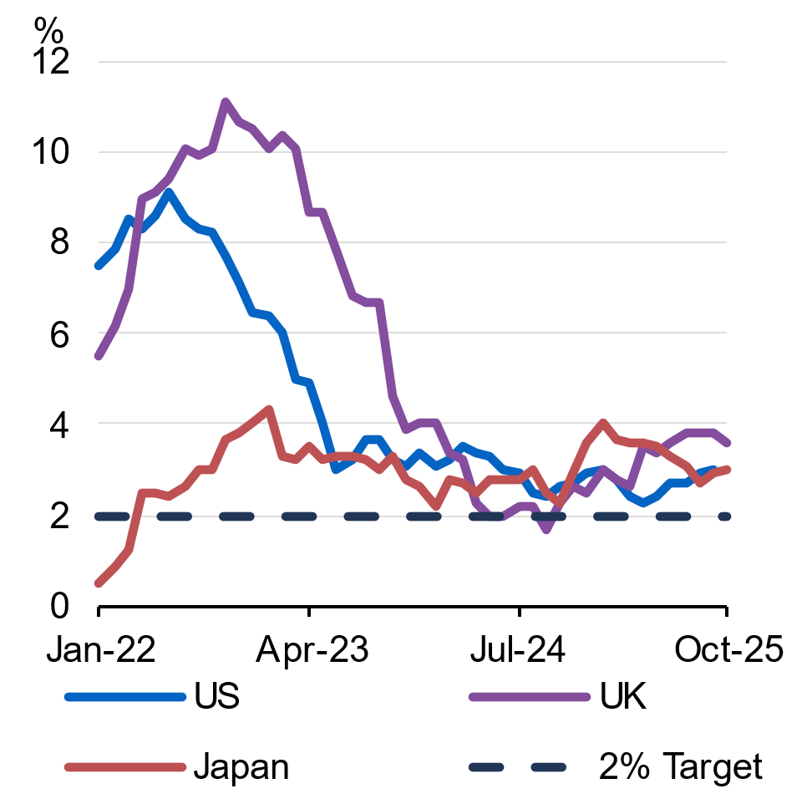 | 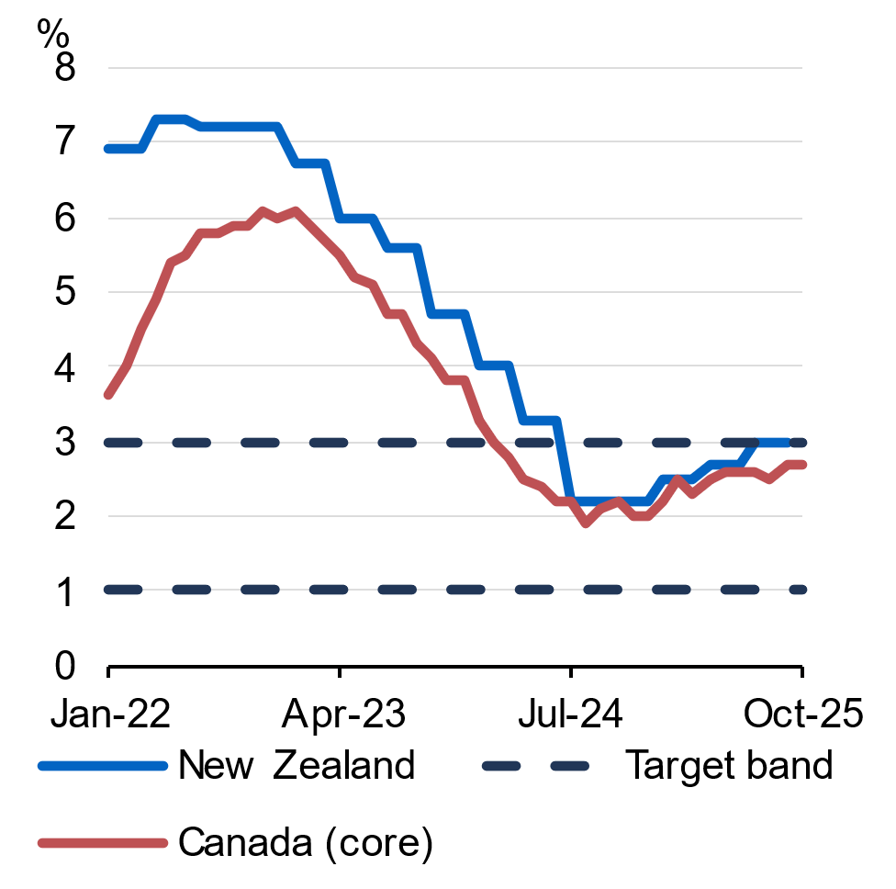
Source: National statistical agencies, LSEG and Treasury. | Source: National statistical agencies, LSEG and Treasury.

The US economy has remained resilient following the imposition of wide-ranging tariffs, and is forecast to grow by 1¾ per cent in 2025 and 2026, and 2 per cent in 2027. The 43-day government shutdown that commenced on 1 October is expected to weigh heavily on growth towards the end of 2025, but a moderate rebound is expected in early 2026. Fiscal policy is also expected to provide moderate support to growth in 2026.
While inflation has eased from its 2022 peak, it remains persistently above the US Federal Reserve’s target of 2 per cent and has recently begun to increase. At the same time, employment growth has eased to 1.1 per cent through the year to September 2025. This shift in labour market conditions prompted the Federal Reserve to re-commence easing monetary policy in September, and subsequently ease policy further in October and December.
China’s economy is forecast to slow over the period ahead. Growth is forecast to meet the official target of ‘around 5 per cent’ this year and then moderate to 4¾ per cent in 2026 and 4½ per cent in 2027 as the economy contends with weak household demand, declining investment, and the ongoing fall-out from intensifying trade and geopolitical tensions, particularly with the US (see Box 2.1).
Conditions in the euro area economy have improved modestly since the middle of 2025. Inflation remains close to the European Central Bank’s target of 2 per cent, and is expected to remain consistent with this target over the forecast period. Real GDP is forecast to grow by 1 per cent in 2025 and 2026, and by 1½ per cent in 2027. Higher growth in economic activity later in the forecast period is expected to be supported by increased government spending, including on infrastructure (particularly in Germany).
Recent trade negotiations between the US and the European Union have resulted in lower US tariffs imposed on imports from the EU compared to those announced in April. These negotiations have also preserved access for European agriculture and certain manufactured products to the US market, although tariffs on steel and aluminium remain high.
Growth in the UK is expected to remain subdued and is forecast to grow by 1 per cent in 2025 and 2026, and by 1¼ per cent in 2027. In part, the subdued growth is due to tighter fiscal policy. High public debt remains a concern for the government and investors, with gilt yields proving sensitive to political and policy developments.
In the context of weak growth and a softening labour market, recent inflation outcomes in the UK continue to complicate the Bank of England’s task in setting monetary policy. Annual inflation in the UK increased from 1.7 per cent in September 2024 to 3.6 per cent in October 2025, while core inflation was 3.4 per cent through the year to October 2025. The higher rate of inflation also reflects the unsustainable rate of wages growth which, despite a softening labour market, remains elevated.
Japan’s economy is expected to navigate global trade headwinds successfully and is forecast to grow by 1 per cent in 2025 and ¾ of a per cent in 2026 and 2027. After years of anaemic economic growth and deflation, inflation has now exceeded the Bank of Japan’s 2 per cent target for nearly four years and recent data suggest that higher inflation could remain stickier for longer than previously expected. Inflation in utilities prices has increased as government subsidies have ended. Acute labour shortages are pushing up wages and stronger demand has provided businesses scope to pass on higher costs. Persistent inflationary pressures are expected to result in the Bank of Japan raising interest rates further in the near term.
India is expected to remain the world’s fastest growing major economy over the forecast period. Real GDP growth is forecast to be 6½ per cent in 2025, 2026 and 2027 due to strength in private consumption, government-supported infrastructure projects, capital investment, and a growing labour force. Inflation has remained below target for much of 2025, which is largely due to falls in food prices.
Other East Asia is forecast to grow by 3¾ in 2025 and 2026, and by 4 per cent in 2027. While Vietnam and other emerging economies could benefit from shifting trade patterns, growth in Taiwan and the Republic of Korea (South Korea) could moderate if easing Chinese demand and heightened trade risks weigh on these export-oriented economies.
Box 2.1: The outlook for the Chinese economy
The Chinese economy faces a number of significant internal and external challenges, although growth has been resilient to date. Chinese exports supported activity in early 2025 as US businesses brought forward orders in expectation of higher tariffs. After these were imposed, falls in US exports were largely offset by exports to alternative markets (Chart 2.3). Following the brief escalation of tensions in October, the subsequent trade agreement between the US and China should bring some near-term stability to trade flows.
Households have been incentivised to spend more on durable goods in 2025 through a trade-in program for vehicles and appliances. However, this is not expected to have a lasting effect on consumption. Real incomes are growing below pre-pandemic rates, and declining property prices have reduced household wealth. This weakness has contributed to Chinese tourist arrivals to Australia and the stock of Chinese students not yet recovering to pre-pandemic levels (Chart 2.4).
Investment also continues to shift away from the real estate sector to high-tech manufacturing, including electric vehicles and semiconductors. Although part of a long-term plan to develop new growth drivers, there has been a broad-based contraction in fixed asset investment through the year to October 2025. This prompted authorities to announce policies to support infrastructure investment.
Beyond these near-term challenges, the Chinese economy faces structural headwinds including a slowing urbanisation rate, and an ageing and shrinking population. These could keep growth below recent averages.
continued on next page

Box 2.1: The outlook for the Chinese economy (continued)
Chart 2.3: Chinese export values | Chart 2.4: 2025 student stock and visitor arrivals as share of the corresponding month in 2019
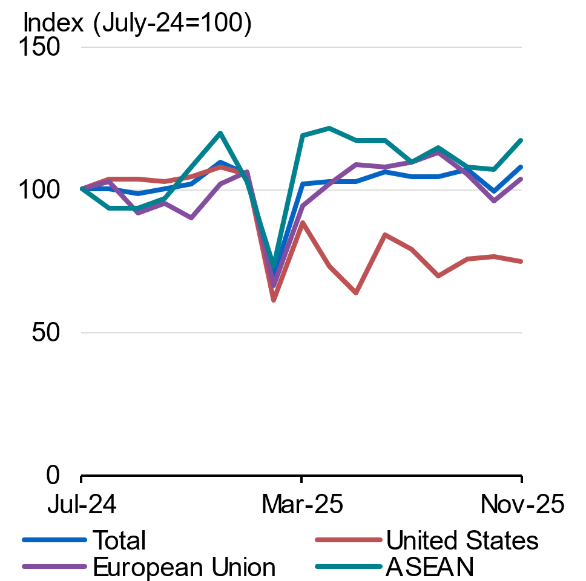 | 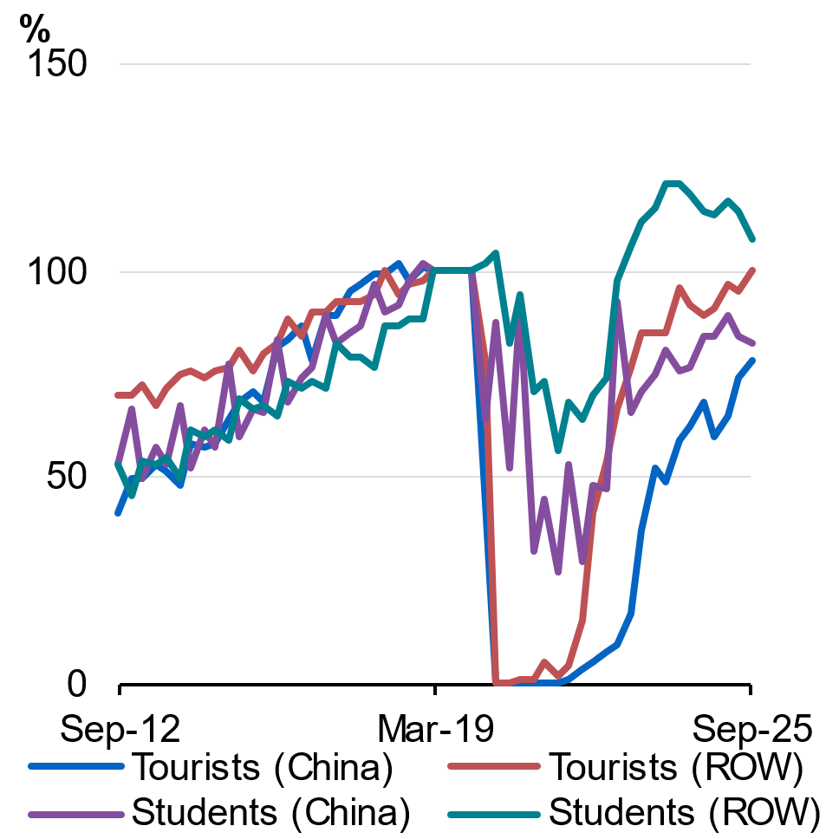
Source: General Administration of Customs China and LSEG Workspace. | Source: ABS Overseas Arrivals and Departures, Department of Home Affairs and Treasury.  Note: Visitor arrivals calculated as quarterly moving average. ROW is Rest of World.

Domestic economic outlook
The Australian economy is gathering momentum in the face of substantial global headwinds (Chart 2.5). Real GDP grew 1.4 per cent in 2024–25 and in through-the-year terms was 2.1 per cent in September quarter 2025, the fastest pace in two years. Real GDP growth is forecast to pick up to 2¼ per cent in both 2025–26 and 2026–27 (Table 2.3).
Private final demand has contributed more to GDP growth than public final demand for four consecutive quarters and it is forecast to remain the major driver of GDP growth (Chart 2.6). Growth in private final demand is forecast to more than double from 1.2 per cent in 2024–25 to 3 per cent in 2025–26. Growth in household consumption is forecast to pick up over 2025–26. This in part reflects robust growth in real household disposable income, which grew by 4.1 per cent in 2024–25 due to a combination of real wages growth, employment growth, tax cuts, and lower interest rates.
Private investment is strengthening. Business investment grew at its fastest rate in nearly five years in the September quarter. Business investment has been supported by investment in data centres, computer software and renewable energy. Lower borrowing costs, rising private demand and elevated capacity utilisation are expected to continue to support business investment going forward. Growth in dwelling investment has also picked up and momentum is expected to be supported by lower financing costs.
Public final demand played an important role in supporting growth, while private demand was subdued. Private demand is picking up and growth in public demand is expected to moderate as existing infrastructure projects are completed and state governments commit to fewer new projects. Growth in public consumption is expected to moderate due to the phasing in of structural reforms to some demand-driven Commonwealth programs.
Inflation remains substantially below its peak in both headline and underlying terms. Recent increases in inflation can be partly attributed to temporary factors, such as the cessation of state electricity rebate schemes, large increases to council property rates and increases in volatile items such as fuel and travel. However, inflation in the prices of new dwellings and market services may be more persistent. Inflation is expected to be 3¾ per cent in 2025–26 and then moderate to 2¾ per cent in 2026–27. Excluding fuels and energy rebates, inflation is expected to sustainably return to the target band by the end of 2026.
The labour market is expected to remain resilient, with the unemployment rate expected to remain low by historic standards, at around 4½ per cent over 2025–26 and 2026–27. The labour force participation rate is expected to remain around 67 per cent, which is close to its record high. Employment growth is forecast to grow by 1¼ per cent in 2025–26 and 1½ per cent in 2026–27, with growth increasingly driven by the market sector. Nominal wages growth is expected to be 3¼ per cent in 2025–26 and 2026–27, which is well above the five-year pre-pandemic average. Annual real wages have grown in each of the past two years, and real wages are expected to grow again in 2026–27. Productivity has grown for four consecutive quarters and a cyclical increase in productivity growth is expected over the forecast period.
Table 2.3: Domestic economy – detailed forecasts^{(a)}
 | Outcomes^{(b)} | Forecasts
 | 2024-25 | 2025-26 |  | 2026-27
 |  | Budget | MYEFO | Budget | MYEFO
Real gross domestic product | 1.4 | 2 1/4 | 2 1/4 | 2 1/2 | 2 1/4
Household consumption | 1.1 | 2 1/4 | 2 1/2 | 2 1/4 | 2 1/4
Dwelling investment | 4.4 | 5 1/2 | 5 1/2 | 7 1/2 | 6
Total business investment^{(c)} | -0.1 | 1 1/2 | 3 | 1 1/2 | 1 1/2
By industry
Mining investment | -1.1 | 2 1/2 | 0 | 3 | 0
Non-mining investment | 0.2 | 1 | 4 | 1 | 2
Private final demand^{(c)} | 1.2 | 2 1/2 | 3 | 2 3/4 | 2 1/2
Public final demand^{(c)} | 4.4 | 3 | 2 3/4 | 2 | 2 1/4
Change in inventories^{(d)} | -0.1 | 0 | - 1/4 | 0 | 0
Gross national expenditure | 1.9 | 2 1/2 | 2 3/4 | 2 1/2 | 2 1/2
Exports of goods and services | 0.9 | 2 1/2 | 2 1/2 | 2 1/2 | 1 1/2
Imports of goods and services | 3.1 | 4 | 4 1/2 | 2 1/2 | 2 1/2
Net exports^{(d)} | -0.5 | - 1/4 | - 1/2 | 0 | - 1/4
Nominal gross domestic product | 3.6 | 3 1/4 | 5 1/4 | 4 | 3 1/4
Prices and wages
Consumer price index^{(e)} | 2.1 | 3 | 3 3/4 | 2 1/2 | 2 3/4
Wage price index^{(f)} | 3.4 | 3 1/4 | 3 1/4 | 3 1/4 | 3 1/4
GDP deflator | 2.2 | 1 | 2 3/4 | 1 1/2 | 1
Labour market
Participation rate (per cent)^{(g)} | 67.0 | 67 | 67 | 66 3/4 | 67
Employment^{(f)} | 2.2 | 1 | 1 1/4 | 1 1/4 | 1 1/2
Unemployment rate (per cent)^{(g)} | 4.2 | 4 1/4 | 4 1/2 | 4 1/4 | 4 1/2
Balance of payments
Terms of trade^{(h)} | -4.0 | -6 | 0 | -3 | -6
Current account balance (per cent of GDP) | -2.3 | -3 3/4 | -2 3/4 | -4 1/4 | -4 3/4
Net overseas migration^{(i)} | 310,000 | 260,000 | 260,000 | 225,000 | 225,000
- Percentage change on preceding year unless otherwise indicated.
- Calculated using original data unless otherwise indicated.
- Excluding second-hand asset sales between the public and private sector.
- Percentage point contribution to growth in GDP.
- Through-the-year growth rate to the June quarter.
- Seasonally adjusted, through-the-year growth rate to the June quarter.
- Seasonally adjusted rate for the June quarter.
- Bulk commodity prices are assumed to decline from elevated levels over four quarters to the end of the December quarter of 2026: the iron ore spot price is assumed to decline to US$60/tonne; the metallurgical coal spot price declines to US$140/tonne; the thermal coal spot price declines to US$70/tonne; and the LNG spot price converges to US$10/mmBtu. The gold price is assumed to decline over eight quarters to a long-run anchor. All bulk prices are in free on board (FOB) terms.
- Net overseas migration (NOM) in 2024–25 remains a forecast.
Note: These forecasts are based on several technical assumptions. The labour market forecasts do not incorporate the November 2025 release of the ABS Labour Force. The exchange rate is assumed to remain around its recent average level – a trade weighted index of around 61 and a $US exchange rate of around 65 US cents. Interest rates are informed by expectations derived from financial market pricing. World oil prices (Malaysian Tapis) are assumed to remain around US$66 per barrel.
Source: ABS Australian National Accounts: National Income, Expenditure and Product; Balance of Payments and International Investment Position, Australia; National state and territory population; Labour Force, Australia; Wage Price Index, Australia; Consumer Price Index, Australia; unpublished ABS data and Treasury.

Chart 2.5: Real GDP growth | Chart 2.6: Contributions to domestic final demand growth
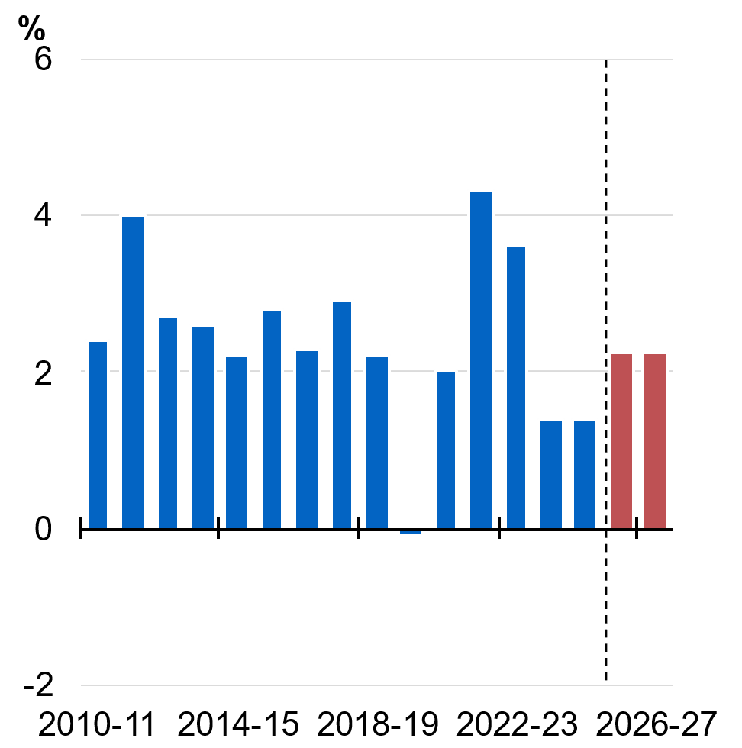 | 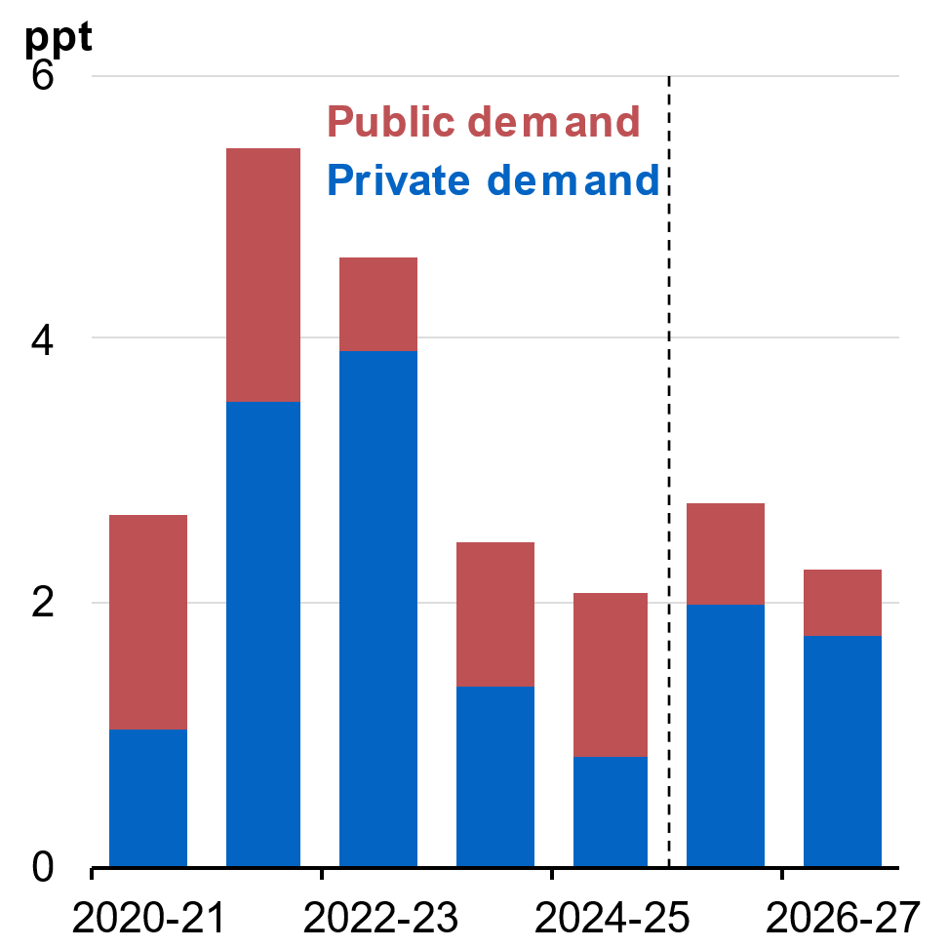
Source: ABS Australian National Accounts:  National Income, Expenditure and  Product and Treasury. | Source: ABS Australian National Accounts:  National Income, Expenditure and  Product and Treasury.

Household consumption
Household consumption grew by 1.1 per cent in 2024–25, supported by stronger growth in real incomes. In per capita terms, real household disposable income grew by 2.4 per cent in 2024–25, which was the fastest annual growth in four years. This was due to a combination of real wages growth, tax cuts and reductions in interest rates. Over the year to June 2025, growth in real household disposable income (RHHDI) per capita in Australia exceeded growth in most major advanced economies and was around double the OECD average (Chart 2.7)
Household consumption is forecast to continue to grow solidly over the forecast period, driven by a continual rise in real incomes. Household consumption is forecast to grow by 2½ per cent in 2025–26 and 2¼ per cent in 2026–27 (Chart 2.8). Real household disposable income per capita is forecast to grow by 1½ per cent in 2025–26 and 1 per cent in 2026–27 due to robust wages growth as well as the tax cuts in 2026 and 2027. Spending on essentials is expected to remain robust over the forecast period. Consumers, however, continue to be price sensitive and discount driven, particularly in relation to discretionary goods and services.

Chart 2.7: Comparison of growth in per capita RHHDI to June 2025 | Chart 2.8: Growth in household consumption
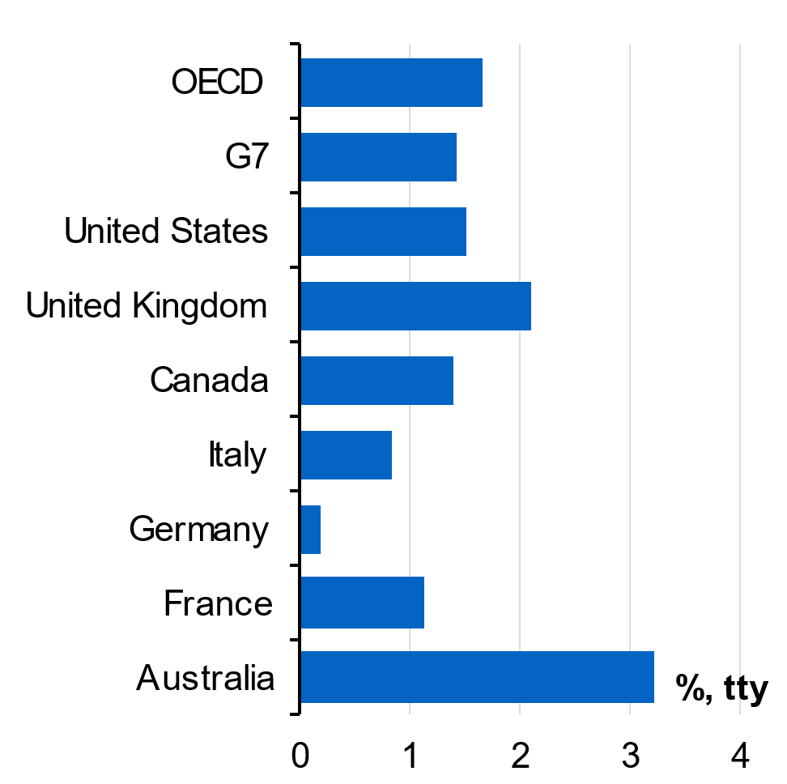 | 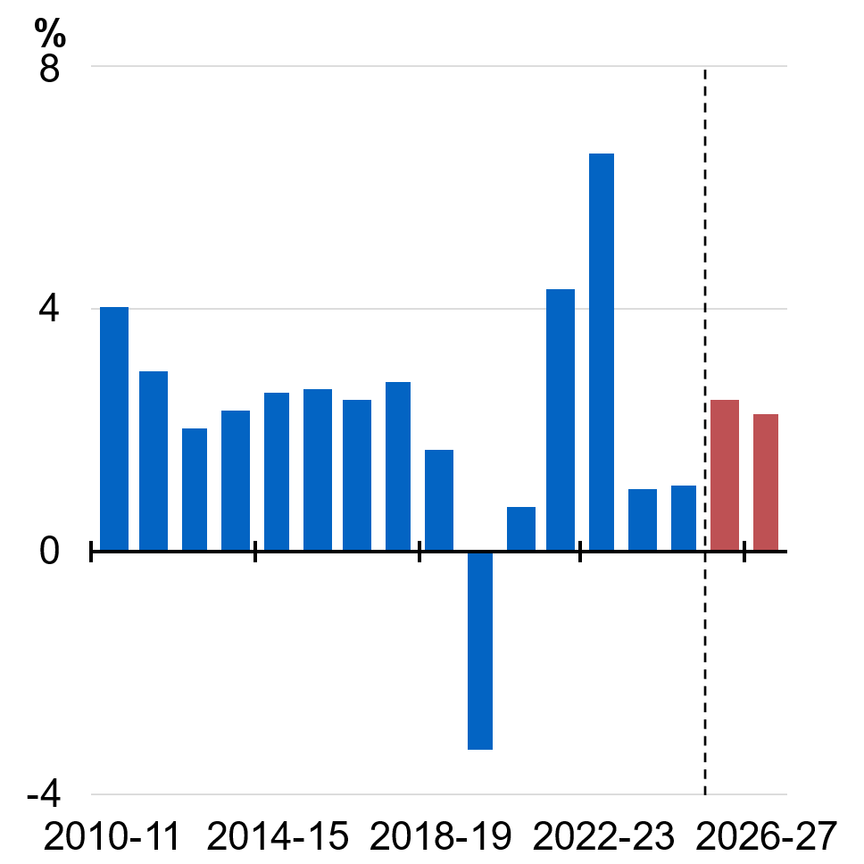
Source: ABS Australian National Accounts: National Income, Expenditure and Product and OECD. | Source: ABS Australian National Accounts:  National Income, Expenditure and  Product and Treasury.

Dwelling investment
Dwelling investment expanded by 4.4 per cent in 2024–25, reflecting an easing in capacity constraints (Chart 2.9). Approvals have picked up and have translated to a 9.0 per cent increase in private commencements over the year to the June quarter 2025. The prices of new dwellings purchased by owner-occupiers, as measured by the CPI, has eased significantly from its peak of around 20 per cent in 2022 to 1.7 per cent through-the-year to October 2025 as inflation in material costs has eased. These trends are supporting the expected pick-up in dwelling investment, with growth forecast to be 5½ per cent in 2025–26 and 6 per cent in 2026–27.

Business investment
Business investment grew strongly in the most recent quarter. Growth in business investment is expected to remain robust, at 3 per cent in 2025–26 and 1½ per cent in 2026–‍27. By the end of the forecast period, non-mining business investment is forecast to reach its highest level on record (Chart 2.10). Lower borrowing costs, rising private demand and elevated capacity utilisation are expected to create better conditions for business investment over the forecast period.
Non-mining business investment is forecast to grow by 4 per cent in 2025–26 and 2 per cent in 2026–27, supported by the automation of supply chains and continued digitisation of business operations, as well as investment in data centres (Box 2.2). Non-dwelling construction activity is expected to accelerate from 2026–27, assisted by a strong pipeline of renewable energy projects.
Mining investment remains subdued and is forecast to be flat in 2025–26 and 2026–27. While some investment in iron ore is expected in order to maintain output close to current levels, metallurgical coal producers are, in aggregate, expected to run down their capital stock over time. Some moderate expansion of gold mining capacity is expected as producers respond to elevated gold prices.
Chart 2.9: Growth in dwelling investment | Chart 2.10: Real non-mining business investment
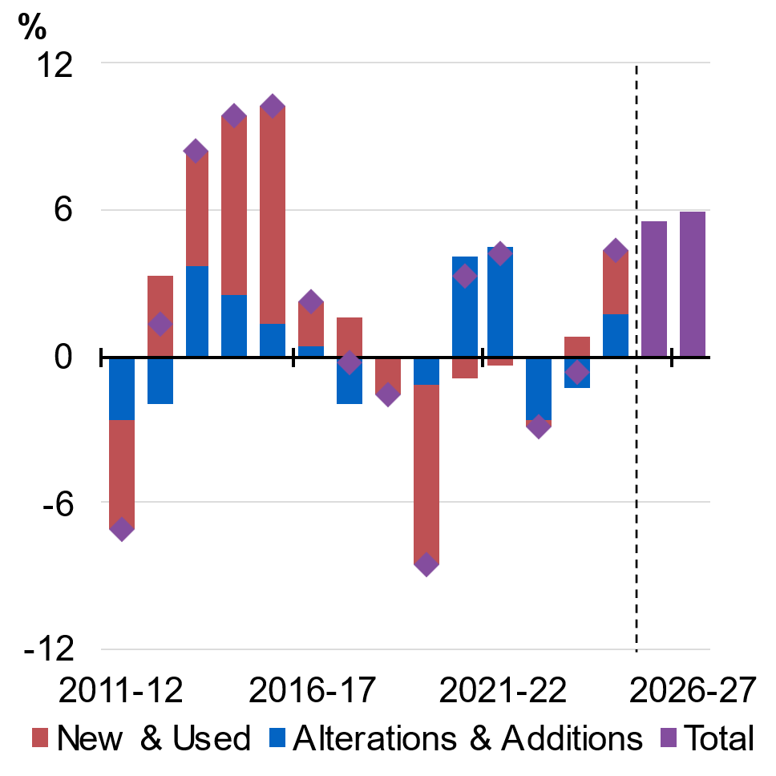 | 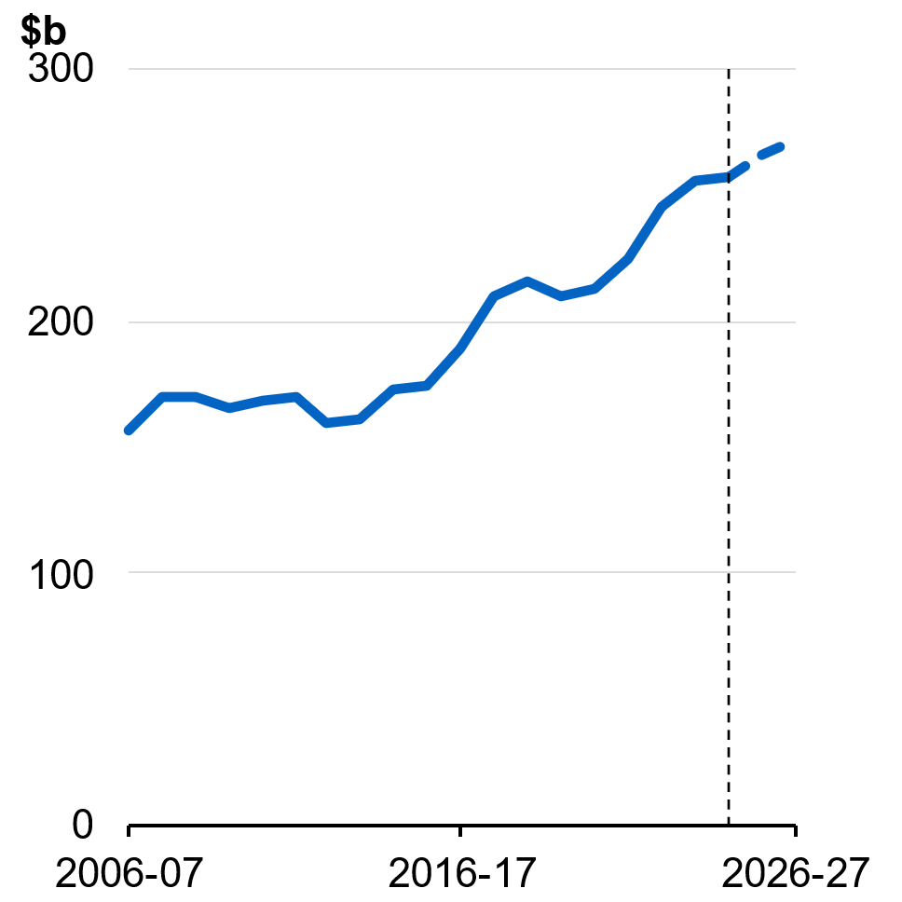
Source: ABS Australian National Accounts: National Income, Expenditure and Product and Treasury. | Source: ABS Australian National Accounts: National Income, Expenditure and Product and Treasury.

Box 2.2: Emerging trends in business investment
Business investment picked up in the September quarter and its changing composition reflects broader structural changes in the Australian economy. Recent data have shown increased investment in the energy transformation, data centres and computer software. Non-mining firms are expecting an increase in their capital expenditure in 2025–26. Firms have upgraded their expectations for capital expenditure for 2025–26 in the most recent surveys and expectations are significantly higher than the first estimate in December 2024 (Chart 2.11). Lower financing costs, rising private demand and high capacity utilisation are working to create a more favourable investment environment. Business investment is forecast to grow 3 per cent in 2025–26 and 1½ per cent in 2026–27. By 2026–27, non-mining business investment is forecast to reach its highest level on record.
Business investment surged by 3.4 per cent in the September quarter. This was the highest quarterly growth since March 2021. Around 80 per cent of the quarter’s growth was attributable to machinery and equipment investment, a large proportion of which is imported, including to support data centre fit-outs. Non-dwelling construction, including the building of data centres and renewable wind, solar and battery storage projects, also contributed to the higher growth over the year.
Firms continue to invest to improve their business operations and systems. Computer software investment has risen steadily over the past ten years and has more than tripled since 2015 as businesses look to improve their operations and systems, including in accounting, financing and security. This has been supported by strong growth in information technology employment, as specialist workforces are needed to enable these digitisation efforts. Infrastructure investments to support digitisation are also increasing. Construction of data centres has accelerated and the accompanying fit-out with equipment has increased over six-fold in the past five years (Chart 2.12).
Policy signals are also guiding investment, particularly in the renewable energy transition. The pipeline of renewable energy projects has increased over three-fold in the past two years, and now represents around $170 billion of nominal investment.
continued on next page

Box 2.2: Emerging trends in business investment (continued)
Chart 2.11 Nominal non-mining CAPEX intentions for 2025–26, year average growth | Chart 2.12: Information media and technology equipment investment
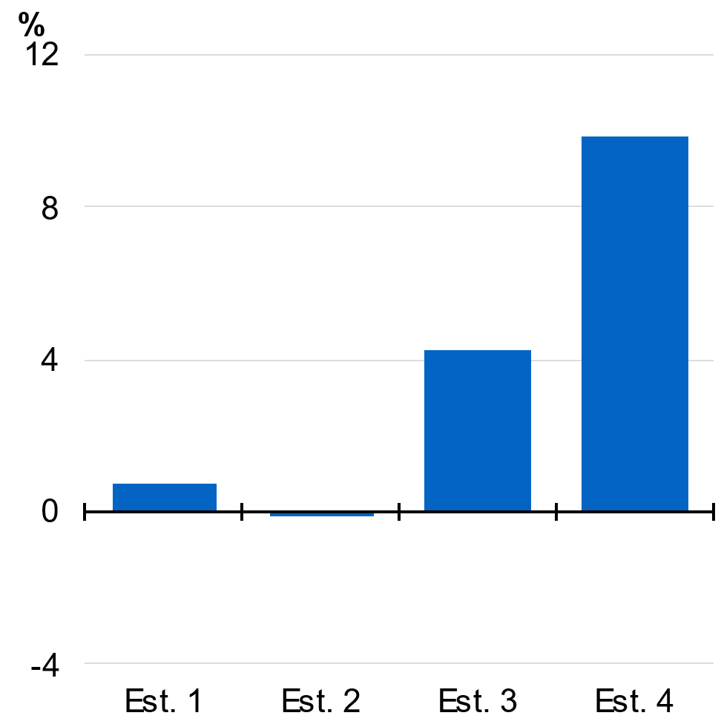 | 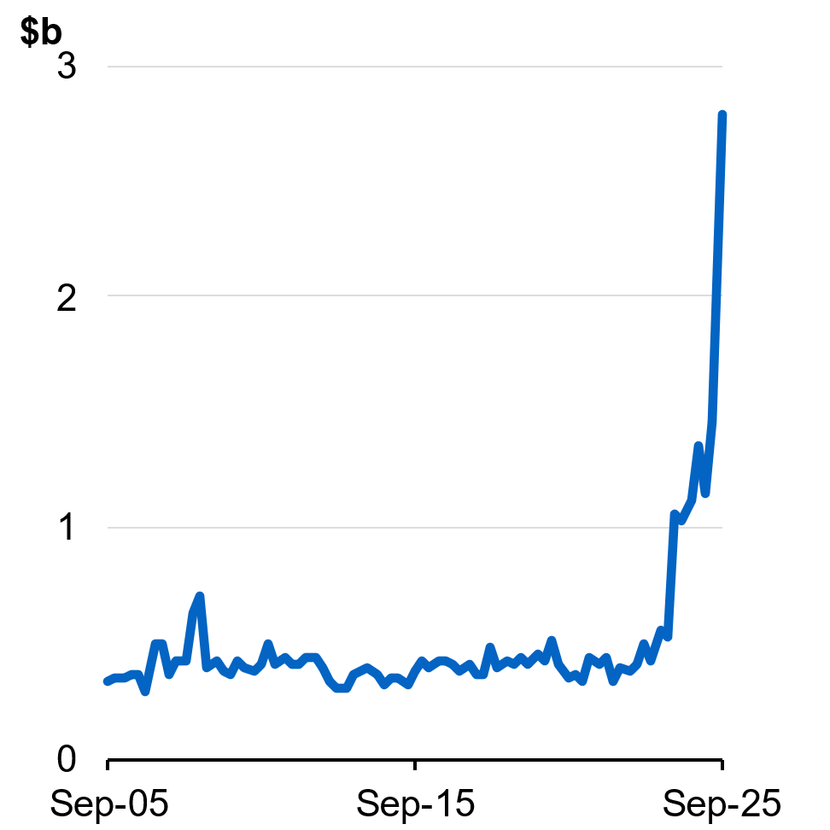
Source: ABS Private New Capital Expenditure and Expected Expenditure, Australia.  Note: Nominal CAPEX intentions are realisation ratio adjusted. | Source: ABS Private New Capital Expenditure and Expected Expenditure, Australia.

Public final demand
Public demand played an important role in supporting the economy during a period of subdued private sector growth. However, the private sector recovery is now underway and growth in public final demand is expected to ease over the forecast period. Public final demand is forecast to grow by 2¾ per cent in 2025–26, and 2¼ per cent in 2026–27 – moderating from growth of 4.4 per cent in 2024–25.
An easing in government consumption growth is expected because of moderating spending on demand-driven programs, such as the NDIS and aged care programs. Growth in public investment is also expected to moderate over the next two years as several large state transport projects reach completion and the number of new state infrastructure projects declines.

International trade
Exports are forecast to grow by 2½ per cent in 2025–26 and 1½ per cent in 2026–27. Growth in non-rural commodity exports is expected to remain subdued. This is largely due to easing demand for metallurgical coal as China continues its transition to less steel-intensive economic activity. Services exports are expected to grow modestly. In part, this reflects shifting preferences by travellers from overseas, especially those from China, towards domestic and closer destinations, as well as a decline in the number of Chinese students in Australia relative to the pre-COVID period. In 2026–27, there is a more subdued outlook for exports compared to Budget and this is the primary driver of the downgrade to real GDP.
Growth in imports is forecast to be 4½ per cent in 2025–26 and 2½ per cent in 2026–27. Growth in goods imports is expected to be supported by a broad array of investment. This includes investment in software, automatic data processing equipment, defence spending, and materials for large state and renewable infrastructure projects. Imports of consumption goods and outbound tourism are forecast to grow in line with increasing consumer demand, particularly for discretionary goods and services.

Inflation
Headline and underlying inflation remain well below their peaks in late 2022. A significant moderation in goods inflation over 2023–24 drove the initial decline in inflation. In 2024–25, disinflation was driven by a moderation in more persistent components of the CPI, including rents, new dwelling purchases and insurance. In addition, Government’s cost-of-living measures, including the government’s Energy Bill Relief Fund (EBRF), helped ease cost-of-living pressures when these pressures were most acute.
Inflation over the year to October 2025 was 3.8 per cent, with the recent increase partly reflecting temporary factors. A significant portion of the recent increase in inflation reflected the cessation of state energy rebates, which contributed around ½ of a percentage point to year-end inflation. Large annual increases in administered prices, which are predominantly determined by regulation or policy settings, including council property rates, and water and sewerage charges have also contributed to the recent increase in inflation (Chart 2.13). Market sector inflation, which moderated significantly over 2024–25, has also increased in recent months but remains lower than administered price inflation. Increases in the prices of volatile items, such as fuel and travel, contributed to this increase but are expected to be temporary.
However, higher inflation was also observed across new dwellings and a range of market service categories, reflecting input price growth and strengthening demand. Persistence in services inflation is consistent with what has been observed overseas, with many advanced economies, such as the UK, New Zealand and the US, currently experiencing elevated services price inflation (Chart 2.14).
Headline inflation is expected to be around 3¾ per cent in 2025–26 as a result of recent outcomes and the cessation of the EBRF. Excluding the effect of rebates and fuel, inflation is forecast to moderate and return sustainably to the target band by the end of 2026 and headline inflation is expected to be in the band by June 2027. Tradable goods inflation is expected to remain relatively low and stable because of subdued growth in import prices of consumer goods. Productivity has grown for four consecutive quarters and if this momentum continues, then it could support a moderation in services inflation.
Chart 2.13 Inflation in different components of the CPI basket | Chart 2.14 Services inflation country comparison
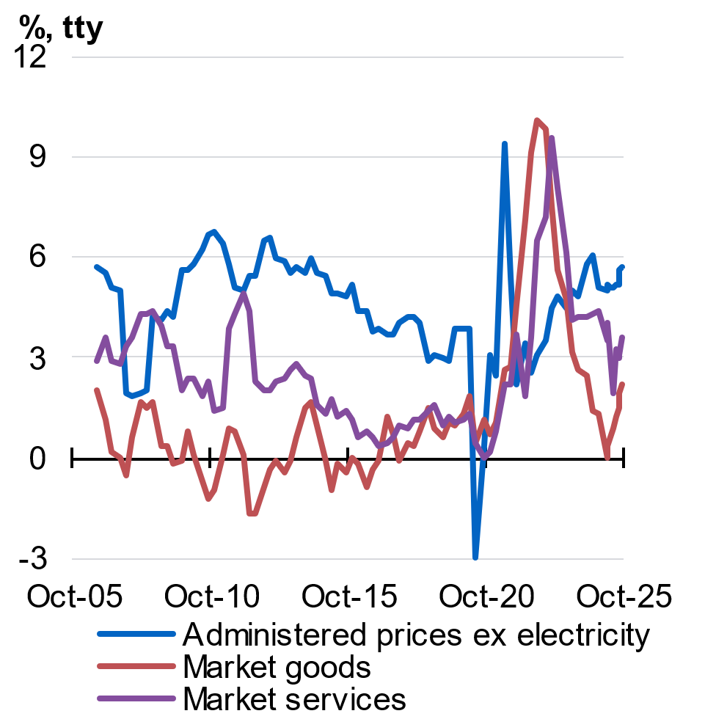 | 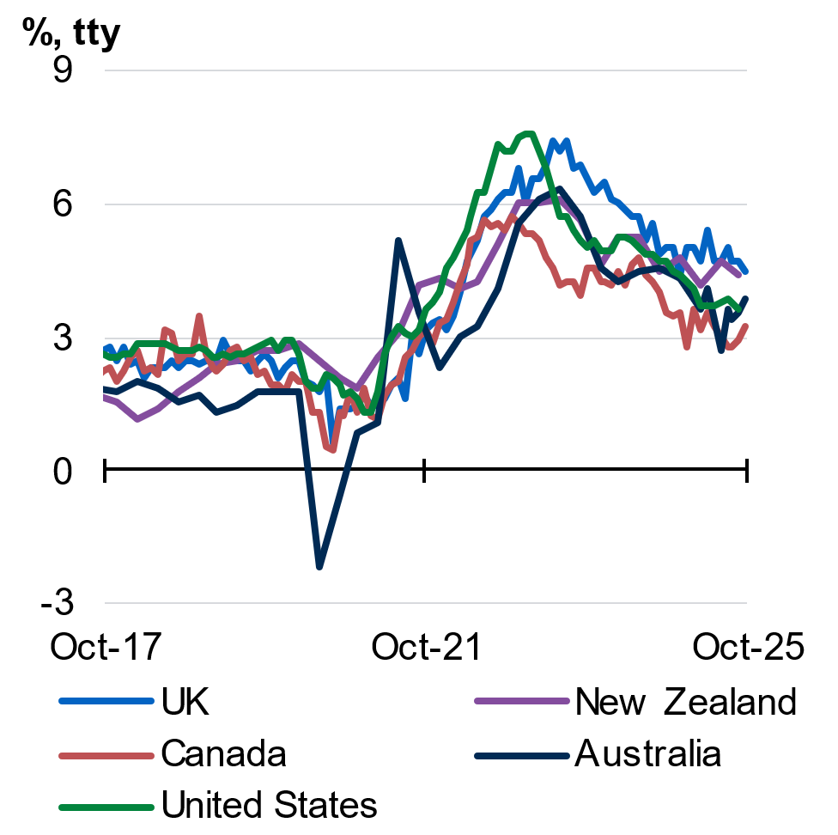
Source: ABS Consumer Price Index and Treasury.  Notes: Estimates prior to the December quarter 2024 are approximations using 2025 expenditure weights. Administered items are those not included in the market sector by the ABS, plus tobacco where most of the price is excise. | Source: LSEG, ABS and Treasury.

The labour market
The decline in inflation in Australia has been achieved while maintaining gains in employment and participation. Compared to previous disinflationary episodes, the unemployment rate has remained low by historical standards. This is in stark contrast with the experience of some other advanced economies, like Canada and New Zealand, where the moderation in inflation has occurred alongside a larger increase in unemployment.
Conditions in the labour market are expected to remain solid, with the unemployment rate forecast to remain low by historic standards, the participation rate near record highs and employment continuing to grow. The unemployment rate was 4.3 per cent in November 2025 (Chart 2.15) and is expected to only modestly rise to be around 4½ per cent over 2025–26 and 2026–27. The slight increase in the forecast unemployment rate from 4¼ per cent since Budget reflects that the participation rate is now forecast to remain around historical highs. The upgrade to the participation rate means the rate of growth in the workforce is expected to exceed the rate of employment growth over the forecast period.
Growth in employment is forecast to ease. Employment grew by 2¼ per cent in 2024–25 and is forecast to grow by 1¼ per cent in 2025–26 and by 1½ per cent in 2026–27. The shift from public to private sector led growth is expected to change the composition of labour demand. Employment growth in the market sector is expected to recover, while labour demand in the non-market sector is expected to ease. The market sector is expected to initially increase hours of its existing workforce and lift labour productivity before it increases employment.
The participation rate is forecast to remain near its recent record highs at around 67 per cent across 2025–26 and 2026–27. This is a result of structural factors such as changing patterns of caring duties supporting increased female participation, later retirements and a greater propensity for migrants to participate in the labour market.
Wages growth is forecast to ease slightly but remain well above the pre-pandemic average. The Wage Price Index is forecast to grow by 3¼ per cent in both 2025–26 and 2026–27, well above the five-year pre-pandemic average rate of 2.1 per cent.
Real wages have grown in each of the past two years (Chart 2.16). Real wages are forecast to grow again in 2026–27 and are expected to be ½ per cent higher through the year to the June quarter 2027.
Chart 2.15: Unemployment rate and its 2010–2019 average | Chart 2.16: Real wages growth and its 2010–2019 average
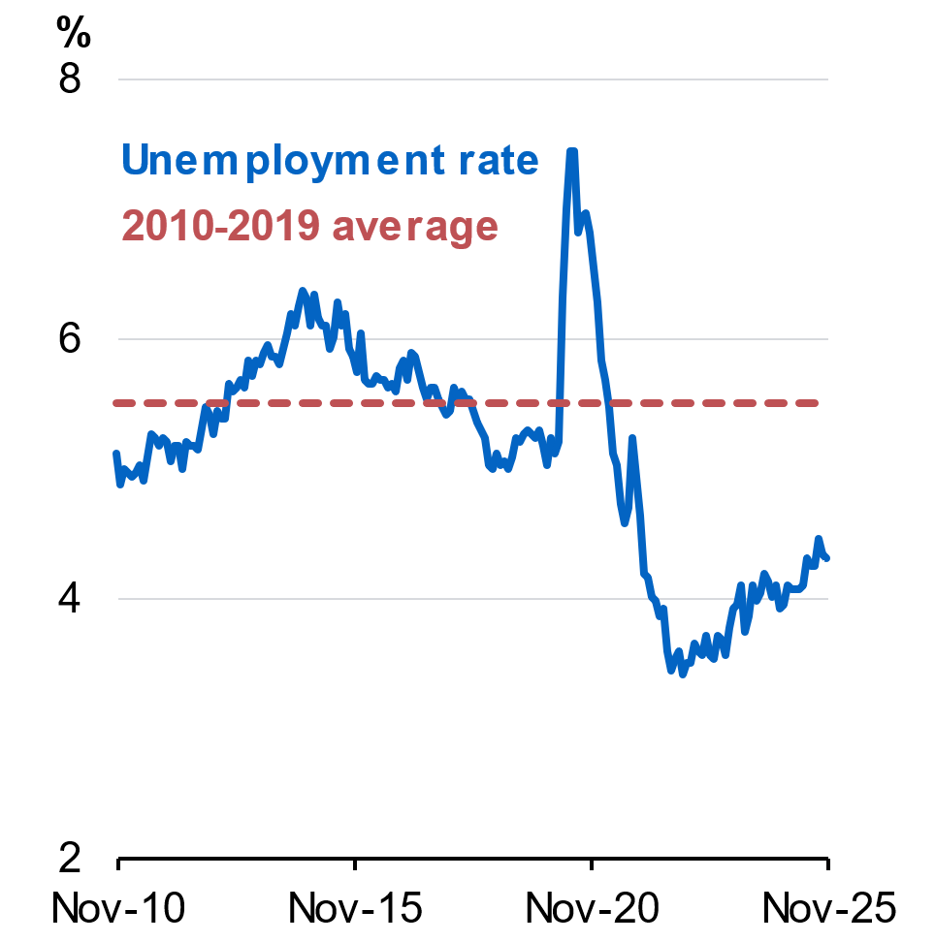 | 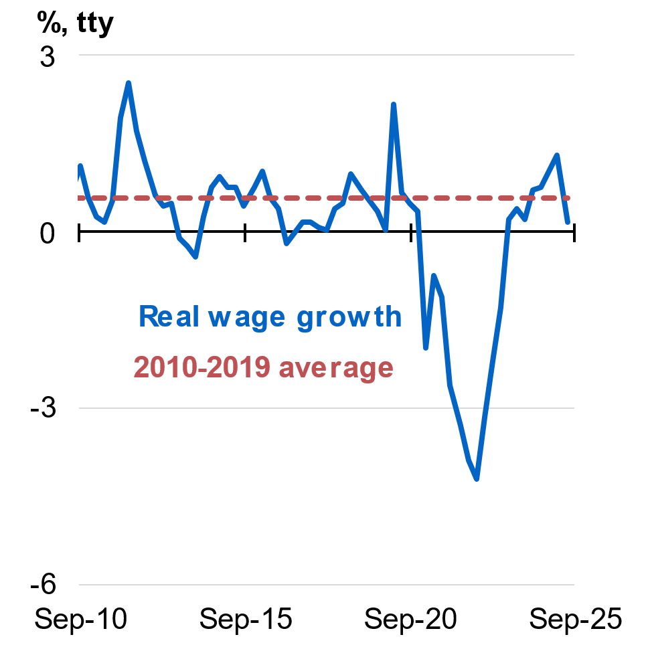
Source: ABS Labour Force, Australia, September 2025. | Source: ABS Consumer Price Index and Wage Price Index, June quarter 2025.

Outlook for the terms of trade and nominal GDP
Australia’s terms of trade are expected to show no growth in 2025–26 and fall by 6 per cent in 2026–27. Bulk commodity prices are assumed to return to long-run fundamental levels by the end of the December quarter 2026.
The prices of most bulk commodities have increased moderately the levels they were at Budget. Iron ore and metallurgical coal prices have been supported by ongoing policy support to economic growth in China. Weaker demand for thermal coal from China has been offset by resilient demand from other East Asian trade partners. LNG prices have declined as well-supplied global oil markets weigh on benchmark energy prices, and weaker demand from China as it switches to alternative sources of gas.
In contrast, the price of gold has increased sharply since Budget. Central bank demand, particularly in emerging economies, combined with recent increases in retail demand, have driven the spot price to near-record highs (see Box 2.3).
Nominal GDP is forecast to grow by 5¼ per cent in 2025–26 and 3¼ per cent in 2026–27. The forecast increase in real GDP growth and growth in some prices is expected to be slightly offset by commodity prices returning to their long-run anchors.

Box 2.3: Gold price assumption in the forecasts
Following a post-pandemic period of relative stability, the gold price has increased by 60 per cent since the beginning of this year and reached historic highs in October 2025 (Chart 2.17). Demand to date has been driven by a number of factors, including expectations of declining interest rates, global uncertainty, central banks in developing economies increasing their gold reserves, greater speculative retail demand, and inelastic short-term supply. These demand dynamics are being supported by ongoing global uncertainty.
Gold price movements have become a new source of volatility for the economic forecasts, particularly for nominal GDP, which is sensitive to the outlook for commodity prices. Australia is the world’s third-largest producer of gold, with 22 per cent of known gold resources. In 2024–25, gold accounted for 12 per cent of Australia’s resources and energy exports by value, behind iron ore (30 per cent) and LNG (17 per cent), and ahead of metallurgical coal (10 per cent). Gold is expected to become Australia’s second largest export by value in 2025–26.
Given its growing size as a source of export revenue, Treasury has updated its forecast framework to recognise the recent large increase in gold prices, while accounting for the risk that gold prices may decline from current high levels. The gold price is assumed to decline over eight quarters to a long-run anchor, which is calibrated to historical shifts in gold prices.
Chart 2.17: Historical spot gold price and glide path assumption
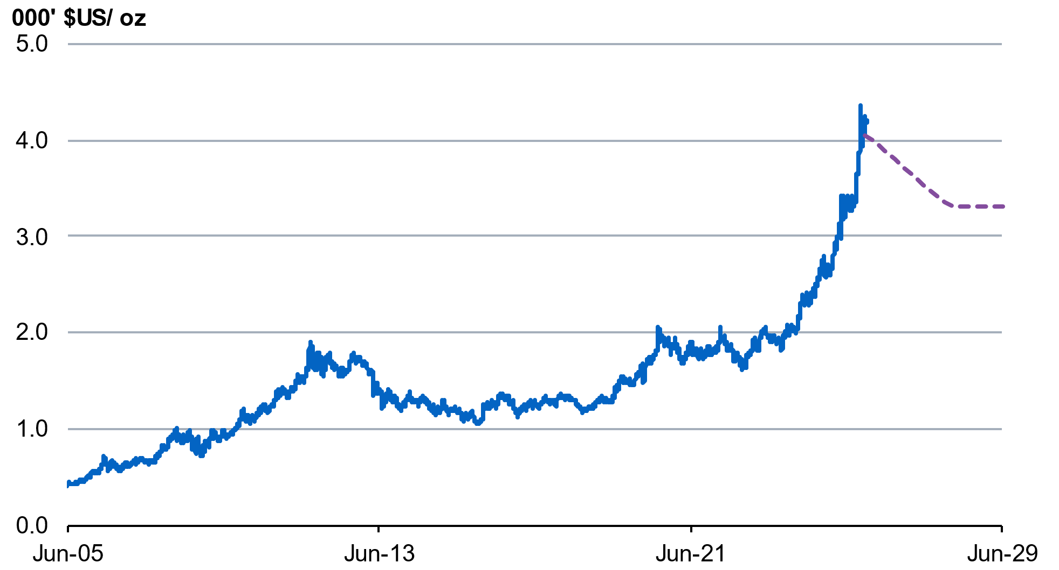
Source: Bloomberg and Treasury.
Note: Dotted line represents eight-quarter glide path assumption for spot gold.

Medium term forecasts and projections
Beyond the detailed forecast horizon, Treasury uses a macroeconometric model of the Australian economy to inform its forecasts and projections. The model returns the economy to its level of potential output, which is estimated based on an analysis of trends for population, productivity, and labour force participation.
Over the medium term, potential GDP is projected to grow by 2½ per cent each year. Annual long-term productivity growth is assumed to be 1.2 per cent –unchanged from the assumption at Budget. The unemployment rate remains at the Non-Accelerating Inflation Rate of Unemployment (NAIRU) assumption of 4¼ per cent and domestic inflation converges to the midpoint of the RBA’s target band.

