Part 3: Fiscal Strategy and Outlook

Overview
The 2025–26 Mid-Year Economic and Fiscal Outlook (MYEFO) strengthens the budget, reduces debt and continues the Government’s responsible approach to economic and fiscal management. The underlying cash deficit and debt are lower in every year of the forward estimates compared to forecasts in the 2025 Pre-Election Economic and Fiscal Outlook (PEFO); net policy decisions improve the budget position over the forward estimates; and every dollar of the tax receipts upgrade has been returned to the budget.
This builds on the progress made on budget repair in the last term, where the Government delivered the largest nominal budget improvement in a single parliamentary term, delivered back-to-back surpluses in the first two years and a substantially lower deficit in the third year.
An underlying cash deficit of $36.8 billion is forecast for 2025–26, $5.4 billion lower than expected at the 2025 PEFO. The underlying cash balance has improved by a cumulative $8.4 billion over the forward estimates compared to the 2025 PEFO. Relative to the 2022 PEFO, the underlying cash balance is forecast to improve by $233.5 billion over the seven years to 2028 – 29 and gross debt is expected to be $176 billion lower in 2025 – 26.
The Government’s fiscal discipline has reduced gross debt in every year of the forward estimates compared to the 2025 PEFO. Gross debt is expected to be $993 billion by the end of 2025 – 26. It is projected to peak at 37.0 per cent at 30 June 2031 and then fall to 33.0 per cent at 30 June 2036. Gross debt is expected to peak at the same level as the 2025 PEFO and 7.9 percentage points lower than the forecast peak at the 2022 PEFO. The improvements to gross debt since the Government came to office means more than $60 billion of interest costs are avoided over the 11 years to 2032– 33.
The Government has delivered this improvement to the budget through restraining spending, identifying savings and returning the entire tax receipts upgrade to the budget. For the first time in eight years, net policy decisions in this MYEFO are positive, improving the budget position by $2.2 billion over the forward estimates. As a result, the Government has returned every single dollar of the tax receipts upgrade to the budget, something that has not happened for more than a decade and a half. The Government has also identified a further $20.0 billion in savings and reprioritisations, taking the total under this Government to $114.1 billion. Since coming to Government, a cumulative 72 per cent of tax upgrades have been returned to the budget.
The Government’s record of spending restraint has continued in this MYEFO, with real growth in payments averaging 1.7 per cent per year over the seven years to 2028–29, around half of the 30-year average of 3.3 per cent. Payments as a share of GDP are forecast to fall over the forward estimates, declining from 26.9 per cent of GDP in 2025 – 26 to 26.5 per cent of GDP by 2028 – 29.
The Government’s fiscal settings are consistent with underlying inflation sustainably returning to the target band by the end of 2026.
This MYEFO delivers on the Government’s election commitments including by funding more free mental health services, support for major and local infrastructure projects and investing $10 billion to deliver up to 100,000 homes reserved for first home buyers. These commitments were more than offset by $7.2 billion of budget improvements, including from reducing spending on consultants and contractors in the Australian Public Service (APS) and increasing student visa application charges.
The Government has been able to achieve all this despite having to fund substantial payment variations and unavoidable spending. This MYEFO includes $35.1 billion in automatic payment parameter variations, including in disaster funding and aged care, and additional support for veterans. New spending commitments since the election include $6.6 billion in urgent and unavoidable spending to give access to new medicines, support security capability and border protection, and sustain core services for veterans. The Government is also progressing key national priorities including improving access to health and aged care services, investing in infrastructure and supporting local jobs.
Consistent with the Commonwealth’s latest offer to states and territories, the Government has provisioned for future payments to the states and territories for the National Health Reform Agreement (NHRA) and Disability Foundational Supports. The Government continues to make progress in addressing large structural spending pressures over time, including the National Disability Insurance Scheme (NDIS), support for veterans and their families and aged care.
Tax receipts have been revised up by $32.6 billion over the forward estimates compared to the 2025 PEFO, excluding GST and policy decisions. The upgrade to tax receipts in this MYEFO is less than the average upgrade in the last six major budget updates. Stronger-than-expected wages, and improved asset returns for individuals, are the primary drivers of upgrade to tax receipts. Over the forward estimates period, all personal income taxpayers will receive two further tax cuts. The upgrade to company taxes is supported by higher mining profits in the near-term, and higher non-mining profits driven by strength in the private sector.
Australia is one of only nine countries with a AAA sovereign credit rating from all three major ratings agencies. The rating reflects this Government’s prudent economic management, which has kept gross debt as a share of the economy low by international standards. Australia’s gross debt to GDP (including all levels of government) is less than half the advanced economy average and more than 70 percentage points below the United States. This strong fiscal position helps support Australia’s economic resilience.
Table 3.1: Australian Government general government sector budget aggregates
 | Estimates |  |  |  |  |  |  |  |  | Projections
 | 2025-26 |  | 2026-27 |  | 2027-28 |  | 2028-29 |  |  | 2035-36
 | $b | % GDP | $b | % GDP | $b | % GDP | $b | % GDP |  | % GDP
Underlying cash balance
MYEFO | -36.8 | -1.3 | -34.3 | -1.1 | -36.2 | -1.1 | -36.0 | -1.1 |  | -0.1
PEFO | -42.2 | -1.5 | -35.4 | -1.2 | -37.1 | -1.2 | -37.0 | -1.1 |  | 0.0
Budget | -42.1 | -1.5 | -35.7 | -1.2 | -37.2 | -1.2 | -36.9 | -1.1 |  | 0.0
Receipts
MYEFO | 749.8 | 25.7 | 777.0 | 25.8 | 805.6 | 25.5 | 846.9 | 25.4 |  | 26.6
PEFO | 735.4 | 25.5 | 766.0 | 25.6 | 797.4 | 25.3 | 840.8 | 25.3 |  | 26.8
Budget | 735.4 | 25.5 | 766.0 | 25.6 | 797.4 | 25.3 | 840.8 | 25.3 |  | 26.8
Tax receipts
MYEFO | 691.1 | 23.6 | 718.5 | 23.8 | 742.3 | 23.5 | 783.6 | 23.5 |  | 24.7
PEFO | 676.1 | 23.5 | 707.6 | 23.6 | 735.9 | 23.4 | 778.3 | 23.4 |  | 24.9
Budget | 676.1 | 23.5 | 707.6 | 23.6 | 735.9 | 23.4 | 778.3 | 23.4 |  | 24.9
Non-tax receipts
MYEFO | 58.6 | 2.0 | 58.5 | 1.9 | 63.3 | 2.0 | 63.3 | 1.9 |  | 1.9
PEFO | 59.3 | 2.1 | 58.4 | 2.0 | 61.4 | 2.0 | 62.6 | 1.9 |  | 1.9
Budget | 59.3 | 2.1 | 58.4 | 2.0 | 61.4 | 2.0 | 62.6 | 1.9 |  | 1.9
Payments(a)
MYEFO | 786.6 | 26.9 | 811.3 | 26.9 | 841.7 | 26.6 | 882.9 | 26.5 |  | 26.8
PEFO | 777.5 | 27.0 | 801.3 | 26.8 | 834.5 | 26.5 | 877.9 | 26.4 |  | 26.8
Budget | 777.5 | 27.0 | 801.7 | 26.8 | 834.6 | 26.5 | 877.7 | 26.4 |  | 26.8
Gross debt(b)
MYEFO | 993.0 | 34.0 | 1,069.0 | 35.4 | 1,142.0 | 36.1 | 1,213.0 | 36.4 |  | 33.0
PEFO | 1,022.0 | 35.5 | 1,092.0 | 36.5 | 1,161.0 | 36.9 | 1,223.0 | 36.8 |  | 31.9
Budget | 1,022.0 | 35.5 | 1,092.0 | 36.5 | 1,161.0 | 36.9 | 1,223.0 | 36.8 |  | 31.9
Net debt(c)
MYEFO | 587.5 | 20.1 | 646.9 | 21.4 | 700.4 | 22.2 | 754.8 | 22.6 |  | 20.3
PEFO | 620.7 | 21.6 | 676.3 | 22.6 | 713.9 | 22.7 | 768.2 | 23.1 |  | 20.2
Budget | 620.3 | 21.5 | 676.3 | 22.6 | 714.1 | 22.7 | 768.2 | 23.1 |  | 20.2
Net interest payments(d)
MYEFO | 18.3 | 0.6 | 20.3 | 0.7 | 27.4 | 0.9 | 28.7 | 0.9 |  | 1.2
PEFO | 18.5 | 0.6 | 21.2 | 0.7 | 26.9 | 0.9 | 28.1 | 0.8 |  | 1.1
Budget | 18.5 | 0.6 | 21.2 | 0.7 | 26.9 | 0.9 | 28.1 | 0.8 |  | 1.1
- Equivalent to cash payments for operating activities, purchases of non-financial assets and principal payments of lease liabilities.
- Gross debt measures the face value of Australian Government Securities (AGS) on issue and is presented as at the end of the financial year.
- Net debt is the sum of interest-bearing liabilities (which includes AGS on issue measured at market value) less the sum of selected financial assets (cash and deposits, advances paid and investments, loans and placements) and is presented as at the end of the financial year.
- Net interest payments are equal to the difference between interest payments and interest receipts.

Economic and Fiscal Strategy
The Government’s Economic and Fiscal Strategy is outlined in Box 3.1. The Strategy is consistent with the requirements of the Charter of Budget Honesty Act 1998, with progress reviewed at each budget update. The Strategy is unchanged since the 2025–26 Budget.
Box 3.1: The Government’s Economic and Fiscal Strategy
The Government’s Economic and Fiscal Strategy will make the economy more resilient and put the budget on a more sustainable footing over time.
The Strategy is focused on the objectives of strong, inclusive and sustainable economic growth, full employment, growing real wages, ensuring women’s economic participation and equality, and improving living standards for all Australians.
The Government will improve the budget position in a measured way, consistent with the overarching goal of reducing gross debt as a share of the economy over time. This approach enables fiscal policy to respond to changes in economic conditions to support macroeconomic stability, including in times of high inflation.
These objectives will be achieved by investments that grow the economy and expand productive capacity, and budget discipline that restrains spending growth and enhances the quality of spending. The budget will be improved in a manner consistent with the objective of maintaining full employment, while continuing to deliver essential services.
Putting the budget on a more sustainable footing will ensure the Government has the fiscal buffers to withstand economic shocks and better manage the fiscal pressures from an ageing population and climate change.
These commitments will be underpinned by the following elements:
- Allowing tax receipts and income support to respond in line with changes in the economy and directing the majority of improvements in tax receipts to budget repair.
- Limiting growth in spending until gross debt as a share of GDP is on a downwards trajectory, while growth prospects are sound and unemployment is low.
- Improving the efficiency, quality and sustainability of spending.
- Focusing new spending on investments and reforms that build the capability of our people, expand the productive capacity of our economy, and support action on climate change.
- Delivering a tax system that funds government services in an efficient, fair and sustainable way.

Delivering on the Economic and Fiscal Strategy
The Government continues to deliver on its Economic and Fiscal Strategy by:
- Improving the budget balance.
  - The underlying cash balance in 2025 – 26 has improved by $5.4 billion since the 2025 PEFO. The underlying cash balance has improved in every year of the forward estimates since the 2025 PEFO, resulting in a cumulative budget improvement of $8.4 billion.
  - Compared to projections at the 2022 PEFO, the underlying cash balance has improved by $6.2 billion in 2025– 26 and by a cumulative $233.5 billion over the seven years to 2028–29.
- Reducing debt as a share of the economy over time.
  - Compared to projections at the 2025 PEFO, gross debt-to-GDP is lower in every year of the forward estimates.
  - Gross debt at 30 June 2026 is forecast to be $29 billion lower than estimated at the 2025 PEFO and $176 billion lower than estimated at the 2022 PEFO.
  - Gross debt-to-GDP is expected to peak at 37.0 per cent at 30 June 2031 and then fall to 33.0 per cent at 30 June 2036. Gross debt is expected to peak at the same level as the 2025 PEFO and 7.9 percentage points lower than the forecast peak at the 2022 PEFO.
  - The cumulative improvements to the budget position, compared to the 2022 PEFO, are expected to save more than $60 billion in interest payments over the 11 years to 2032–33.
- Repairing the budget through savings and re-prioritisations.
  - Net policy decisions have improved the budget position by $2.2 billion over the forward estimates. This is the first time since the 2017–18 Budget that net policy decisions have been positive.
  - This MYEFO provides $20.0 billion in savings and reprioritisations. This brings total savings and spending reprioritisations to $114.1 billion, and total budget improvements to $145.0 billion, since the 2022 PEFO.
- Limiting spending.
  - Real payments growth over the seven years to 2028–29 averages 1.7 per cent per year, and 2.1 per cent per year over the four years to 2028–29.
  - This compares to an annual average of 3.3 per cent over the past 30 years.
- Returning the majority of tax receipt upgrades to the budget.
  - The 2025–26 MYEFO returns all tax receipt upgrades to the budget. This is the first time this has occurred since the 2009–10 MYEFO.
  - Since coming to government, the Government has returned to the budget 72 per cent of tax receipt upgrades over the seven years to 2028 – 29.
Chart 3.1: Underlying cash balance | Chart 3.2: Gross debt
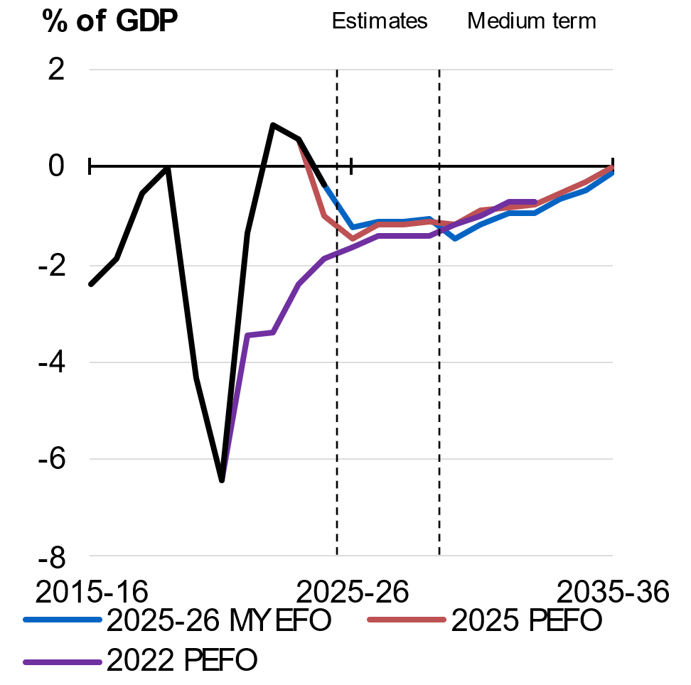 | 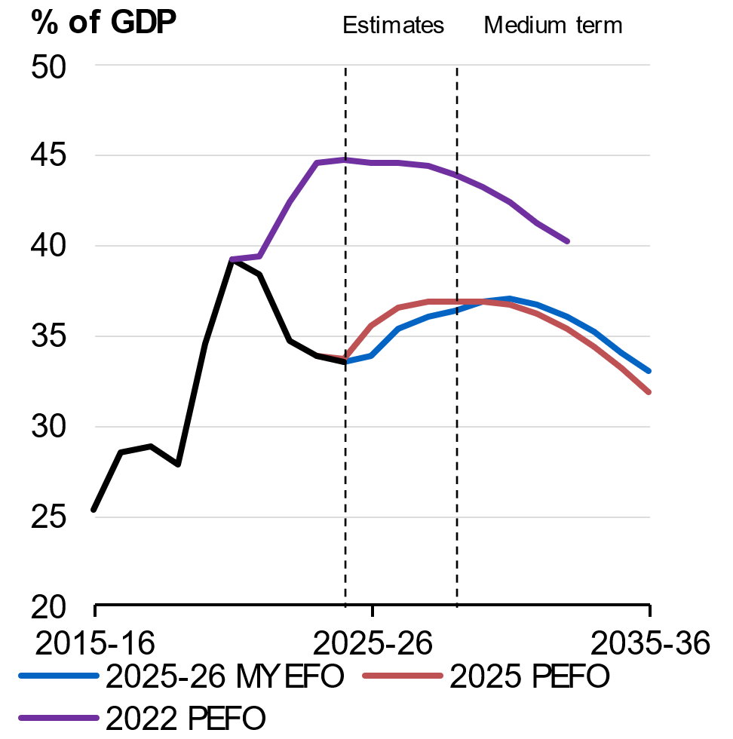
Source: Treasury. | Source: Australian Office of Financial Management, Treasury.

International comparisons of fiscal performance
Australia’s strong record of responsible economic management has kept gross debt well below international benchmarks. Australia is one of only nine countries with a AAA credit rating from all three major ratings agencies, reflecting the strength and resilience of the economy.
While many advanced economies are projected to experience increases in debt-to-GDP in 2025 and 2026, Australia’s general government gross debt (including all levels of government) is forecast to remain broadly stable, maintaining comparatively low debt-to-GDP. According to International Monetary Fund (IMF) projections, Australia’s gross debt-to-GDP is less than half the advanced economy average (Chart 3.3), and the fifth lowest gross debt-to-GDP ratio in the G20.
Maintaining low levels of government debt helps to keep borrowing costs down, preserves fiscal flexibility to respond to future economic challenges, and supports the sustainable funding of essential services.
Chart 3.3: Gross debt in 2025
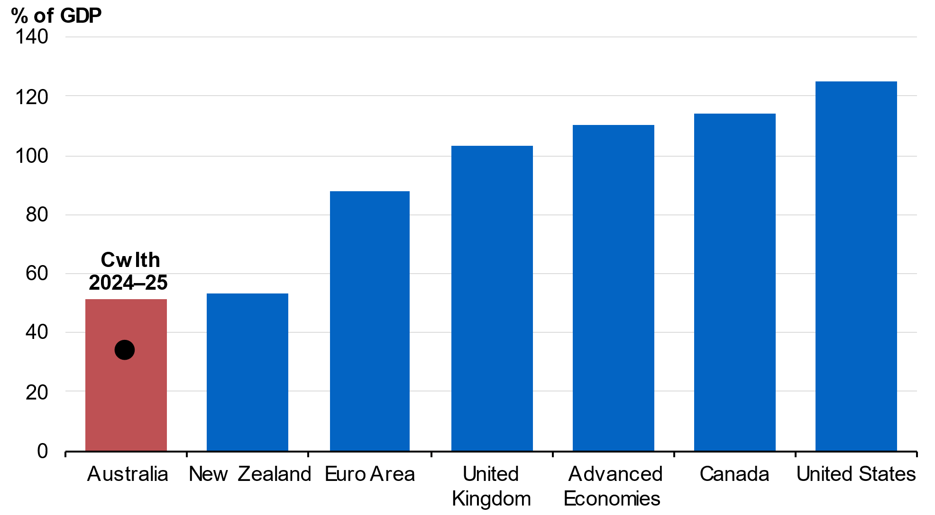
Note: International Monetary Fund fiscal data are produced on a consistent basis across countries. They are produced for calendar years and on a general government basis. They are not directly comparable with fiscal aggregates reported elsewhere in the MYEFO.
Source: Treasury, International Monetary Fund.

Fiscal outlook

Underlying cash balance estimates
The underlying cash balance has improved by $8.4 billion over the four years to 2028–29 since the 2025 PEFO.
The 2025–26 underlying cash balance is estimated to be a $36.8 billion deficit (1.3 per cent of GDP), which is a $5.4 billion improvement compared to the 2025 PEFO and a 0.2 percentage points improvement as a proportion of GDP (Table 3.2).
The underlying cash deficit is then expected to improve to $36.0 billion (1.1 per cent of GDP) by 2028–29.
Net policy decisions have improved the underlying cash balance by $2.2 billion over the four years to 2028 – 29. This includes reducing spending on consultants and contractors in the APS, strengthening program integrity in the Veterans’ Affairs portfolio, gradually returning deeming rates to pre-pandemic settings, and increasing student visa application charges. This is the first time in eight years that net policy decisions are positive in a budget update. Parameter and other variations since PEFO have improved the underlying cash balance by $6.2 billion over the four years to 2028–29.
Table 3.2: Reconciliation of general government sector underlying cash balance estimates
 | Estimates
 | 2025-26 | 2026-27 | 2027-28 | 2028-29 |  | Total
 | $m | $m | $m | $m |  | $m
2025-26 Budget underlying cash balance | -42,122 | -35,706 | -37,247 | -36,854 |  | -151,929
Per cent of GDP | -1.5 | -1.2 | -1.2 | -1.1
Changes from 2025-26 Budget to
2025 PEFO
Effect of policy decisions(a) | -226 | -380 | -276 | -223 |  | -1,105
Effect of parameter and other variations | 183 | 720 | 436 | 49 |  | 1,387
Total variations | -43 | 339 | 160 | -174 |  | 282
2025 PEFO underlying cash balance | -42,165 | -35,366 | -37,087 | -37,028 |  | -151,647
Per cent of GDP | -1.5 | -1.2 | -1.2 | -1.1
Changes from 2025 PEFO to
2025-26 MYEFO
Effect of policy decisions(a)(b)
Receipts | -151 | -103 | -819 | -511 |  | -1,584
Payments | 1,758 | 44 | -2,156 | -3,399 |  | -3,754
Total policy decisions impact on
underlying cash balance | -1,909 | -147 | 1,337 | 2,888 |  | 2,170
Effect of parameter and other variations(b)
Receipts | 14,585 | 11,158 | 8,989 | 6,590 |  | 41,322
Payments | 7,275 | 9,948 | 9,428 | 8,442 |  | 35,094
Total parameter and other variations impact on
underlying cash balance | 7,310 | 1,210 | -439 | -1,852 |  | 6,229
2025-26 MYEFO underlying cash balance | -36,764 | -34,303 | -36,189 | -35,993 |  | -143,248
Per cent of GDP | -1.3 | -1.1 | -1.1 | -1.1
- Excludes secondary impacts on public debt interest of policy decisions and offsets from the Contingency Reserve for decisions taken.
- A positive number for receipts improves the underlying cash balance, while a positive number for payments worsens the underlying cash balance.

Medium-term projections
The medium-term fiscal outlook is broadly in line with the 2025 PEFO. The underlying cash balance improves over the medium term, returning to broad balance by 2035–36 (Chart 3.4). This is in line with what was expected at the 2025 PEFO.
Chart 3.4: Payments and receipts
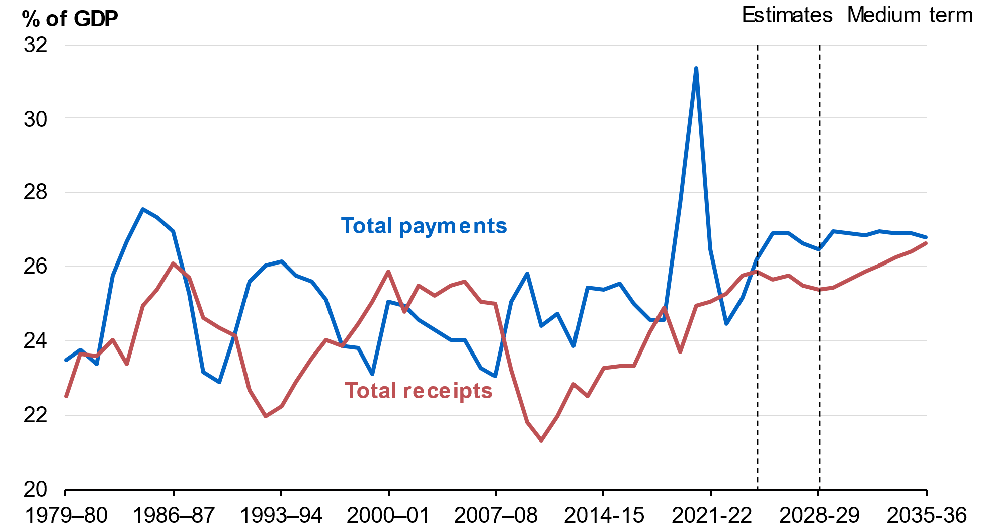
Source: Treasury.

Total receipts as a share of GDP have been revised modestly downwards over the medium term compared to the 2025 PEFO projections (Chart 3.5). Total receipts are projected to be 25.4 per cent of GDP in 2028–29, rising to 26.6 per cent of GDP by 2035–36.
Total payments are projected to grow from 26.5 per cent of GDP in 2028–29 to 26.8 per cent of GDP in 2035–36 (Chart 3.6). This is consistent with what was expected at the 2025 PEFO.
The fastest growing major payments are interest on government debt, the NDIS, defence, hospitals payments, medical benefits payments, and the Child Care Subsidy (Chart 3.7).
Chart 3.5: Total receipts | Chart 3.6: Total payments
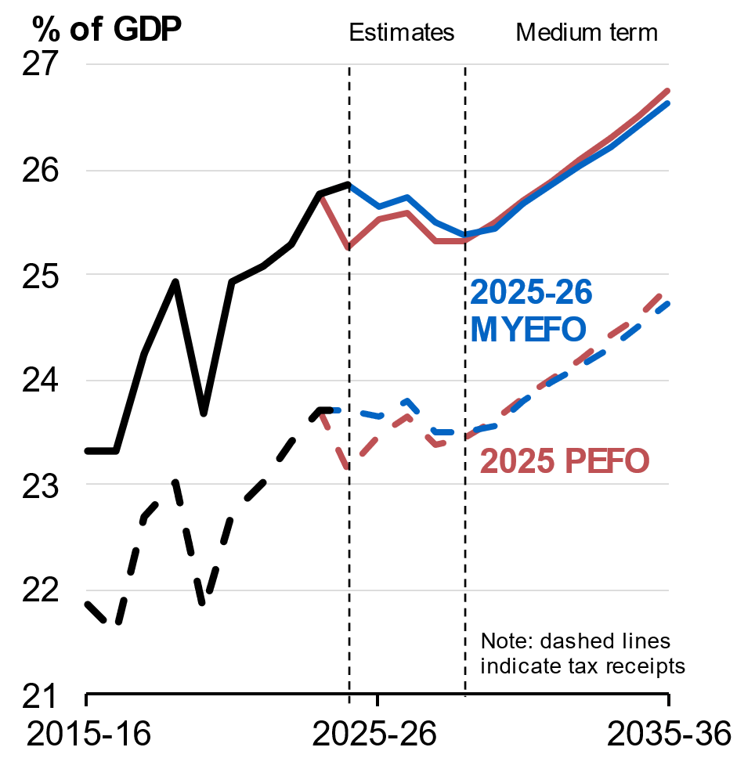 | 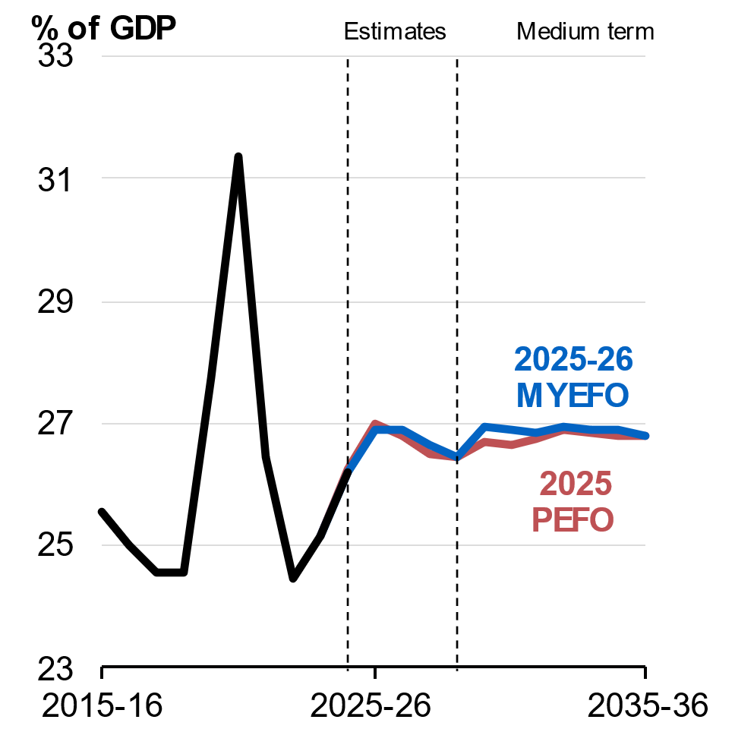
Source: Treasury. | Source: Treasury.

Chart 3.7: Average annual growth in major payments from 2025–26 to 2035–36
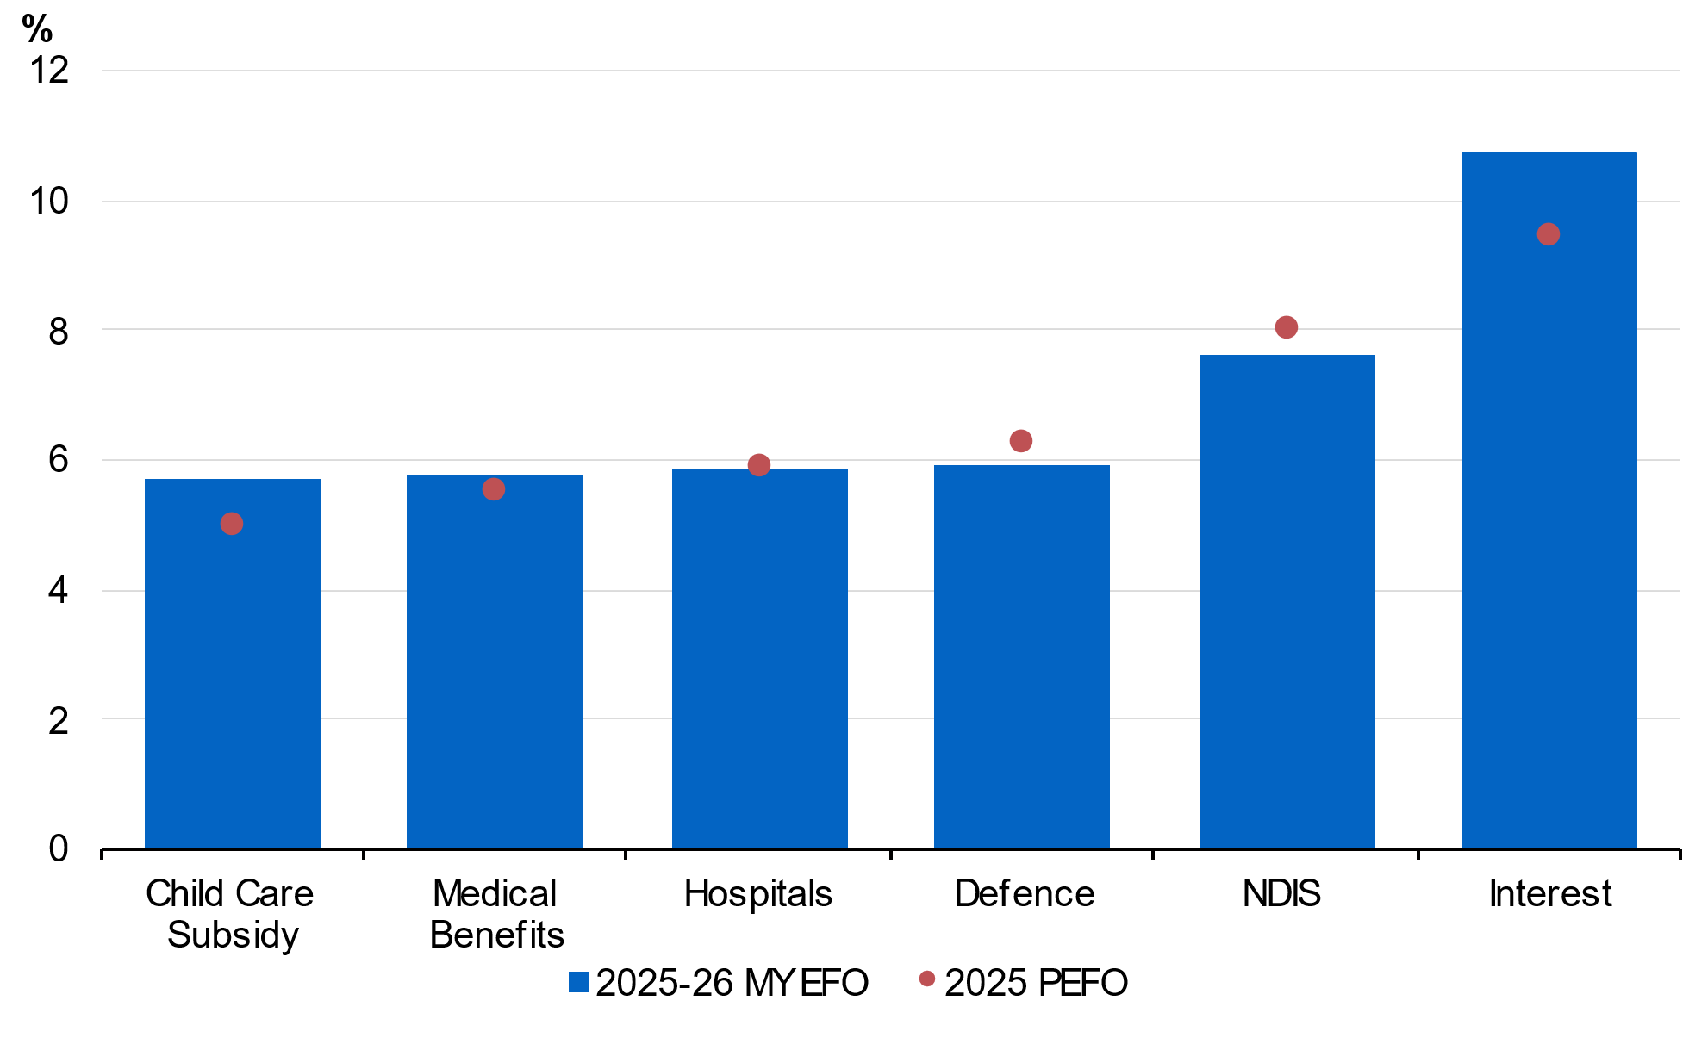
Note: Shows major payments that are growing faster than nominal GDP over the projection period. Interest refers to interest payments on Australian Government Securities. NDIS refers to the Australian Government’s contribution to payments for NDIS participant supports.
Aged care was a fastest growing major payment in the 2025–26 Budget but is no longer projected to grow faster than nominal GDP and so is not included in the chart.
Source: Treasury.

Growth in some major payments over the ten–year projection period to 2035–36 has changed compared to the 2025 PEFO.
- Interest payments growth is expected to average 10.7 per cent over the projection period compared to 9.5 per cent at the 2025 PEFO. This reflects an improved gross debt outcome reducing interest payments at the start of the period, offset by increased borrowing and gross debt towards the end of the projections.
- NDIS Commonwealth funded participant payments growth is expected to average 7.6 per cent over the projection period, compared to 8.1 per cent at the 2025 PEFO. This reflects higher costs at the start of the projection period resulting in slower growth over the decade and lower spending towards the end of the projection period due to updated NDIS Actuary estimates.
- Defence payments growth is expected to average 5.9 per cent compared to 6.3 per cent at the 2025 PEFO. This reflects a bring-forward of planned investment causing higher spending at the start of the projection period as well as a revised estimate for the final year, resulting in slower growth over the decade.
- Child Care Subsidy payments growth is expected to average 5.7 per cent over the projection period compared to 5.1 per cent at the 2025 PEFO, largely reflecting higher-than-estimated child care use by families in the forward estimates.
- Aged care payments growth is expected to average 4.9 per cent over the projection period, lower than the projected growth rate of nominal GDP, compared to 5.2 per cent at the 2025 PEFO, reflecting weaker-than-expected growth in aged care prices in the forward estimates.

Receipts estimates
Total receipts over the forward estimates have increased by $39.7 billion since the 2025 PEFO, driven by both higher tax receipts and higher non-tax receipts.
Tax receipts have been revised up by $37.6 billion over the four years to 2028–29 compared to the 2025 PEFO, with the upgrade concentrated in the near-term. Excluding GST and policy decisions, tax receipts have been revised up by $32.6 billion. The upgrade in this MYEFO is less than the average of the last six major budget updates. Forecasts for personal income tax, company tax, superannuation fund taxes and GST receipts are all higher, partly offset by a downgrade to tobacco excise receipts. The upgrades are driven by strength in a range of factors including wages, savings income, corporate profits and consumption.
Since the 2025 PEFO, non-tax receipts are expected to decrease by $0.6 billion in 2025–26 (Table 3.3) and increase by $2.1 billion over the four years to 2028–29.
Total receipts as a proportion of GDP are expected to decrease over the forward estimates, from 25.7 per cent of GDP in 2025–26 to 25.4 per cent of GDP in 2028–29. Tax receipts are expected to fall from 23.6 per cent of GDP in 2025–26 to 23.5 per cent of GDP in 2028–29.
Table 3.3: Reconciliation of 2025–26 general government (cash) receipts
 | Estimates |  |  | Change from 2025 PEFO
 | 2025 PEFO | 2025–26 MYEFO
 | $m | $m |  | $m | %
Individuals and other withholding taxes
Gross income tax withholding | 310,600 | 312,500 |  | 1,900 | 0.6
Gross other individuals | 79,900 | 86,000 |  | 6,100 | 7.6
less: Refunds | 40,800 | 40,600 |  | -200 | -0.5
Total individuals and other withholding tax | 349,700 | 357,900 |  | 8,200 | 2.3
Fringe benefits tax | 5,080 | 5,310 |  | 230 | 4.5
Company tax | 140,400 | 144,700 |  | 4,300 | 3.1
Superannuation fund taxes | 25,560 | 30,010 |  | 4,450 | 17.4
Petroleum resource rent tax | 1,950 | 1,500 |  | -450 | -23.1
Income taxation receipts | 522,690 | 539,420 |  | 16,730 | 3.2
Goods and services tax | 94,234 | 95,654 |  | 1,420 | 1.5
Wine equalisation tax | 1,200 | 1,160 |  | -40 | -3.3
Luxury car tax | 1,200 | 1,120 |  | -80 | -6.7
Excise and customs duty
Petrol | 7,450 | 7,300 |  | -150 | -2.0
Diesel | 17,850 | 17,610 |  | -240 | -1.3
Other fuel products | 2,020 | 1,680 |  | -340 | -16.8
Tobacco | 7,050 | 5,450 |  | -1,600 | -22.7
Beer | 2,780 | 2,710 |  | -70 | -2.5
Spirits | 3,380 | 3,270 |  | -110 | -3.3
Other alcoholic beverages(a) | 1,830 | 1,810 |  | -20 | -1.1
Other customs duty
Textiles, clothing and footwear | 170 | 160 |  | -10 | -5.9
Passenger motor vehicles | 380 | 300 |  | -80 | -21.1
Other imports | 1,620 | 1,550 |  | -70 | -4.3
less: Refunds and drawbacks | 730 | 1,380 |  | 650 | 89.0
Total excise and customs duty | 43,800 | 40,460 |  | -3,340 | -7.6
Major Bank Levy | 1,850 | 1,880 |  | 30 | 1.6
Agricultural levies | 669 | 707 |  | 38 | 5.6
Visa application charges | 4,199 | 4,576 |  | 377 | 9.0
Other taxes | 6,244 | 6,166 |  | -78 | -1.2
Indirect taxation receipts | 153,396 | 151,722 |  | -1,674 | -1.1
Taxation receipts | 676,086 | 691,142 |  | 15,056 | 2.2
Sales of goods and services | 21,921 | 21,528 |  | -393 | -1.8
Interest received | 9,389 | 9,103 |  | -286 | -3.0
Dividends and distributions | 7,416 | 7,558 |  | 142 | 1.9
Other non-taxation receipts | 20,540 | 20,460 |  | -80 | -0.4
Non-taxation receipts | 59,266 | 58,649 |  | -617 | -1.0
Total receipts | 735,353 | 749,792 |  | 14,439 | 2.0
Memorandum:
Total excise | 32,450 | 31,680 |  | -770 | -2.4
Total customs duty | 11,350 | 8,780 |  | -2,570 | -22.6
Capital gains tax(b) | 27,600 | 31,500 |  | 3,900 | 14.1
- ‘Other alcoholic beverages’ are those not exceeding 10 per cent by volume of alcohol (excluding beer, brandy and wine).
- ‘Capital gains tax’ is part of gross other individuals, company tax and superannuation fund taxes.

Table 3.4: Reconciliation of 2026–27 general government (cash) receipts
 | Estimates |  |  | Change from 2025 PEFO
 | 2025 PEFO | 2025-26 MYEFO
 | $m | $m |  | $m | %
Individuals and other withholding taxes
Gross income tax withholding | 327,000 | 328,700 |  | 1,700 | 0.5
Gross other individuals | 84,900 | 89,500 |  | 4,600 | 5.4
less: Refunds | 41,900 | 42,400 |  | 500 | 1.2
Total individuals and other withholding tax | 370,000 | 375,800 |  | 5,800 | 1.6
Fringe benefits tax | 5,110 | 5,370 |  | 260 | 5.1
Company tax | 144,500 | 147,300 |  | 2,800 | 1.9
Superannuation fund taxes | 26,110 | 29,110 |  | 3,000 | 11.5
Petroleum resource rent tax | 1,800 | 1,500 |  | -300 | -16.7
Income taxation receipts | 547,520 | 559,080 |  | 11,560 | 2.1
Goods and services tax | 99,309 | 101,560 |  | 2,251 | 2.3
Wine equalisation tax | 1,240 | 1,210 |  | -30 | -2.4
Luxury car tax | 1,270 | 1,180 |  | -90 | -7.1
Excise and customs duty
Petrol | 7,600 | 7,550 |  | -50 | -0.7
Diesel | 18,770 | 18,430 |  | -340 | -1.8
Other fuel products | 2,070 | 1,710 |  | -360 | -17.4
Tobacco | 6,800 | 4,800 |  | -2,000 | -29.4
Beer | 2,910 | 2,760 |  | -150 | -5.2
Spirits | 3,430 | 3,280 |  | -150 | -4.4
Other alcoholic beverages(a) | 1,930 | 1,860 |  | -70 | -3.6
Other customs duty
Textiles, clothing and footwear | 180 | 160 |  | -20 | -11.1
Passenger motor vehicles | 350 | 270 |  | -80 | -22.9
Other imports | 1,680 | 1,640 |  | -40 | -2.4
less: Refunds and drawbacks | 730 | 730 |  | 0 | 0.0
Total excise and customs duty | 44,990 | 41,730 |  | -3,260 | -7.2
Major Bank Levy | 1,930 | 1,970 |  | 40 | 2.1
Agricultural levies | 684 | 697 |  | 13 | 1.9
Visa application charges | 4,402 | 4,971 |  | 569 | 12.9
Other taxes | 6,211 | 6,087 |  | -123 | -2.0
Indirect taxation receipts | 160,036 | 159,406 |  | -630 | -0.4
Taxation receipts | 707,556 | 718,486 |  | 10,930 | 1.5
Sales of goods and services | 22,974 | 23,025 |  | 52 | 0.2
Interest received | 8,939 | 9,091 |  | 152 | 1.7
Dividends and distributions | 7,766 | 7,766 |  | 0 | 0.0
Other non-taxation receipts | 18,736 | 18,662 |  | -74 | -0.4
Non-taxation receipts | 58,414 | 58,544 |  | 130 | 0.2
Total receipts | 765,970 | 777,030 |  | 11,059 | 1.4
Memorandum:
Total excise | 33,810 | 32,900 |  | -910 | -2.7
Total customs duty | 11,180 | 8,830 |  | -2,350 | -21.0
Capital gains tax(b) | 27,600 | 30,700 |  | 3,100 | 11.2
- ‘Other alcoholic beverages’ are those not exceeding 10 per cent by volume of alcohol (excluding beer, brandy and wine).
- ‘Capital gains tax’ is part of gross other individuals, company tax and superannuation fund taxes.

Table 3.5: Australian Government general government (cash) receipts
 | Actual |  | Estimates
 | 2024-25 |  | 2025-26 | 2026-27 | 2027-28 | 2028-29
 | $m |  | $m | $m | $m | $m
Individuals and other withholding taxes
Gross income tax withholding | 295,827 |  | 312,500 | 328,700 | 348,200 | 368,300
Gross other individuals | 81,707 |  | 86,000 | 89,500 | 92,500 | 101,100
less: Refunds | 39,223 |  | 40,600 | 42,400 | 45,600 | 47,700
Total individuals and other withholding tax | 338,312 |  | 357,900 | 375,800 | 395,100 | 421,700
Fringe benefits tax | 4,927 |  | 5,310 | 5,370 | 5,530 | 5,840
Company tax | 138,762 |  | 144,700 | 147,300 | 146,900 | 151,700
Superannuation fund taxes | 25,700 |  | 30,010 | 29,110 | 28,110 | 30,310
Petroleum resource rent tax | 1,420 |  | 1,500 | 1,500 | 1,300 | 1,050
Income taxation receipts | 509,121 |  | 539,420 | 559,080 | 576,940 | 610,600
Goods and services tax | 90,322 |  | 95,654 | 101,560 | 106,848 | 113,702
Wine equalisation tax | 1,134 |  | 1,160 | 1,210 | 1,270 | 1,310
Luxury car tax | 1,088 |  | 1,120 | 1,180 | 1,240 | 1,300
Excise and customs duty
Petrol | 7,306 |  | 7,300 | 7,550 | 7,750 | 8,000
Diesel | 17,262 |  | 17,610 | 18,430 | 19,130 | 19,730
Other fuel products | 1,731 |  | 1,680 | 1,710 | 1,710 | 1,760
Tobacco | 7,767 |  | 5,450 | 4,800 | 4,550 | 4,350
Beer | 2,729 |  | 2,710 | 2,760 | 2,790 | 2,850
Spirits | 3,320 |  | 3,270 | 3,280 | 3,280 | 3,300
Other alcoholic beverages(a) | 1,789 |  | 1,810 | 1,860 | 1,900 | 1,950
Other customs duty
Textiles, clothing and footwear | 153 |  | 160 | 160 | 150 | 140
Passenger motor vehicles | 339 |  | 300 | 270 | 220 | 90
Other imports | 1,504 |  | 1,550 | 1,640 | 1,250 | 890
less: Refunds and drawbacks | 711 |  | 1,380 | 730 | 730 | 730
Total excise and customs duty | 43,188 |  | 40,460 | 41,730 | 42,000 | 42,330
Major Bank Levy | 1,768 |  | 1,880 | 1,970 | 2,060 | 2,170
Agricultural levies | 664 |  | 707 | 697 | 703 | 716
Visa application charges | 4,154 |  | 4,576 | 4,971 | 5,198 | 5,438
Other taxes | 6,403 |  | 6,166 | 6,087 | 6,010 | 6,033
Indirect taxation receipts | 148,723 |  | 151,722 | 159,406 | 165,329 | 173,001
Taxation receipts | 657,844 |  | 691,142 | 718,486 | 742,269 | 783,601
Sales of goods and services | 22,024 |  | 21,528 | 23,025 | 24,545 | 25,546
Interest received | 10,545 |  | 9,103 | 9,091 | 9,478 | 9,841
Dividends and distributions | 7,262 |  | 7,558 | 7,766 | 8,323 | 9,126
Other non-taxation receipts | 19,277 |  | 20,460 | 18,662 | 20,939 | 18,810
Non-taxation receipts | 59,107 |  | 58,649 | 58,544 | 63,285 | 63,322
Total receipts | 716,951 |  | 749,792 | 777,030 | 805,554 | 846,923
Memorandum:
Total excise | 31,294 |  | 31,680 | 32,900 | 33,890 | 34,940
Total customs duty | 11,894 |  | 8,780 | 8,830 | 8,110 | 7,390
Capital gains tax(b) | 30,900 |  | 31,500 | 30,700 | 31,300 | 32,600
- ‘Other alcoholic beverages’ are those not exceeding 10 per cent by volume of alcohol (excluding beer, brandy and wine).
- ‘Capital gains tax’ is part of gross other individuals, company tax and superannuation fund taxes.

Receipts policy decisions over the forward estimates
Policy decisions since the 2025 PEFO are expected to decrease tax receipts by $3.7 billion over the four years to 2028–29. Key tax receipts measures include:
- Superannuation Reforms – Boosting the Low Income Superannuation Tax Offset and practical changes to Better Targeted Superannuation Concessions. This measure is estimated to decrease receipts by $3.8 billion and increase payments by $475.8 million over the four years to 2028 – 29.
- Migration – Uplift of Visa Application Charge for student visas. This measure is estimated to increase receipts by $740.0 million and decrease GST payments to the states and territories by $20.0 million over the four years to 2028 – 29.
- OECD Crypto Asset Reporting Framework and domestic reporting. This measure is estimated to increase receipts by $170.0 million and increase payments by $57.6 million over the four years to 2028 – 29.
Since the 2025 PEFO, policy decisions are expected to decrease non-tax receipts by $0.1 billion in 2025–26 and increase non-tax receipts by $2.1 billion over the four years to 2028–29. This includes the standard non-tax receipt impacts of Pharmaceutical Benefits Scheme listings.
Further details of Government policy decisions are provided in Appendix A: Policy Decisions taken since the 2025 PEFO.

Receipts parameter and other variations over the forward estimates
Parameter and other variations since the 2025 PEFO are expected to increase total receipts by $14.6 billion in 2025–26; tax receipts have increased by $15.1 billion and non-tax receipts have decreased by $0.5 billion.
Over the four years to 2028–29, total receipts are expected to increase by $41.3 billion since the 2025 PEFO, due to parameter and other variations. This reflects upgrades in personal income tax, superannuation fund taxes, company tax and GST; partially offset by a downgrade to tobacco excise receipts.
Since the 2025 PEFO, parameter and other variations are expected to decrease non-tax receipts by $0.5 billion in 2025–26 and have no material net impact on non-tax receipts over the four years to 2028–29. Decreases in non-tax receipts are largely driven by updated pharmaceutical pricing assumptions and changes to predicted prescription volumes, and a decrease in the expected dividends to be received from Government Business Enterprises. Broadly equivalent increases in non-tax receipts are largely driven by an increase in state and territory contributions for blood and blood products, and a forecast increase in earnings from the Future Fund and other Australian Government Investment Funds.
The key economic parameters that influence tax receipts and revenue are shown in Table 3.6.
Table 3.6: Key economic parameters for tax receipts^{(a)}
 | Outcome | Forecasts
 | 2024–25 | 2025–26 | 2026–27 | 2027–28 | 2028–29
Revenue parameters
Nominal gross domestic product | 3.6 | 5 1/4 | 3 1/4 | 4 3/4 | 5 1/2
Change since 2025 PEFO |  | 2 | -3/4 | -1/2 | 0
Compensation of employees (b) | 6.2 | 5 3/4 | 4 1/2 | 5 | 5 1/2
Change since 2025 PEFO |  | 1 1/4 | 1/4 | 0 | 1/4
Corporate gross operating surplus (c) | -2.9 | 4 1/4 | -1 | 4 | 6 3/4
Change since 2025 PEFO |  | 5 1/2 | -2 1/4 | -1 1/2 | 3/4
Non-farm gross mixed income | 0.9 | 5 1/2 | 6 3/4 | 6 1/2 | 6 3/4
Change since 2025 PEFO |  | -2 3/4 | -1/2 | -3/4 | 1/4
Property income (d) | 8.4 | 2 3/4 | 5 | 5 3/4 | 6
Change since 2025 PEFO |  | 1/2 | 1 | 3/4 | 1
Consumption subject to GST | 2.3 | 5 | 5 1/4 | 5 1/4 | 5 1/2
Change since 2025 PEFO |  | 0 | 1 | 1/4 | 1
- Current prices, per cent change on previous year. Changes since PEFO are percentage points. The economic parameters used to prepare the 2025 PEFO were unchanged from those presented at the 2025–26 Budget.
- Compensation of employees measures total remuneration earned by employees.
- Corporate gross operating surplus is an Australian System of National Accounts measure of company profits, gross of depreciation.
- Property income measures income derived from rent, dividends and interest.
Source: ABS Australian National Accounts: National Income, Expenditure and Product; and Treasury.

Compared to the 2025 PEFO, personal income tax receipts excluding policy decisions, have been revised up by $8.7 billion in 2025–26 and by $23.2 billion over the four years to 2028 – 29. Income tax withholding has been revised up by $1.9 billion in 2025–26 and $4.8 billion over the four years to 2028–29, reflecting higher wages. Net other individuals (gross other individuals less refunds) receipts have been revised up by $6.7 billion in 2025 – 26 and $18.4 billion over the four years to 2028–29, due to strong tax collections –particularly pay-as-you-go instalments – higher capital gains, and increased savings income.
Company tax receipts have been revised up by $4.3 billion in 2025–26 and by $12.8 billion over the four years to 2028–29, driven by stronger corporate profits. The improved outlook for profits is due to both non-mining profits flowing from higher nominal private sector activity and a near-term increase in mining profits reflecting higher bulk commodity and gold prices.
Superannuation fund tax receipts have been revised up by $4.3 billion in 2025–26 and by $10.1 billion over the four years to 2028–29. The upward revision reflects higher superannuation contributions (from higher wages) and tax from investment earnings.
Fringe benefits tax receipts have been upgraded by $0.2 billion in 2025–26 and $1.2 billion over the four years to 2028–29, reflecting strength in current-year collections and higher compensation of employees.
Petroleum resource rent tax receipts have been revised down by $0.5 billion in 2025–26 and by $1.5 billion over the four years to 2028–29. This downgrade reflects a lower assumed oil price and an increase in credits for decommissioning expenditure incurred by projects no longer producing.
Total excise and customs duty receipts have been downgraded by $3.3 billion in 2025–26 and by $13.1 billion over the four years to 2028–29. This is largely due to lower tobacco excise receipts, which have been downgraded by $1.6 billion in 2025–26 and $8.2 billion over the four years to 2028–29, owing to lower-than-expected tobacco excise collections to date. This reflects the persistent and significant decline in legal tobacco consumption. A weaker outlook for alcohol and fuel excise receipts also contributes to the downgrade.
GST receipts have been upgraded by $1.4 billion in 2025–26 and by $8.9 billion over the four years to 2028–29. This reflects stronger current year collections supported by higher nominal consumption growth across the forward estimates.

Payments estimates
Since the 2025 PEFO, total payments have increased by $9.0 billion in 2025–26 and by $31.3 billion over the four years to 2028–29. Real payments growth is expected to average 1.7 per cent over the seven years to 2028–29 and 2.1 per cent over the four years to 2028–29.

Payment policy decisions over the forward estimates
New policy decisions since the 2025 PEFO have increased total payments by $1.8 billion in 2025–26 and decreased total payments by $3.8 billion over the four years to 2028–29.
Major policy decisions since the 2025 PEFO that have decreased payments over the four years to 2028–29 include:
- reducing spending on external labour and other non-wage expenses like travel, hospitality and property, which is expected to decrease payments by $6.8 billion over the four years to 2028–29, delivering and expanding on the Government’s election commitment made during the 2025 federal election.
- ensuring support under the Cheaper Home Batteries program is aligned with contemporary battery technologies and household needs while continuing to provide cheaper batteries for consumers, which is expected to decrease payments by $6.7 billion over the four years to 2028–29.
- returning to the practice of updating the social security deeming rates on financial assets to reflect market returns, which is expected to decrease payments by $1.9 billion over the four years to 2028–29.
- reprofiling Housing Australia Future Fund disbursements and funding to align with the delivery model, which combined with additional support is expected to increase payments by $4.4 billion over the life of Round 3 but is expected to decrease payments by $742.6 million over the four years to 2028–29.
- strengthening program integrity across the Veterans’ Affairs portfolio by reducing service provider and advocate non-compliance and fraud, which is expected to decrease payments by $678.4 million over the four years to 2028–29.
- reprioritising funding across the Climate Change, Energy, the Environment and Water portfolio to deliver on key Government priorities, which is expected to decrease payments by $534.4 million over the four years to 2028–29.
Major policy decisions since the 2025 PEFO that have increased payments over the four years to 2028–29 include:
- funding for new and amended listings on the Pharmaceutical Benefits Scheme and Life Saving Drugs program, which is expected to increase payments by $1.8 billion over the four years to 2028–29.
- funding to provide more free mental health services and grow the mental health workforce, which is expected to increase payments by $1.1 billion over the four years to 2028–29, delivering on the Government’s election commitment made during the 2025 federal election.
- funding to prioritise prevention, treatment and rehabilitation services to support the long-term health and wellbeing of veterans and serving members, which is expected to increase payments by $739.2 million over the four years to 2028–29.
- funding to ensure the viability and quality of aged care and support a growing number of older Australians to remain in their homes as they age, which is expected to increase payments by $692.2 million over the four years to 2028–29.
- funding for major and local community infrastructure projects across Australia, which is expected to increase payments by $618.6 million over the four years to 2028–29, including delivering on the Government’s election commitment made during the 2025 federal election.
- funding for road and rail infrastructure priorities to support productivity and jobs, which is expected to increase payments by $573.8 million over the four years to 2028–29.
- funding to enable first home buyers to get into housing sooner, which is expected to increase payments by $519.1 million over the four years to 2028–29, delivering on the Government’s election commitment made during the 2025 federal election.
- funding to support Australian industries and protect local jobs, including to maintain the operation of Glencore’s Mount Isa copper smelter and Townsville copper refinery and support the Whyalla steelworks during administration, which is expected to increase payments by $491.4 million over the four years to 2028–29.
- funding to build a stronger, fairer and more sustainable superannuation system including by boosting the Low Income Superannuation Tax Offset to support low income earners to build their retirement savings, which is expected to increase payments by $475.8 million over the four years to 2028–29.

Payment parameter and other variations over the forward estimates
Parameter and other variations since the 2025 PEFO have increased payments by $7.3 billion in 2025 – 26 and $35.1 billion over the four years to 2028–29.
This is primarily driven by higher estimated payments for the Cheaper Home Batteries program, higher GST entitlements for payments to the states and territories and payments under the Disaster Recovery Funding Arrangements. These increases are partially offset by lower estimated payments for the Fuel Tax Credits Scheme and the Commonwealth Debt Management program.
Major increases in payments from parameter and other variations since the 2025 PEFO include:
- payments related to the Cheaper Home Batteries program, which are expected to increase by $3.4 billion in 2025–26 and $11.6 billion over the four years to 2028 – 29, largely reflecting higher demand for household batteries under the program. This is partially offset by the Government’s changes under the Sustaining the Cheaper Home Batteries Program measure, which results in a revised total cost for the program of $7.2 billion over the four years to 2028 – 29.
- GST-related payments to the states and territories, which are expected to increase by $2.5 billion in 2025–26 and $10.4 billion over the four years to 2028 – 29, and are largely offset by an increase in GST receipts.
- payments related to the National Partnership Payments – Natural Disaster Relief program, which are expected to increase by $3.1 billion in 2025–26 and $6.3 billion over the four years to 2028 – 29, largely reflecting updated estimates for future expenditure on past disaster events.
- payments related to the Support for Seniors program, which are expected to increase by $326.4 million in 2025–26 and $3.0 billion over the four years to 2028 – 29, largely reflecting a higher-than-projected rate of indexation and increased recipient numbers for the Age Pension.
- payments related to the NDIS, which are expected to increase by $1.1 billion in 2025 – 26 and $2.3 billion over the four years to 2028 – 29, largely reflecting revised projections from the NDIS Actuary in the 2024 – 25 Annual Financial Sustainability Report.
- payments related to the Defence Force Superannuation Benefits program, which are expected to increase by $501.0 million in 2025 – 26 and $2.1 billion over the four years to 2028 – 29, largely reflecting revised valuation of the unfunded liability for the military superannuation schemes by the Australian Government Actuary.
- payments related to the Child Care Subsidy program, which are expected to decrease by $149.1 million in 2025 – 26 and increase by $2.0 billion over the four years to 2028 – 29, largely reflecting higher-than-estimated child care use by families. This is partially offset by higher-than-expected family taxable incomes which reduces families’ Child Care Subsidy entitlement.
- payments related to non-government schools, which are expected to increase by $505.0 million in 2025 – 26 and by $1.7 billion over the four years to 2028 – 29, largely reflecting an increase in non-government school enrolments, and an increase in the number of students with a disability eligible to attract a higher level of funding.
- payments related to the Financial Support for Carers program, which are expected to increase by $248.8 million in 2025 – 26 and by $1.6 billion over the four years to 2028 – 29, largely reflecting higher-than-expected recipient numbers.
- payments related to the Military Rehabilitation Compensation Acts – Health and Other Care Services program, which are expected to increase by $72.9 million in 2025 – 26 and $1.2 billion over the four years to 2028–29, largely reflecting increases in eligible recipients in part as a flow on result of the Government’s efforts to clear the claims backlog, and the value of average medical benefits provided under the program.
Major decreases in payments from parameter and other variations since the 2025 PEFO include:
- payments related to the Fuel Tax Credits Scheme program, which are expected to decrease by $768.4 million in 2025 – 26 and by $3.4 billion over the four years to 2028 – 29, largely reflecting lower-than-expected Fuel Tax Credit claims.
- payments related to the Commonwealth Debt Management program, which are expected to decrease by $816.0 million in 2025 – 26 and by $1.7 billion over the four years to 2028 – 29, largely reflecting lower levels of Australian Government Securities (AGS) on issue.
- payments related to the Aged Care Services program, which are expected to decrease by $133.1 million in 2025 – 26 and by $1.3 billion over the four years to 2028 – 29, largely reflecting updates to the Australian National Aged Care Classification funding model recommended by the Independent Health and Aged Care Pricing Authority. This is partially offset by increases to the Hotelling Supplement rate. Delays to the commencement of the new Aged Care Act 2024 have also resulted in a relatively lower increase to payments under the program.
Consistent with past budgets, the underlying cash balance has been improved by regular draw down of the conservative bias allowance. Details of this draw down are provided at Appendix B: Supplementary expenses table and the Contingency Reserve.

Headline cash balance estimates
The headline cash balance adjusts the underlying cash balance to include net cash flows from investments in financial assets for policy purposes (IFAPPs). This includes Specialist Investment Vehicles which invest in projects that deliver public value and a financial return to taxpayers. For example, Clean Energy Finance Corporation (CEFC) loans and equity investments impact the headline cash balance but not the underlying cash balance. Table 3.7 details differences between the underlying and headline cash balance estimates.
A headline cash deficit of $58.6 billion (2.0 per cent of GDP) is estimated in 2025–26, compared to an estimated deficit of $65.2 billion at the 2025 PEFO. The improvement is predominantly driven by the improvement in the underlying cash balance. The headline cash balance decreases to an estimated deficit of $62.7 billion (2.1 per cent of GDP) in 2026 – 27, before moderating to a deficit of $57.5 billion (1.7 per cent of GDP) in 2028–29.
Estimated net cash outflows for IFAPPs increased by $9.0 billion over the four years to 2028 – 29 compared to the 2025 PEFO.
Policy decisions contributing to the increase in net cash outflows include:
- An additional $2.6 billion in concessional loans to community housing providers, to support delivery of more than 21,000 social and affordable homes through Round 3 of the Housing Australia Future Fund. Further information can be found in the 2025 – 26 MYEFO measure Housing Australia Future Fund Round 3.
- $2.0 billion in concessional loans, expected over three years from 2026– 27, to support states, territories and industry to deliver up to 100,000 new, well-located dwellings reserved for sale to first home buyers. An additional $6.0 billion in concessional loans will be provided beyond 2028 – 29. Further information can be found in the 2025 – 26 MYEFO measure Support for Homebuyers.
- $1.0 billion for the Regional Investment Corporation to deliver new concessional loans to farm businesses and drought-affected farm-related businesses and a broadened loan scope to include assistance for improving climate resilience, boosting sector productivity and supporting agriculture to be part of Australia’s net zero transition. Further information can be found in the 2025 – 26 MYEFO measure Future of the Regional Investment Corporation.
Parameter and other variations contributing to the increase in net cash outflows for IFAPPs include:
- $735.8 million in additional investing cash flows across the forward estimates on Export Finance Australia’s National Interest Account including the Critical Minerals Facility, reflecting revisions to the timing of capital investments.
- $611.8 million in additional net loan drawdowns on the $4 billion line of credit provided to support the Housing Australia Affordable Housing Bond Aggregator.
- $501.6 million in additional outflows over the forward estimates for the Australian Business Securitisation Fund, reflecting updated estimates for the pipeline of proposals.

The increase in net cash outflows for IFAPPs was partially offset by a number of parameter and other variations, including:
- $3.5 billion in lower investments by the CEFC over the forward estimates, reflecting revised timeframes for capital deployment across Rewiring the Nation as well as other CEFC activities.
- $793.2 million in lower investments by the Northern Australia Infrastructure Facility (NAIF) over the forward estimates, reflecting a reduction in expected loan commitments.

Table 3.7: Reconciliation of general government sector underlying and headline cash balance estimates
 | Estimates
 | 2025-26 | 2026-27 | 2027-28 | 2028-29 |  | Total
 | $m | $m | $m | $m |  | $m
2025-26 MYEFO underlying cash balance | -36,764 | -34,303 | -36,189 | -35,993 |  | -143,248
plus Net cash flows from investments in
financial assets for policy purposes(a)
Student loans | -4,804 | -5,231 | -5,751 | -6,199 |  | -21,986
NBN Investment | -1,337 | -186 | 0 | 0 |  | -1,523
Snowy Hydro Limited loan | -1,450 | -1,450 | -1,450 | 0 |  | -4,350
Snowy Hydro Limited investment | -975 | 0 | 0 | 0 |  | -975
Australian apprenticeship support loans | -133 | -142 | -138 | -134 |  | -547
CEFC loans and investments | -1,286 | -3,962 | -4,167 | -5,141 |  | -14,557
Northern Australia Infrastructure Facility | -675 | -450 | -461 | -335 |  | -1,921
NRFC loans and investments | -1,920 | -2,505 | -3,015 | -3,399 |  | -10,839
Australian Business Securitisation Fund | -653 | -101 | -101 | -1 |  | -857
Drought and rural assistance loans | -386 | -91 | -78 | 90 |  | -465
Official Development Assistance
- Multilateral Replenishment | -202 | -151 | -188 | -197 |  | -738
Historical state and territory loans | 97 | 101 | 100 | 94 |  | 391
Home Equity Access Scheme | -232 | -289 | -335 | -364 |  | -1,219
Housing Australia | -2,795 | -7,383 | -2,819 | -2,162 |  | -15,159
Indigenous Business Australia
home and business loans | -219 | -111 | -114 | -114 |  | -558
National Interest Account
loans and investments | -696 | -906 | -624 | 5 |  | -2,221
COVID-19 Support for Indonesia - loan | 100 | 100 | 100 | 100 |  | 400
Financial Assistance to
Papua New Guinea - loan | 169 | 169 | 169 | 169 |  | 677
Rex Airlines | -65 | -30 | 4 | 9 |  | -82
Net other(b) | -4,333 | -5,770 | -3,241 | -3,953 |  | -17,298
Total net cash flows from investments in
financial assets for policy purposes | -21,796 | -28,389 | -22,111 | -21,532 |  | -93,828
2025-26 MYEFO headline cash balance | -58,560 | -62,691 | -58,300 | -57,525 |  | -237,076
- A positive number denotes a cash inflow; a negative number denotes a cash outflow.
- ‘Net other’ includes amounts that cannot be itemised, including commercial-in-confidence transactions and decisions taken but not yet announced.

The Government’s balance sheet
The balance sheet measures the value of the Government’s assets and liabilities. Changes in the balance sheet reflect movements in the underlying cash balance, additional balance sheet commitments, and market valuation effects including from changes in yields.
Different balance sheet metrics measure different groupings of assets and liabilities.
- Gross debt measures the face value of Australian Government Securities on issue. This is the amount that the Government pays back to investors at maturity, independent of fluctuations in market prices.
- Net debt is measured at market value and incorporates specific financial assets and liabilities and provides a broader measure of the financial obligations of the Government than gross debt.
- Net financial worth is the sum of all financial assets less all liabilities. The assets of the Future Fund and the public sector superannuation liability that the Future Fund will finance are included in net financial worth.
- Net worth is the sum of all assets less all liabilities. It includes non-financial assets such as buildings and plant, equipment, and infrastructure.
Further information on definitions is available in Part 7: Australian Government Budget Financial Statements.

Gross debt estimates and projections
The Government’s responsible budget management has resulted in lower debt in both nominal terms and as a share of the economy compared to the 2025 PEFO in every year of the forward estimates.
At 30 June 2026, gross debt is forecast to be 34.0 per cent of GDP ($993 billion), 1.5 percentage points lower than the estimate of 35.5 per cent of GDP ($1,022 billion) at the 2025 PEFO and 10.7 percentage points lower than the estimate of 44.7 per cent of GDP ($1,169 billion) at the 2022 PEFO.
Gross debt is estimated to peak at 37.0 per cent of GDP in 2030–31, the same level as at the 2025 PEFO and a year later. Gross debt is then projected to fall to 33.0 per cent of GDP by 30 June 2036, compared to 31.9 per cent of GDP projected at the 2025 PEFO.
Over the forward estimates, bond yields are assumed to remain at a recent average of daily spot rates at the time of the MYEFO update. Since the 2025 – 26 Budget, the assumed weighted average cost of borrowing for issuance of Treasury Bonds in the forward estimates has increased from 4.3 to 4.4 per cent, reflecting shifts in market expectations for future cash rates and broader economic uncertainty.
Increased yields since the 2025–26 Budget increase net interest and gross debt over time.
Total interest payments are estimated to be 0.9 per cent of GDP in 2025–26, broadly unchanged from the 2025 PEFO. Interest payments are estimated to peak at 1.6 per cent of GDP in 2032–33.
Part 4: Debt Statement contains further information on yield assumptions and interest payments. Part 5: Sensitivity Analysis contains information on the impact on the underlying cash balance and gross debt if the future trajectory for yields is higher or lower than assumed.

Net debt estimates and projections
Net debt is estimated to be 20.1 per cent of GDP ($587.5 billion) at 30 June 2026 (Table 3.8), lower than the estimate of 21.6 per cent of GDP ($620.7 billion) in the 2025 PEFO. The improvement since the 2025 PEFO reflects a lower market value of Australian Government Securities on issue resulting from the improved headline cash balance outcome in 2024–25, combined with a higher value of investments through collective investment vehicles.
Over the medium term, net debt as a percentage of GDP is projected to peak at 23.4 per cent in 2030–31 and decline to 20.3 per cent of GDP at 30 June 2036, 0.2 percentage points higher than at the 2025 PEFO (Chart 3.8).
Chart 3.8: Net debt
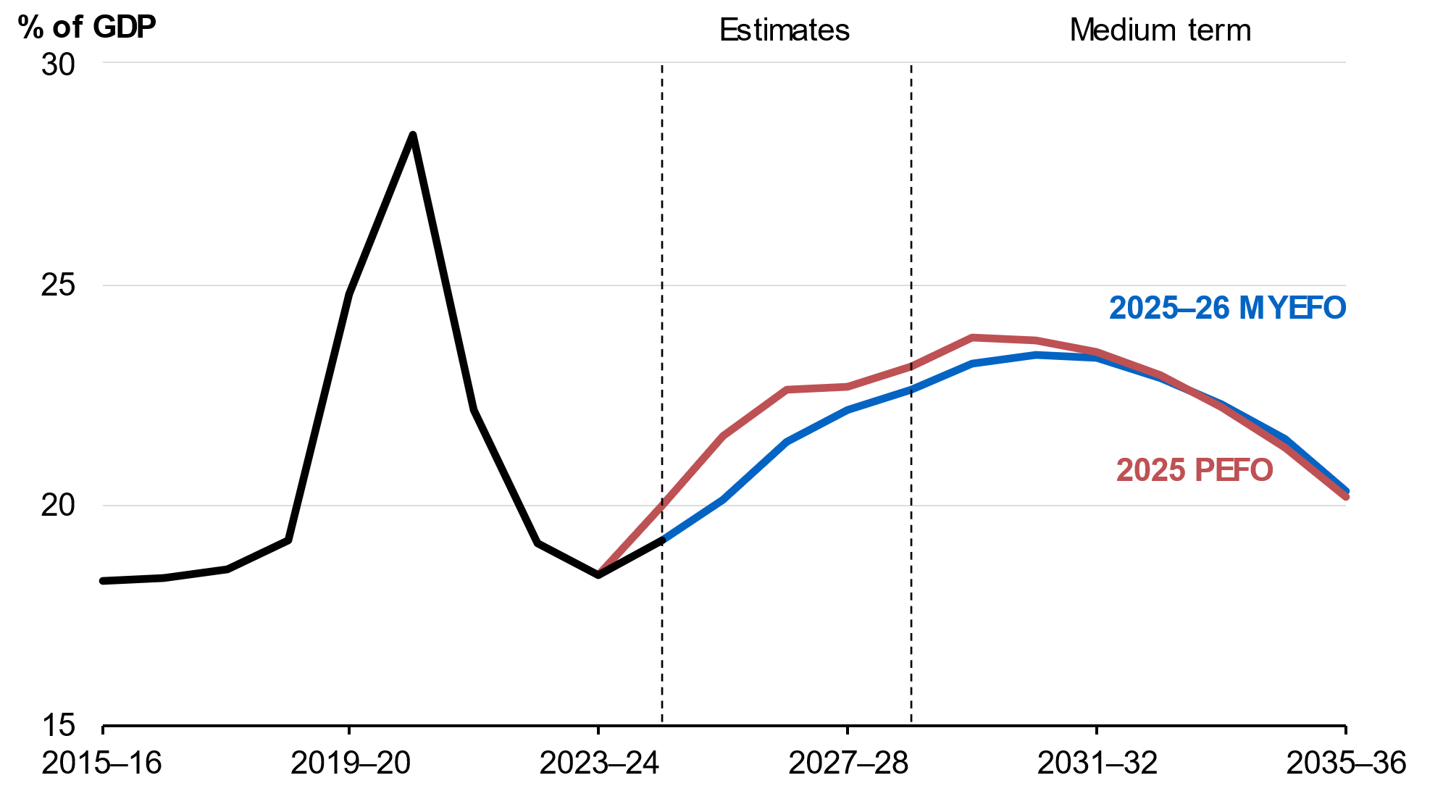
Source: Treasury.

Further information on gross debt and net debt estimates across the forward estimates is provided in Part 4: Debt Statement.

Net financial worth and net worth estimates and projections
Net financial worth is estimated to be minus 30.2 per cent of GDP (minus $881.7 billion) at 30 June 20‍26 (Table 3.8), compared with the estimate of minus 29.5 per cent of GDP (minus $850.1 billion) at the 2025 PEFO.
Net financial worth is projected to deteriorate to minus 31.4 per cent of GDP at 30 June 2030 before improving to minus 26.9 per cent of GDP at 30 June 2036 (Chart 3.9).
Chart 3.9: Net financial worth
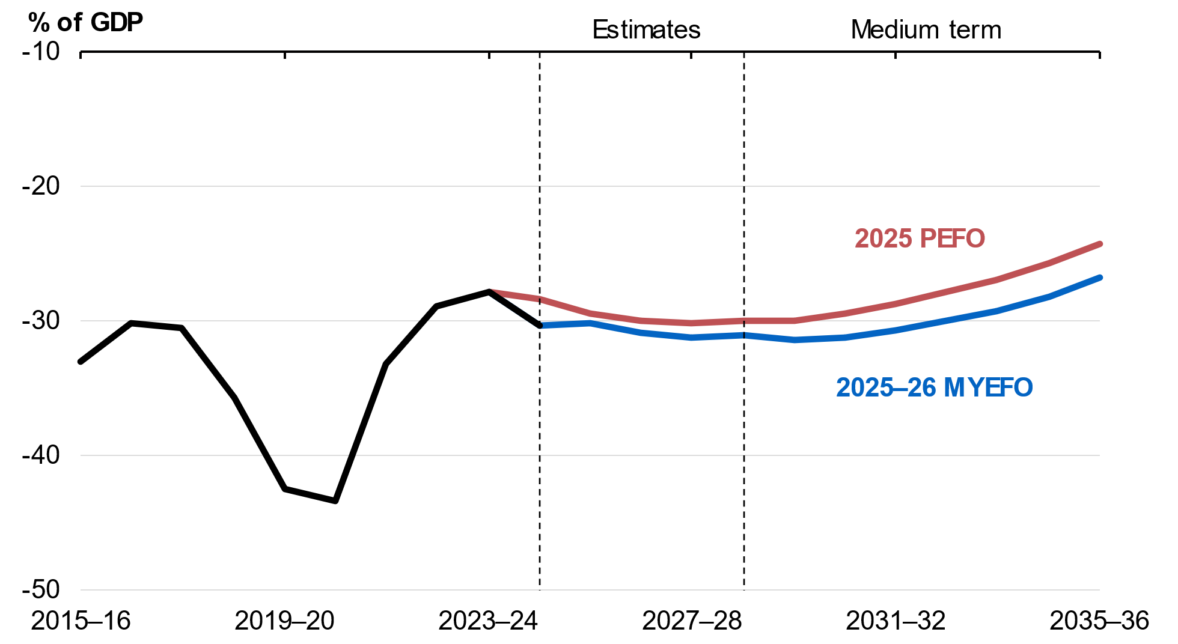
Source: Treasury.

Net worth is estimated to be minus 22.0 per cent of GDP (minus $644.3 billion) at 30 June 2026 (Table 3.8), compared with the estimate of minus 21.6 per cent of GDP (minus $621.8 billion) at the 2025 PEFO.
The change in net worth and net financial worth since the 2025 PEFO largely reflects increases in the liabilities for military compensation and provisions for claims for veterans’ benefits. This is partially offset by a lower market value of Australian Government Securities on issue resulting from the improved headline cash balance outcome in 2024–25, combined with a higher value of investments through collective investment vehicles.
Net worth is projected to decline to minus 23.4 per cent of GDP by 30 June 2030 before improving over the medium term.
Table 3.8: Australian Government general government sector balance sheet aggregates^{(a)}
 | Estimates
 | 2025-26 |  | 2026-27 |  | 2027-28 |  | 2028-29
 | $b | % GDP | $b | % GDP | $b | % GDP | $b | % GDP
Financial assets
MYEFO | 688.3 | 23.5 | 735.1 | 24.4 | 781.0 | 24.7 | 827.8 | 24.8
PEFO | 677.5 | 23.5 | 715.0 | 23.9 | 752.9 | 23.9 | 789.2 | 23.8
Budget | 677.8 | 23.5 | 715.0 | 23.9 | 752.7 | 23.9 | 789.2 | 23.8
Non-financial assets
MYEFO | 237.4 | 8.1 | 246.8 | 8.2 | 257.3 | 8.1 | 267.2 | 8.0
PEFO | 228.3 | 7.9 | 236.4 | 7.9 | 247.6 | 7.9 | 257.3 | 7.8
Budget | 228.3 | 7.9 | 236.4 | 7.9 | 247.6 | 7.9 | 257.3 | 7.8
Total assets
MYEFO | 925.8 | 31.7 | 981.9 | 32.5 | 1,038.3 | 32.9 | 1,095.1 | 32.8
PEFO | 905.8 | 31.5 | 951.4 | 31.8 | 1,000.4 | 31.8 | 1,046.5 | 31.5
Budget | 906.1 | 31.5 | 951.3 | 31.8 | 1,000.3 | 31.8 | 1,046.5 | 31.5
Total liabilities
MYEFO | 1,570.1 | 53.7 | 1,665.4 | 55.2 | 1,766.0 | 55.9 | 1,866.3 | 56.0
PEFO | 1,527.6 | 53.1 | 1,610.6 | 53.8 | 1,701.0 | 54.0 | 1,786.6 | 53.8
Budget | 1,527.9 | 53.1 | 1,610.6 | 53.8 | 1,701.0 | 54.0 | 1,786.6 | 53.8
Net worth
MYEFO | -644.3 | -22.0 | -683.4 | -22.7 | -727.6 | -23.0 | -771.2 | -23.1
PEFO | -621.8 | -21.6 | -659.2 | -22.0 | -700.5 | -22.3 | -740.1 | -22.3
Budget | -621.8 | -21.6 | -659.2 | -22.0 | -700.7 | -22.3 | -740.1 | -22.3
Net financial worth
MYEFO | -881.7 | -30.2 | -930.2 | -30.8 | -984.9 | -31.2 | -1,038.4 | -31.1
PEFO | -850.1 | -29.5 | -895.6 | -29.9 | -948.1 | -30.1 | -997.4 | -30.0
Budget | -850.1 | -29.5 | -895.6 | -29.9 | -948.3 | -30.1 | -997.4 | -30.0
Gross debt
MYEFO | 993.0 | 34.0 | 1,069.0 | 35.4 | 1,142.0 | 36.1 | 1,213.0 | 36.4
PEFO | 1,022.0 | 35.5 | 1,092.0 | 36.5 | 1,161.0 | 36.9 | 1,223.0 | 36.8
Budget | 1,022.0 | 35.5 | 1,092.0 | 36.5 | 1,161.0 | 36.9 | 1,223.0 | 36.8
Net debt
MYEFO | 587.5 | 20.1 | 646.9 | 21.4 | 700.4 | 22.2 | 754.8 | 22.6
PEFO | 620.7 | 21.6 | 676.3 | 22.6 | 713.9 | 22.7 | 768.2 | 23.1
Budget | 620.3 | 21.5 | 676.3 | 22.6 | 714.1 | 22.7 | 768.2 | 23.1
Total interest payments
MYEFO | 27.4 | 0.9 | 29.4 | 1.0 | 36.8 | 1.2 | 38.5 | 1.2
PEFO | 27.9 | 1.0 | 30.2 | 1.0 | 36.7 | 1.2 | 38.2 | 1.2
Budget | 27.9 | 1.0 | 30.2 | 1.0 | 36.7 | 1.2 | 38.2 | 1.2
Net interest payments(b)
MYEFO | 18.3 | 0.6 | 20.3 | 0.7 | 27.4 | 0.9 | 28.7 | 0.9
PEFO | 18.5 | 0.6 | 21.2 | 0.7 | 26.9 | 0.9 | 28.1 | 0.8
Budget | 18.5 | 0.6 | 21.2 | 0.7 | 26.9 | 0.9 | 28.1 | 0.8
- Assets, liabilities, net worth, net financial worth, gross debt and net debt are presented as at the end of each financial year.
- Net interest payments are equal to the difference between interest payments and interest receipts.

Accrual budget aggregates
Accrual accounting records income and costs at the time they are incurred. Cash accounting records income and costs at the time of the associated actual cash flow. Differences in estimates arise where there is a difference between the timing of an activity and the associated cash flow.

Net operating balance estimates
The net operating balance is an accrual measure, reflecting revenue minus expenses. It excludes the fiscal impact of the Commonwealth’s net new capital expenditure.
The net operating balance is expected to be a deficit of $43.6 billion (1.5 per cent of GDP) in 2025–26 (Table 3.9), compared to an expected deficit of $35.4 billion (1.2 per cent of GDP) in the 2025 PEFO.

Fiscal balance estimates
The fiscal balance is the accrual equivalent of the underlying cash balance and equals the net operating balance less net new capital expenditure.
The fiscal balance is expected to be a deficit of $54.8 billion (1.9 per cent of GDP) in 2025 – 26 (Table 3.9), compared to an expected deficit of $44.2 billion (1.5 per cent of GDP) in the 2025 PEFO.
Table 3.9: Australian Government general government sector accrual aggregates
 | Estimates
 | 2025-26 |  | 2026-27 |  | 2027-28 |  | 2028-29
 | $b | % GDP | $b | % GDP | $b | % GDP | $b | % GDP
Revenue
MYEFO | 765.6 | 26.2 | 793.6 | 26.3 | 820.8 | 26.0 | 864.1 | 25.9
PEFO | 750.3 | 26.1 | 783.6 | 26.2 | 815.4 | 25.9 | 862.5 | 26.0
Budget | 750.3 | 26.1 | 783.6 | 26.2 | 815.4 | 25.9 | 862.5 | 26.0
Expenses
MYEFO | 809.2 | 27.7 | 819.0 | 27.1 | 854.0 | 27.0 | 897.5 | 26.9
PEFO | 785.7 | 27.3 | 806.5 | 27.0 | 842.8 | 26.8 | 889.6 | 26.8
Budget | 785.7 | 27.3 | 806.6 | 27.0 | 842.9 | 26.8 | 889.4 | 26.8
Net operating balance
MYEFO | -43.6 | -1.5 | -25.4 | -0.8 | -33.2 | -1.1 | -33.4 | -1.0
PEFO | -35.4 | -1.2 | -23.0 | -0.8 | -27.4 | -0.9 | -27.1 | -0.8
Budget | -35.4 | -1.2 | -23.0 | -0.8 | -27.5 | -0.9 | -26.9 | -0.8
Net capital investment
MYEFO | 11.2 | 0.4 | 10.4 | 0.3 | 10.0 | 0.3 | 10.4 | 0.3
PEFO | 8.8 | 0.3 | 9.1 | 0.3 | 12.0 | 0.4 | 10.2 | 0.3
Budget | 8.8 | 0.3 | 9.1 | 0.3 | 12.0 | 0.4 | 10.2 | 0.3
Fiscal balance
MYEFO | -54.8 | -1.9 | -35.8 | -1.2 | -43.2 | -1.4 | -43.7 | -1.3
PEFO | -44.2 | -1.5 | -32.1 | -1.1 | -39.4 | -1.3 | -37.3 | -1.1
Budget | -44.2 | -1.5 | -32.2 | -1.1 | -39.5 | -1.3 | -37.1 | -1.1
Table 3.10 provides a reconciliation of fiscal balance estimates, including the impact of policy decisions and parameter and other variations on revenue and expenses since the 2025 PEFO.
Table 3.10: Reconciliation of general government sector fiscal balance estimates
 | Estimates
 | 2025-26 | 2026-27 | 2027-28 | 2028-29 |  | Total
 | $m | $m | $m | $m |  | $m
2025-26 Budget fiscal balance | -44,178 | -32,174 | -39,545 | -37,087 |  | -152,985
Per cent of GDP | -1.5 | -1.1 | -1.3 | -1.1
2025 PEFO fiscal balance | -44,221 | -32,116 | -39,385 | -37,261 |  | -152,984
Per cent of GDP | -1.5 | -1.1 | -1.3 | -1.1
Changes from 2025 PEFO
to 2025-26 MYEFO
Effect of policy decisions(a)(b)
Revenue | -895 | -676 | -1,334 | -971 |  | -3,877
Expenses | 661 | 1,334 | -1,766 | -3,755 |  | -3,526
Net capital investment | 609 | 795 | 366 | 103 |  | 1,873
Total policy decisions impact on fiscal balance | -2,165 | -2,805 | 65 | 2,681 |  | -2,224
Effect of parameter and other variations(b)
Revenue | 16,221 | 10,718 | 6,664 | 2,555 |  | 36,156
Expenses | 22,856 | 11,097 | 12,969 | 11,639 |  | 58,561
Net capital investment | 1,790 | 492 | -2,413 | 77 |  | -54
Total parameter and other variations impact on
fiscal balance | -8,426 | -871 | -3,893 | -9,161 |  | -22,351
2025-26 MYEFO fiscal balance | -54,812 | -35,792 | -43,213 | -43,741 |  | -177,558
Per cent of GDP | -1.9 | -1.2 | -1.4 | -1.3
- Excludes secondary impacts on public debt interest of policy decisions and offsets from the Contingency Reserve for decisions taken.
- A positive number for revenue improves the fiscal balance, while a positive number for expenses and net capital investment worsens the fiscal balance.

Revenue estimates
Revenue is the accrual accounting equivalent of cash-based receipts. Changes in revenue are generally driven by the same factors as receipts. Revenue amounts can be higher or lower than the cash equivalents as they include amounts that a taxpayer is liable to pay
but has not paid. The differences between the accrual and cash amounts generally reflect timing differences.
Total revenue has been revised up by $15.3 billion in 2025–26 since the 2025 PEFO (Table 3.11).
Table 3.11: Reconciliation of 2025–26 general government (accrual) revenue
 | Estimates |  |  | Change on PEFO
 | PEFO | MYEFO
 | $m | $m |  | $m | %
Individuals and other withholding taxes
Gross income tax withholding | 314,100 | 315,800 |  | 1,700 | 0.5
Gross other individuals | 84,500 | 91,600 |  | 7,100 | 8.4
less: Refunds | 40,800 | 40,600 |  | -200 | -0.5
Total individuals and other withholding tax | 357,800 | 366,800 |  | 9,000 | 2.5
Fringe benefits tax | 5,150 | 5,560 |  | 410 | 8.0
Company tax | 143,500 | 147,800 |  | 4,300 | 3.0
Superannuation fund taxes | 25,580 | 29,880 |  | 4,300 | 16.8
Petroleum resource rent tax | 1,980 | 1,820 |  | -160 | -8.1
Income taxation revenue | 534,010 | 551,860 |  | 17,850 | 3.3
Goods and services tax | 99,300 | 101,030 |  | 1,730 | 1.7
Wine equalisation tax | 1,210 | 1,110 |  | -100 | -8.3
Luxury car tax | 1,210 | 1,130 |  | -80 | -6.6
Excise and customs duty
Petrol | 7,450 | 7,320 |  | -130 | -1.7
Diesel | 17,850 | 17,660 |  | -190 | -1.1
Other fuel products | 2,020 | 1,680 |  | -340 | -16.8
Tobacco | 7,050 | 5,450 |  | -1,600 | -22.7
Beer | 2,780 | 2,720 |  | -60 | -2.2
Spirits | 3,380 | 3,270 |  | -110 | -3.3
Other alcoholic beverages(a) | 1,830 | 1,810 |  | -20 | -1.1
Other customs duty
Textiles, clothing and footwear | 170 | 160 |  | -10 | -5.9
Passenger motor vehicles | 380 | 300 |  | -80 | -21.1
Other imports | 1,620 | 1,550 |  | -70 | -4.3
less: Refunds and drawbacks | 730 | 1,380 |  | 650 | 89.0
Total excise and customs duty | 43,800 | 40,540 |  | -3,260 | -7.4
Major bank levy | 1,870 | 1,900 |  | 30 | 1.6
Agricultural levies | 669 | 707 |  | 38 | 5.6
Visa application charges | 4,199 | 4,576 |  | 377 | 9.0
Other taxes | 8,036 | 7,127 |  | -908 | -11.3
Indirect taxation revenue | 160,294 | 158,120 |  | -2,174 | -1.4
Taxation revenue | 694,304 | 709,980 |  | 15,676 | 2.3
Sales of goods and services | 22,261 | 21,987 |  | -274 | -1.2
Interest | 10,619 | 10,159 |  | -461 | -4.3
Dividends and distributions | 7,434 | 7,591 |  | 157 | 2.1
Other non-taxation revenue | 15,649 | 15,876 |  | 227 | 1.5
Non-taxation revenue | 55,964 | 55,613 |  | -350 | -0.6
Total revenue | 750,268 | 765,593 |  | 15,325 | 2.0
Memorandum:
Total excise | 32,450 | 31,760 |  | -690 | -2.1
Total customs duty | 11,350 | 8,780 |  | -2,570 | -22.6
Capital gains tax(b) | 27,600 | 31,500 |  | 3,900 | 14.1
- ‘Other alcoholic beverages’ are those not exceeding 10 per cent by volume of alcohol (excluding beer, brandy and wine).
- ‘Capital gains tax’ is part of gross other individuals, company tax and superannuation fund taxes.

Table 3.12: Reconciliation of 2026–27 general government (accrual) revenue
 | Estimates |  |  | Change on PEFO
 | PEFO | MYEFO
 | $m | $m |  | $m | %
Individuals and other withholding taxes
Gross income tax withholding | 330,700 | 332,200 |  | 1,500 | 0.5
Gross other individuals | 90,000 | 94,200 |  | 4,200 | 4.7
less: Refunds | 41,900 | 42,400 |  | 500 | 1.2
Total individuals and other withholding tax | 378,800 | 384,000 |  | 5,200 | 1.4
Fringe benefits tax | 5,180 | 5,620 |  | 440 | 8.5
Company tax | 147,900 | 150,500 |  | 2,600 | 1.8
Superannuation fund taxes | 26,130 | 29,140 |  | 3,010 | 11.5
Petroleum resource rent tax | 1,680 | 1,590 |  | -90 | -5.4
Income taxation revenue | 559,690 | 570,850 |  | 11,160 | 2.0
Goods and services tax | 104,560 | 107,240 |  | 2,680 | 2.6
Wine equalisation tax | 1,250 | 1,220 |  | -30 | -2.4
Luxury car tax | 1,280 | 1,180 |  | -100 | -7.8
Excise and customs duty
Petrol | 7,600 | 7,570 |  | -30 | -0.4
Diesel | 18,770 | 18,490 |  | -280 | -1.5
Other fuel products | 2,070 | 1,710 |  | -360 | -17.4
Tobacco | 6,800 | 4,800 |  | -2,000 | -29.4
Beer | 2,910 | 2,780 |  | -130 | -4.5
Spirits | 3,430 | 3,280 |  | -150 | -4.4
Other alcoholic beverages(a) | 1,930 | 1,860 |  | -70 | -3.6
Other customs duty
Textiles, clothing and footwear | 180 | 160 |  | -20 | -11.1
Passenger motor vehicles | 350 | 270 |  | -80 | -22.9
Other imports | 1,680 | 1,640 |  | -40 | -2.4
less: Refunds and drawbacks | 730 | 730 |  | 0 | 0.0
Total excise and customs duty | 44,990 | 41,830 |  | -3,160 | -7.0
Major bank levy | 1,950 | 1,990 |  | 40 | 2.1
Agricultural levies | 684 | 697 |  | 13 | 1.9
Visa application charges | 4,402 | 4,971 |  | 569 | 12.9
Other taxes | 7,929 | 6,927 |  | -1,002 | -12.6
Indirect taxation revenue | 167,045 | 166,055 |  | -990 | -0.6
Taxation revenue | 726,735 | 736,905 |  | 10,170 | 1.4
Sales of goods and services | 23,485 | 23,526 |  | 41 | 0.2
Interest | 10,662 | 10,568 |  | -94 | -0.9
Dividends and distributions | 7,786 | 7,808 |  | 21 | 0.3
Other non-taxation revenue | 14,895 | 14,798 |  | -97 | -0.7
Non-taxation revenue | 56,829 | 56,699 |  | -129 | -0.2
Total revenue | 783,564 | 793,605 |  | 10,041 | 1.3
Memorandum:
Total excise | 33,810 | 33,000 |  | -810 | -2.4
Total customs duty | 11,180 | 8,830 |  | -2,350 | -21.0
Capital gains tax(b) | 27,600 | 30,700 |  | 3,100 | 11.2
- ‘Other alcoholic beverages’ are those not exceeding 10 per cent by volume of alcohol (excluding beer, brandy and wine).
- ‘Capital gains tax’ is part of gross other individuals, company tax and superannuation fund taxes.

Expense estimates
Expenses are the accrual accounting equivalent of cash-based payments. The differences between the accrual and cash amounts generally reflect where there is a timing difference between the expense accruing and cash payments occurring. Common examples include employee-related liabilities such as superannuation benefits programs and long service leave, government insurance and guarantee schemes, concessional loans and purchases of non-financial assets.
Since the 2025 PEFO, total expenses have been revised up by $23.5 billion in 2025–26 and by $55.0 billion over the four years from 2025 – 26 to 2028 – 29.
Movements in expenses over the forward estimates period are broadly consistent with movements in cash payments. A key exception is the Higher Education Loan Program, where debt remissions are recorded as accrual expenses with no impact on cash payments, with a material expense impact in 2025 – 26 largely driven by the 20 per cent student debt reduction provided through the 2024 – 25 MYEFO measure Building Australia’s Future – A fairer deal for students.
Table 3.13: Reconciliation of general government sector expense estimates
 | Estimates
 | 2025-26 | 2026-27 | 2027-28 | 2028-29 |  | Total
 | $m | $m | $m | $m |  | $m
2025-26 Budget expenses | 785,670 | 806,594 | 842,949 | 889,397 |  | 3,324,610
2025 PEFO expenses | 785,715 | 806,539 | 842,792 | 889,576 |  | 3,324,622
Changes from 2025 PEFO to
2025-26 MYEFO
Effect of policy decisions(a) | 661 | 1,334 | -1,766 | -3,755 |  | -3,526
Effect of economic parameter variations
Total economic parameter variations | 4,673 | 5,951 | 5,824 | 6,535 |  | 22,983
Unemployment benefits | 1,768 | 1,672 | 1,112 | 285 |  | 4,836
Prices and wages | 737 | 2,076 | 2,720 | 3,056 |  | 8,590
Interest and exchange rates | -123 | -39 | 34 | -18 |  | -146
GST payments to the states(b) | 2,291 | 2,242 | 1,958 | 3,212 |  | 9,702
Public debt interest | -688 | -1,321 | -841 | -611 |  | -3,460
Program specific parameter variations | 17,496 | 9,159 | 11,192 | 9,965 |  | 47,811
Other variations | 1,376 | -2,692 | -3,206 | -4,250 |  | -8,772
Total variations | 23,517 | 12,431 | 11,204 | 7,883 |  | 55,035
2025-26 MYEFO expenses | 809,232 | 818,970 | 853,996 | 897,459 |  | 3,379,657
- Excludes secondary impacts on public debt interest of policy decisions and offsets from the Contingency Reserve for decisions taken.
- GST entitlement for 2025–26 accounts for the balancing adjustment from 2024–25.

Net capital investment estimates
Net capital investment is broadly defined as the sale and acquisition of non-financial assets, less depreciation expenses. It provides a measure of the overall growth in capital assets (including buildings and infrastructure, specialist military equipment, and computer software) after taking into account depreciation and amortisation as previously acquired assets age.
Government capital spending involves acquisition of physical assets, financial assets and provision of grants and subsidies to others (primarily state and territory governments), which they then use to acquire assets.
Table 3.14: Reconciliation of general government sector net capital investment estimates
 | Estimates
 | 2025-26 | 2026-27 | 2027-28 | 2028-29 |  | Total
 | $m | $m | $m | $m |  | $m
2025-26 Budget net capital investment | 8,771 | 9,140 | 12,025 | 10,196 |  | 40,132
2025 PEFO net capital investment | 8,774 | 9,140 | 12,026 | 10,196 |  | 40,136
Changes from 2025 PEFO to
2025-26 MYEFO
Effect of policy decisions(a) | 609 | 795 | 366 | 103 |  | 1,873
Effect of parameter and other variations | 1,790 | 492 | -2,413 | 77 |  | -54
Total variations | 2,399 | 1,287 | -2,046 | 180 |  | 1,819
2025-26 MYEFO net capital investment | 11,173 | 10,427 | 9,980 | 10,376 |  | 41,955
- Excludes secondary impacts on public debt interest of policy decisions and offsets from the Contingency Reserve for decisions taken.

Structural budget balance estimates
The structural budget balance estimate adjusts the underlying cash balance to remove the estimated effects of cyclical factors that have a temporary impact on receipts and payments. These factors include deviations in commodity prices and economic activity from their long-run levels. The structural budget balance can provide insight into the sustainability of fiscal settings.
The structural balance is estimated rather than observed, so it is sensitive to the assumptions and parameters that underpin it. Commodity price volatility has increased the uncertainty around the estimate.
The overall trajectory for the structural budget balance is broadly consistent with the 2025 – 26 Budget. While the near-term has changed, the structural budget balance is still projected to increase towards balance by the end of the medium term.
The estimate of the structural budget balance for 2024–25 has improved since the 2025 – 26 Budget to a deficit of 0.6 per cent of GDP, consistent with the higher-than-expected underlying cash balance outcome for that year (Chart 3.10).
The structural budget position is forecast to remain in deficit over the projection period, peaking at 1.5 per cent of GDP in 2025–26 and then narrowing to the end of the forward estimates.
Cyclical factors are estimated to have a small positive contribution to the underlying cash balance in 2025–26, in large part due to elevated commodity prices. This recedes as commodity prices return to their assumed long-run levels.
Chart 3.10: Structural budget balance
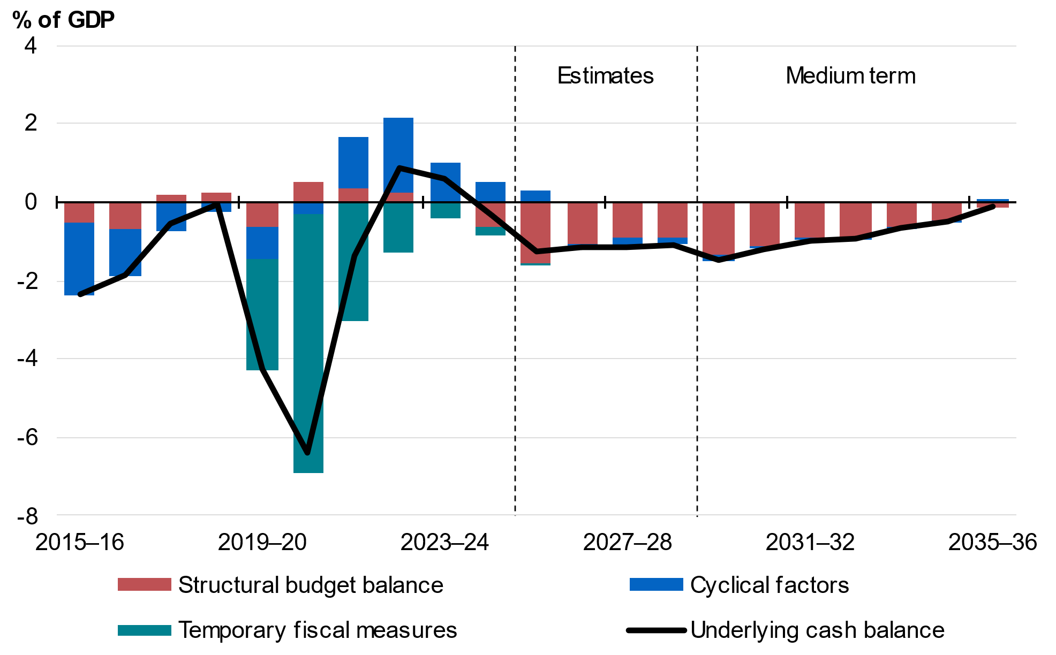
Note: The approach separating the budgetary impact of cyclical factors from structural measures follows the methodology detailed in Treasury Working Paper 2013–01. Cyclical factors measure the estimated impact on the underlying cash balance from automatic stabilisers and cyclical movements in asset and commodity prices. Temporary fiscal measures comprise direct economic and health support measures initiated between the onset of the COVID-19 pandemic and the 2022–23 October Budget. Underspends in these direct economic and health support measures are not captured in the derivation of the structural budget balance, which may alter the structural budget balance estimate in those years.
Source: Treasury.

