Part 4: Debt Statement
The Debt Statement provides information on Government gross debt, net debt, Australian Government Securities (AGS) issuance and interest costs.
This MYEFO demonstrates the Government’s ongoing commitment to reducing gross debt as a share of the economy over time. Gross debt is expected to be lower than estimated at the 2025 Pre-election Economic and Fiscal Outlook (PEFO) in every year of the forward estimates as a proportion of the economy.
By the end of 2025–26, gross debt is expected to be $993 billion (34.0 per cent of GDP), lower than the $1,022 billion (35.5 per cent of GDP) estimated at the 2025 PEFO and considerably less than the $1,169 billion (44.7 per cent of GDP) estimated at the 2022 PEFO. Gross debt is expected to peak at 37.0 per cent of GDP in 2030–31, the same level as at the 2025 PEFO and 7.9 percentage points lower than the 44.9 per cent of GDP peak estimated at the 2022 PEFO, before falling to 33.0 per cent in 2035–36.
Net debt in 2025–26 is expected to be $587.5 billion or 20.1 per cent of GDP, 1.5 percentage points of GDP ($33.2 billion) lower than estimated at the 2025 PEFO.
Interest payments on AGS are estimated to be $25.5 billion in 2025–26, increasing to $36.7 billion by 2028–29. Over the four years to 2028–29, interest payments on AGS are expected to be $1.7 billion lower than estimated at the 2025 PEFO.

Australian Government Securities issuance
The Australian Government finances its activities either through receipts or borrowing. When receipts fall short of payments, the Government borrows by issuing AGS.
The Australian Office of Financial Management (AOFM) is responsible for issuing AGS and managing the Government’s financing activities. The AOFM exercises operational independence in the execution of its duties. Further details on the AOFM’s operations can be found on the AOFM website at www.aofm.gov.au.

Estimates of AGS on issue
Estimates of AGS on issue are published in both face value and market value terms in this Statement.
- The face value of AGS on issue (also referred to as gross debt) is the amount the Government pays back to investors at maturity, independent of fluctuations in market prices. The total face value of AGS on issue changes when new securities are issued, or when securities are repurchased or reach maturity.
- The market value of AGS on issue represents the value of securities as traded on the secondary market, which changes continuously with movements in market prices (often quoted as a yield to maturity). Consistent with external reporting standards, the market value of AGS on issue is reported in the Australian Government general government sector balance sheet.
The Commonwealth Inscribed Stock Act 1911 (CIS Act) requires the Treasurer to issue a direction stipulating the maximum face value of relevant AGS that may be on issue. Effective from 7 October 2020, the then Treasurer directed that the maximum face value of AGS that can be on issue is $1,200 billion.

Gross debt is estimated to be $993 billion (34.0 per cent of GDP) at 30 June 2026, increasing to $1,213 billion (36.4 per cent of GDP) at 30 June 2029. Gross debt relative to GDP is expected to be lower than at the 2025 PEFO across each year of the forward estimates. The decline in gross debt relative to GDP since the PEFO reflects the stronger than expected headline cash balance outcome in 2024–25, improvements in the financing requirement across the forward estimates and upward revisions to nominal GDP.
Table 4.1: Estimates of AGS on issue subject to the Treasurer’s Direction^{(a)(b)}
 | Estimates
 | 2025-26 | 2026-27 | 2027-28 | 2028-29
 | $b | $b | $b | $b
Face value – end-of-year | 993 | 1,069 | 1,142 | 1,213
Per cent of GDP | 34.0 | 35.4 | 36.1 | 36.4
Face value – within-year peak(c) | 996 | 1,069 | 1,154 | 1,218
Per cent of GDP(c) | 34.1 | 35.4 | 36.5 | 36.5
Month of peak(c) | Apr-26 | Apr-27 | May-28 | Apr-29
Market value – end-of-year | 943 | 1,028 | 1,108 | 1,191
Per cent of GDP | 32.3 | 34.1 | 35.1 | 35.7
- The Treasurer’s Direction applies to the face value of AGS on issue. This table also shows the equivalent market value of AGS that are subject to the Treasurer’s Direction.
- The stock and securities that are excluded from the current limit set by the Treasurer’s Direction are outlined in subsection 51JA(2A) of the CIS Act.
- The precise within-year timing of cash receipts and payments is not known. Estimated peaks of AGS on issue are therefore subject to considerable uncertainty.
Source: AOFM

Changes in AGS on issue since the 2025 PEFO
The decrease in total face value of AGS on issue primarily reflects an improved financing requirement over the forward estimates, and the impact of the improved headline cash balance outcome for 2024–25, which effectively pre-funds some of the Government’s future financing requirements.
Additionally, recent changes in yields have influenced estimates of AGS on issue. While shifts in yields affect interest payments and the financing requirement, the impact has varied across the yield curve. The change in yields is estimated to decrease the face value of gross debt by $2.5 billion by the end of the forward estimates compared with the 2025 PEFO.
Table 4.2: Estimates of AGS on issue subject to the Treasurer’s Direction – reconciliation from the 2025 PEFO to the 2025–26 MYEFO
 | 2025-26 | 2026-27 | 2027-28 | 2028-29
 | $b | $b | $b | $b
Total face value of AGS on issue subject to the Treasurer's Direction as at 2025 PEFO | 1,022 | 1,092 | 1,161 | 1,223
Factors affecting the change in face value of AGS on issue from 2025 PEFO to 2025-26 MYEFO
Cumulative receipts decisions | 0.2 | 0.3 | 1.1 | 1.6
Cumulative receipts variations | -14.6 | -25.7 | -34.7 | -41.3
Cumulative payment decisions | 1.8 | 1.8 | -0.4 | -3.8
Cumulative payment variations | 7.3 | 17.2 | 26.7 | 35.1
Cumulative change in net investments in financial assets(b) | -1.3 | 4.3 | 6.5 | 9.0
Other contributors | -22.3 | -21.7 | -18.7 | -10.9
Total face value of AGS on issue subject to the Treasurer's Direction as at 2025-26 MYEFO | 993 | 1,069 | 1,142 | 1,213
- Cumulative impact of decisions and variations from 2025–26 to 2028–29. Increases to payments are shown as positive and increases to receipts are shown as negative.
- Change in net cash flows from investments in financial assets for policy purposes only.
Note: End-of-year data.

Breakdown of AGS currently on issue
Table 4.3 provides a breakdown of the AGS on issue by type of security as at 3 December 2025.
Table 4.3: Breakdown of current AGS on issue
 | On issue as at 3 December 2025
 | Face value | Market value
 | $m | $m
Treasury Bonds | 873,749 | 800,166
Treasury Indexed Bonds | 39,192 | 48,717
Treasury Notes | 40,000 | 39,719
Total AGS subject to Treasurer's Direction(a) | 952,942 | 888,602
Other stock and securities | 5 | 5
Total AGS on issue | 952,947 | 888,608
- Includes Green Treasury Bonds
- The stock and securities that are excluded from the current limit set by the Treasurer’s Direction are outlined in subsection 51JA(2A) of the CIS Act.
Source: AOFM.

Treasury Bonds
As at 3 December 2025, there were 29 Treasury Bond lines on issue, with a weighted average term to maturity of around 6.6 years and the longest maturity extending June 2054.
One Treasury Bond line is the Green Treasury Bond maturing in June 2034. The Government issued its first Green Treasury Bond in June 2024. Green Treasury Bonds provide financing or refinancing for specific government programs that progress Australia’s net zero transformation and support Australia’s environmental objectives. Annual Allocation and Impact Reports for Green Treasury Bonds are published on the AOFM website.
Table 4.4: Treasury Bonds on issue
 |  | On issue as at
Coupon |  | 3 December 2025
Per cent | Maturity | $m | Timing of interest payments^{(a)}
4.25 | 21-Apr-26 | 39,600 | Twice yearly | 21-Apr | 21-Oct
0.50 | 21-Sep-26 | 39,400 | Twice yearly | 21-Sep | 21-Mar
4.75 | 21-Apr-27 | 39,400 | Twice yearly | 21-Apr | 21-Oct
2.75 | 21-Nov-27 | 36,000 | Twice yearly | 21-Nov | 21-May
2.25 | 21-May-28 | 37,900 | Twice yearly | 21-May | 21-Nov
2.75 | 21-Nov-28 | 43,300 | Twice yearly | 21-Nov | 21-May
3.25 | 21-Apr-29 | 42,000 | Twice yearly | 21-Apr | 21-Oct
2.75 | 21-Nov-29 | 44,500 | Twice yearly | 21-Nov | 21-May
2.50 | 21-May-30 | 41,000 | Twice yearly | 21-May | 21-Nov
1.00 | 21-Dec-30 | 42,800 | Twice yearly | 21-Dec | 21-Jun
1.50 | 21-Jun-31 | 43,200 | Twice yearly | 21-Jun | 21-Dec
1.00 | 21-Nov-31 | 44,500 | Twice yearly | 21-Nov | 21-May
1.25 | 21-May-32 | 43,200 | Twice yearly | 21-May | 21-Nov
1.75 | 21-Nov-32 | 32,500 | Twice yearly | 21-Nov | 21-May
4.50 | 21-Apr-33 | 26,700 | Twice yearly | 21-Apr | 21-Oct
3.00 | 21-Nov-33 | 28,200 | Twice yearly | 21-Nov | 21-May
3.75 | 21-May-34 | 25,000 | Twice yearly | 21-May | 21-Nov
4.25 | 21-Jun-34 | 10,000 | Twice yearly | 21-Jun | 21-Dec
3.50 | 21-Dec-34 | 29,200 | Twice yearly | 21-Dec | 21-Jun
2.75 | 21-Jun-35 | 30,850 | Twice yearly | 21-Jun | 21-Dec
4.25 | 21-Dec-35 | 22,900 | Twice yearly | 21-Dec | 21-Jun
4.25 | 21-Mar-36 | 22,100 | Twice yearly | 21-Mar | 21-Sep
4.25 | 21-Oct-36 | 16,000 | Twice yearly | 21-Oct | 21-Apr
3.75 | 21-Apr-37 | 21,300 | Twice yearly | 21-Apr | 21-Oct
3.25 | 21-Jun-39 | 11,200 | Twice yearly | 21-Jun | 21-Dec
2.75 | 21-May-41 | 15,600 | Twice yearly | 21-May | 21-Nov
3.00 | 21-Mar-47 | 14,200 | Twice yearly | 21-Mar | 21-Sep
1.75 | 21-Jun-51 | 20,200 | Twice yearly | 21-Jun | 21-Dec
4.75 | 21-Jun-54 | 11,000 | Twice yearly | 21-Jun | 21-Dec
- Where the timing of an interest payment falls on a non-business day, the payment will occur on the following business day.
Source: AOFM.

Treasury Indexed Bonds
As at 3 December 2025, there were six Treasury Indexed Bond (TIB) lines on issue, with a weighted average term to maturity of around 9.1 years and the longest maturity extending to February 2050.
Table 4.5: Treasury Indexed Bonds on issue
 |  | On issue as at
Coupon |  | 3 December 2025
Per cent | Maturity | $m | Timing of interest payments^{(a)}
0.75 | 21-Nov-27 | 7,350 | Quarterly | 21-Nov | 21-Feb | 21-May | 21-Aug
2.50 | 20-Sep-30 | 7,642 | Quarterly | 20-Sep | 20-Dec | 20-Mar | 20-Jun
0.25 | 21-Nov-32 | 6,500 | Quarterly | 21-Nov | 21-Feb | 21-May | 21-Aug
2.00 | 21-Aug-35 | 7,100 | Quarterly | 21-Aug | 21-Nov | 21-Feb | 21-May
1.25 | 21-Aug-40 | 6,000 | Quarterly | 21-Aug | 21-Nov | 21-Feb | 21-May
1.00 | 21-Feb-50 | 4,600 | Quarterly | 21-Feb | 21-May | 21-Aug | 21-Nov
- Where the timing of an interest payment falls on a non-business day, the payment will occur on the following business day.
Source: AOFM

Treasury Notes
As at 3 December 2025, there were seven Treasury Note lines on issue. Treasury Notes do not pay a coupon.
Table 4.6: Treasury Notes on issue
 | On issue as at 3 December 2025
Maturity | $m | Timing of interest payment
12-Dec-25 | 7,000 | At maturity | 12-Dec
30-Jan-26 | 6,000 | At maturity | 30-Jan
13-Feb-26 | 9,000 | At maturity | 13-Feb
27-Feb-26 | 6,500 | At maturity | 27-Feb
13-Mar-26 | 4,000 | At maturity | 13-Mar
27-Mar-26 | 5,500 | At maturity | 27-Mar
10-Apr-26 | 2,000 | At maturity | 10-Apr
Source: AOFM

Non-resident holdings of AGS on issue
As at the September 2025 quarter, the proportion of non-resident holdings of AGS was 49 per cent (Chart 4.1), down from historical highs of around 76 per cent in 2012. While the value of non-resident holdings of AGS has increased significantly over this time, the proportion has fallen since the rate of buying by non-resident investors has not matched the rate of issuance. In addition, the Reserve Bank of Australia’s bond purchase operations in 2020 and 2021 reduced the amount of AGS available to other investors, including non-residents.
Chart 4.1: Non-resident holdings of AGS
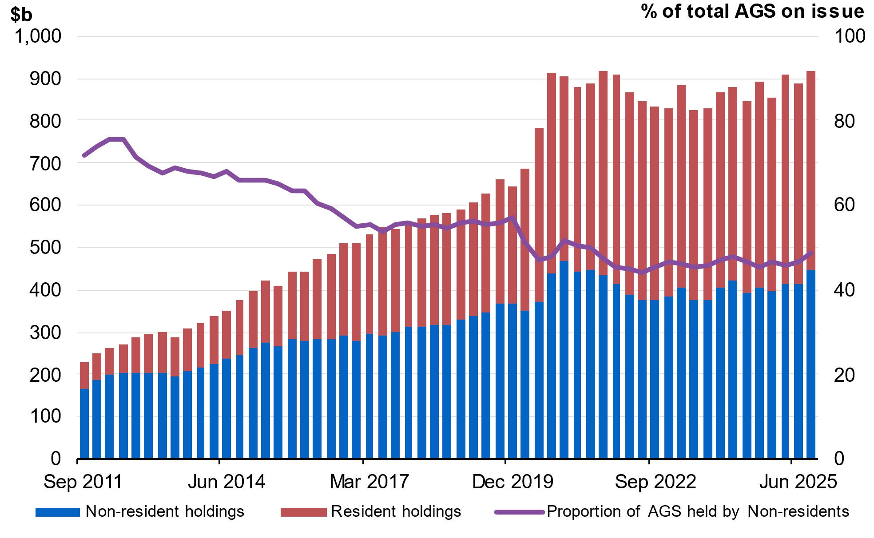
Note: Data refer to the repo-adjusted market value of holdings.
Source: ABS Balance of Payments and International Investment Position, Australia September 2025, AOFM, RBA.

Net debt
Net debt is equal to the sum of interest-bearing liabilities (which include AGS on issue measured at market value) less the sum of selected financial assets (cash and deposits, advances paid and investments, loans and placements). As net debt incorporates both selected financial assets and liabilities at their fair value, it provides a broader measure of the Government’s financial obligations than gross debt.
Not all government assets or liabilities are included in the measurement of net debt. For example, the Government’s unfunded superannuation liability is not accounted for in net debt, nor are holdings of equities, for example, those held by the Future Fund or the Government’s equity investment in the NBN.
Table 4.7: Liabilities and assets included in net debt
 | Estimates
 | 2025-26 | 2026-27 | 2027-28 | 2028-29
 | $m | $m | $m | $m
Liabilities included in net debt
Deposits held | 416 | 416 | 416 | 416
Government securities(a) | 942,518 | 1,027,847 | 1,108,193 | 1,190,511
Loans | 34,181 | 35,127 | 35,797 | 35,881
Lease liabilities | 18,599 | 17,634 | 17,388 | 16,339
Total liabilities included in net debt | 995,715 | 1,081,024 | 1,161,794 | 1,243,148
Assets included in net debt
Cash and deposits | 73,588 | 75,947 | 80,268 | 83,949
Advances paid | 73,794 | 87,975 | 100,801 | 113,038
Investments, loans and placements | 260,862 | 270,215 | 280,321 | 291,325
Total assets included in net debt | 408,244 | 434,137 | 461,390 | 488,311
Net debt | 587,471 | 646,888 | 700,404 | 754,837
- Government securities are presented at market value.

Changes in net debt since the 2025 PEFO
Net debt is expected to be lower in 2025–26, and across each year of the forward estimates compared to the 2025 PEFO. The improvement in 2025–26 primarily reflects changes to the financing requirement in addition to greater investments, loans and placements. While movements in yields traditionally influence the market value of AGS on issue, this has not had a significant impact in the 2025–26 MYEFO.
Table 4.8: Net debt – reconciliation from the 2025 PEFO to the 2025‍–‍26 MYEFO
 | 2025-26 | 2026-27 | 2027-28 | 2028-29
 | $b | $b | $b | $b
Net debt as at 2025 PEFO | 620.7 | 676.3 | 713.9 | 768.2
Changes in financing requirement | -25.9 | -16.5 | -10.8 | -0.3
Impact of yields on AGS | -0.1 | 0.4 | 1.0 | 1.8
Asset and other liability movements | -7.3 | -13.3 | -3.7 | -14.9
Cash and deposits | -0.3 | -5.6 | -11.9 | -22.6
Advances paid | 4.1 | 4.0 | 3.8 | 2.4
Investments, loans and placements | -12.3 | -13.2 | 2.5 | 2.9
Other movements | 1.2 | 1.5 | 2.0 | 2.4
Total movements in net debt from  2025 PEFO to 2025-26 MYEFO | -33.2 | -29.4 | -13.5 | -13.4
Net debt as at 2025-26 MYEFO | 587.5 | 646.9 | 700.4 | 754.8

Interest on AGS
Estimates of the interest payments and expense of AGS on issue include the cost of AGS already on issue and future AGS issuance.
- The cost of AGS already on issue reflects the actual yield at the time of issuance.
- The expected cost of future AGS issuance is based on a recent average of daily spot rates across the yield curve at the time of a budget estimates update.
Interest payments on AGS are estimated to be lower across the forward estimates compared to the 2025 PEFO. The decrease is driven by the lower borrowing requirement and lower issuance of debt compared to the 2025‍ PEFO.
Chart 4.2 shows the yield curve assumptions underpinning the 2022 PEFO, 2025 PEFO and the 2025–26 MYEFO. The curve has pivoted since the 2025 PEFO, with yields higher from the 10-year tenor and beyond. Yields remain significantly higher than the 2022 PEFO curve. Since the 2025 PEFO, yields have remained volatile, reflecting shifts in market expectations and broader economic uncertainty.
The assumed weighted average cost of borrowing has increased to 4.4 per cent for future issuance of Treasury Bonds over the forward estimates in this update, broadly reflecting the above drivers. This is higher than the assumed weighted average yields of 4.3 per cent at the 2025 PEFO and 2.2 per cent at the 2022 PEFO.
Chart 4.2: Yield curve assumptions from 2025–26 to 2028–29
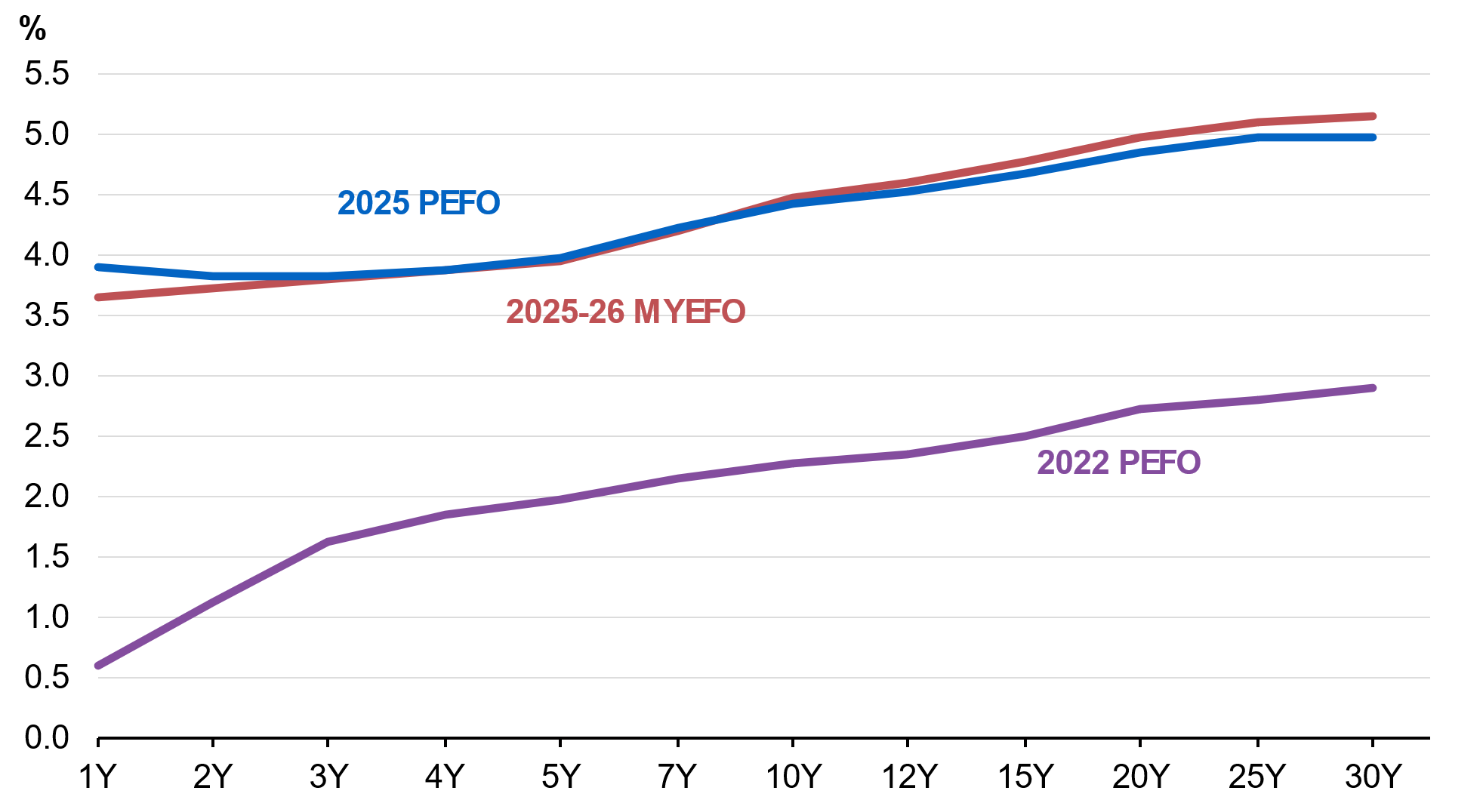
Source: AOFM.

By the end of the forward estimates total interest payments are estimated to be $38.5 billion, of which $36.7 billion relates to AGS on issue (Table 4.9). Compared to the 2025 PEFO, total interest payments as a share of GDP are estimated to remain broadly unchanged across the forward estimates.
Interest receipts as a share of GDP are estimated to remain unchanged across each year of the forward estimates compared to the 2025 PEFO.
Net interest payments as a share of GDP are estimated to remain unchanged in 2025–26 at 0.6 per cent, and broadly unchanged across all years of the forward estimates, compared to the 2025 PEFO.
Table 4.9: Interest payments, interest receipts and net interest payments^{(a)}
 | Estimates
 | 2025-26 | 2026-27 | 2027-28 | 2028-29
 | $m | $m | $m | $m
Interest payments on AGS(b) | 25,486 | 27,673 | 35,073 | 36,709
Per cent of GDP | 0.9 | 0.9 | 1.1 | 1.1
Interest payments | 27,390 | 29,383 | 36,849 | 38,511
Per cent of GDP | 0.9 | 1.0 | 1.2 | 1.2
Interest receipts | 9,103 | 9,091 | 9,478 | 9,841
Per cent of GDP | 0.3 | 0.3 | 0.3 | 0.3
Net interest payments(c) | 18,287 | 20,292 | 27,371 | 28,670
Per cent of GDP | 0.6 | 0.7 | 0.9 | 0.9
- Interest payments and receipts are a cash measure, with the relevant amount recognised in the period in which the interest payment is made or interest is received.
- Interest payments include interest payments on AGS, loans and other borrowing, as well as interest payments on lease liabilities.
- Net interest payments are equal to the difference between interest payments and interest receipts.

As well as cash accounting terms, interest costs related to AGS are also presented on accrual accounting terms. The difference between the cash interest payments and accrual interest expense generally relates to the timing of when the interest cost is recognised.
- Interest payments are recognised in the period when they are paid during the life of the security.
- Interest expense is recognised in the period in which an expense is incurred during the life of the security, rather than when it is actually paid.
Table 4.10 shows changes in interest expense, interest income and net interest expense over the forward estimates.
Table 4.10: Interest expense, interest income and net interest expense^{(a)}
 | Estimates
 | 2024-25 | 2025-26 | 2026-27 | 2027-28
 | $m | $m | $m | $m
Interest expense on AGS | 27,731 | 31,760 | 36,650 | 41,094
Per cent of GDP | 0.9 | 1.1 | 1.2 | 1.2
Total interest expense(b) | 39,245 | 42,615 | 48,628 | 50,465
Per cent of GDP | 1.3 | 1.4 | 1.5 | 1.5
Interest income | 10,159 | 10,568 | 11,363 | 12,063
Per cent of GDP | 0.3 | 0.4 | 0.4 | 0.4
Net interest expense(c) | 29,086 | 32,047 | 37,265 | 38,403
Per cent of GDP | 1.0 | 1.1 | 1.2 | 1.2
- Interest expense is an accrual measure, with the relevant amount recognised in the period in which the expense is incurred, but not necessarily paid.
- Interest expense includes interest expense on AGS, loans and other borrowing, as well as interest expense on lease liabilities and other financing costs (including debt not expected to be repaid (DNER).
- Net interest expense is equal to the difference between interest expenses and interest income.

For Treasury Indexed Bonds (TIBs), the final repayment amount paid to investors includes an additional amount to reflect the impact of inflation over the life of the security. This additional amount is not included in the calculation of face value.

