Part 5: Sensitivity Analysis
Economic and fiscal forecasts and projections are underpinned by a range of assumptions and judgements based on the best available information at the time of preparation. In practice, economic and fiscal circumstances can evolve in ways that differ from expectations.
Sensitivity analysis assesses the degree of uncertainty surrounding current forecasts by showing the impact of changes in assumptions for key variables on forecasts of economic and fiscal aggregates.
The following sensitivity analyses are considered due to their variability and importance for economic and fiscal aggregates presented in budget updates:
- Higher and lower iron ore prices.
- Higher and lower yields over the medium term.

Movements in the iron ore price
The forecasts for nominal GDP and tax receipts are sensitive to commodity price assumptions, including iron ore prices. See Part 2: Economic Outlook for information on recent developments in commodity prices.
This analysis considers the impact of a permanent US$10 per tonne increase and decrease in the iron ore price on nominal GDP and tax receipts relative to the MYEFO baseline forecast. Results are presented in Table 5.1.
Table 5.1: Sensitivity analysis of a US$10 per tonne movement in iron ore prices
 | US$10/tonne FOB^{(a)} increase |  |  |  |  | US$10/tonne FOB decrease
 | 2025–26 | 2026–27 | 2027–28 | 2028–29 |  | 2025–26 | 2026–27 | 2027–28 | 2028–29
Nominal GDP ($billion) | 4.8 | 2.4 | 5.3 | 9.9 |  | -4.8 | -2.4 | -5.3 | -9.9
Tax receipts ($billion) | 0.3 | 0.3 | 0.3 | 1.9 |  | -0.3 | -0.3 | -0.3 | -1.9
- Prices are presented in free-on-board (FOB) terms which exclude the cost of freight.
Source: Treasury

The effects of a US$10 per tonne increase and decrease in the iron ore price are broadly symmetric. A US$10 per tonne increase in the iron ore price increases nominal GDP by around $4.8 billion in 2025–26, rising to around $9.9 billion in 2028–29.
The economic response to a permanent change in the price of iron ore is derived from a generic terms of trade shock using a macroeconomic model. Higher iron ore export prices result in a higher terms of trade, which leads directly to higher output prices and nominal GDP. The volume of output and exports in the mining sector increase in response to higher iron ore prices. However, an appreciation in the exchange rate leads to a substitution to imports, which partially offsets the increase in exports and GDP. This change in the exchange rate also acts to reduce domestic inflation through lower import prices.
A US$10 per tonne increase in the assumed price for iron ore exports is expected to result in an increase in tax receipts of around $0.3 billion in each year from 2025–26 to 2027–28, before increasing to $1.9 billion in 2028–29. An increase in iron ore prices increases mining company profits and therefore company tax receipts. This builds over time as tax receipts incorporate the full impact of the iron ore price increase on nominal GDP and due to the lag between when profits are realised and tax is paid by companies. The lower domestic prices result in lower individuals and other withholding taxes and indirect tax receipts, partially offsetting the increase in company tax receipts.

Alternative pathways for yields
The cost of Government borrowing reflects yields on Australian Government Securities and the level of debt.
Given the uncertainty surrounding the global and domestic outlook for yields, Treasury makes the following technical assumptions:
- Over the forward estimates, government bond yields are fixed at rates observed prior to the Budget update.
- After the forward estimates, the 10-year bond yield converges linearly towards the long-run nominal GDP growth rate over 15 years. This is broadly consistent with the long-run approaches of comparable advanced economies. Other tenor yields are assumed to maintain their historical relativity to the 10-year bond yield.
The higher yield sensitivity analysis assumes bond yields transition to 100 basis points higher than baseline by 30 June 2027. Yields are then held constant over the remainder of the forward estimates to 2028–29, before linearly converging to the long-run yield assumption of the nominal GDP growth rate over 15 years (Chart 5.1). The lower yield sensitivity analysis is symmetric. Other economic parameters are assumed to remain unchanged from baseline forecasts to isolate the direct impact on fiscal aggregates.
Chart 5.1: Baseline and alternative pathways for the 10-year bond yield
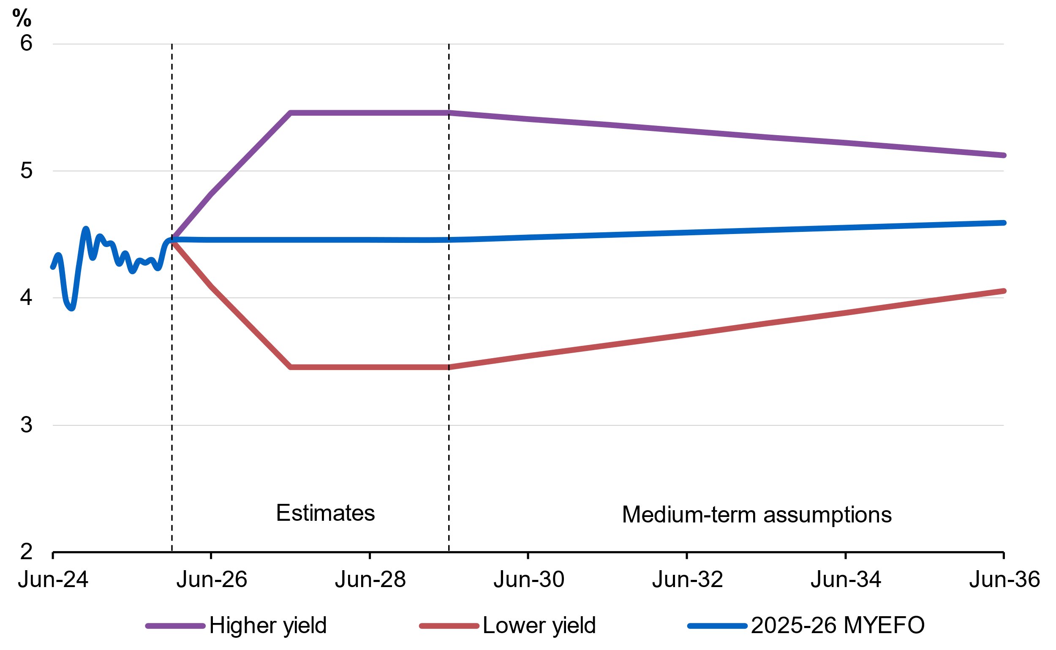
Source: Reserve Bank of Australia and Treasury
Note: Actual yields as at the end of each calendar month up to December 2025.

Higher yields increase public debt interest payments and receipts earned on investments. As government interest bearing liabilities usually exceed interest bearing assets, higher yields lead to a deterioration in the underlying cash balance. Lower yields have the reverse effect, improving the underlying cash balance.
The higher yield assumption results in a deterioration to the underlying cash balance of 0.3 percentage points of GDP by 2035–36 and increases gross debt by 1.8 percentage points of GDP at 30 June 2036 (Chart 5.2).
The lower yield assumption results in an improvement to the underlying cash balance of 0.2 percentage points of GDP by 2035–36. Under the lower yield assumption, cumulative improvements to the underlying cash balance reduce gross debt by 1.8 percentage points of GDP at 30 June 2036.
Chart 5.2: Gross debt, impact of alternative yield assumptions
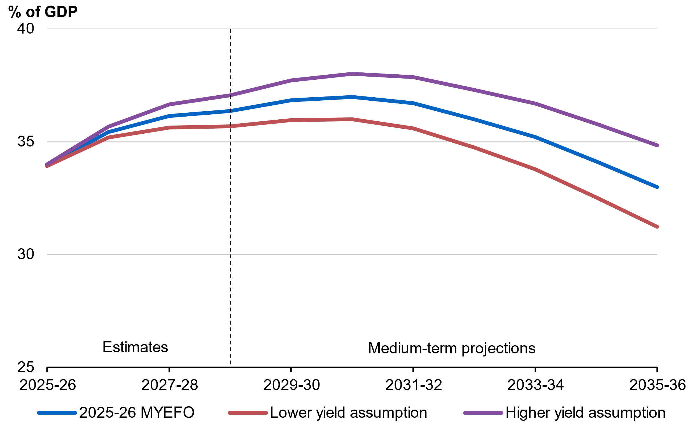
Source: Australian Office of Financial Management and Treasury

Assessments of past forecasting performance and confidence interval analysis of forecasts are included in the 2025–26 Budget, Budget Paper No 1: Statement 7: Forecasting Performance and Sensitivity Analysis.

